WEEKLY 5
Q1 IDMC EASY
1A SCREENSHOT OF THE MAPPING DESIGN BEFORE EXECUTION
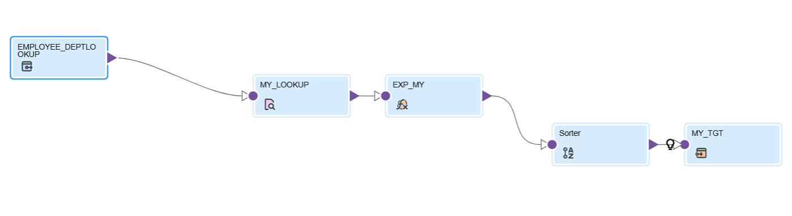
1B SCREENSHOT OF THR MAPPING AFTER SUCCESSFUL EXECUTION
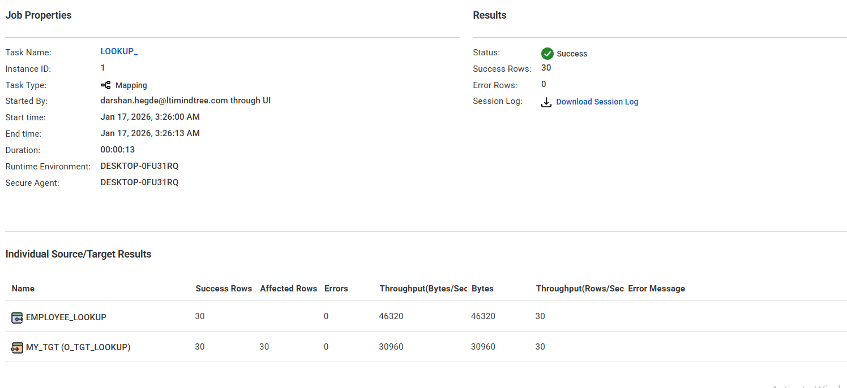
1C SCREENSHOT OF THE LOOKUP CONDITION AND THE RETUREND PORTS
LOOKUP CONDITION
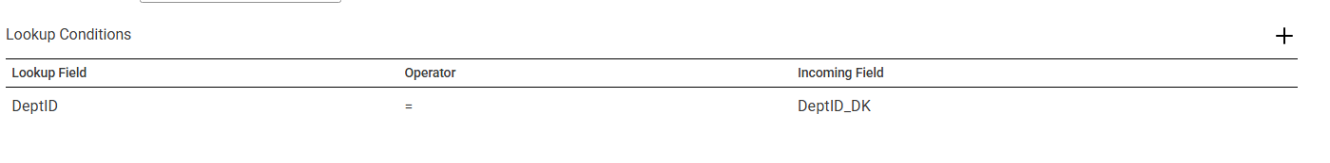
RETURN FIELDS
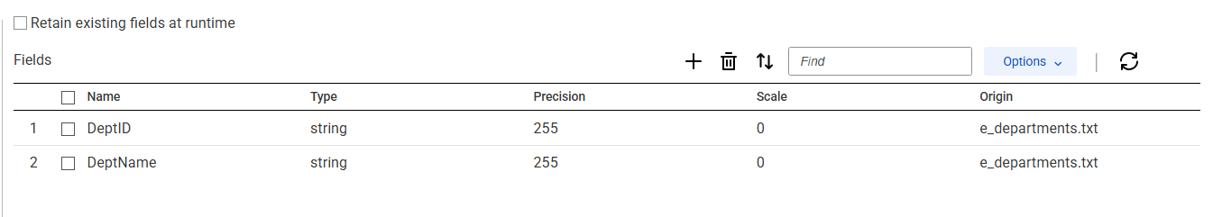

1D SCREENSHOT OF THE EXPRESSION TRANSFORMATION AND THE SHOWING CALCULATION
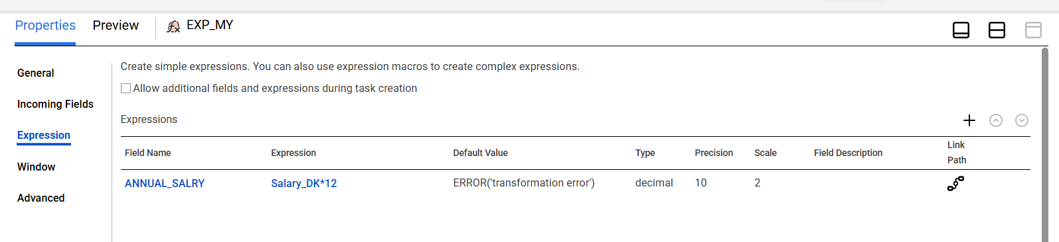
1E ANNUAL SALARY = SALARY * 12
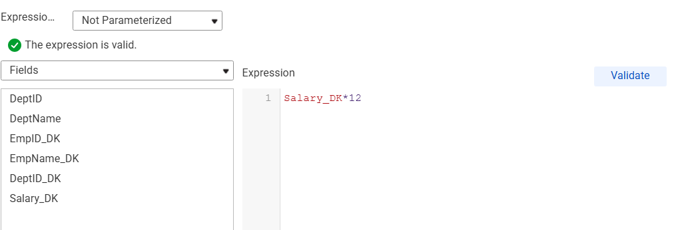
1F SCREENSHOT OF THE SORTER CONFIGURATION
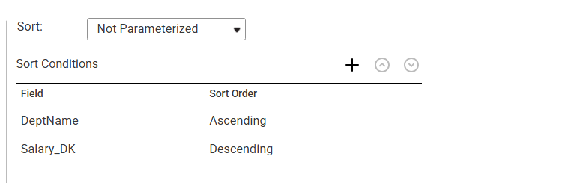
1G SCREENSHOT OF THE FINAL OUTPUT TABLE
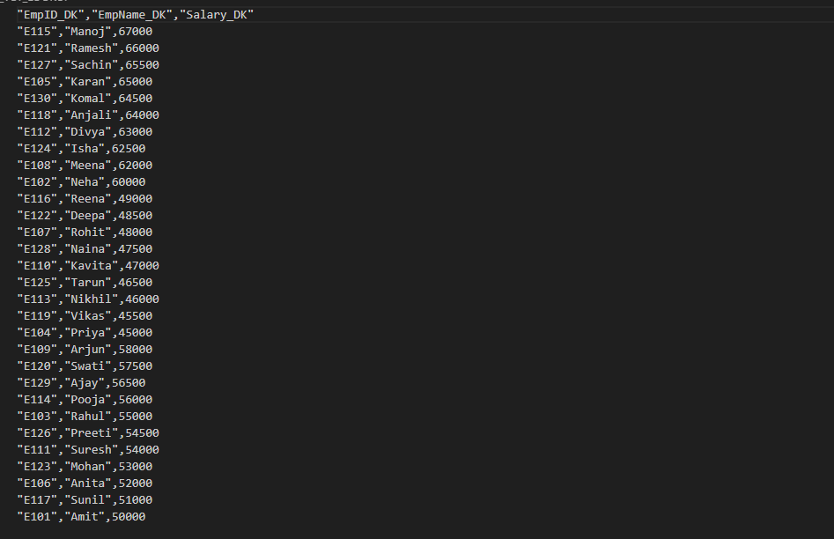

Q2 IDMC MEDIUM
2A screenshot of the mapping design before execution
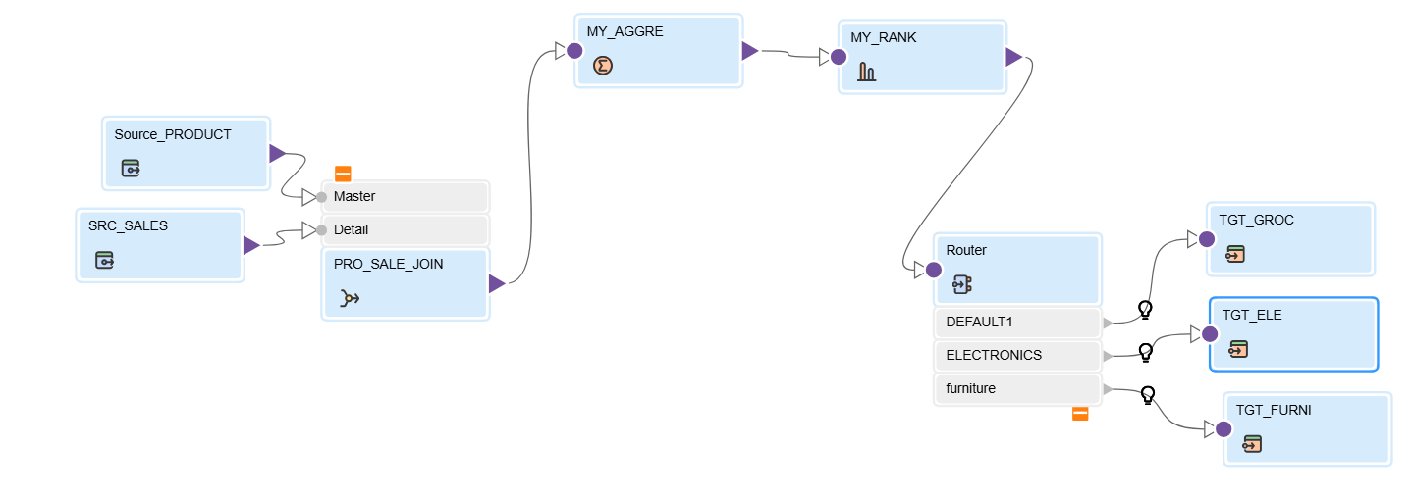

2B screenshot of the mapping after successful execution
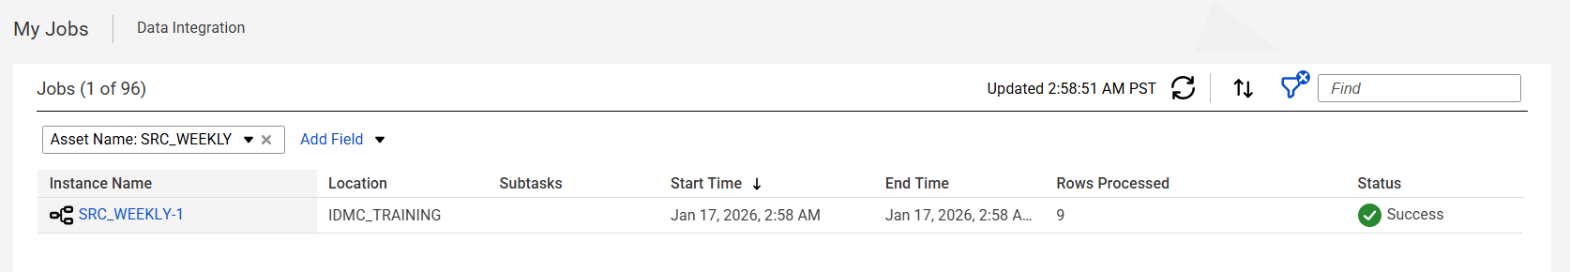
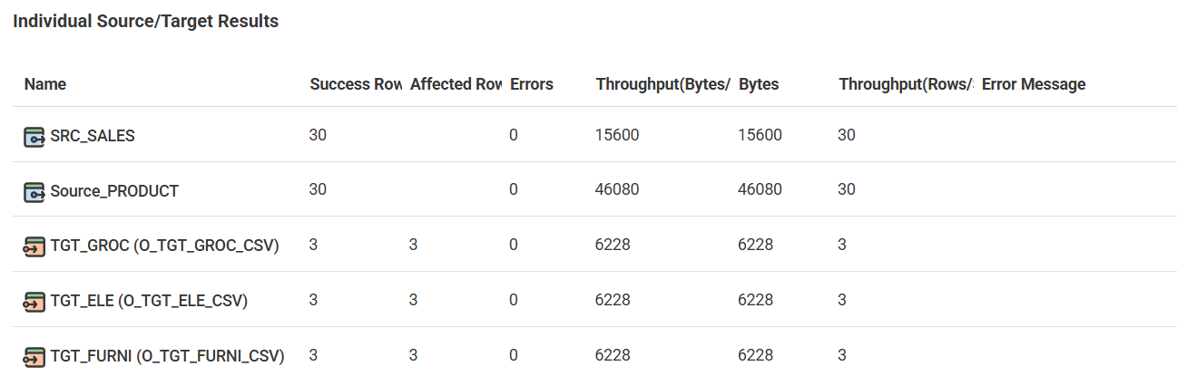
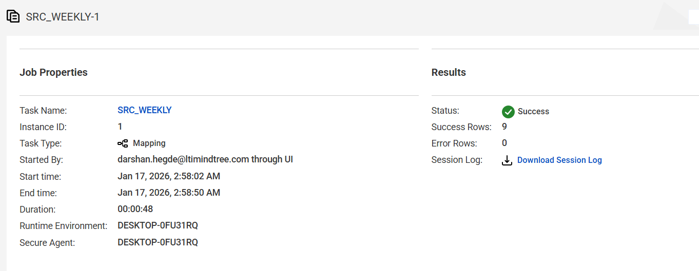

2c screenshot of the joiner, aggregator rank and the router conditions
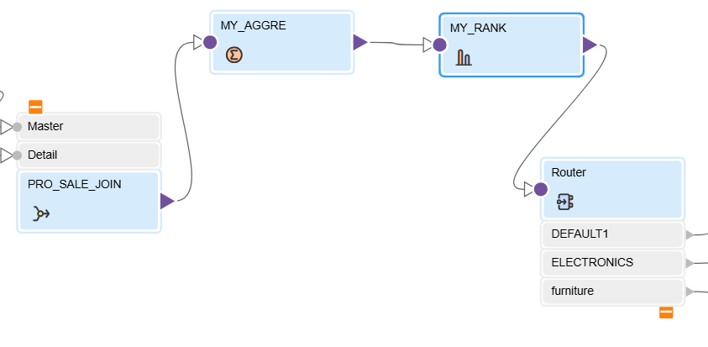
JOINER:
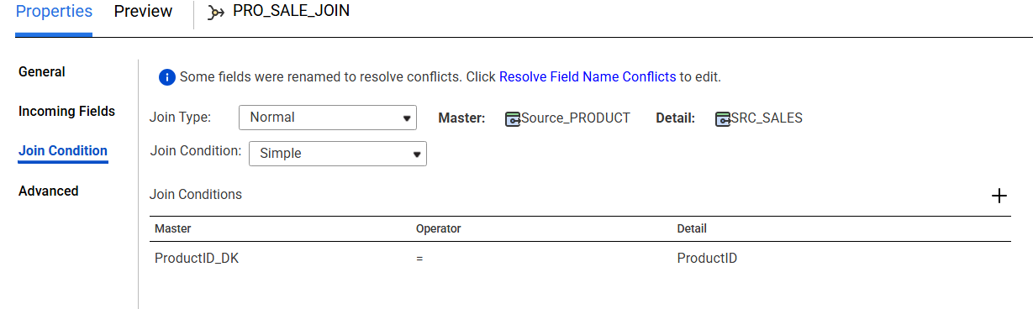
AGGREGATOR
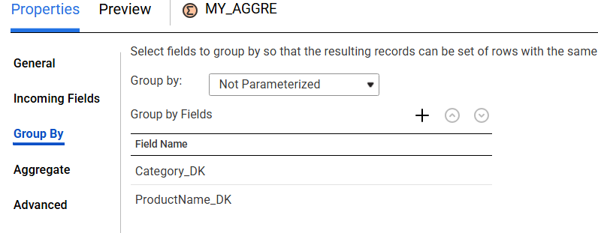
RANK:
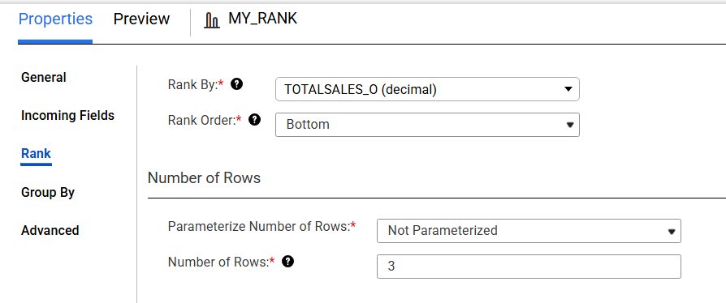
ROUTER:
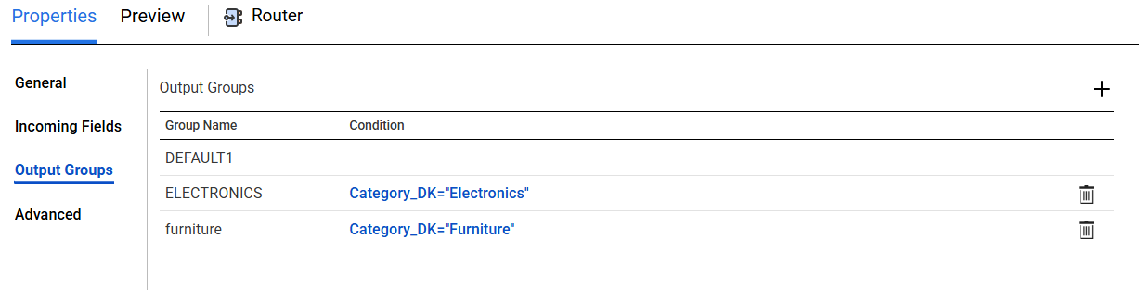

2d screenshot showing rank configuration ( top=3 group by category)
TOP 3 RANKING

GROUP_BY CATEGORY
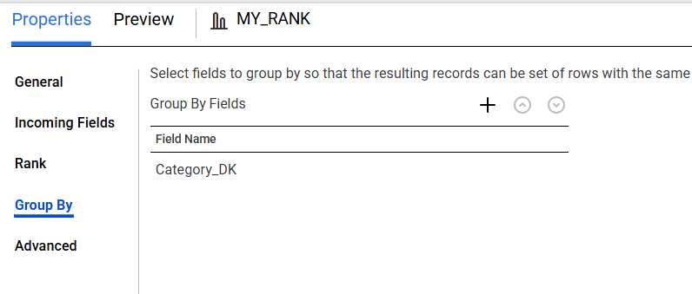

2e code/configuration screenshot for the total_sales=sum(sales_amount)
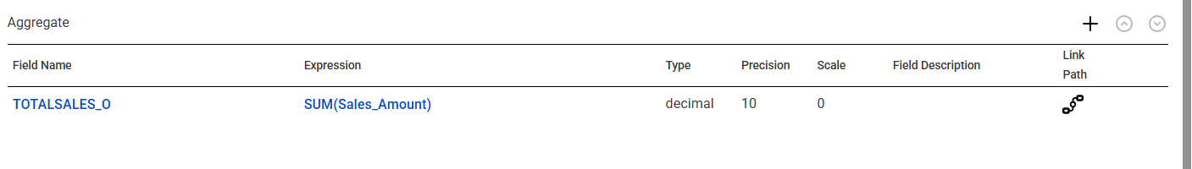

2f screenshot of the final output ( table or the flatfile ) generated from each router group

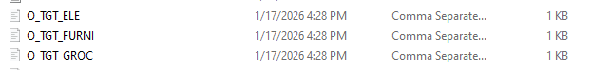
ELECTRONICS .CSV FILE
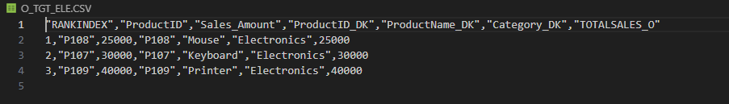
GROCERIES.CSV FILE
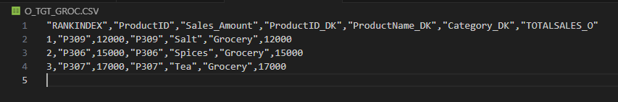
FURNITURES.CSV FILE
