Question 1 snowflake aws s3 external stage load and materialized view creation
1a sql used for external stage and table creation
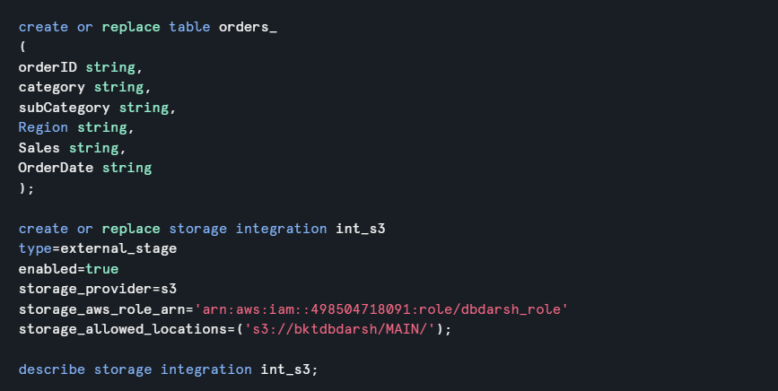
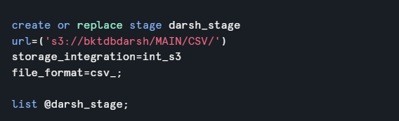
1b sql used for loading data from aws s3
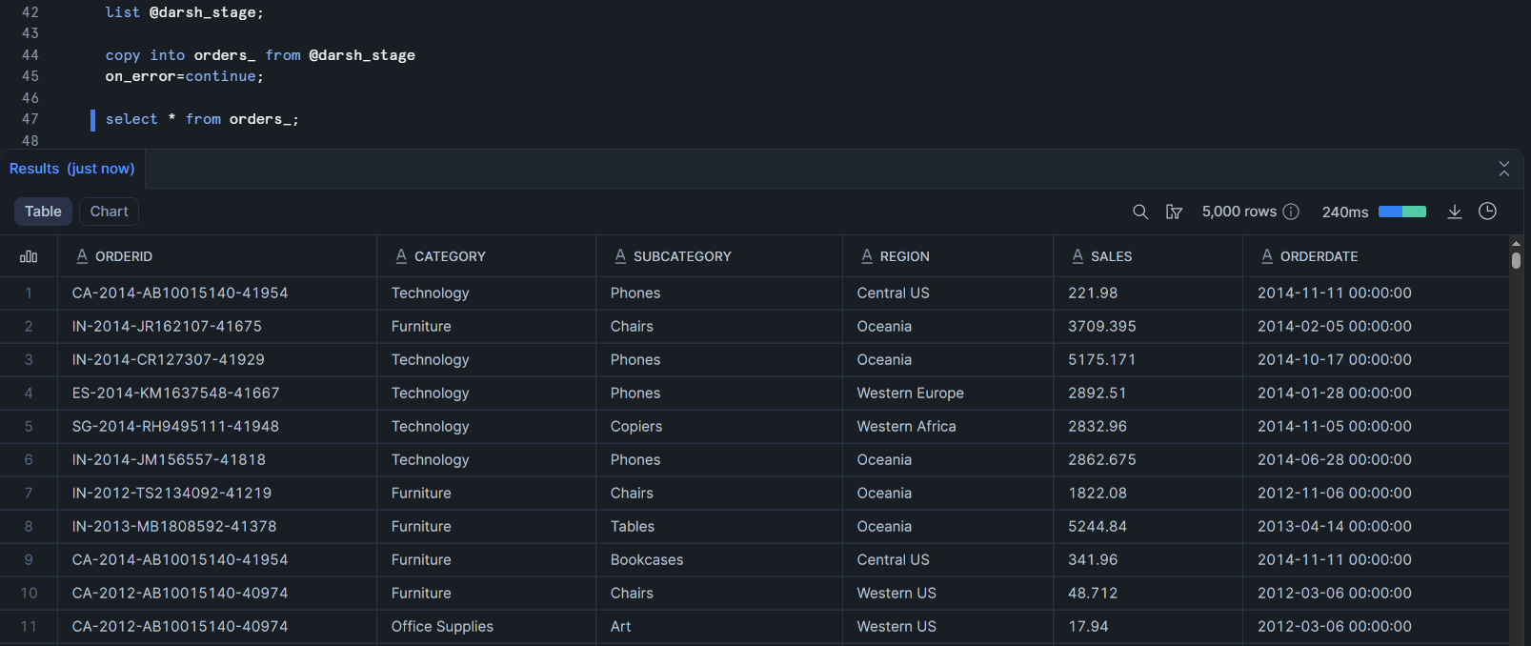

1c sql used for materialized view creation


1d sql used for validating thr data from materialized view
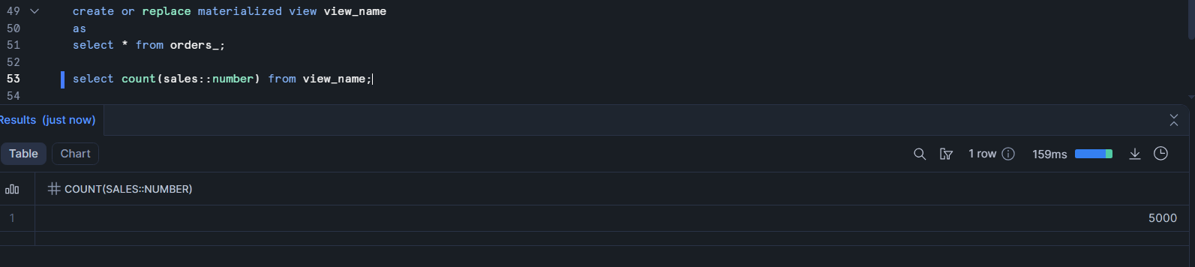

2 snowflake external stage data load with row access policy implementation
2a sql used for external stage creation and table creation
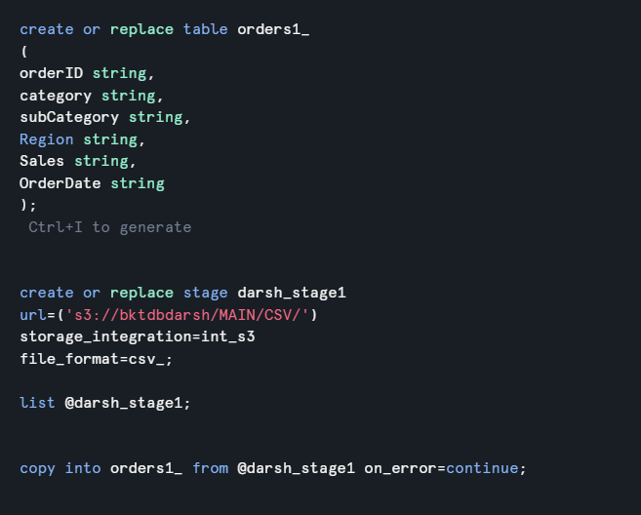
2b sql used for loading data from aws
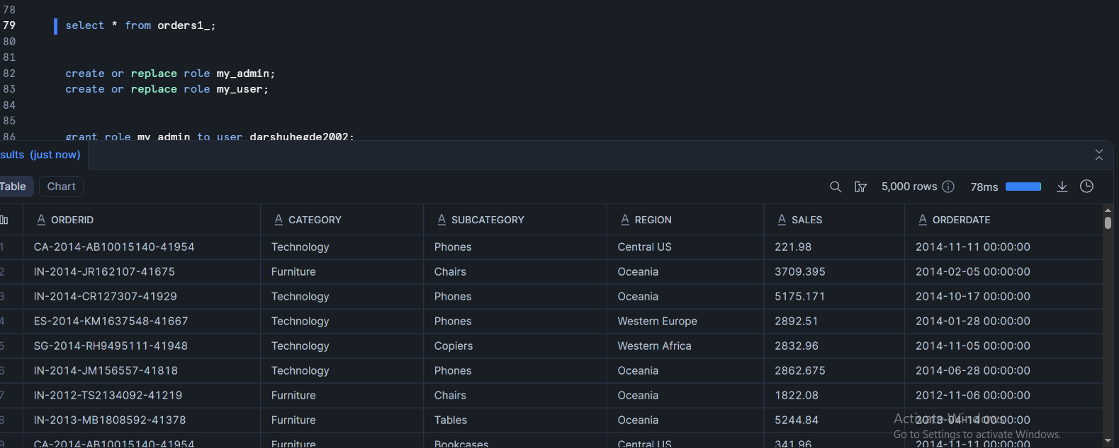
2c sql query used for the role creation and privilege grants
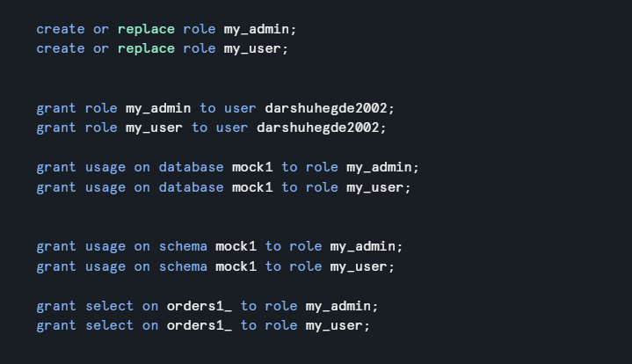

2d sql used for the row access policy creation and assignment
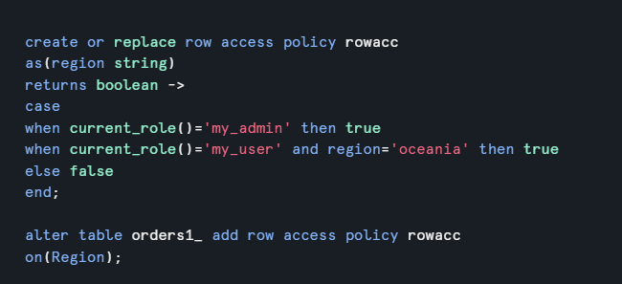
2e query output validating row_level access for different roles
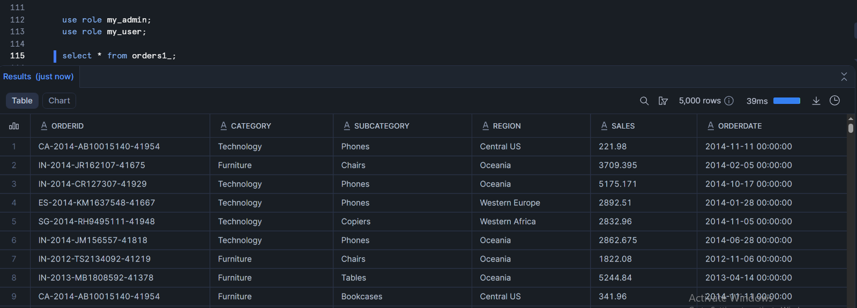

Q3 snowflake named internal stage – data load and unload and integrity validation
3a sql used for stage and table setup
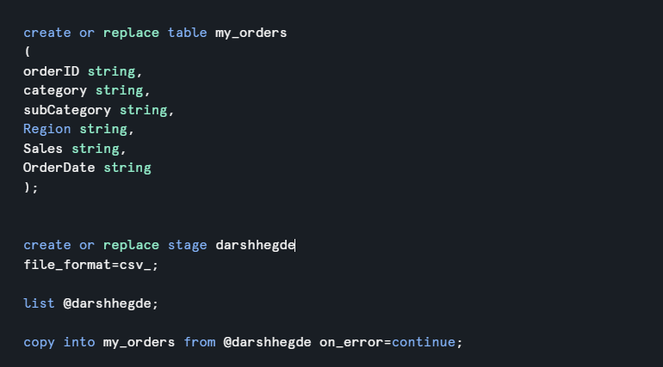

3b sql used for loading and unloading operations
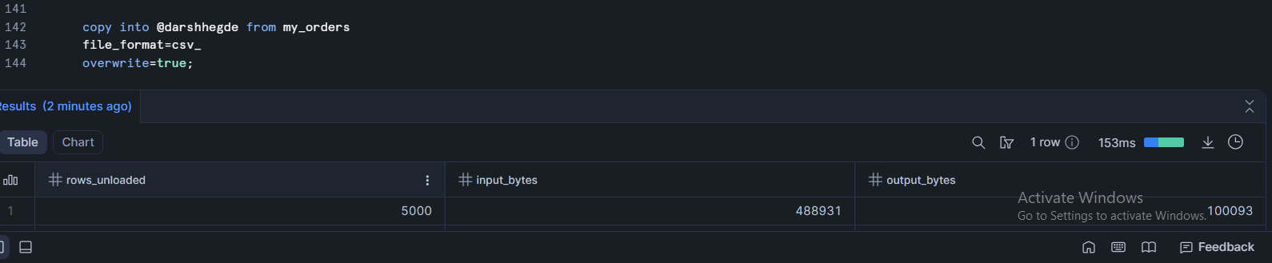
3c sql query for validation

3d output providing data consistency
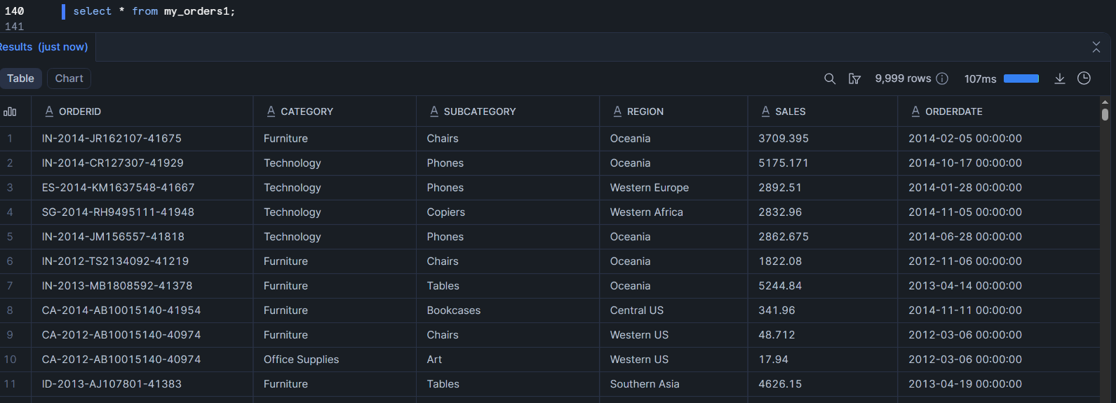
Q4 End to end cdc handling using snowflake streams and tasks
4a sql used for base table and audit table creation
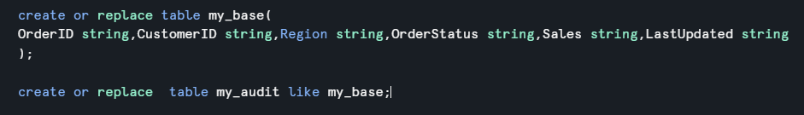
4b sql used for stream definition
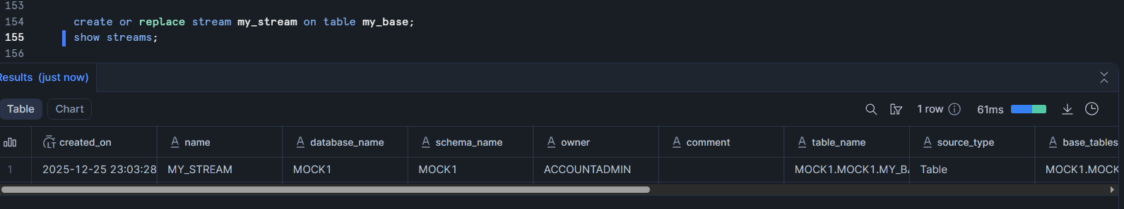
4c sql used for task creation
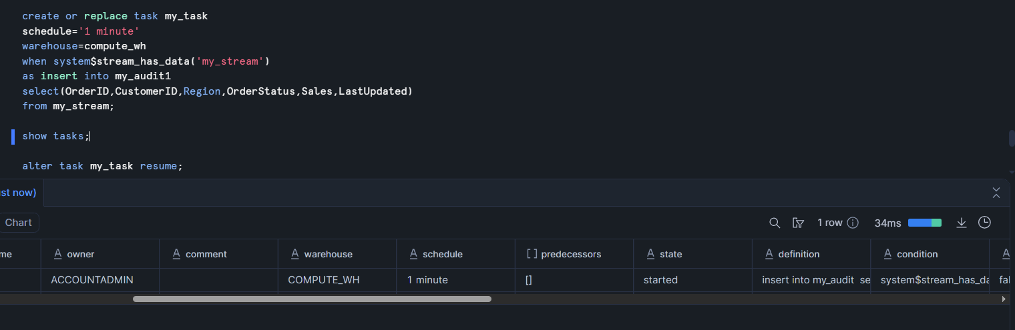

4d sql used simulate data changes
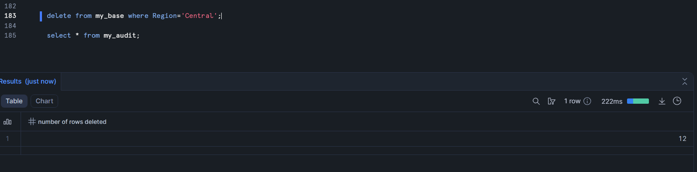

4e query output showing cdc captured and processed
