MILESTONE 2 ASSESSMENT
Q1 AWS s3 data load with advanced rbac, row access policy and column masking
1a Sql used for external stage and table creation
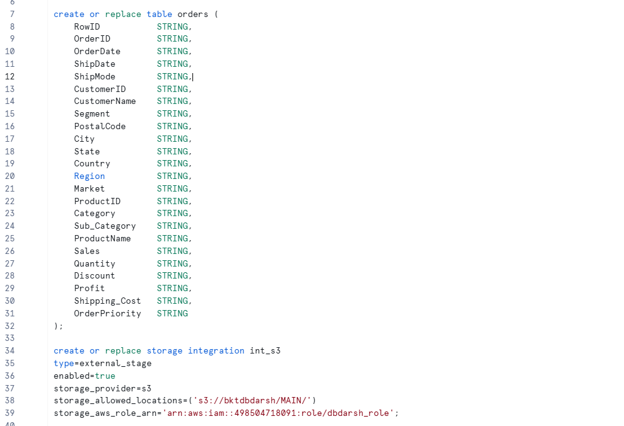
Stage creation
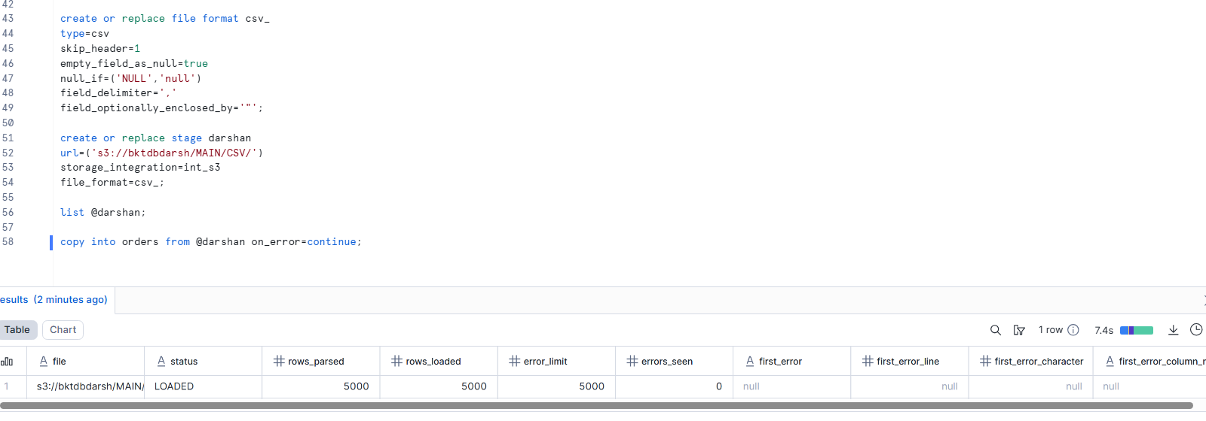

Tabled data loaded from s3
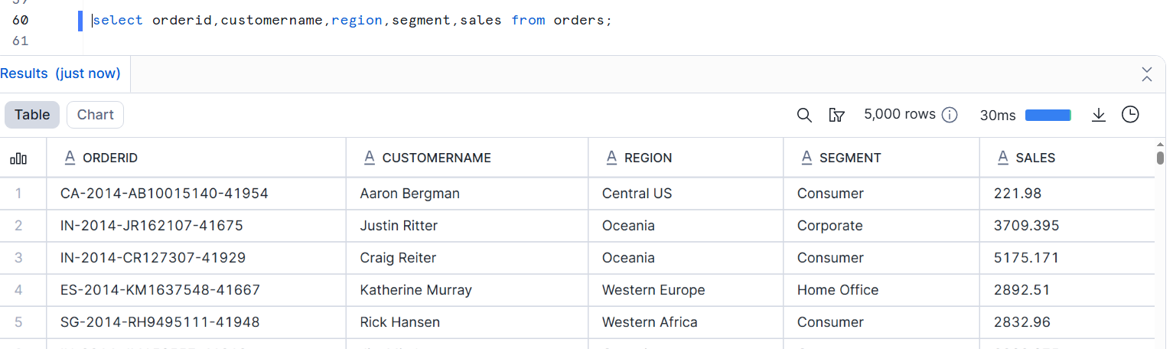

1b SQL used for role creation and privilege grants
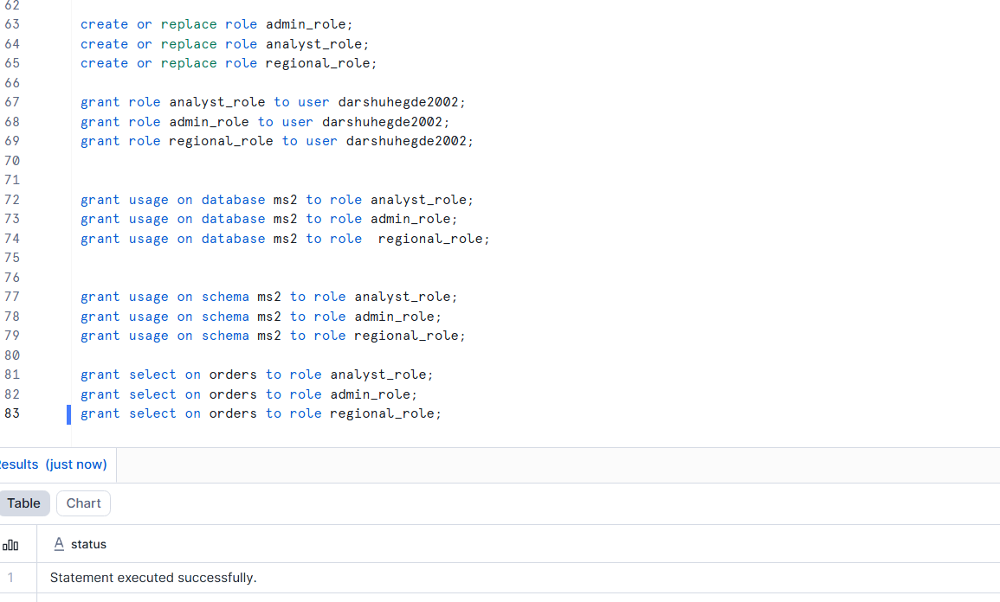
1C SQL used for masking policy creation and applications
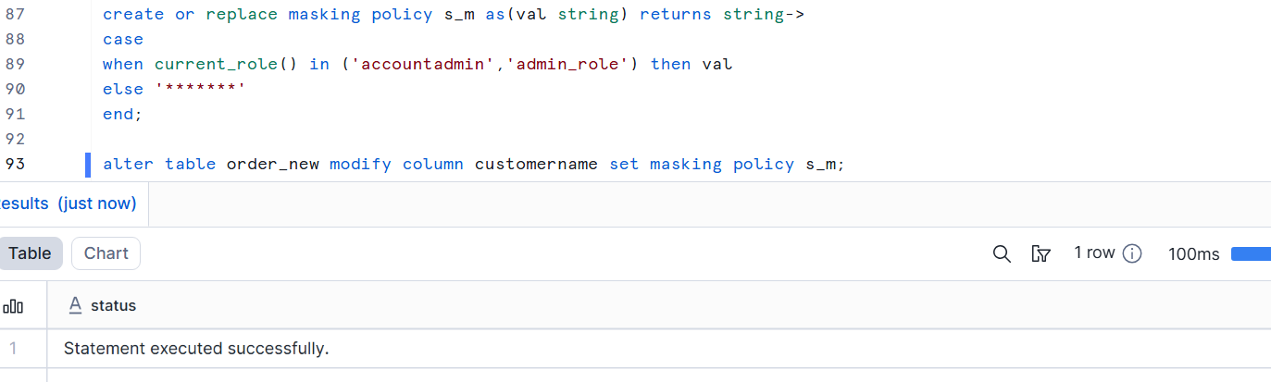

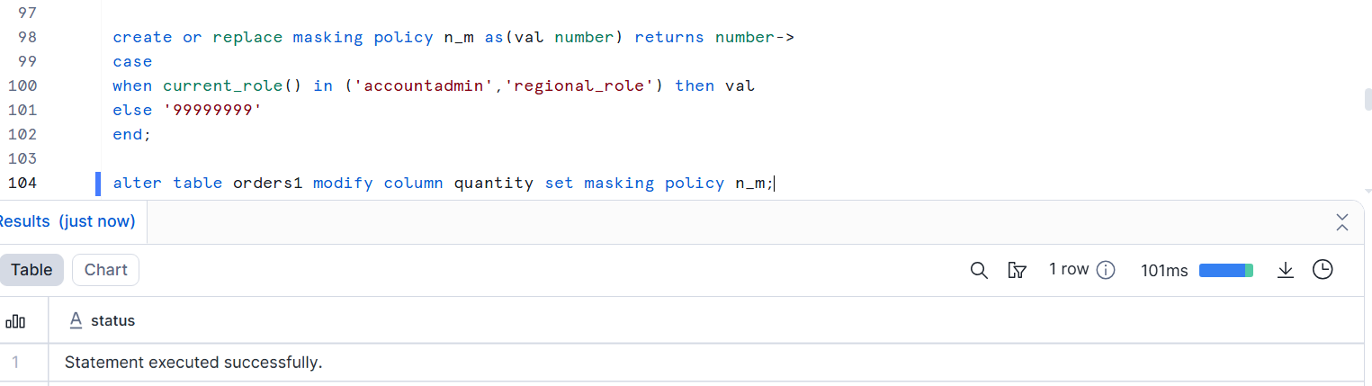

1d SQL used for row access policy creation and assignment
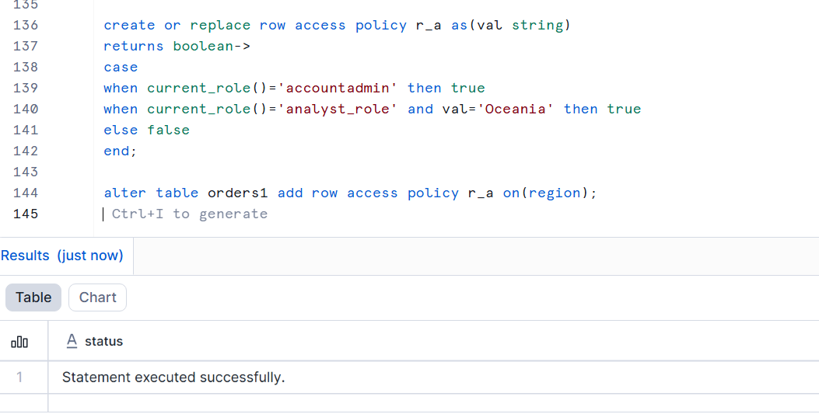

1e query outputs providing the roles based masking and row restriction
Before String masking
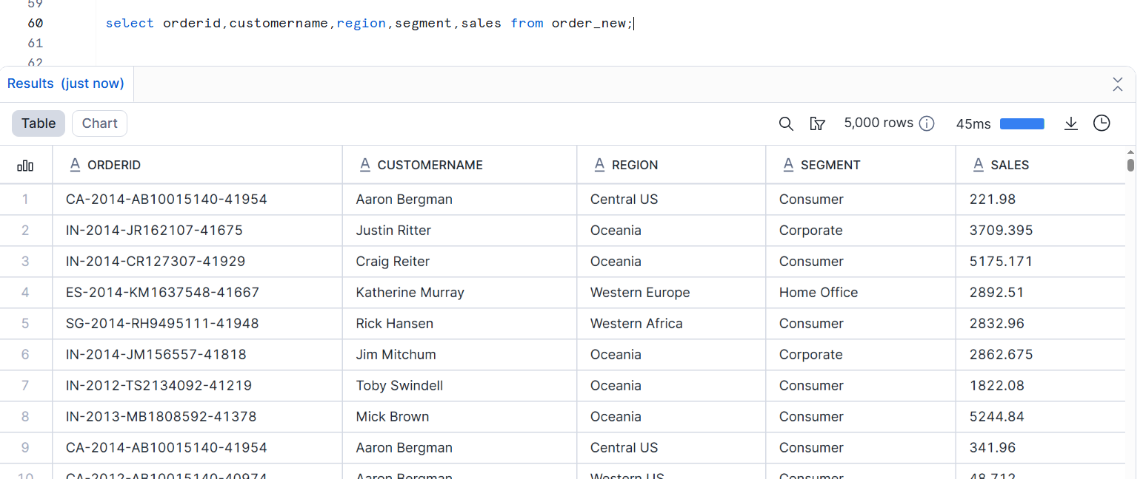
After string masking
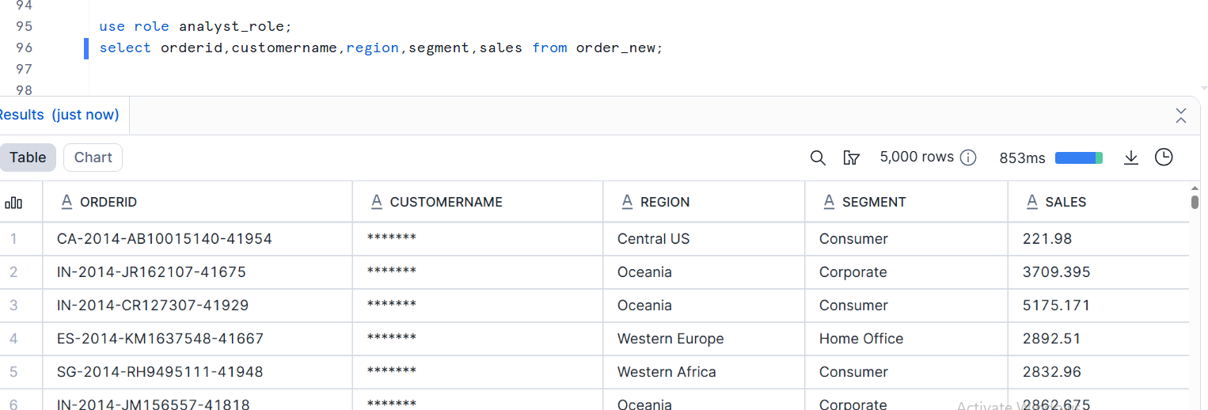

Before number masking
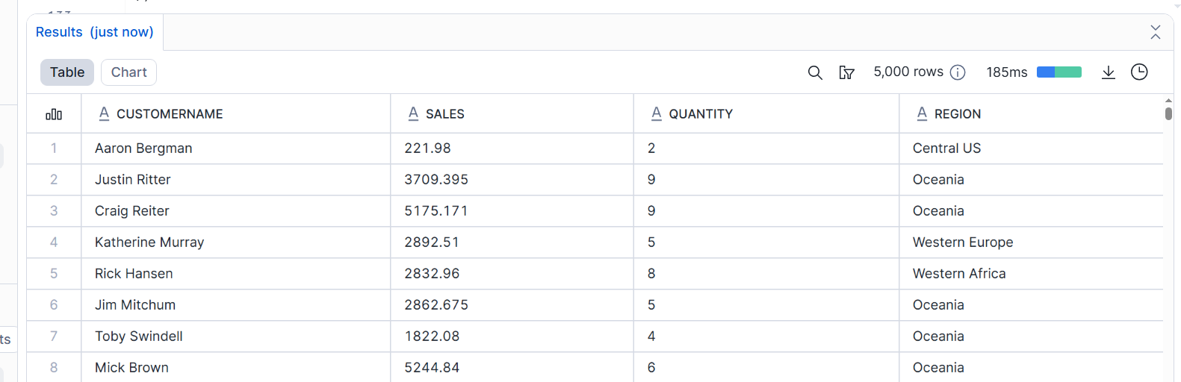
after number masking
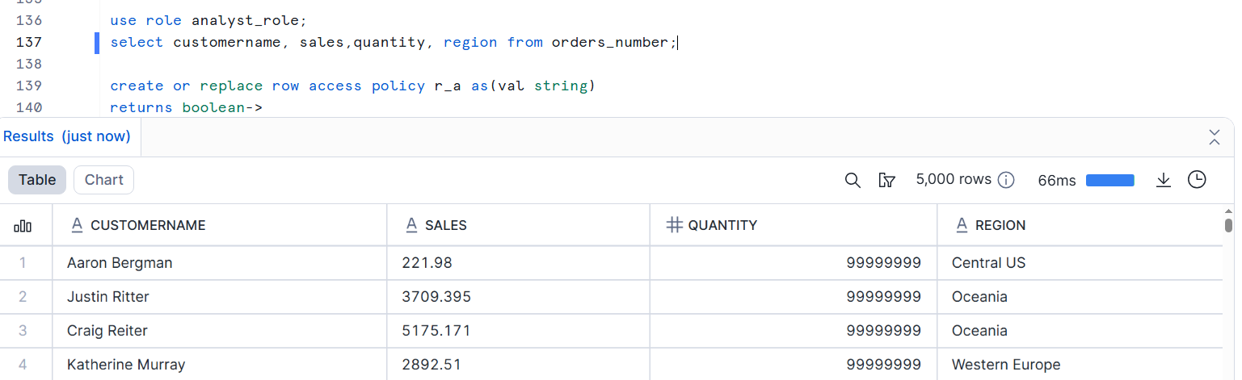

Before Row ACCESS policy
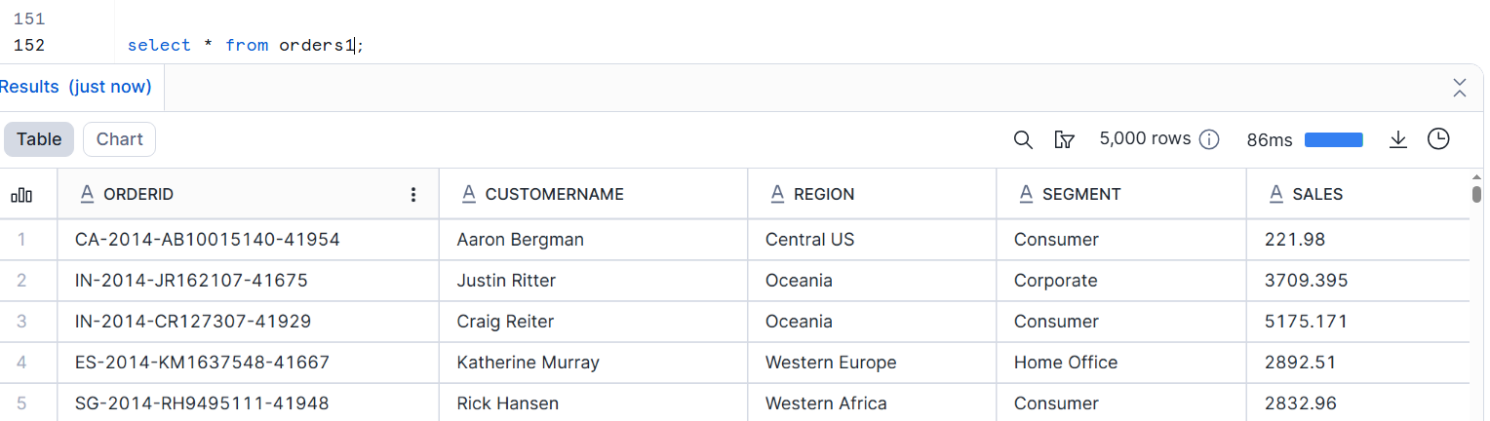
After applying row access policy
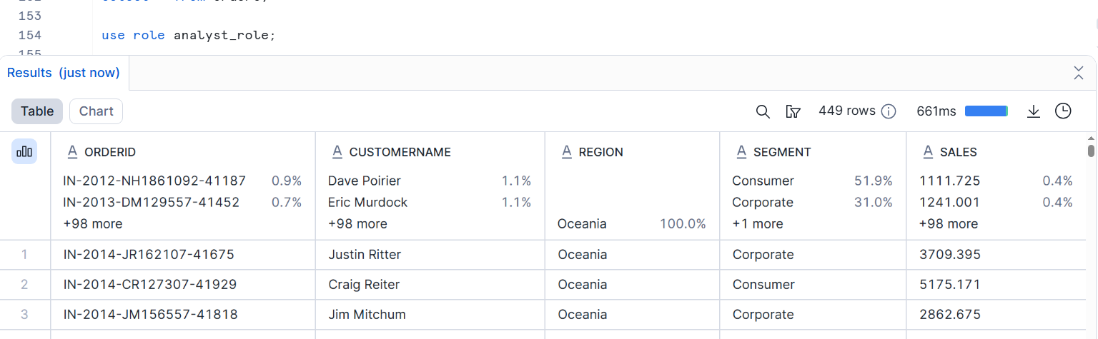
Q2 snowpipe auto_ingest with incremental validation and error monitoring
2a sql used for external stage and table creation
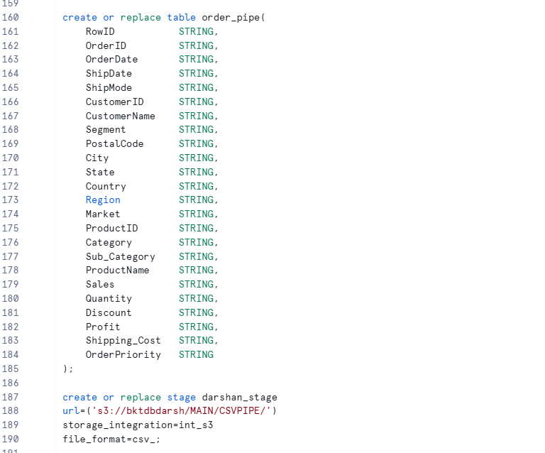
2b sql used for snowpipe creation
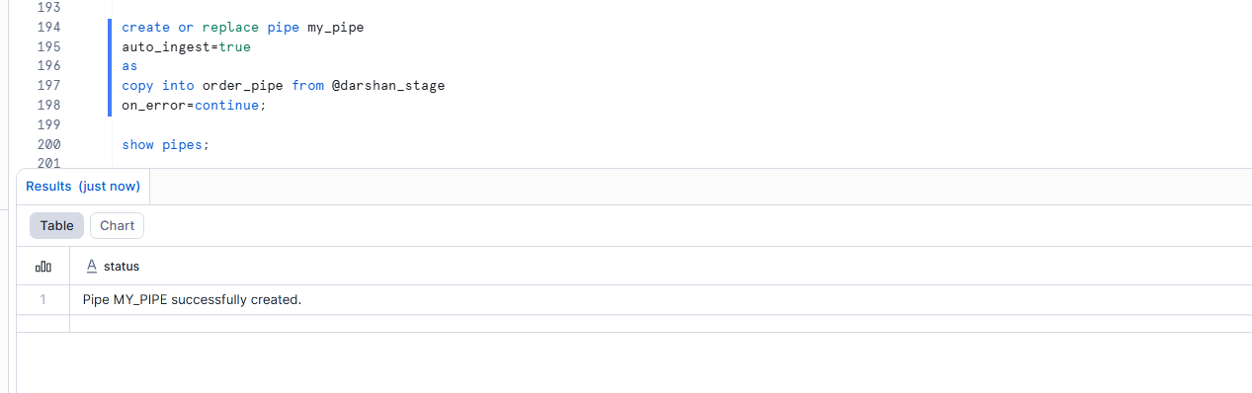
2c query output showing incremental data ingestion
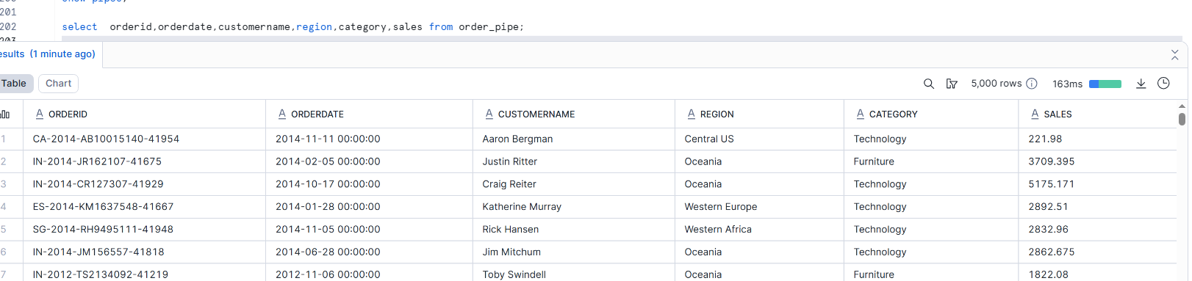

after inserting another file into the bucket
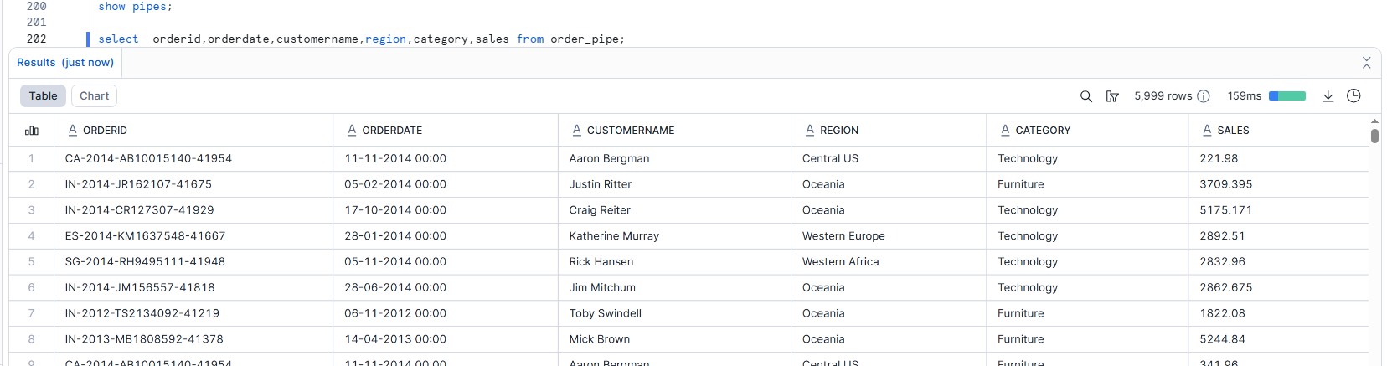
2d snowpipe load history output
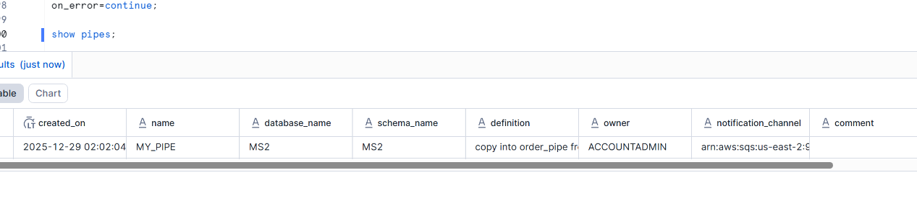
2e evidence showing no failed records or errors

Q3 snowflake user stage dataload and materialized view creation and data unloading
3a sql used for table creation
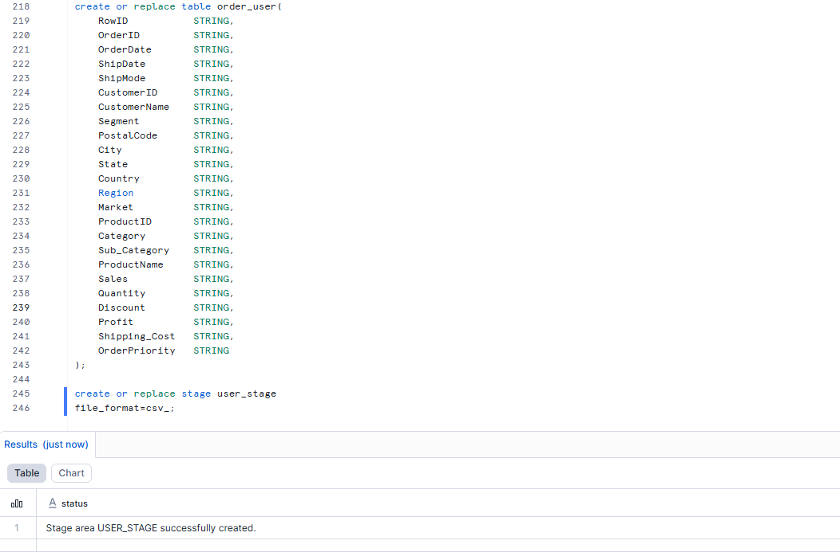
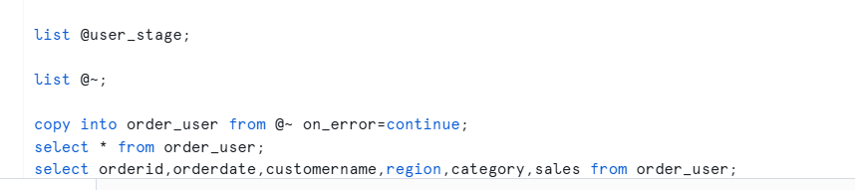

3b sql used for the loading of the data from the user stage
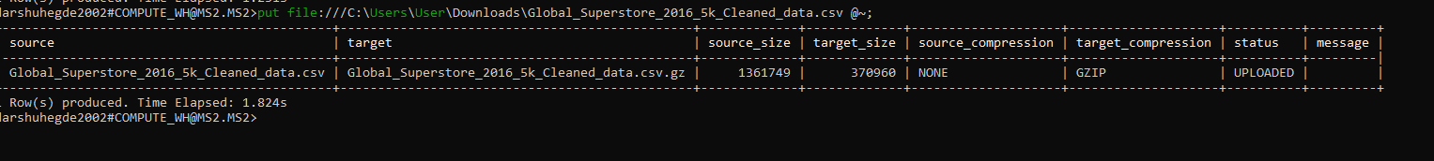

3c sql used for creation of materialized view
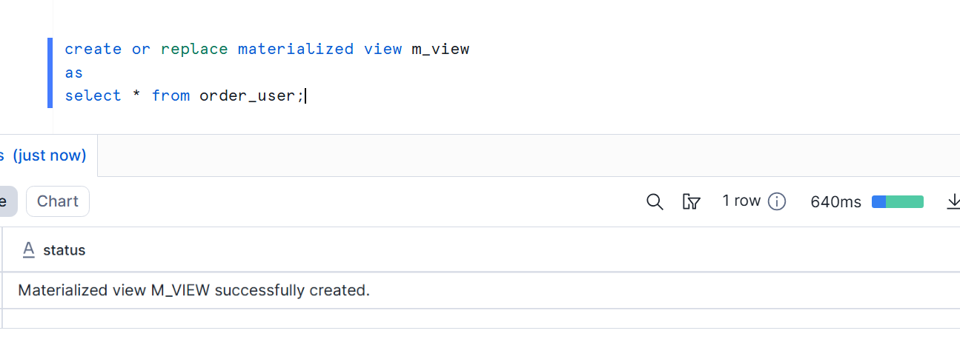
3d sql used for unloading the data
3e query output validating data loaded and materialized view results
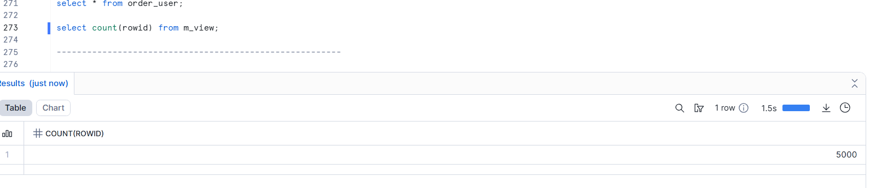
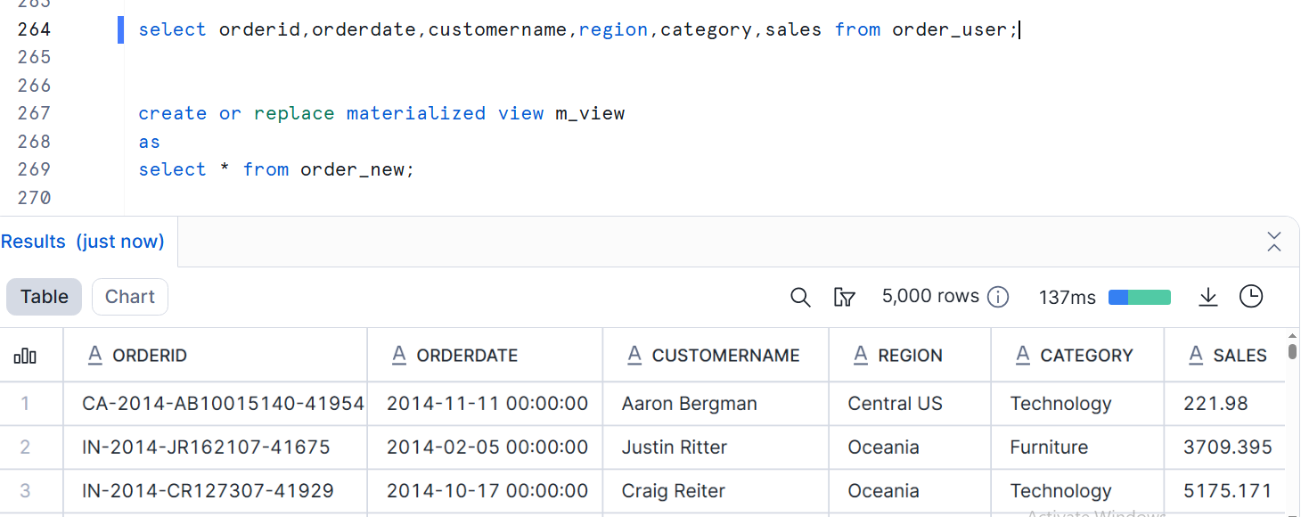

Q4 Snowflake table type,data retention validation, table stage load and secure data sharing
4a sql used for creation of temporary, transient, permanent tables
Permanent table
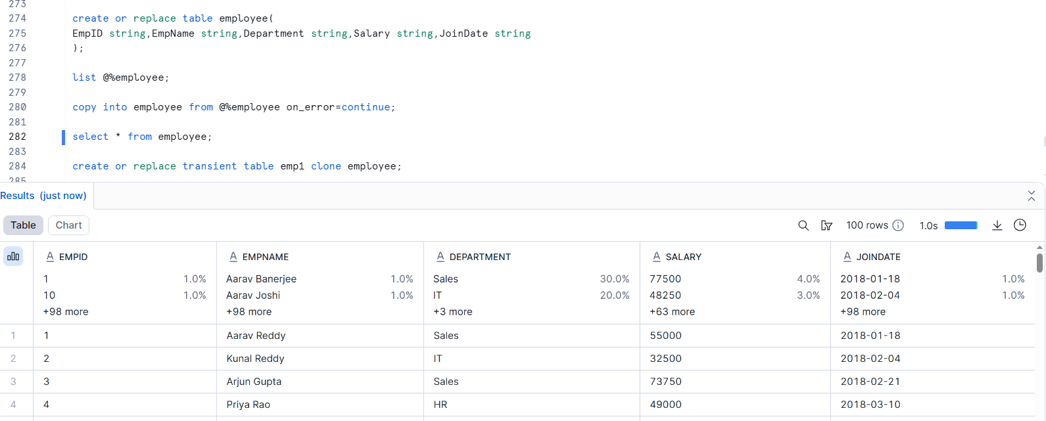
Transient table
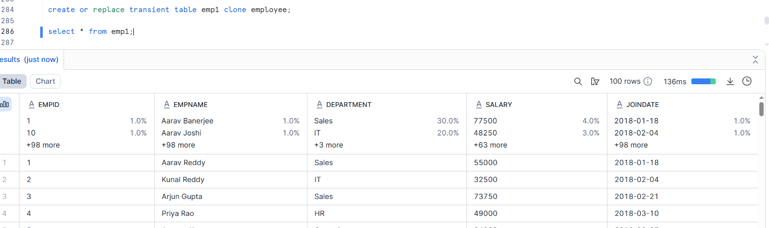

Temporary table
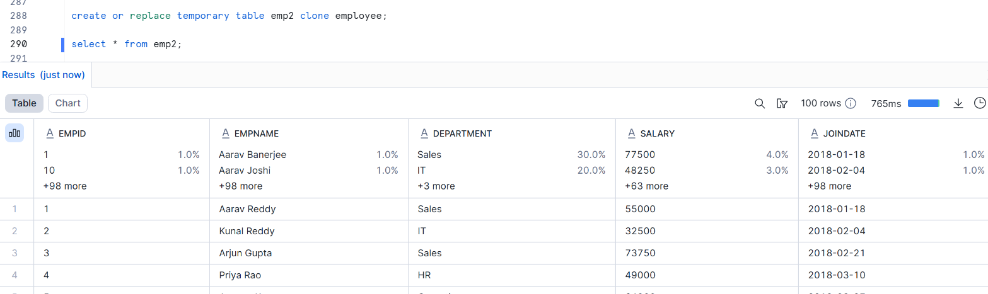

4b SQL used for loading the data using table stage


4c data retenetion for all tables
Permanent table
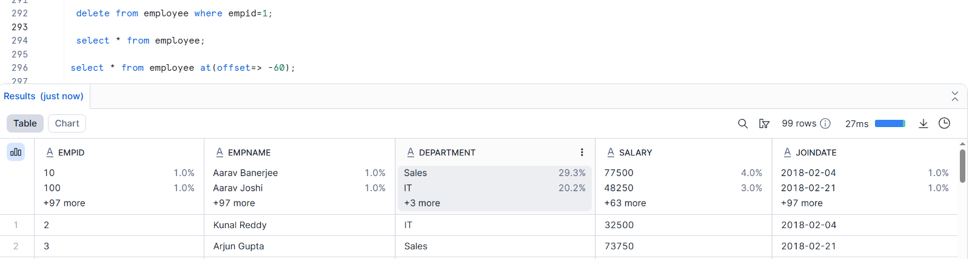
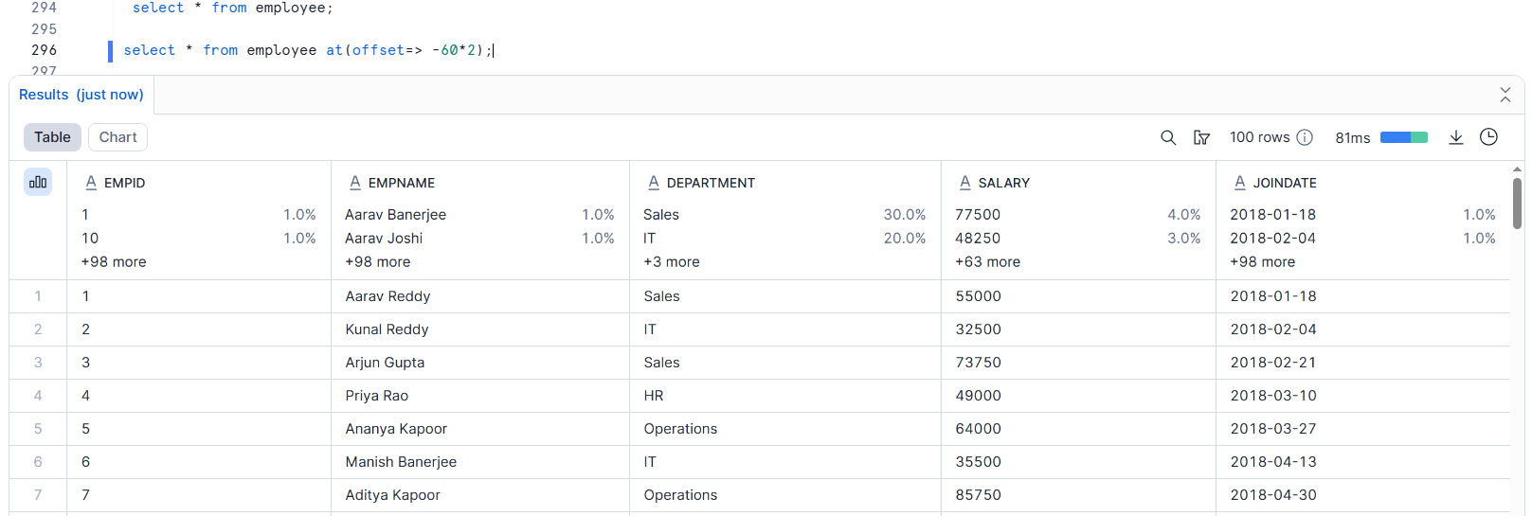
For transient table
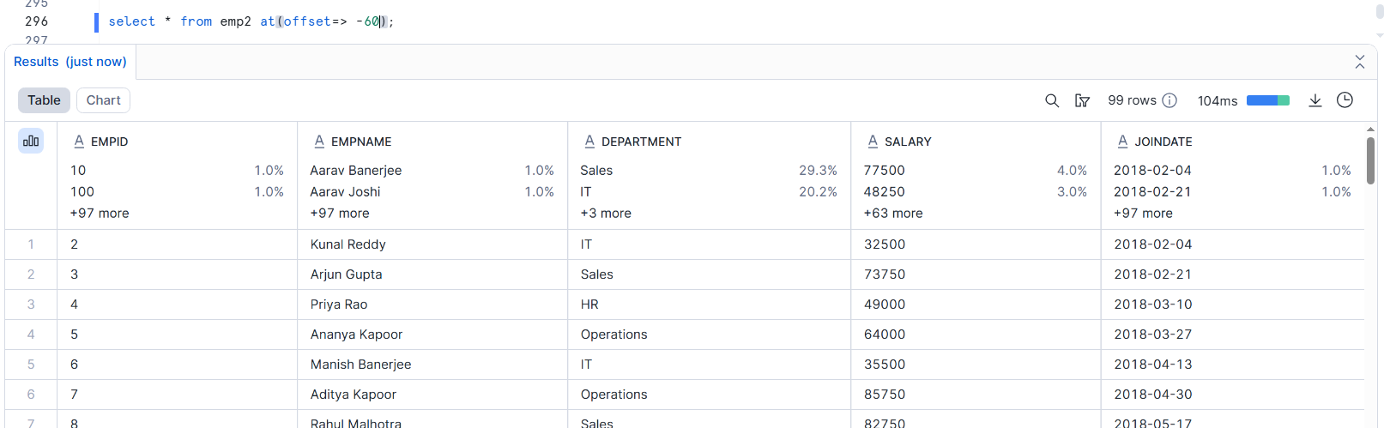

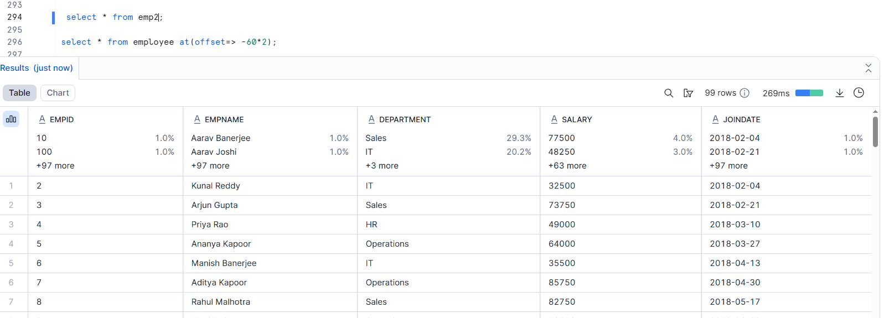

For temporary table
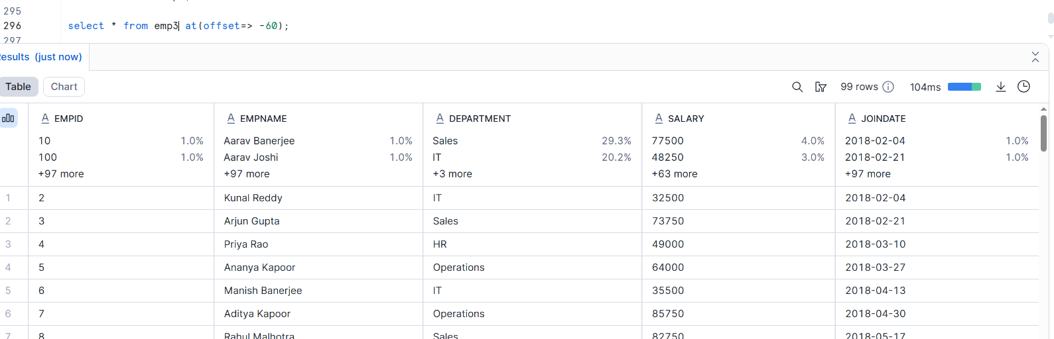

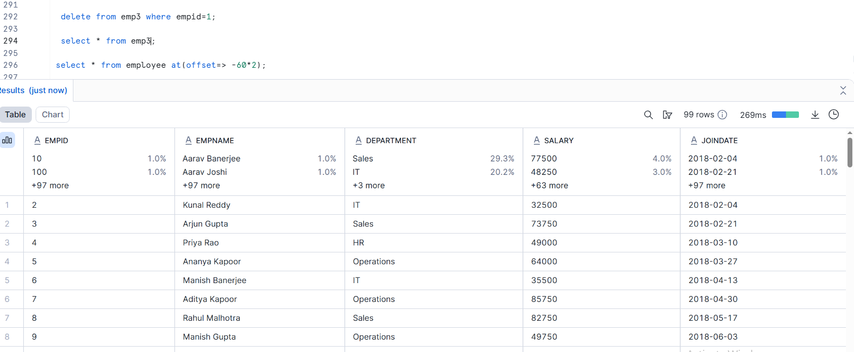

4D sql used for secure data share creation and grants
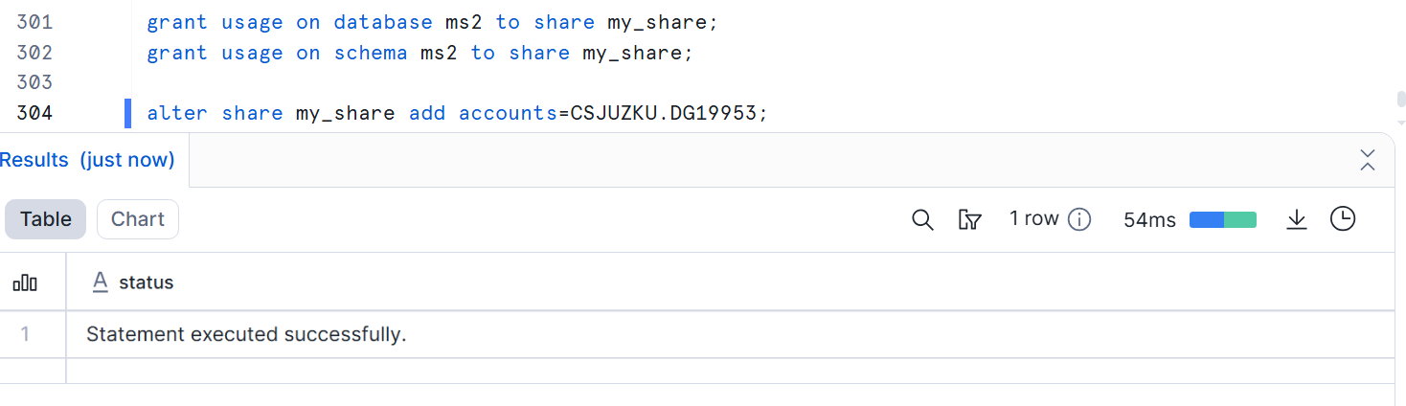

4e show shares
