MILESTONE 4
Q1 AWS S3-> snowflake with connected lookup
1a AWS source configuration
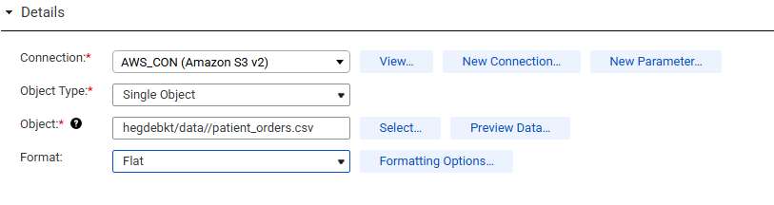
1b lookup transformation setup
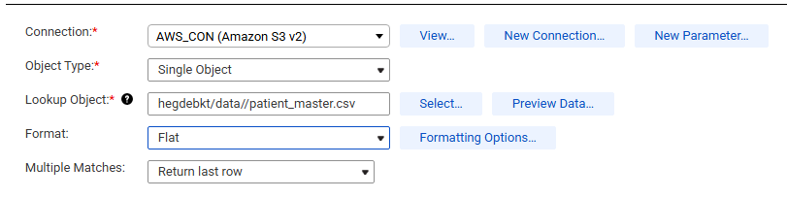
1c expression transformation
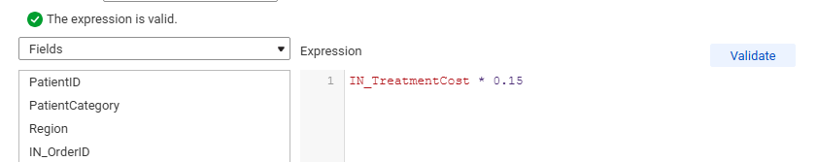
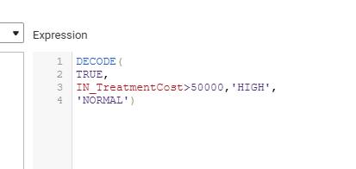

1d parameter definition
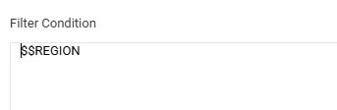
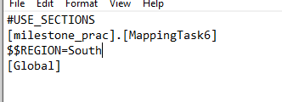
1e Filter configuration
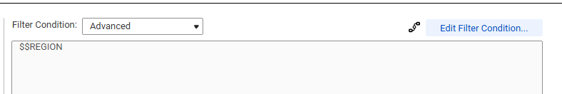
1f aggregator transformation

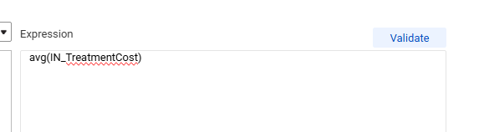
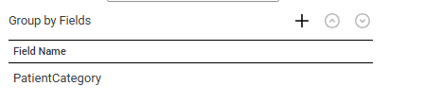

1g mapping task execution success
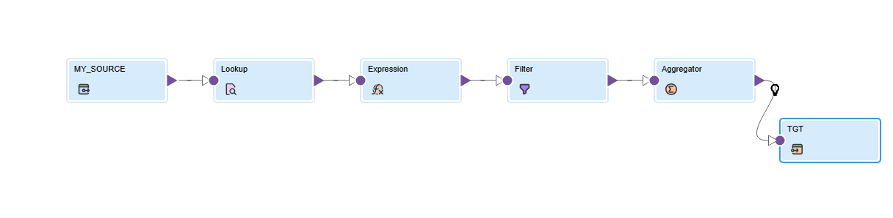
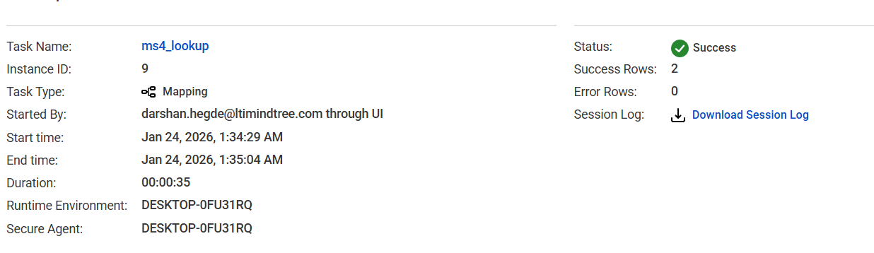

1h snowflake target table

Q2 FLATFILE -> SNOWFLAKE ( MAPPING TASK + TASKFLOW)
2a flatfile source configuration
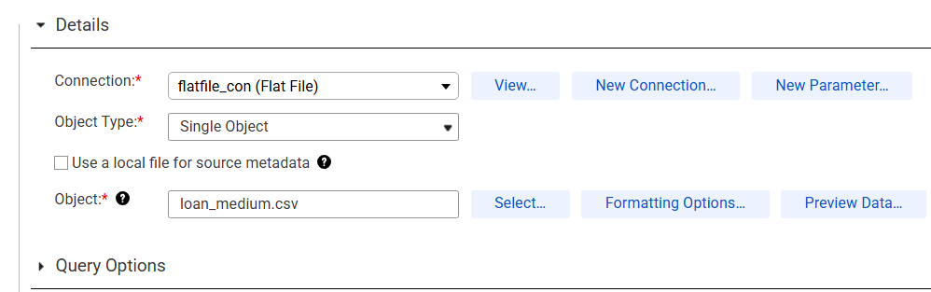

2b expression transformation
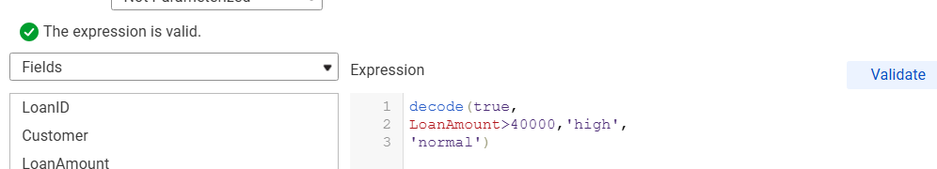
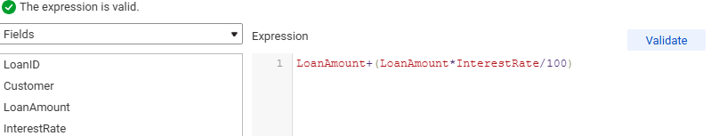

2c parameter definition
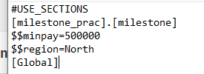

2d filter configuration
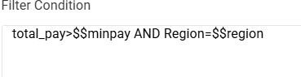
2e aggregation transformation
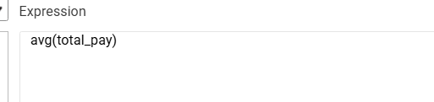
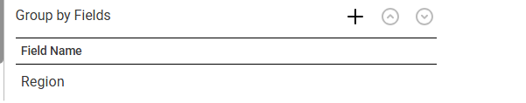
2f mapping task success
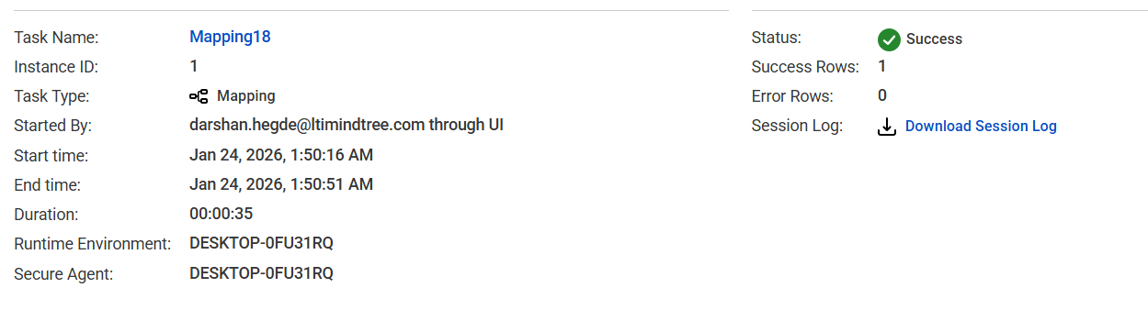
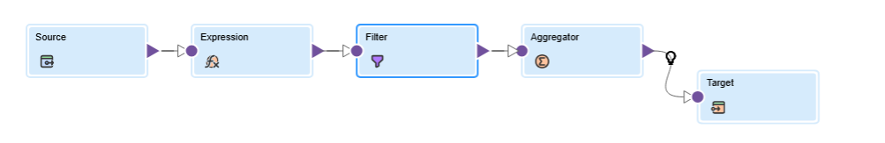

2g taskflow
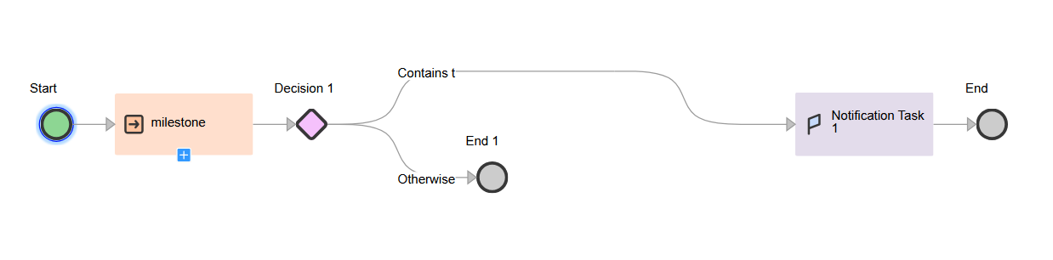
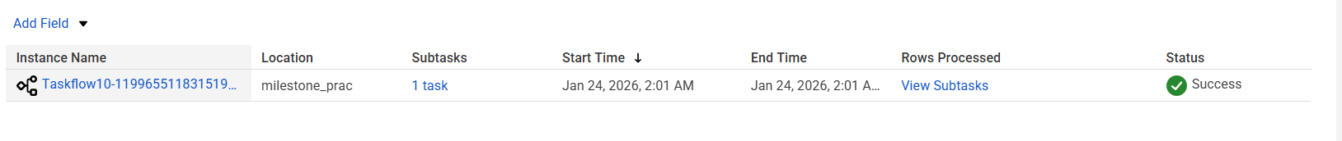
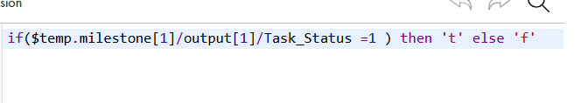
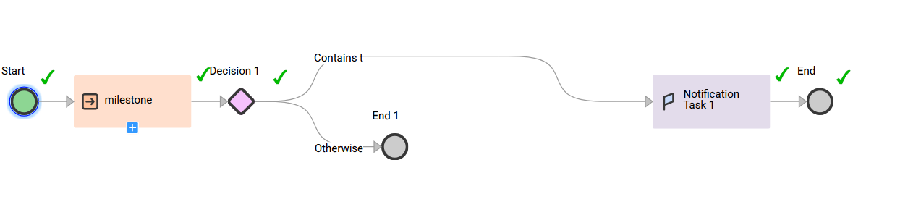

2h snowflake target table

Q3 FLAT FILE TO snowflake
3a flat file source configuration
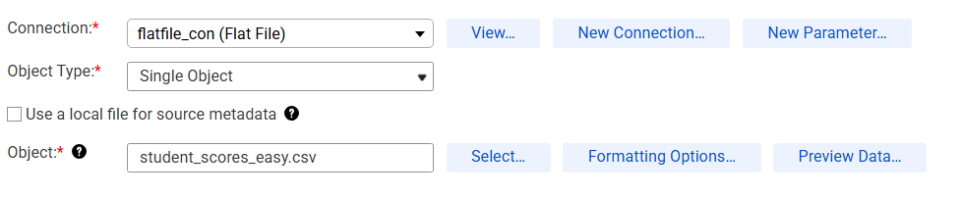
3b expression transformation
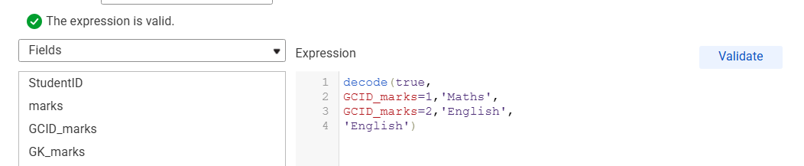
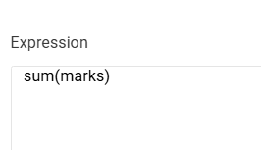
3c Rank transformation
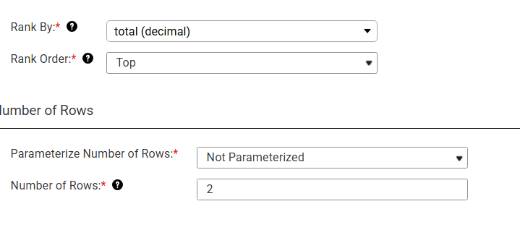
3d mapping success
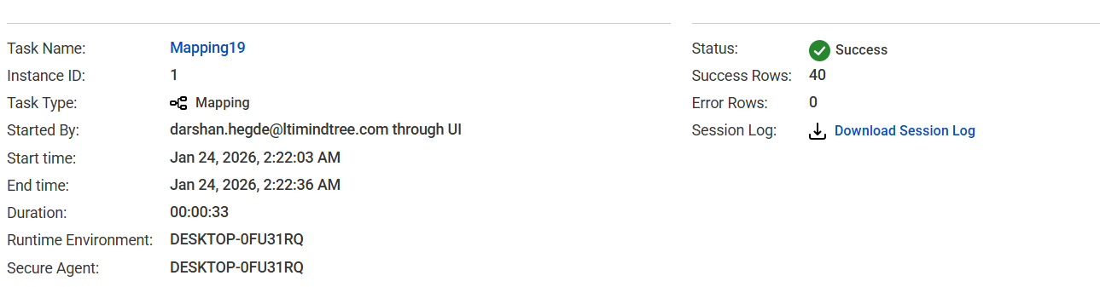
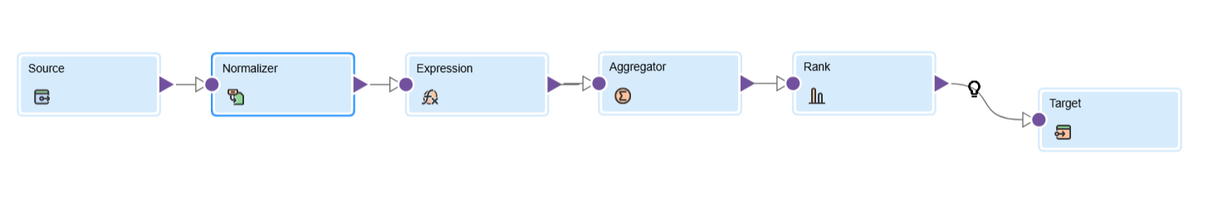
3e snowflake success table
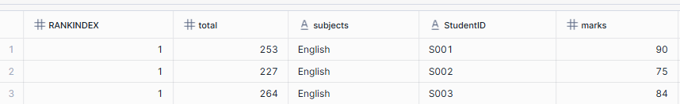

Q4 AWS S3 + Flat file -> oracle
4a AWS S3 configuration
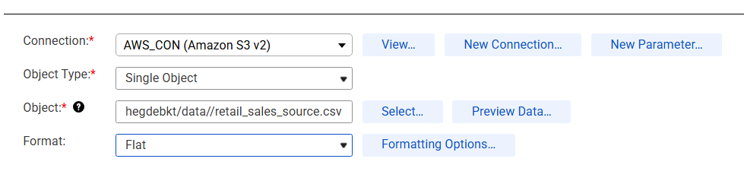

4b Flat file configuration
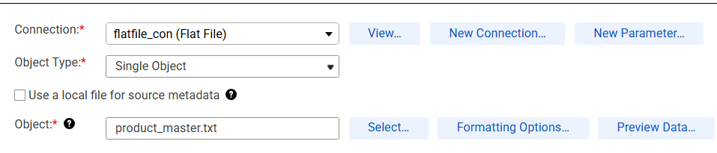
4c Joiner transformation
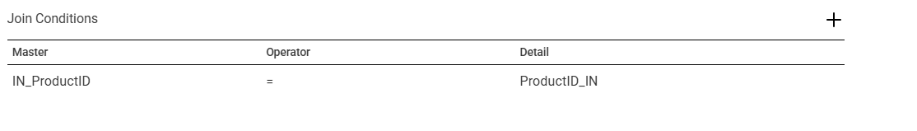
4d expression


4e rank configuration
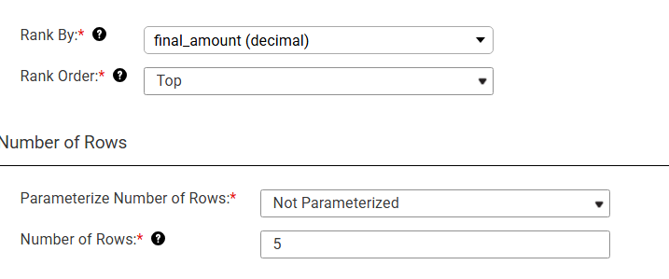
4f mapping execution success status
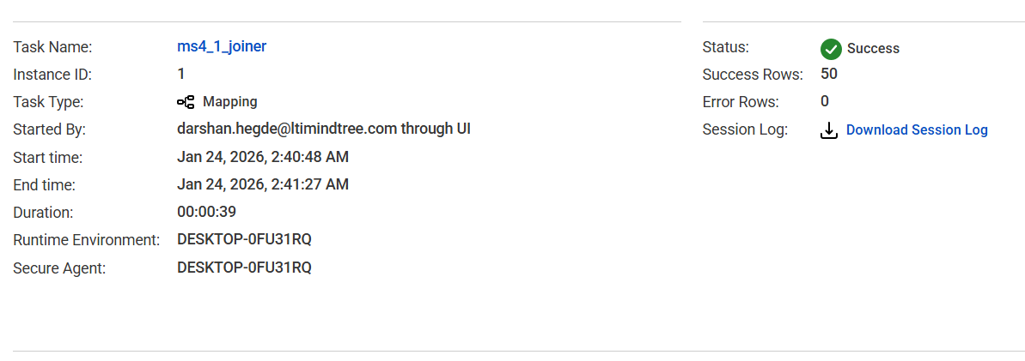
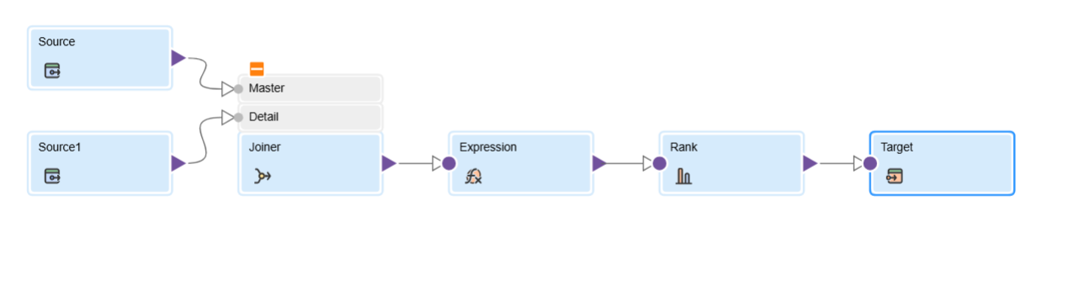

4g oracle target table load
