Q1 Create a mapping task in informatica iics to load employees data from a flat file into snowflake using expressions, a filter and a sorter
1A flat file source connection
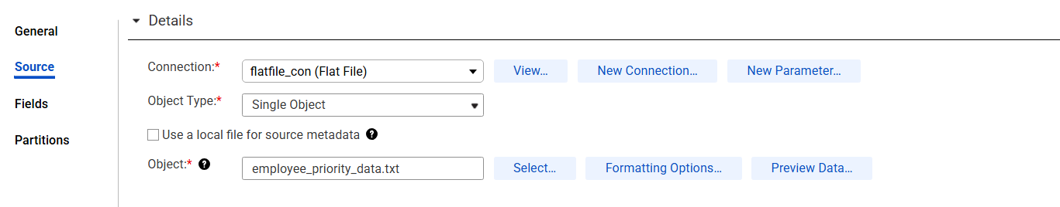
1B expression 1 ( Full Name creation)
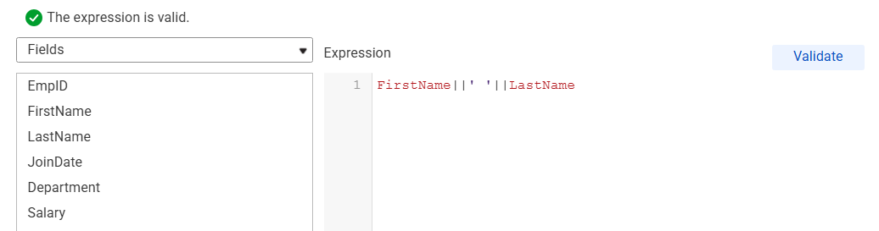
1C Expression 2 (priority configuration )
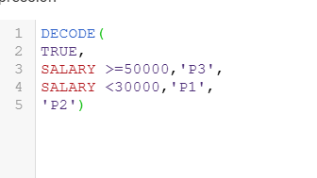
1D filter Category p3 and p3
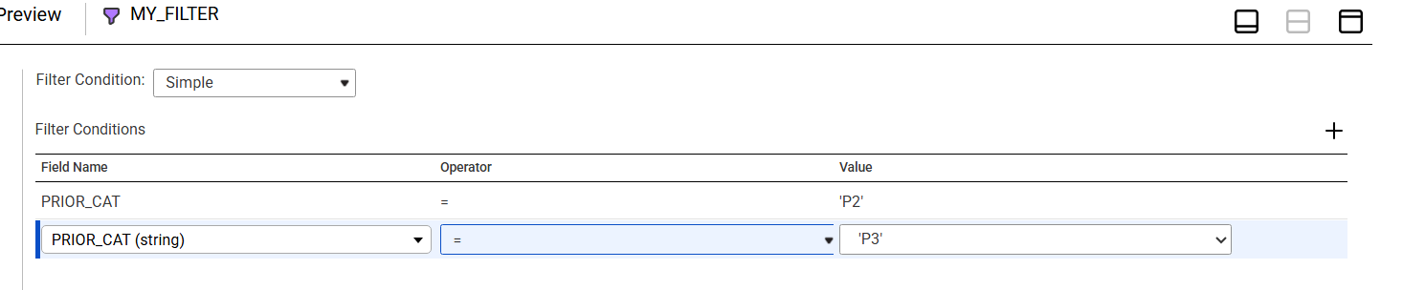
1E sorter condition ( join date ascending)
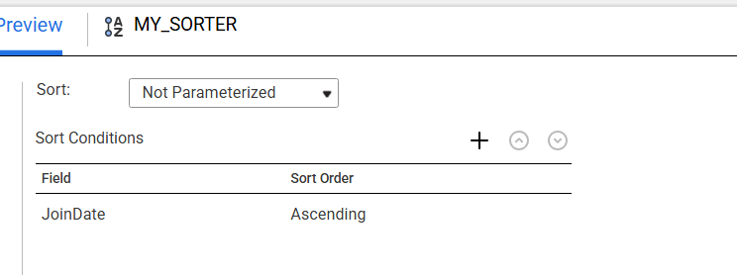
1F Mapping execution showing success
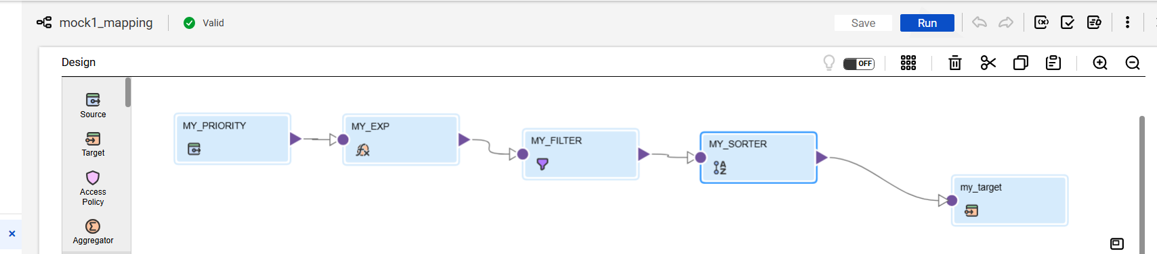

1D output

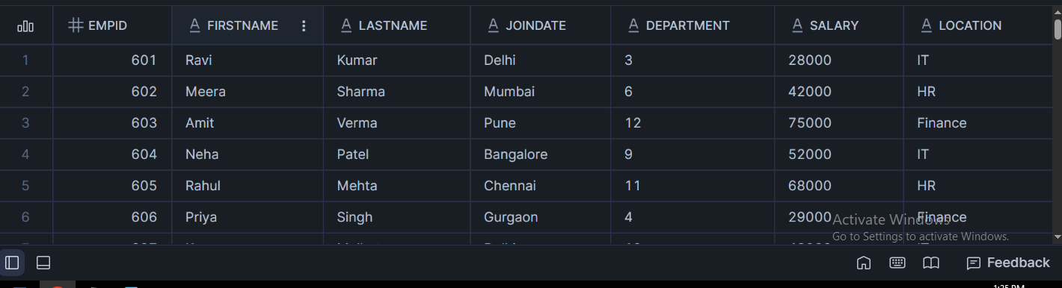

Q2 Create a mapping to load sales data from the a flat file to snowflake by deriving the quarter info and applying filters
2a flat file source configuration
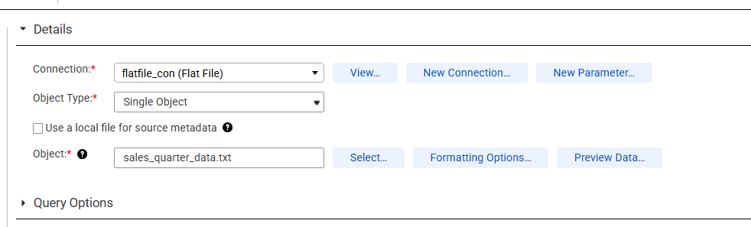
2b expression configuration for quarter derivation
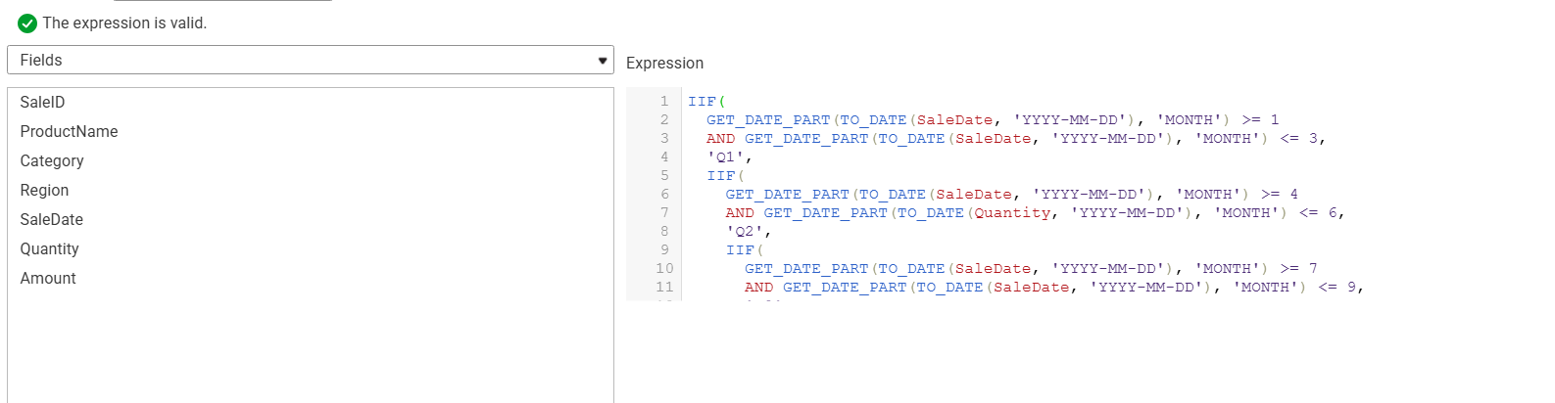
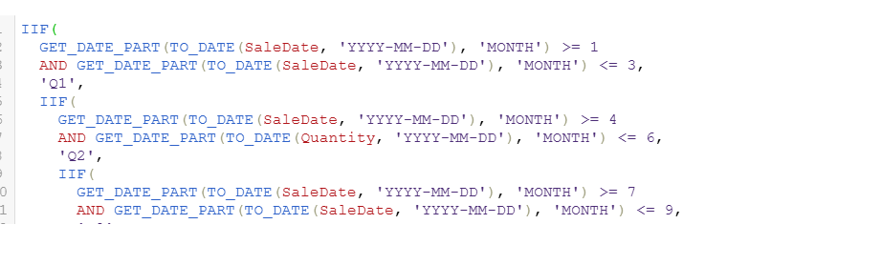
2c filter configuration
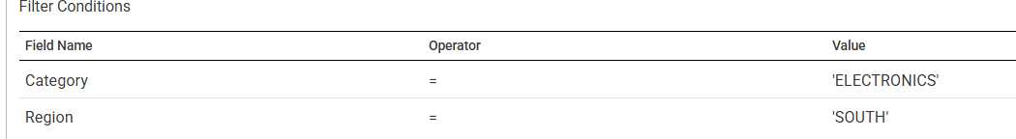

2d mapping execution success
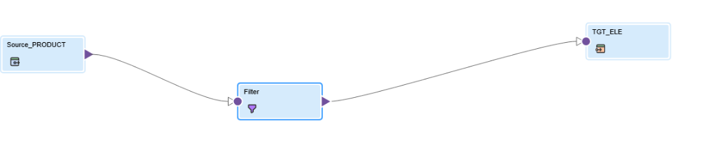
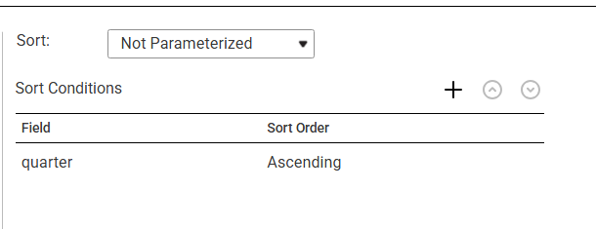
2e snowflake target table 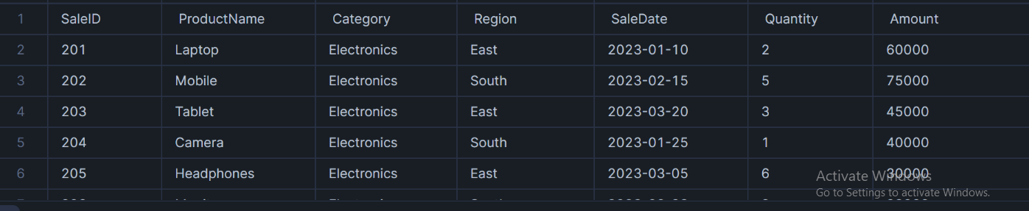

Q3 create a mapping task with parameterized filter
3a flat file source configuration
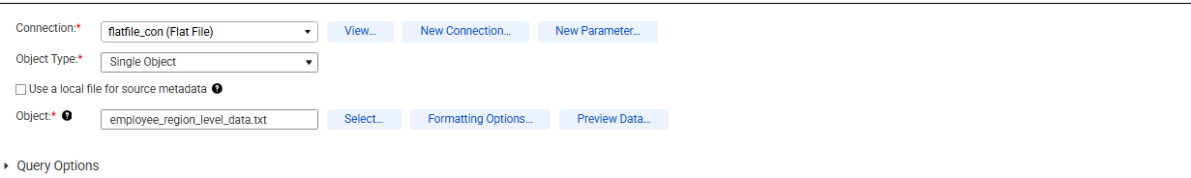
3b expression 1 ( region derivation)
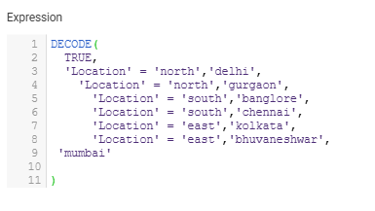
3c expression 2(employee level)
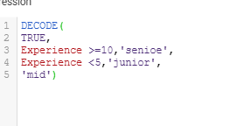

3d parameter definition
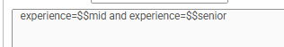
3e parameter filter configuration
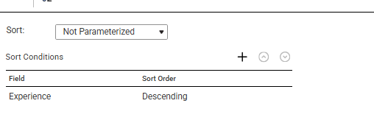3f sorter defination

3f mapping task execution
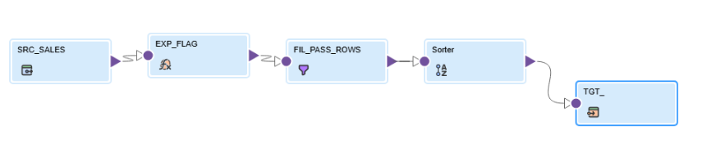
3d snowflake table
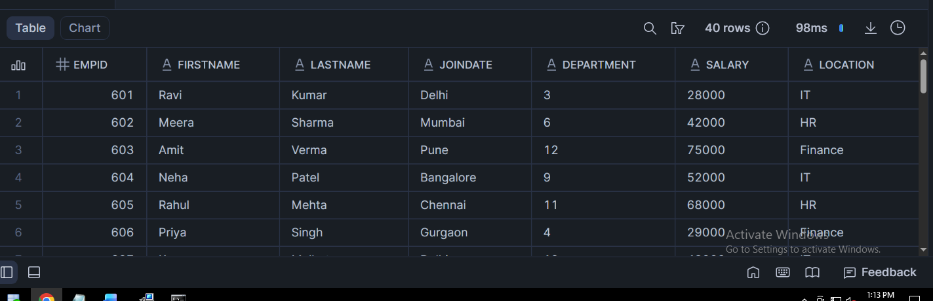

Q4
- Mapping task 1
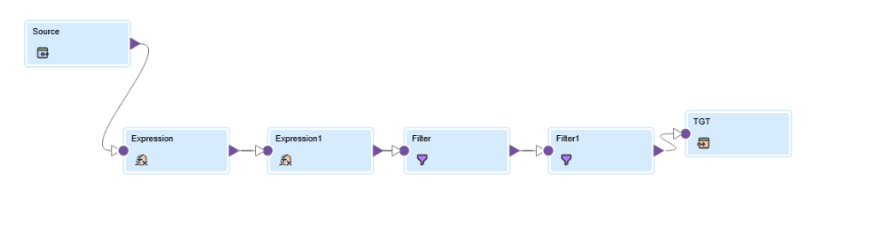
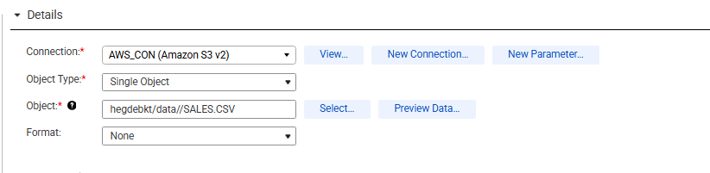
- Decision step config
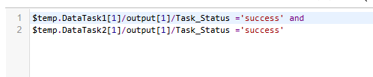
- Mapping task 2
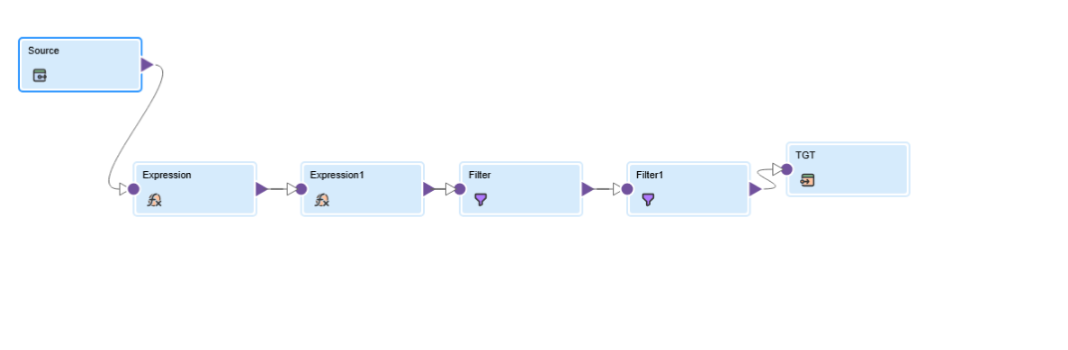

- Final output



