MS 4 MOCK 2
Q1 Mapping using aws source connected lookup expression and parameterized filter
1a aws source configuration
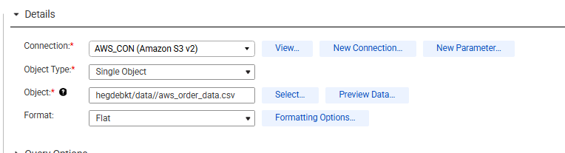
1b connected lookup configuration
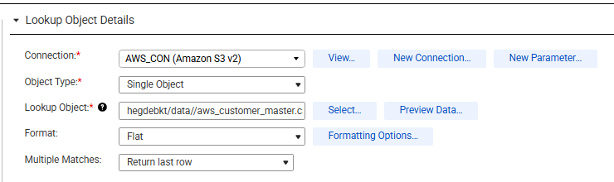
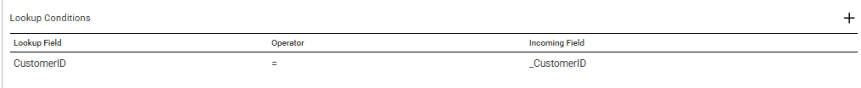
1c expression transformation
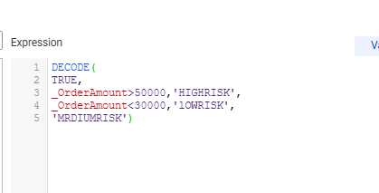
1d parameter definition
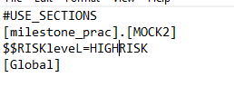
1e mapping execution success
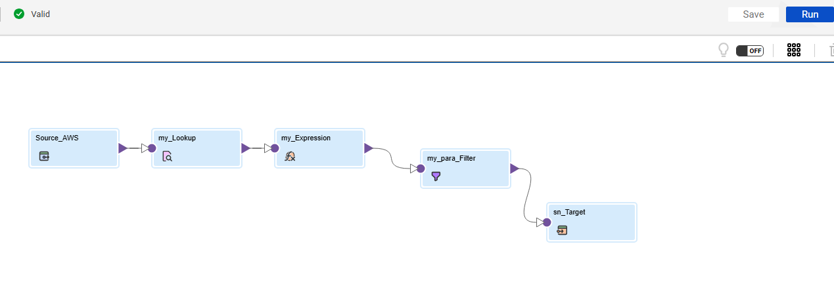
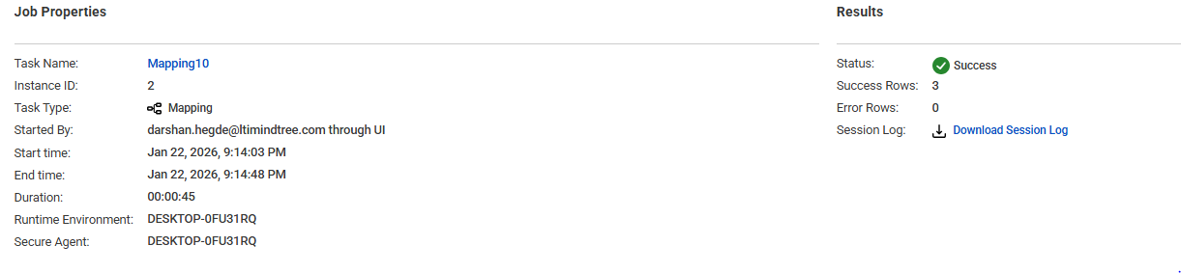
1f snowflake table load
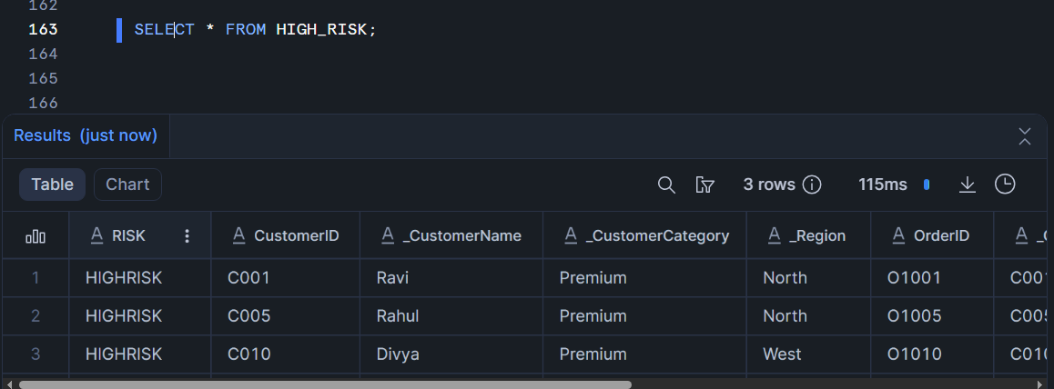

Q2 MAPPING USING FLATFILE AND SNOWFLAKE SOURCES WITH ORACLE TARGET
2A FLAT FILE SOURCE CONFIGURATION
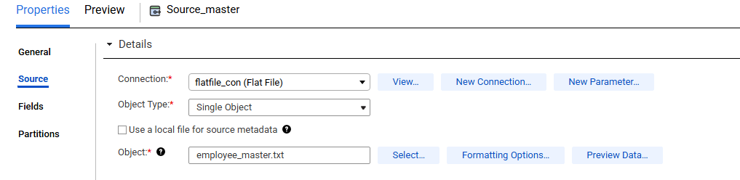
2BSNOWFLAKE SOURCE CONFIGURATION
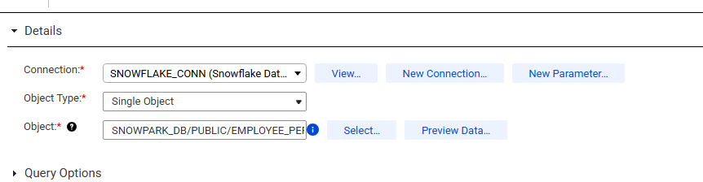

2C JOINER TRANSFORMATION
2D EXPRESSION TRANSFORMATION
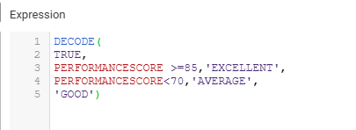

2E AGGREGATOR TRANSFORMATION
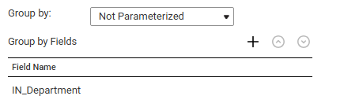
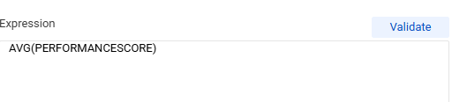

2F PARMETER DEFINATION AND FILTER CONFIGURATION
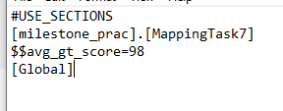

2G SORTER CONFIGURATION
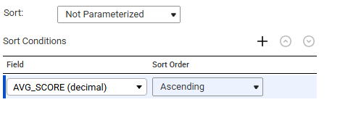

2H MAPPING EXECUTION

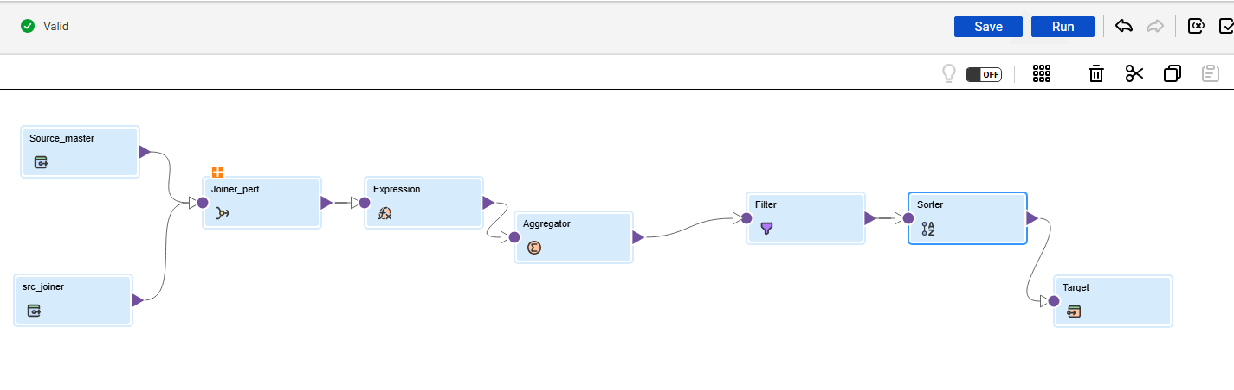

2I TARGET TABLE LOADED DATA
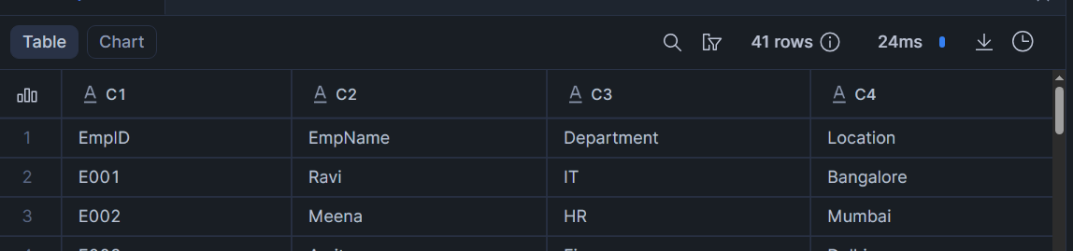

Q3 MAPPING USING SORCE, expression ,rank, filter and sorter
3a snowflake source configuration
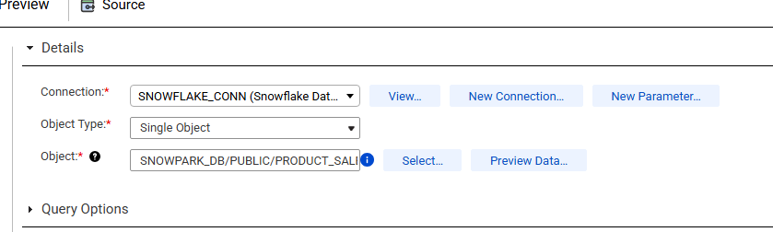
3b expression transformation
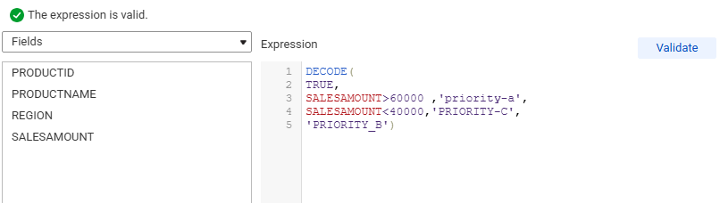
3c rank transformation
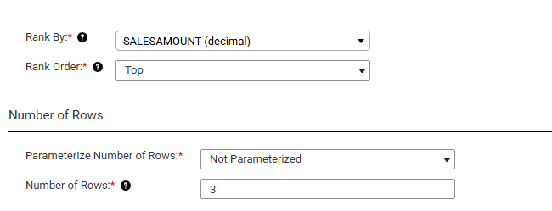

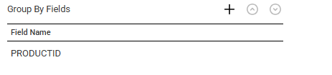
3d filter transformation
3e sorter configuration
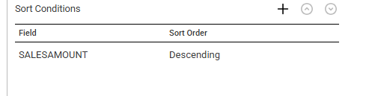
3f mapping success
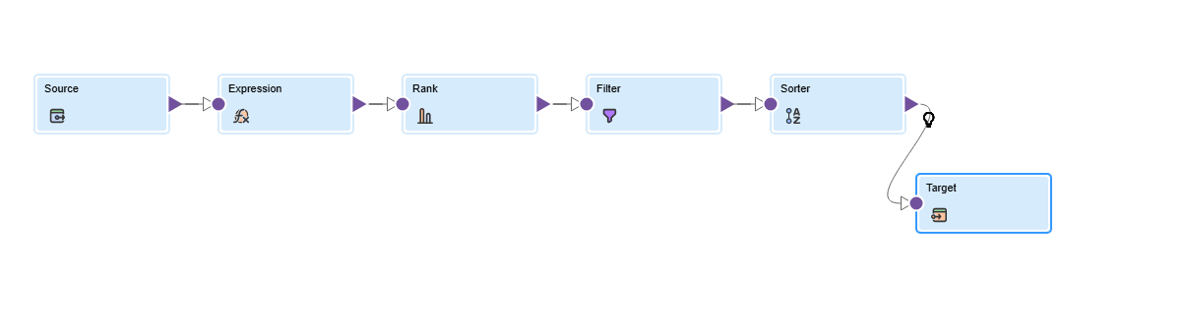


3g oracle target table
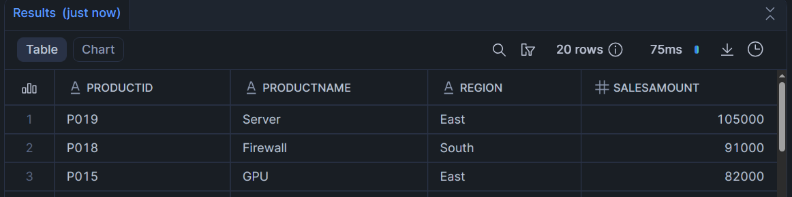

Q4 mapping using normalizer aggregation expression and rank
4a source definition
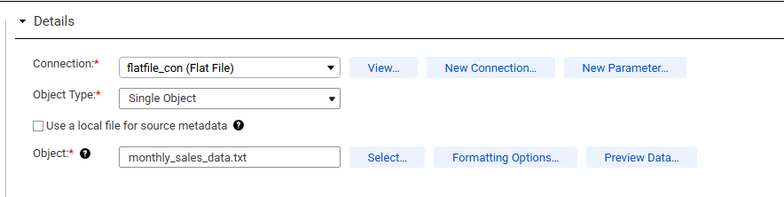
4b normalizer transformation
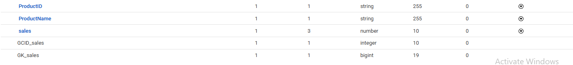
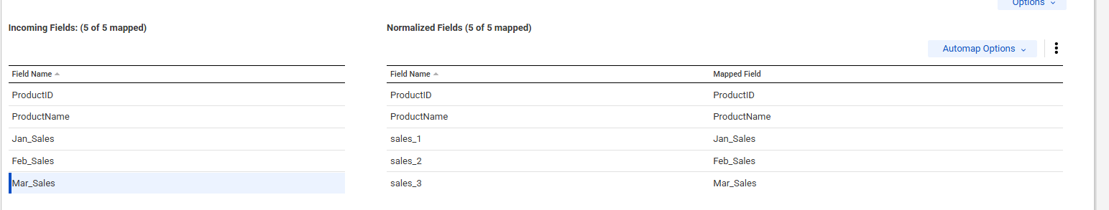

4c expression transformation
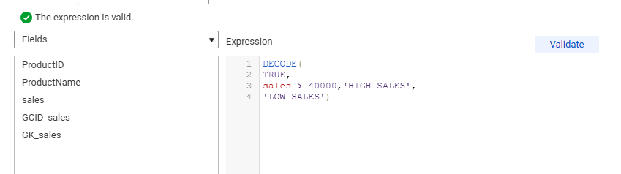

4d aggregator
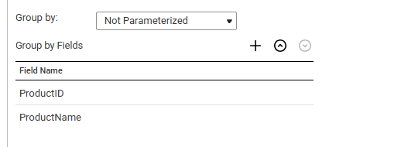
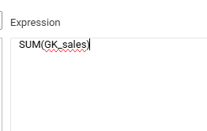

4e rank transformation
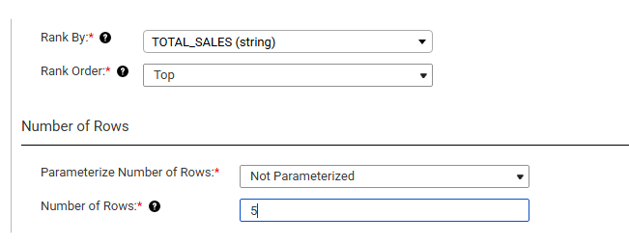
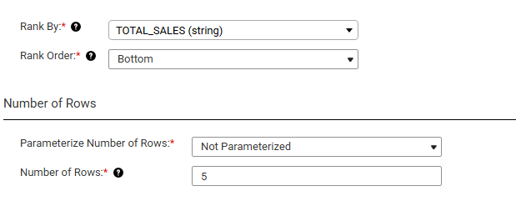

4f mapping success

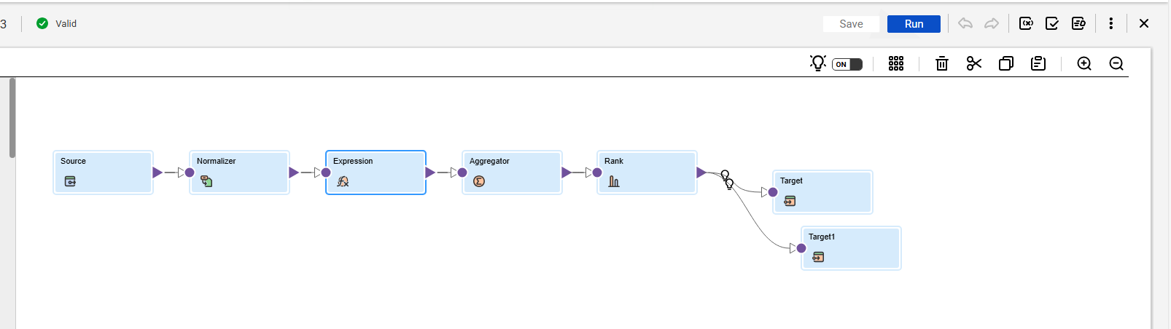

4g data loaded into snowflake
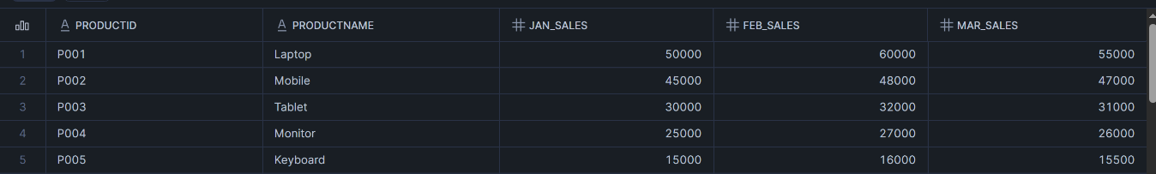
4h data loaded into oracle


