INTELLIGENT INTEGRATED SKILL MARKETPLACE
evolving toward a Workforce Mobility OS
Architecture Document
Document Version 1.0
Status: Draft — Circulated for Engineering and Client Review
Prepared for: Solution, Application and Deployment Architecture Review

Document Title | IISM Architecture Document — Solution, Application & Deployment
Version | 1.0
Prepared By | Product & Engineering — IISM Programme
Distribution | Engineering, Technical Client Reviewers
Classification | Confidential — Not for Public Circulation
Companion Documents | High-Level Design; Product Requirements Document; Functional Requirements Specification; Business Requirements Document; Architecture Decision Record

Document Control

Revision History
Version | Date | Author | Summary of Changes
0.1 | 2026-09-24 | Engineering | Initial draft, alongside the HLD, BRD, PRD and FRS.
1.0 | 2026-09-24 | Engineering | First version circulated for review.

Approval
Role | Name | Signature / Approval | Date
Engineering Lead
Solution Architect / Technical Reviewer
Product Owner

Table of Contents
Right-click and choose “Update Field” to generate the table of contents.

1 Purpose, Scope and Relationship to the High-Level Design
This document was requested as a distinct deliverable from the High-Level Design (HLD) already produced, and the distinction is real rather than a relabelling. Both describe the same system; they answer different questions and are read by different audiences.
Document | Question It Answers | Notation
High-Level Design (HLD) | What modules and datastores exist, how do they depend on one another, and structurally how does data move through the system? | ASCII diagrams, dependency tables — engineering-facing, version-controllable as text
This document | How does the system sit in its business and technical context (Solution), how is it internally layered and componentised (Application), and how is it actually run and where is it planned to run (Deployment)? | Rendered C4-style diagrams — for engineering onboarding and for a technical audience on the client side who expect diagrams, not monospace text

Concretely, this document adds three views the HLD does not attempt:
- Solution Architecture — the platform placed in its full context: every person and external system it talks to, built or planned, in one diagram (Section 2).
- Application Architecture, one level deeper than the HLD's module map — a proper layered view inside the API process (routing, service, domain, adapter, data access) and a component-level drill-down into the platform's single most architecturally significant module (Section 3).
- Deployment Architecture as its own subject, not a summary table — both what actually runs today (a developer's laptop) and the planned production topology on AWS, as two separate, honestly labelled diagrams (Section 4).
Nothing in this document is at odds with the HLD; where the two describe the same fact (for example, the module dependency direction) they say the same thing. This document does not repeat the HLD's business-rule-adjacent content — the placement of future functionality and external hooks — which remains the HLD's Section 9.

2 Solution Architecture
Solution Architecture answers one question: how does this system sit among the people and other systems around it, independent of how it is built internally.

2.1 System Context
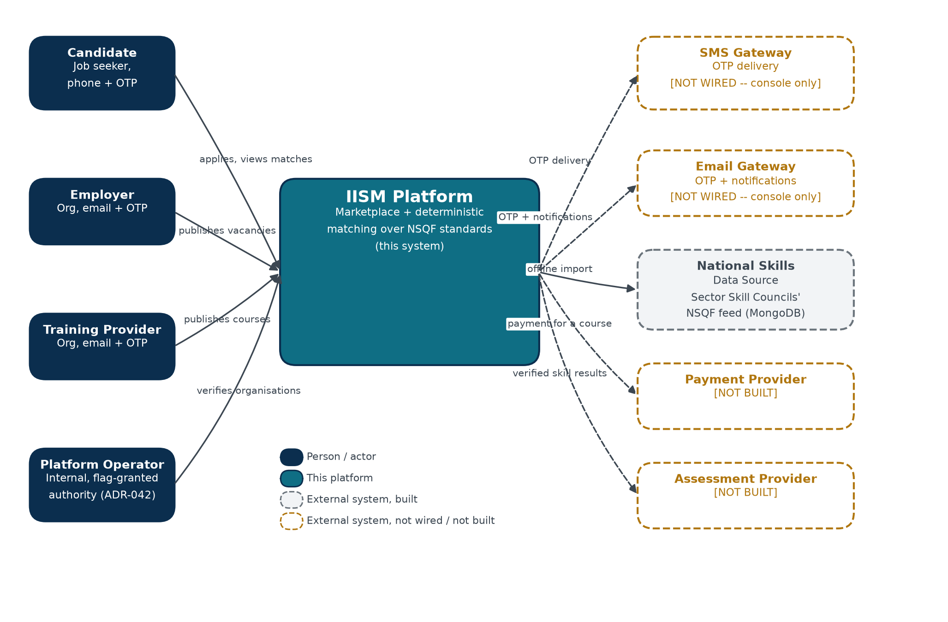
Figure 1. System Context — every person and external system the platform talks to, built (solid border) or not yet (dashed amber).

Four actor types reach the platform directly (Business Requirements Document §6); five external systems are named in the architecture, of which two are built but not production-wired (SMS and email both run a console-only implementation that refuses to start in a real production environment) and three are not built at all. This matches the High-Level Design §5 exactly — the same five integrations, presented here as a picture rather than a table.

2.2 Solution Capabilities Map
Which part of the solution realises each business capability named in the Business Requirements Document §5 and §7.
Business Capability | Realised By
Skill-gap matching and course recommendation | The API's Domain / Scoring Layer (Section 3.2), consuming the NSQF taxonomy imported from the National Skills Data Source
Vacancy and course publishing, self-serve | The API's Service Layer, marketplace/ module
The candidate pool and applicant inbox | The API's Service Layer, applications/ and matching/employer.py
Team management and role-based access | The API's Service Layer, identity/ module, enforced by the Authorization cross-cutting concern
Organisation verification (trust badge) | The API's Service Layer, operations/ module, gated by the Platform Operator authority named in Figure 1
Data export, consent and erasure (DPDP) | The API's Service Layer, privacy/ module
Notification and job alerts | The Worker container (Section 3.1), acting on the outbox the API writes

2.3 Non-Functional Architecture Drivers
Driver | Architectural Response
Data residency (DPDP Act, 2023) | Planned production deployment is entirely within AWS ap-south-1 (Mumbai); see Section 4.2.
Explainability of every match | Scoring is a pure function with no model call (ADR-036) — see the Domain / Scoring Layer, Section 3.2.
Low-end device, constrained data | The Web Application container is an installable PWA with an enforced first-load budget.
Multi-tenant isolation | Enforced in the Authorization cross-cutting concern, never in individual route handlers (ADR-039, ADR-042).
Extensibility to new external systems | Every integration in Figure 1 sits behind an adapter interface (ADR-017) — a new one is an addition, not a change to existing code.

3 Application Architecture
Application Architecture answers how the system is built internally — its containers, its internal layering, and, for the one module that carries the platform's core claim, its components.

3.1 Container View
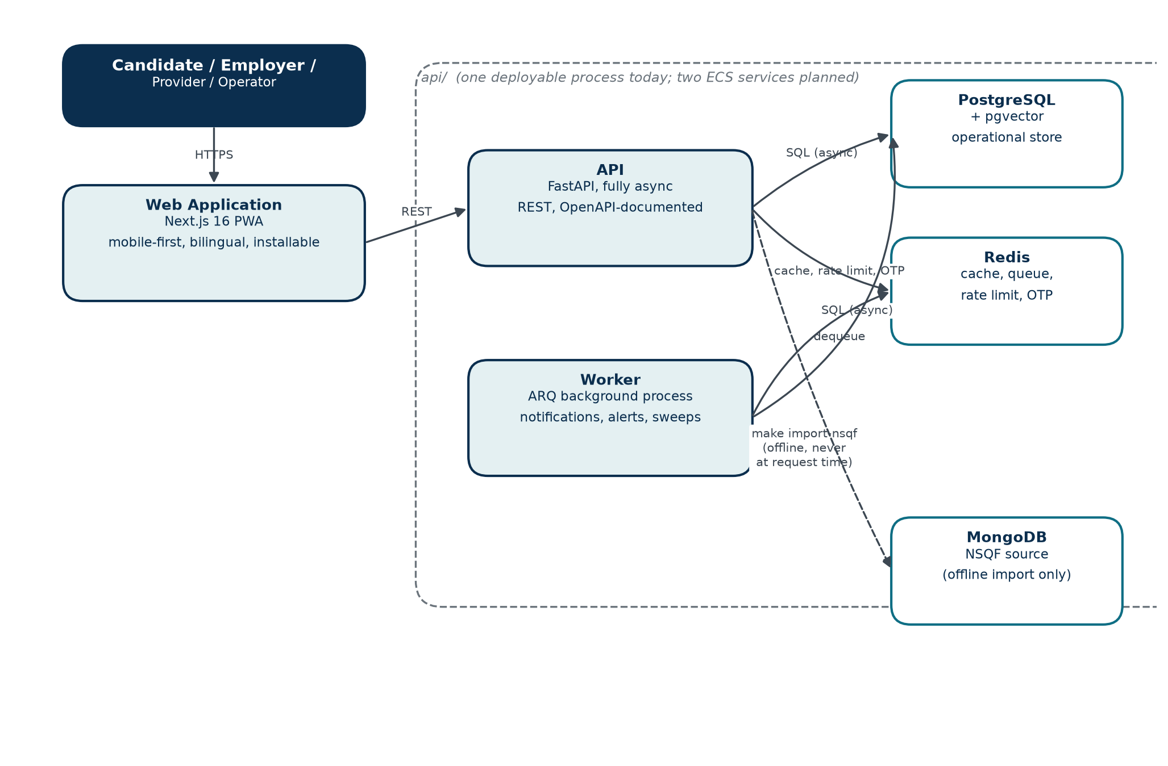
Figure 2. Containers — the deployable units and the protocols between them. One process today (api + worker on one host); two ECS services in the planned topology (Section 4.2).

The web application and the API communicate over REST only, through a TypeScript client generated directly from the API's own OpenAPI schema — a contract mismatch surfaces as a type error, not a runtime failure. The worker shares the API's codebase but runs as a separate process with its own entry point, because ARQ's CLI applies its own logging configuration after import, which the platform's structured-logging setup has to work around (see api/worker.py).

3.2 Layered Design Inside the API Container
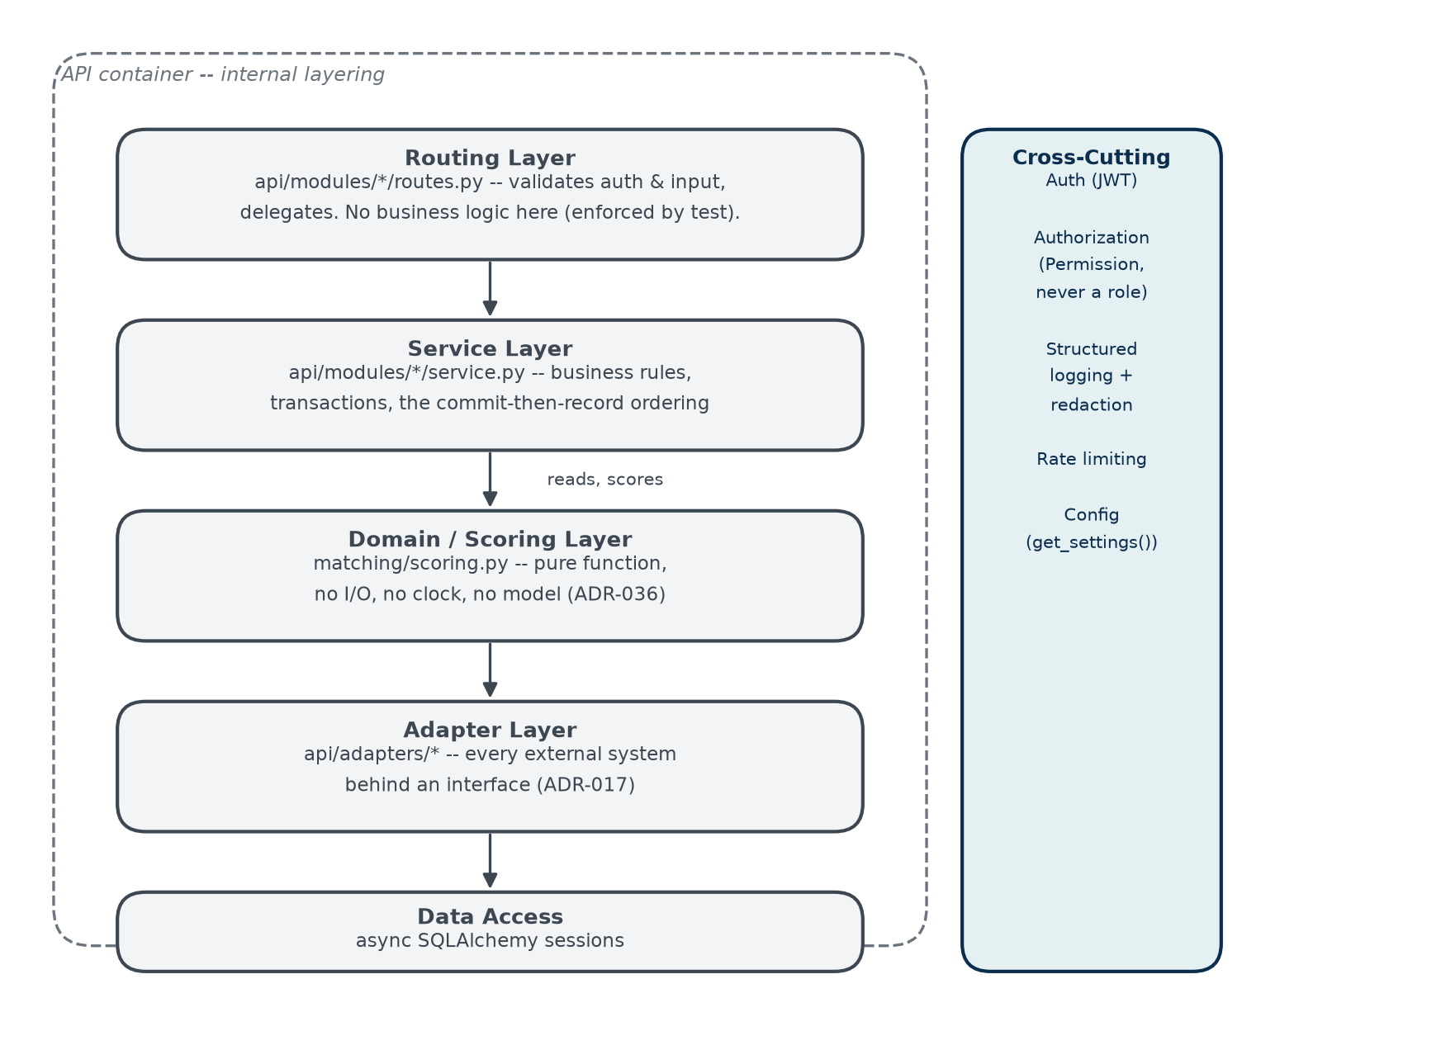
Figure 3. Internal layering. The Routing Layer's freedom from business logic is enforced, not just conventional — a source-reading test fails on the next handler that reaches into a service's internals.

The Service Layer also calls the Adapter Layer and Data Access directly for non-scoring work (queuing a notification, reading a candidate profile) — simplified out of Figure 3 for readability, since the strict top-to-bottom path shown is what matters for the platform's one non-negotiable rule: nothing above the Domain / Scoring Layer, and nothing inside it, may perform I/O, read the clock, or call a model (ADR-036).

3.3 Component View — matching/, the Platform's Core
One module is worth a component-level view: matching/ is where the platform's central claim — explainable, deterministic skill-gap scoring — actually lives, and it is the only module populated in the Intelligence Layer today (career_paths/ and a general intelligence/ module are named in the architecture with no code, per ADR-008 and ADR-005/013/018).
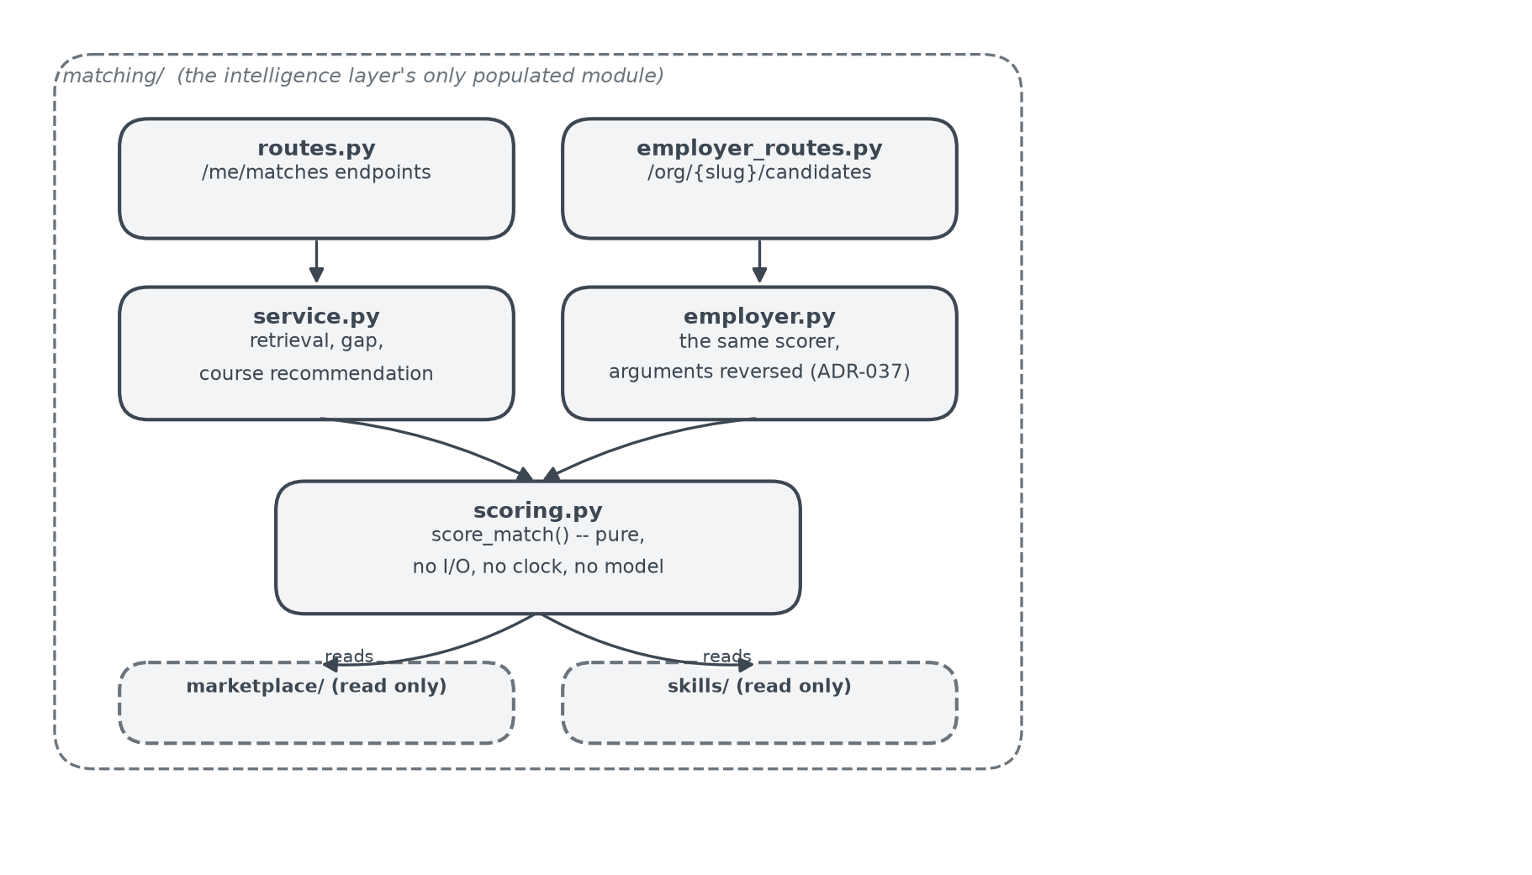
Figure 4. matching/ components. scoring.py is called by both the candidate-facing path (service.py) and the employer console (employer.py) — the same function, arguments reversed (ADR-037). There is no second scoring implementation anywhere in the codebase.

3.4 Design Patterns in Use
Pattern | Where | Why
Adapter | api/adapters/* | Every external system behind one interface per integration (ADR-017); a new vendor is a new implementation, not a change to a calling module.
Dependency injection | FastAPI's Depends(), throughout routing | Authentication, authorization and the database session are resolved once per request and passed in, never constructed inside a handler.
Pure function / no side effects | matching/scoring.py | A score must be reproducible against a fixed reference set and auditable to a regulator (ADR-036); neither survives a function with I/O or a clock.
Service layer | api/modules/*/service.py | Business rules and transaction boundaries live in one place per module, never in the routing layer (enforced, Section 3.2).
Outbox | notifications/ | A side effect (sending a message) is queued inside the same transaction that caused it, and executed later by the worker — a request never waits on, or fails because of, an external delivery vendor.

4 Deployment Architecture
Two topologies, shown separately and labelled honestly: what actually runs today, and what is planned per ADR-028 and provisioned nowhere yet.

4.1 Current Deployment — Local Development
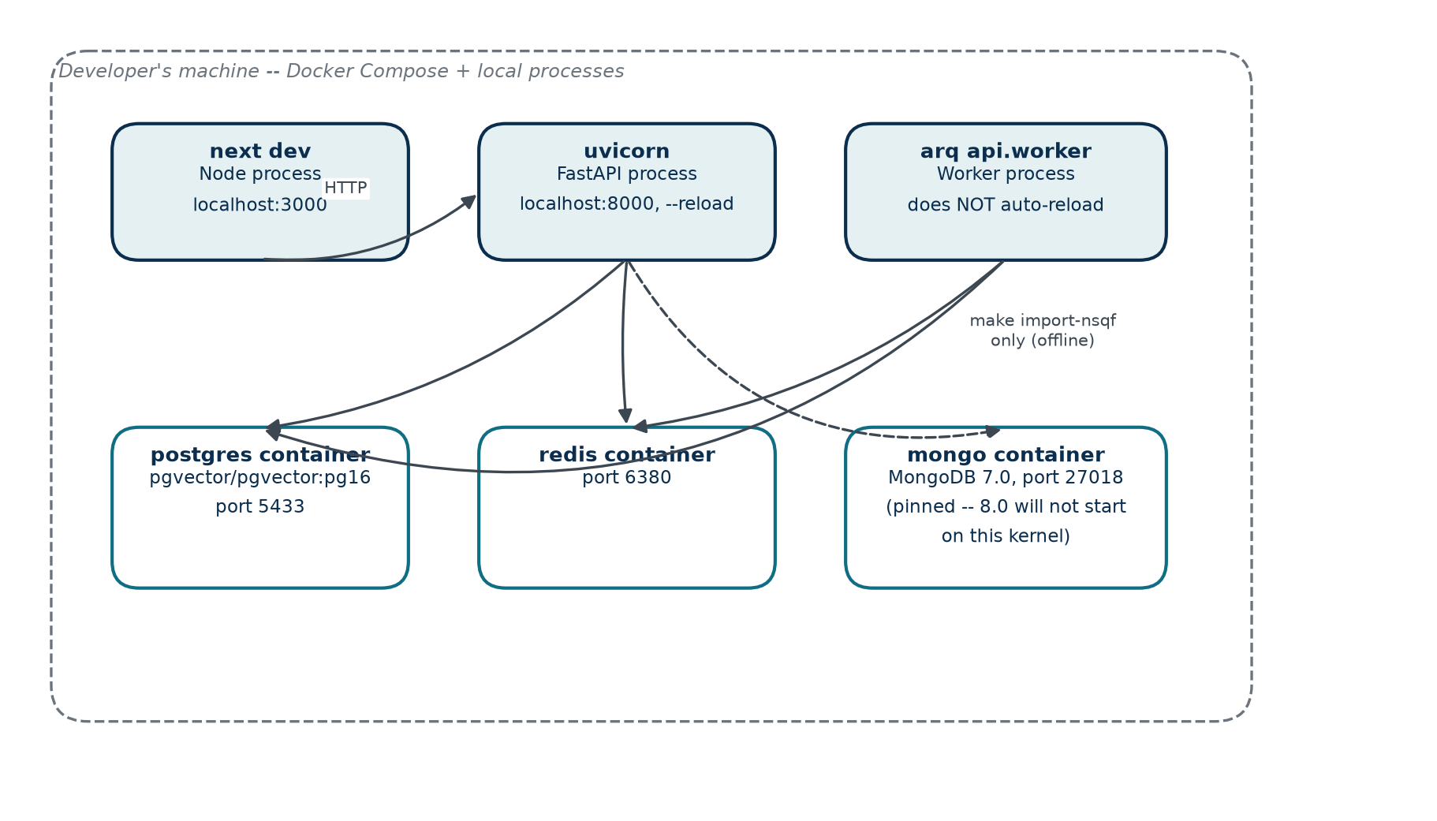
Figure 5. What is actually running today: one developer machine, Docker Compose for the three datastores, and the API/worker/web as local processes.

Every non-default port (5433, 6380, 27018) is deliberate — chosen so a pre-existing local Postgres, Redis or Mongo installation is never disturbed. MongoDB is pinned to 7.0: version 8.0 refuses to start on the Linux kernel Docker Desktop for macOS runs.

4.2 Planned Production Deployment (ADR-028)
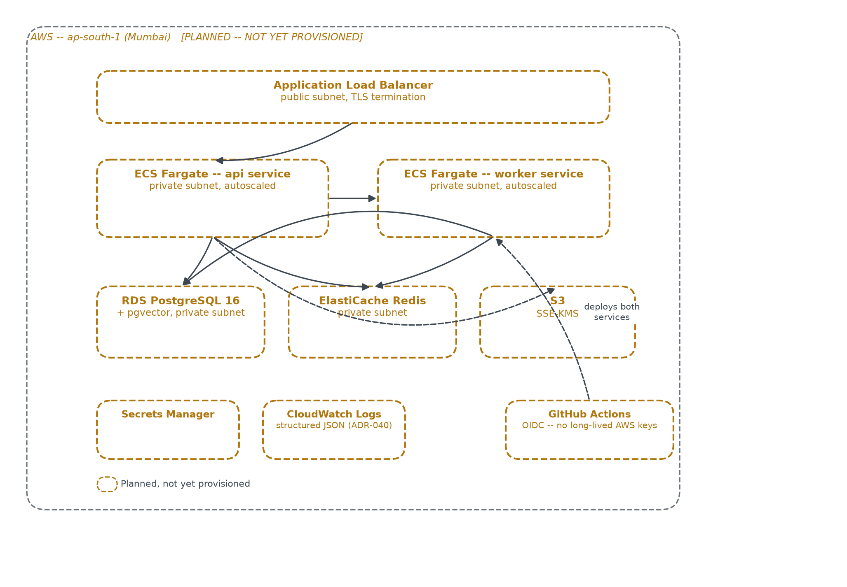
Figure 6. The planned AWS topology. Every box here is dashed amber because nothing in this diagram has been provisioned — there is no Terraform written for it yet.

India residency (ap-south-1) is a hard constraint once real candidate data is collected, per the Digital Personal Data Protection Act, 2023. CI authenticates to AWS through GitHub Actions' OIDC provider; no long-lived AWS access key exists or is planned to exist anywhere in the pipeline.

4.3 Environment Strategy
Environment | Purpose | Status
Development | Local iteration, the topology in Figure 5 | Live — the only environment that exists today
Test | Automated test suite, testcontainers-backed, ephemeral per run | Live, in CI
Staging (planned) | Pre-production validation on the real AWS topology | Not provisioned
Production (planned) | Figure 6's topology, serving real users | Not provisioned

4.4 CI/CD Pipeline
GitHub Actions runs on every change: dependency install from a locked file, a security audit of both the Python and the JavaScript dependency trees, linting, type checking, the full test suite, and a first-load JavaScript budget check on the web build. Deployment itself — the arrow from GitHub Actions in Figure 6 — is planned, not built: there is no pipeline stage today that deploys anywhere, because there is nowhere yet to deploy to.

5 Cross-References
For… | See
The exact functional behaviour any of these components implement | Functional Requirements Specification, Section 4
Why each architectural decision in this document was made this way, and what alternatives were rejected | Architecture Decision Record
Where a future capability (payment, assessment, semantic matching) should attach to the architecture shown here | High-Level Design, Section 9
The business capability each part of this architecture exists to serve | Business Requirements Document, Sections 5–7
The user-facing feature each component realises, as a user story | Product Requirements Document, Section 5

6 Appendices

Appendix A — Notation Legend
Every diagram in this document uses one consistent visual vocabulary:
- Navy, filled — a person or actor (a human using the system).
- Teal, filled — the system itself, at the level the diagram is drawn (the whole platform in Figure 1; a container in Figures 2 and 5).
- Light teal, outlined — a container or a component — something built and live.
- White, teal outline — a datastore.
- Grey, dashed — an external system that is built and reachable, but not part of this codebase (the National Skills Data Source).
- Amber, dashed — planned but not yet built or provisioned. Every box carrying this style is a placeholder, never a claim that something exists.

Appendix B — Document Set Summary
- Business Requirements Document — why this exists, and what the business needs.
- Product Requirements Document — what is built, for whom, in what order.
- Functional Requirements Specification — exhaustive behaviour and business rules.
- High-Level Design — macro architecture and where new capability attaches to it, in text and ASCII.
- This document — Solution, Application and Deployment Architecture, as rendered diagrams.
- Architecture Decision Record — the reasoning behind every decision named above.

Appendix C — Change Control
This document should be revisited whenever a container is added or removed, an internal layer's responsibility changes, or the deployment topology moves from planned to provisioned — at which point Figure 6 is redrawn without the dashed amber styling for whatever has actually been built.

