INTELLIGENT INTEGRATED SKILL MARKETPLACE
evolving toward a Workforce Mobility OS
High-Level Design
Document Version 1.0
Status: Draft — Circulated for Engineering Review
Prepared for: Engineering Onboarding and Technical Client Due Diligence

Document Title | IISM High-Level Design (HLD)
Version | 1.0
Prepared By | Product & Engineering — IISM Programme
Distribution | Engineering, Technical Client Reviewers
Classification | Confidential — Not for Public Circulation
Companion Documents | Product Requirements Document; Functional Requirements Specification; Business Requirements Document; Architecture Decision Record

Document Control

Revision History
Version | Date | Author | Summary of Changes
0.1 | 2026-09-24 | Engineering | Initial draft, alongside the BRD, PRD and FRS.
1.0 | 2026-09-24 | Engineering | First version circulated for review.

Approval
Role | Name | Signature / Approval | Date
Engineering Lead
Product Owner
Security / Compliance Reviewer

Table of Contents
Right-click and choose “Update Field” to generate the table of contents.

1 Purpose and Scope
This High-Level Design (HLD) documents the macro architecture of the Intelligent Integrated Skill Marketplace as it exists today: the module and data-store boundaries, the external integrations built and implied, how data actually moves through the system for the platform’s core operations, and — forward-looking — where the functionality recorded as future backlog in the Product Requirements Document should logically attach given the boundaries already in place.
It is written for engineers onboarding onto the codebase and for technical reviewers on the client side conducting due diligence, and assumes familiarity with standard web architecture terms. It deliberately does not restate the business rules in the Functional Requirements Specification, nor the reasoning behind each architectural choice, which is recorded in full in the Architecture Decision Record (42 decisions) — this document names the decision being applied and moves on.

1.1 What This Document Covers
- The system’s macro architecture: modules, their boundaries, and their dependency direction (Section 3).
- Every datastore in use, what it holds, and its approximate current scale (Section 4).
- Every external integration point that is built, and every one implied by the architecture but not yet implemented (Section 5).
- How data actually flows for the platform’s core operations, in structural diagrams (Section 6).
- Where new functionality and external hooks should sit, given the module boundaries already in place (Section 8).
It does not cover: infrastructure-as-code detail, CI/CD pipeline configuration, or line-level API contracts — the OpenAPI schema generated directly from the running service is the source of truth for the latter.

2 Architectural Style and Guiding Principles
Principle | Decision | Reference
Layered system | A Marketplace Layer (records, transactions) and an Intelligence Layer (scoring, matching) are kept decoupled. The Intelligence Layer consumes Marketplace data; it owns none of it. | ADR-001
Modular monolith | One deployable application, internally organised into strictly bounded modules under api/modules/. Each module exposes a narrow public interface through its __init__.py; other modules import only from that interface, never from a module’s internals. | ADR-014
API-first, REST | Every capability, including one consumed only by another internal module, is reachable through a documented REST endpoint. No GraphQL. | ADR-016
Event-driven for async work | Matching precomputation, notification delivery and scheduled sweeps run through a worker, never inline in a request handler. | ADR-006, ADR-027
Adapter pattern for every external system | No module calls a third-party SDK directly. Every external system — payment, assessment, notification, the national skills-data source — sits behind an adapter interface in api/adapters/. | ADR-017
Deterministic decides, a model only explains | No AI model output ever decides a score or a match. Where a model is used at all, it runs at write time, never inside a request, and its output is cached. | ADR-005, ADR-018, ADR-036

These six decisions are what make the module map in Section 3 legible: the dependency direction is not incidental, it is the mechanism by which the modular monolith could later be split into services without a rewrite (ADR-014’s stated purpose).

3 Macro Architecture
One deployable FastAPI application (a modular monolith, ADR-014), internally split into bounded modules under api/modules/, cross-cutting concerns under api/core/, and every external system reached through an adapter under api/adapters/. The web client is a separate deployable Next.js application talking to the API over REST only.
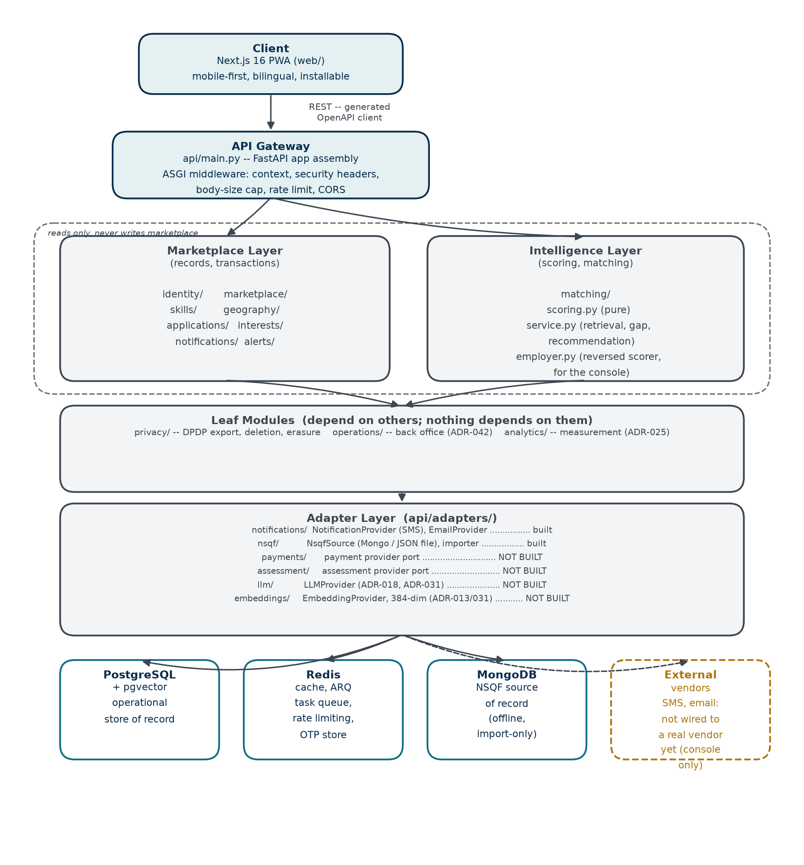
Figure 1. Macro architecture, top to bottom: client, API gateway, the two functional layers, the leaf modules, the adapter layer, and the datastores/external systems each adapter reaches.

3.1 Module Directory
Every module under api/modules/ today, its layer, and its dependency direction. “Depends on” names what it imports through another module’s public interface only — never another module’s internals (ADR-014).
Module | Layer | Depends On | Nothing Depends On It?
identity | Marketplace | — (foundational) | No — nearly everything depends on it
marketplace | Marketplace | identity, geography, skills | No
skills | Marketplace (taxonomy) | — (foundational) | No
geography | Marketplace | — (foundational) | No
applications | Marketplace | marketplace, matching | No
interests | Marketplace | marketplace, matching | No
notifications | Marketplace (outbox) | identity | No — alerts and others enqueue through it
alerts | Marketplace (worker-only) | matching, notifications, marketplace | Yes
matching | Intelligence | marketplace, skills (reads only) | No — applications, alerts and the console all depend on it
privacy | Leaf | every module above | Yes
operations | Leaf | identity, marketplace | Yes
analytics | Leaf | — (foundational) | No — every module records through it

career_paths/ and a general-purpose intelligence/ module are named in the architecture (ADR-008, ADR-005/013/018) and reserved in the module tree’s own documentation, but carry no code today — see Section 9.

4 Databases and Schemas
Three datastores are in use today, each for a distinct reason (ADR-003, ADR-034), plus one engine feature — pgvector — that is enabled and structurally present but not yet exercised by any table.

4.1 PostgreSQL — the Operational Store of Record
Every request-time read and write goes through PostgreSQL. 44 tables, grouped below by the domain they belong to, with row counts as verified directly against the development instance.
Domain | Representative Tables | Approx. Scale
NSQF taxonomy (imported, read-heavy) | skills, qualification_packs, occupations, sectors, awarding_bodies, qp_skills, skill_concepts | 21,355 skills; 4,424 qualification packs; 238,370 performance criteria
Geography (imported, read-heavy) | states, districts, sub_districts | 36 states; 766 districts; 7,100 sub-districts
Identity and organisations | users, tenants, memberships, invitations | Scales with registered accounts
Marketplace records | jobs, courses, job_skills, course_skills, candidate_profiles, candidate_skills | Scales with published inventory and candidate activity
Transactions and disclosure | applications, course_interests, saved_jobs, job_alerts | Scales with platform usage
Trust and measurement | tenant_verification_events, analytics_events, notifications | Append-only event logs; analytics_events is periodically purged past its retention window
Localisation | content_translations | One row per translated field per locale; empty until something is actually translated (ADR-041)

4.2 pgvector — Enabled, Not Yet Used
The pgvector extension is installed and confirmed live by the platform’s own health check, but no table carries an embedding column today. This is a deliberate, structural placeholder: ADR-013 and ADR-031 already fix the implementation (self-hosted sentence-transformers, 384 dimensions) and ADR-036 defers turning it on until deterministic matching has a measured baseline to improve against. See Section 9.2.

4.3 MongoDB — Source of Record for the National Skills Feed
MongoDB holds the raw, versioned national skills-data feed exactly as published, and nothing else. It is never read at request time — only the offline import process opens a connection to it (ADR-034).
Collection | Holds | Imported?
qualifications, standards, curricula, sectors, states, districts | The national skills framework’s own published documents | Yes — projected into PostgreSQL by api/adapters/nsqf/importer.py
ssc | A portal account registry — personal names, emails, phone numbers and bank details with no product use | No, deliberately (ADR-035). No module under api/ may read it.

4.4 Redis — Four Distinct Uses Behind One Connection
Use | What Lives There
ARQ task queue | Jobs the worker process picks up: notification delivery, job alerts, expiry sweeps, analytics purging.
Cache | Short-lived read caching for expensive lookups.
Rate limiting | Per-account and per-IP request counters for sign-in, application and organisation-creation limits.
One-time passcode store | OTP codes, hashed, with attempt counters — never the plaintext code at rest.

5 External APIs and Integrations
Every external system, built or implied, sits behind an adapter interface under api/adapters/ (ADR-017) — no module ever calls a third-party SDK directly. This is what makes the “not built” rows below additions rather than refactors: the seam already exists in the architecture, only the implementation behind it is missing.

5.1 Built and Live
Integration | Adapter | Current Implementation
SMS delivery (candidate OTP) | NotificationProvider (api/adapters/notifications/) | Console implementation only — prints to the log in development, refuses to start in production. No production SMS vendor is wired in.
Email delivery (org OTP, notifications) | EmailProvider (api/adapters/notifications/) | Same pattern — console-only, refuses in production.
National skills-data feed | NsqfSource (api/adapters/nsqf/) | Two implementations: a live MongoDB reader and a JSON-file reader used by the test suite. Offline, import-time only — never called from a request.

5.2 Referenced or Implied, Not Yet Implemented
Named in the Architecture Decision Record, with the adapter contract already specified, but with no implementation behind the interface.
Integration | Named In | What It Would Do
Payment provider | ADR-025 | Process payment for a paid course or a future subscription. The adapter interface point is named; there is no order, entitlement, invoice or payout model in the schema at all.
Assessment provider | Implied by the SKILL_SOURCES design (self_declared / inferred / assessed / certified) | Supply independently verified skill results that would outrank a candidate’s self-declared skills in scoring.
LLM provider | ADR-018, ADR-031 | Structured extraction from a résumé or a job description, and cached explanation text — never a score or a match decision (ADR-005, ADR-036).
Embedding provider | ADR-013, ADR-031 | Produce the 384-dimension vectors that would feed a semantic-similarity scoring component, stored in the pgvector column described in Section 4.2.
Aadhaar verification | ADR-011 | Optional identity verification, deliberately never the primary identifier.

6 Data Flow Diagrams
Four flows that between them cover every shape of movement in the system: a synchronous read, an asynchronous write-triggered side effect, an offline batch import, and the platform’s one deliberate identity-disclosure mechanism.

6.1 Synchronous Request — Reading a Candidate’s Matches
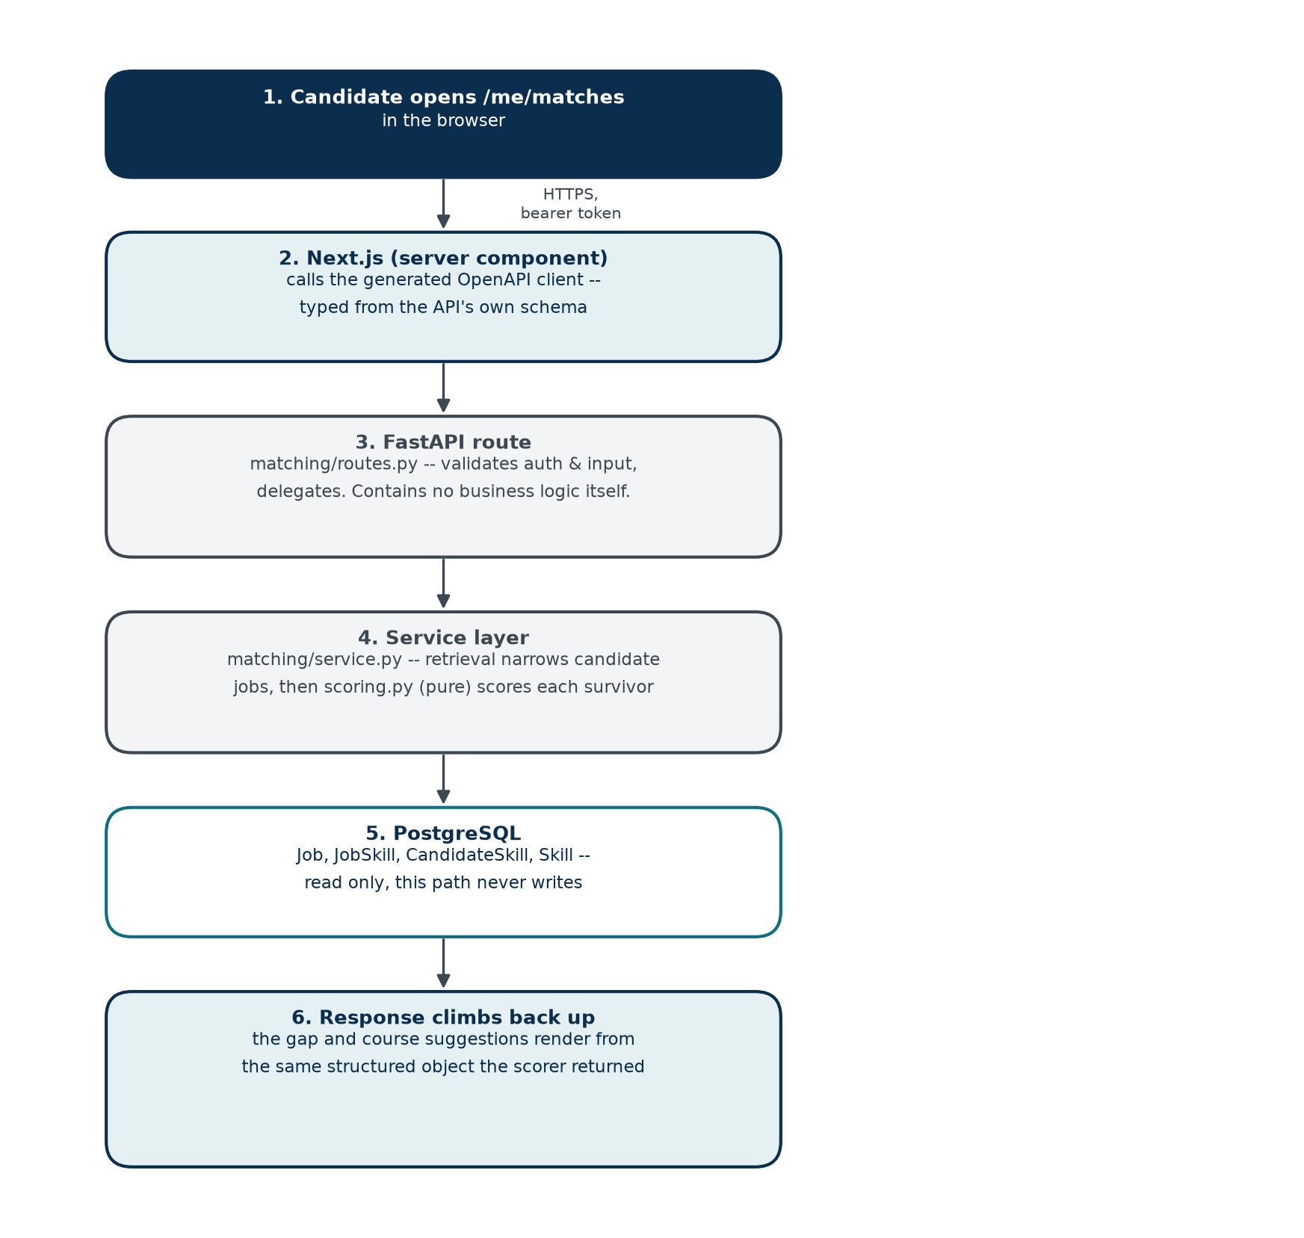
Figure 2. A read-only request. No step here ever writes to PostgreSQL.

6.2 Asynchronous — A Write Triggers a Background Side Effect
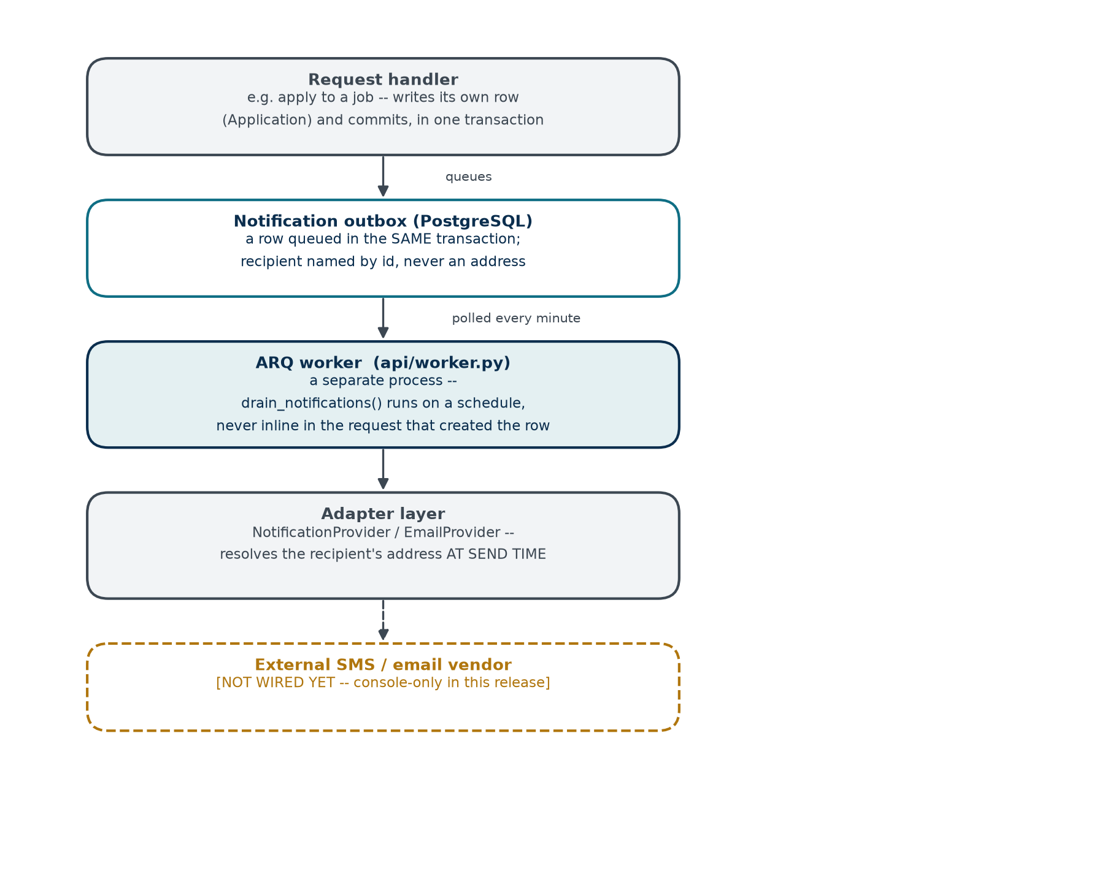
Figure 3. Notification delivery, event-driven (ADR-006). The same shape applies to job alerts and scheduled expiry sweeps -- a cron on the worker, never inline in a request handler.

6.3 Offline Batch — Importing the National Skills Feed
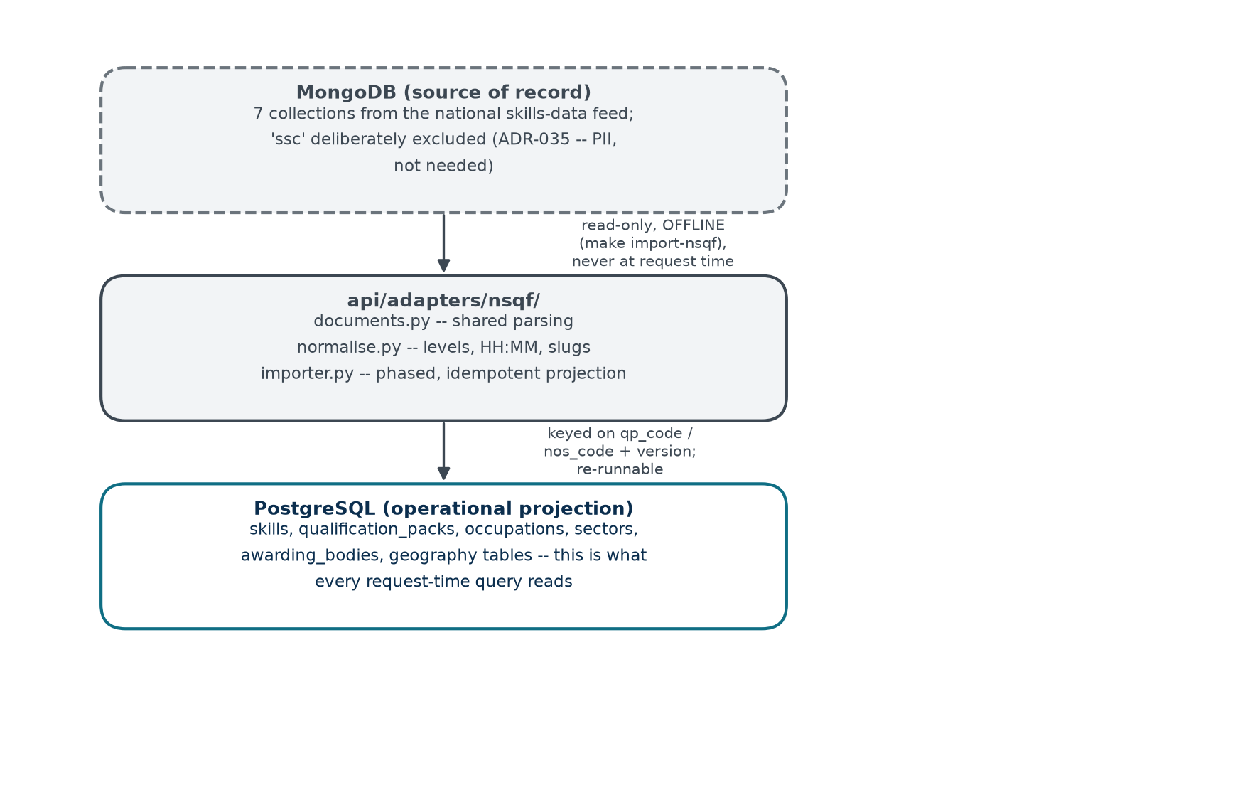
Figure 4. One-directional, re-runnable, and the only path that ever reads MongoDB (ADR-034).

6.4 The One Deliberate Identity Disclosure
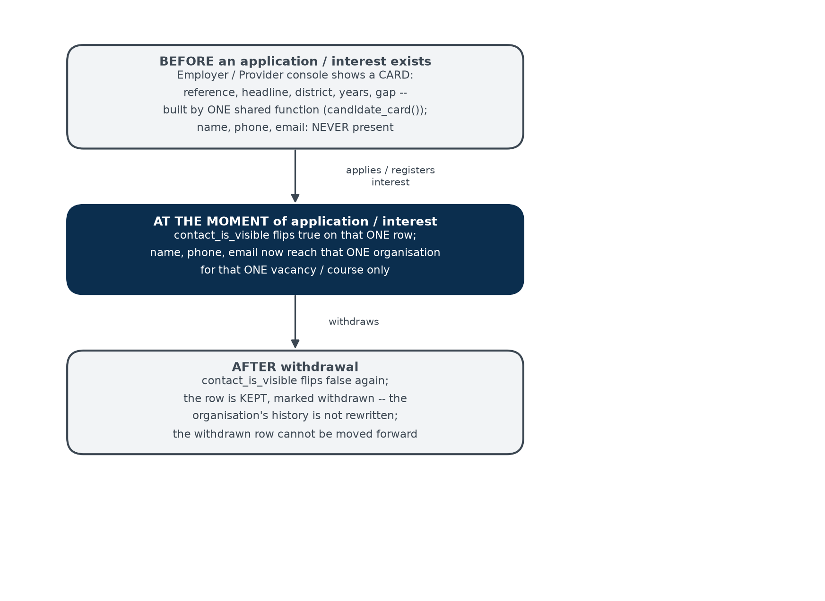
Figure 5. Applying to a job and registering course interest are the platform's only two moments a candidate's identity crosses to an organisation -- both follow this exact shape.

7 Cross-Cutting Concerns
Concern | Implementation
Authentication | Stateless JWT access tokens (15-minute life) plus a longer-lived refresh token; no password anywhere in the product. Two credential paths (phone/OTP, email/OTP) converge on one token-issuance function.
Authorization | Two independent layers: require() resolves a Permission from membership role, scoped to a tenant taken from the path (ADR-039); require_operator() resolves a global, flag-granted authority with no tenant at all (ADR-042). Neither layer is a role check — both ask for a named Permission.
Request pipeline | Pure ASGI middleware only, in order: request context (id, user, tenant bound to structured-logging context) → security headers → body-size cap → rate limiting → CORS → routing. Never BaseHTTPMiddleware, which would break context propagation into request-scoped logging.
Logging | Structured JSON to stdout, one shared processor tail for both structlog and the standard library logger, with an explicit, unbypassable redaction filter (ADR-023, ADR-040). OTPs, phone numbers, résumé content and assessment results are never permitted to reach a log sink.
Configuration | Environment variables through a single pydantic-settings object, read via get_settings() inside functions — never bound at import time, so tests can override it.
Observability beyond logs | Deferred (ADR-040 supersedes the OpenTelemetry/Prometheus/Grafana tooling named in ADR-019). Adequate for a single development instance; not yet built for a deployed one.

8 Deployment Topology
Planned per ADR-028, not yet provisioned. Today the system runs only in local development, orchestrated by docker-compose.
Component | Planned Target | Today
API and worker | AWS ECS Fargate, two services (api, worker), ap-south-1 (Mumbai) | A single local process each, no container orchestration
PostgreSQL | RDS PostgreSQL 16 with pgvector | Local Docker container, port 5433
Redis | ElastiCache | Local Docker container, port 6380
Object storage (future) | S3 with SSE-KMS | Not provisioned — nothing is stored yet
Secrets | AWS Secrets Manager | A local .env file
Infrastructure definition | Terraform, no console configuration | Not yet written

India residency (ap-south-1) is a hard constraint once real candidate data is collected, per the Digital Personal Data Protection Act, 2023 (ADR-028).

9 Where Future Functionality Should Sit
Every item below is placed against the module and adapter boundaries already in the tree (Section 3), so each is an addition to the architecture rather than a reshaping of it. This is the technical counterpart to the backlog framed by business value in the Business Requirements Document (§14) and by product priority in the Product Requirements Document (§8).

9.1 External Data Collection Points — One Shape, Reused
Every external integration below arrives at the platform the same structural way: an external event reaches a new adapter, which calls the existing service layer, which writes to the same tables self-serve publishing already writes to. This is not a convenient coincidence — it is ADR-026’s rule (seeded, self-serve and integrated inventory must be indistinguishable downstream) applied one layer further out.
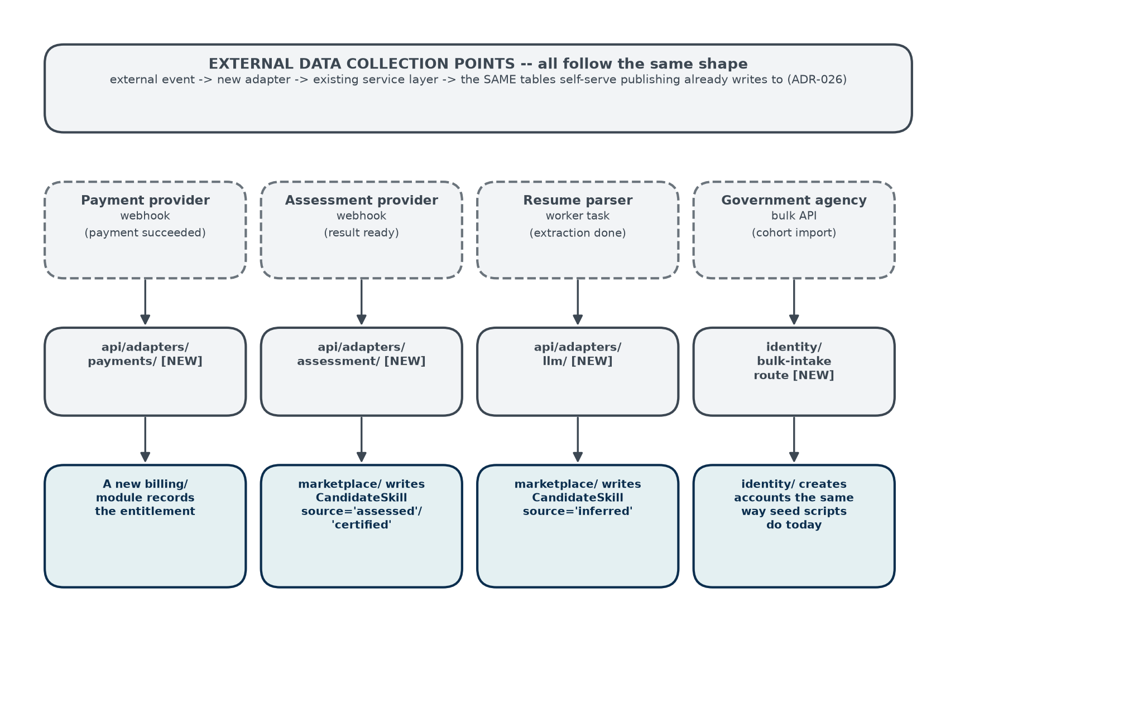
Figure 6. Four external collection points, one shape.

9.2 Semantic Similarity in Matching — an Additive Scoring Component
This is the clearest case of a hook the architecture already has a slot for: pgvector is enabled today with nothing stored in it (Section 4.2), and ADR-013/031 already fix the embedding model and dimension. The addition is purely additive to the existing weighted sum — it does not touch the deterministic components already shipped, and stays bounded so it can refine a ranking but never override a hard skill requirement (ADR-036).
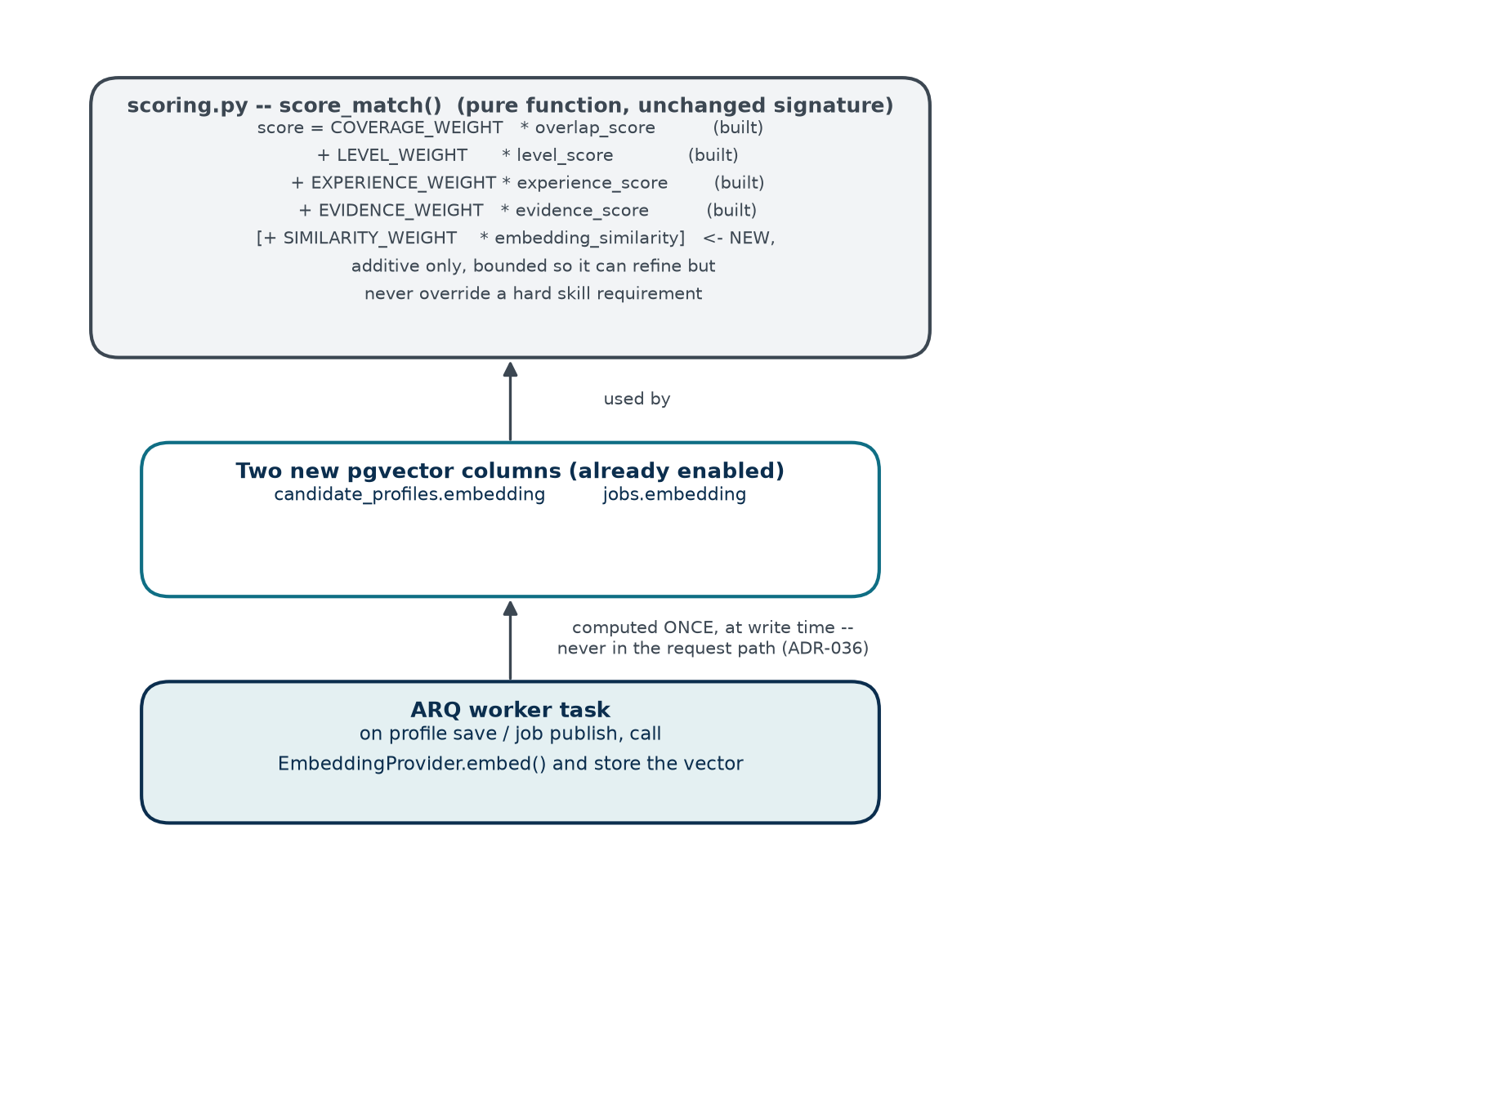
Figure 7. A new scoring term, computed at write time by a worker task, never inside the scoring function itself and never inside a request.

9.3 Placement Summary by Capability
Capability | Where It Sits | New or Existing?
Configurable match weighting | core/config.py gains a weights object; scoring.py accepts it as a parameter instead of reading module constants. | Existing module, new parameter
Recommendation “not interested” signal | analytics/ — one new entry in EVENT_NAMES and the CHECK constraint that must be widened alongside it. | Existing module, additive
Payment / monetisation | A new adapters/payments/ port, plus a new module (e.g. billing/) for orders, entitlements and invoices — marketplace/ gains no payment logic itself. | New adapter, new module
Assessment-provider integration | A new adapters/assessment/ port; the result lands through the existing profile_service write path, tagged source=‘assessed’ or ‘certified’ — no change to matching/, which already trusts those tiers. | New adapter, existing write path
Résumé upload and extraction | Object storage (S3) behind the ADR-023 encryption path, a new adapters/llm/ port for extraction, writing through the same profile service path tagged source=‘inferred’. | New adapter and storage, existing write path
Semantic similarity | See Section 9.2. | New adapter (embeddings/), new columns, additive scoring term
Skill-relationship graph / career paths | A new career_paths/ module, already reserved in the architecture (ADR-008) with no code. Depends on a new SkillRelation table under skills/. | New module
Gig / short-term work | A new, sibling module at the same level as marketplace/ — explicitly not an extension of Job, which models a permanent vacancy. Reuses geography/ and skills/. | New module
Government agency bulk enrolment | A new bulk-intake route in identity/, constructing accounts the same way scripts/seed_candidates.py already does server-side. | New route, existing pattern
External system / API-key access | A new ServiceAccount model in identity/ and a second authentication scheme in core/security.py, alongside JWT rather than replacing it. | New model, new auth path
Verification-status notification | notifications/ already has everything needed — this is one new enqueue call from operations/set_verification, not a new component. | Existing modules, wiring only

10 Appendices

Appendix A — Technology Stack Summary
Layer | Choice | ADR
Backend language / framework | Python 3.12, FastAPI, fully async | ADR-002
Primary database | PostgreSQL with pgvector | ADR-003
NSQF source of record | MongoDB, offline import only | ADR-034
Async task runner | ARQ over Redis (not Celery) | ADR-027, amends ADR-006
Cache | Redis | ADR-020
Search | PostgreSQL full-text search (OpenSearch deferred) | ADR-021
Frontend | Next.js 16 (App Router), React, TypeScript, installable PWA | ADR-029
Logging | Structured JSON to stdout, no vendor SDK | ADR-040, supersedes ADR-019 tooling
Deployment target (planned) | AWS ap-south-1, ECS Fargate, Terraform | ADR-028

Appendix B — Document Set Summary
- Business Requirements Document — why this exists, and what the business needs.
- Product Requirements Document — what is built, for whom, in what order.
- Functional Requirements Specification — exhaustive behaviour and business rules.
- High-Level Design (this document) — the macro architecture and where new capability attaches to it.
- Architecture Decision Record — the reasoning behind every decision named above.

Appendix C — Change Control
This document should be revisited whenever a module boundary changes, a datastore is added or repurposed, or a new external integration is built — at which point the corresponding row in Section 9 moves from a placement recommendation to a description of what actually exists.

