MAHESHCHANDRA HEGDE  Chief Technology Officer (CTO) | Enterprise Architect | Creative Technologist  Bangalore, India | +91 9535253329 / 7022407280 | hid.mahesh@gmail.com  Portfolio: hegdemahesh.in | Technoyana: technoyana.in | LinkedIn: linkedin.com/in/maheshchandrahegde | 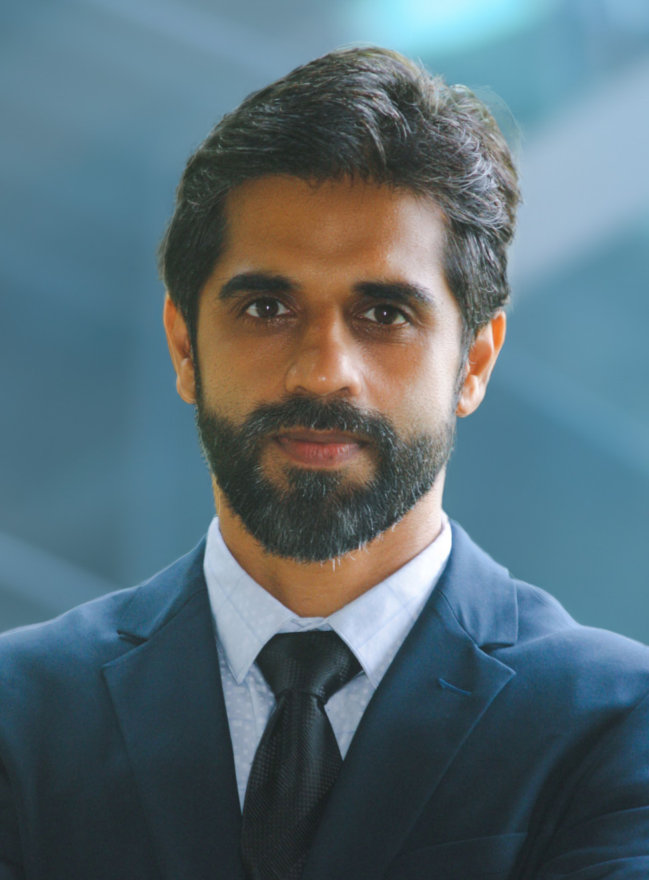

EXECUTIVE PROFILE & SUMMARY
Versatile Technology Leader, Enterprise Architect, and Product Strategist with 18+ years of track record architecting high-performance digital products, distributed cloud platforms, and immersive spatial 3D systems. Expert in React, Angular, TypeScript, Node.js, Web Components (LitElement), Cloud architectures (GCP/Firebase, AWS), and resilient offline-first PWAs. Dual-disciplined background blending Human Interface Design (M.S. in Computing, UK) with Electronics & Communication Engineering (B.E.), bridging high-level executive vision with hands-on architectural rigor.
Currently serving as Chief Technology Officer (CTO) at eBodhya Technologies, spearheading the platform architecture, AI evaluation engines, and engineering execution for an Academic Intelligence Operating System, alongside leading Technoyana Digital Transformation Services as Founder & CTO (incubating deep-tech product studios including SrushtiLabs' generative 3D platforms, VoxelForge AI, Ayam3d, and Twitan's high-reliability sports SaaS suite, Shutlify & Twicket). Proven background executing mission-critical enterprise modernizations (4-year zero-downtime migration of Cisco Stadium Vision Director), clinical ICU software (Philips Healthcare ICCA), and cross-framework UI design systems.
CORE COMPETENCIES & TECHNICAL SKILLS
- Executive & Technical Leadership: Chief Technology Officer (CTO), Enterprise Architecture, System Modernization, AI Roadmaps, Agile/Scrum, Engineering Governance
- Frontend & Web Systems: React, TypeScript, Angular, Web Components (LitElement), Next.js, Vite, Redux, Modern JavaScript (ES6+), HTML5/CSS3, WCAG 2.1 AA
- AI, Spatial Computing & 3D: Generative 3D Asset Creation, Mesh Synthesis, Automated Retopology, Tileable PBR Textures & Upscaling, Three.js, WebGL, 3ds Max, Blender
- Cloud, Backend & Offline: Node.js, Express, Firebase / Google Cloud Platform (GCP), AWS, REST APIs, Micro-frontends, PWA (Offline-first / IndexedDB)
- Enterprise Security & Reliability: Healthcare Security (MFA, RBAC, XSS Prevention), HIPAA/PHI Data Protection, Zero Memory-Leak Continuous Clinical Uptime
- Design Systems & UX Strategy: Enterprise UI Design Systems, Design-to-Code Automation, Interactive Prototyping, Figma, Adobe XD, Photoshop, Human-Interface Design
PROFESSIONAL EXPERIENCE
Chief Technology Officer (CTO) | eBodhya Technologies Private Limited (Sep 2026 – Present)
Bengaluru, India · Academic Intelligence Operating System & EdTech SaaS Platform
- Spearhead the long-term technology vision, system architecture, and product engineering roadmap for eBodhya's proprietary Academic Intelligence Operating System.
- Architect core generative and structured AI evaluation workflows—unifying dynamic question banks, automated grading pipelines, and real-time student learning analytics into an institutional source of truth.
- Direct end-to-end cloud infrastructure, API architectures, data protection standards, and CI/CD automation, ensuring high-concurrency reliability and rapid deployment across educational institutions.
Founder & Chief Technology Officer (CTO) | Technoyana Digital Transformation Services Pvt. Ltd. (May 2021 – Present)
Bengaluru, India · Enterprise Product Engineering, Spatial AI & High-Reliability SaaS Studio
- Direct end-to-end technology vision, cloud architecture, and product engineering across Technoyana's incubator portfolio and enterprise consulting initiatives.
- SrushtiLabs (Spatial AI & 3D Tech Division): Architected VoxelForge AI (srushtilabs.com/voxelforge/), a generative 3D asset platform producing modular, low-poly 3D models and asset bundles optimized for real-time engines including Unreal Engine, Unity, and WebGL.
- Ayam3d (ayam3d.in): Engineered parametric AI 3D mesh synthesis engine transforming natural language prompts into production 3D assets with automated retopology and tileable PBR texture pipelines; secured early investor validation.
- Twitan (Sports SaaS Studio): Architected Shutlify (Badminton OS - twitan.com), an end-to-end tournament management platform featuring automated knockout/round-robin fixture engines, live court arbitration, multi-court scheduling, and offline-first PWA resilience for venue Wi-Fi drops (deployed at tournaments like HBL Sirsi).
- Twicket: Developed high-fidelity real-time scoring and match statistics engine for cricket tournaments.
- Specialized Engineering Solutions: Designed customized CNC machine controller interfaces and automated CAD/CAM toolpath pipelines; delivered architectural 3D simulations and an escrow-backed financial parking payment application with secure transaction settlement.
Senior Technical Lead (React / Node.js) | Cyient Limited / Philips Healthcare (Nov 2023 – Mar 2025)
Bengaluru, India · Philips IntelliSpace Critical Care & Anesthesia (ICCA) · Mission-Critical ICU Software
- Led web-tier engineering and frontend architecture for Philips ICCA clinical software deployed in hospital ICUs and anesthesia departments globally.
- Ensured 24/7 continuous clinical reliability with zero memory leaks and sub-second UI responsiveness under dense, real-time streaming patient telemetry.
- Strictly enforced enterprise healthcare security policies including Multi-Factor Authentication (MFA), Cross-Site Scripting (XSS) prevention, granular Role-Based Access Control (RBAC), and strict patient data privacy compliance.
- Governed code quality, architectural standards, automated regression testing, and modular micro-frontends across distributed agile squads.
Development Lead / Senior Analyst | Ness Digital Engineering (Oct 2019 – Apr 2020)
Bengaluru, India · Entertainment Management Application (Angular / AWS / Node.js)
- Architected the complete single-page application structure using Angular, TypeScript, Node.js, and AWS cloud infrastructure.
- Enforced strict accessibility standards (WCAG 2.1 AA), frontend security best practices, and code quality linters across the engineering squad.
- Took technical ownership of the CI/CD deployment pipelines, successfully delivering the application to client production on schedule.
User Interface Architect | Moonraft Innovation Labs (Unit of UST Global) (May 2019 – Jul 2019)
Bengaluru, India · Enterprise UI Design System & Mobile Engineering
- Architected and engineered a centralized Cross-Framework UI Design System using LitElement (Web Components), React, and Angular, packaged and distributed via npm.
- Completely eliminated component duplication across multiple engineering squads, ensuring seamless brand coherence and automated upgradability.
- Led the mobile application development squad building a high-performance cross-platform guest booking app for TLC Group of Hotels using Ionic and Angular.
Associate Project Manager & Senior Systems Analyst | UST Global / Cisco Systems (Feb 2015 – Feb 2019)
Bengaluru, India & Global Deployment · Cisco Stadium Vision Director (4+ Years Dedicated Tenure)
- Led the phased, zero-downtime legacy modernization of Cisco Stadium Vision Director from legacy Adobe Flash/Flex to modern Angular and React modules across premier international sporting stadiums.
- Architected hybrid micro-frontend bridges allowing legacy and modern components to coexist, preventing any disruption to live stadium operations.
- Managed cross-functional agile teams delivering single-page operational dashboards that substantially improved venue operational efficiency.
- Awarded three consecutive UST Global Certificates of Excellence (2015, 2016, 2018) for client-first commitment and outstanding engineering delivery.
UI Architect & Tech Lead | ThoughtFocus Technologies (Oct 2011 – Mar 2014)
Bengaluru, India · Aftermarket Parts 3D Explorer & Enterprise Solutions
- Architected an enterprise Aftermarket Parts Explorer catalog supporting millions of industrial and automotive parts with high-speed search and filtering.
- Engineered an interactive 3D inspection viewer enabling buyers to explore, rotate, and measure 3D models of components prior to purchasing.
- Established rapid design-to-code prototyping pipelines; bootstrapped enterprise search systems and logistics management applications for a large milk/dairy corporation.
Independent Consultant (UX Designer & Full-Stack Developer) | Cisco Systems & Vodafone (Apr 2008 – Feb 2011)
Bengaluru, India · Building Management Systems (BMS) Unified Dashboard
- Designed and developed the Cisco Campus Unified Facility Dashboard, integrating telemetry and control for AHUs, VRVs, industrial chillers, and campus environmental sensors.
- Awarded formal Cisco Certificate of Appreciation (2010) for outstanding operational visualization and intelligent facility telemetry. Delivered real-time data visualization dashboards for Vodafone.
Earlier Career & Foundational Experience | InnoBrik, CAE, Cognizant (2004 – 2015)
Bengaluru & Chennai, India · Product Advisory, Flight Simulators & Mainframe Systems
- InnoBrik Software Technologies (Co-Founder & Technical Leader | Feb 2011 – Jan 2015): Spearheaded product engineering, tech stack evaluation, and agile delivery across startup ventures and enterprise client engagements.
- CAE Simulation Technologies (Visual Database Developer | Sep 2007 – Apr 2008): Engineered high-fidelity 3D synthetic visual databases, topographical terrain models, and procedural runway textures for real-time military and civil flight simulators under locked 60 FPS budgets.
- Cognizant Technology Solutions (Programmer Analyst Trainee | Apr 2004 – Dec 2004): Maintained mission-critical mainframe applications, COBOL routines, and DB2 database queries for the DUNSLINK commercial credit platform.
EDUCATION & HONORS
Master of Science (M.S.) in Computing  Robert Gordon University, Scotland, UK (2005–2006)  Specialization: Human Interface Design & Development  Bachelor of Engineering (B.E.) in ECE  Bapuji Institute of Engineering & Technology, Davanagere (1999–2003)  Electronics & Communication Engineering | Cisco Certificate of Appreciation (2010)  Excellence in UX design and engineering for Cisco Campus Unified BMS Facility Dashboard.  UST Global Certificates of Excellence (2015, 2016, 2018)  Triple recognition for technical leadership, zero-downtime migration, and delivery on Cisco Stadium Vision.

