Heart Disease Risk Analysis
Using UCI Cleveland Dataset

Internship Project Report

Author: Swananda
Date: September 23, 2026
Dataset: UCI Heart Disease (Cleveland) — 303 patients, 14 features

1. Introduction
Cardiovascular disease is the leading cause of death worldwide, accounting for approximately 17.9 million deaths annually (WHO, 2023). Early detection of heart disease risk factors can significantly improve patient outcomes and reduce healthcare costs. This project performs a comprehensive Exploratory Data Analysis (EDA) on the UCI Cleveland Heart Disease dataset to uncover patterns and risk factors associated with heart disease diagnosis.
The objectives of this project are:
(1) Load and clean the dataset, handling any missing or erroneous values.
(2) Perform thorough EDA including univariate, bivariate and correlation analysis.
(3) Build an interactive dashboard for visual exploration.
(4) Derive actionable clinical insights from the data.

2. Dataset Description
The Cleveland Heart Disease dataset is sourced from the UCI Machine Learning Repository. It contains 303 patient records with 13 clinical features and 1 binary target variable indicating the presence (1) or absence (0) of heart disease.

2.1 Feature Dictionary
Feature | Type | Description
age | Continuous | Age of patient in years
sex | Binary | 0 = Female, 1 = Male
cp | Categorical | Chest pain type (1–4)
trestbps | Continuous | Resting blood pressure (mm Hg)
chol | Continuous | Serum cholesterol (mg/dl)
fbs | Binary | Fasting blood sugar > 120 mg/dl (1 = True)
restecg | Categorical | Resting ECG results (0–2)
thalach | Continuous | Maximum heart rate achieved
exang | Binary | Exercise-induced angina (1 = Yes)
oldpeak | Continuous | ST depression induced by exercise
slope | Categorical | Slope of peak exercise ST segment (1–3)
ca | Categorical | Number of major vessels coloured by fluoroscopy (0–3)
thal | Categorical | Thalassemia type (3 = normal, 6 = fixed defect, 7 = reversable)
target | Binary | Heart disease diagnosis (0 = No, 1 = Yes)

3. Data Loading & Cleaning
The dataset was loaded from the Excel file heart_disease_cleveland.xlsx using pandas. The following cleaning steps were applied:
- Whitespace stripping: Leading/trailing spaces removed from all string columns.
- Blank string replacement: Empty strings converted to NaN (pandas NA).
- Missing value imputation: Numeric columns filled with column median; categorical columns filled with column mode.
- Result: 0 missing values found — the dataset was already clean after whitespace handling.
- Export: Cleaned data saved to heart_disease_cleveland_cleaned.csv (303 rows × 14 columns).
Dataset statistics after cleaning:
Total records | 303
Total features | 14 (13 predictors + 1 target)
No Disease (0) | 164 patients (54.1%)
Disease (1) | 139 patients (45.9%)
Age range | 29 – 77 years (mean 54.4)
Missing values | 0 (after cleaning)

4. Exploratory Data Analysis (EDA)

4.1 Continuous Feature Distributions
Histograms were plotted for all continuous features to understand their distributions. Age is roughly normally distributed around 54 years. Cholesterol and resting blood pressure show right-skewed distributions with a few high-value outliers.
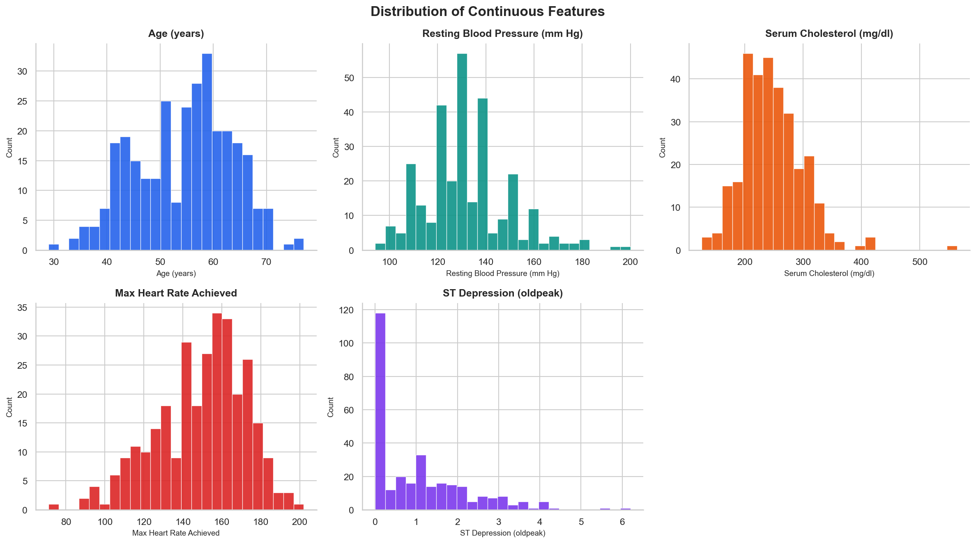
Figure 1: Histograms of continuous features (age, BP, cholesterol, max HR, ST depression)

4.2 Categorical Feature Distributions
Bar charts reveal the distribution of each categorical variable. The dataset is male-dominated (206 males vs 97 females). Chest pain type 4 (asymptomatic) is most frequent. Most patients have 0 major vessels coloured (CA=0).
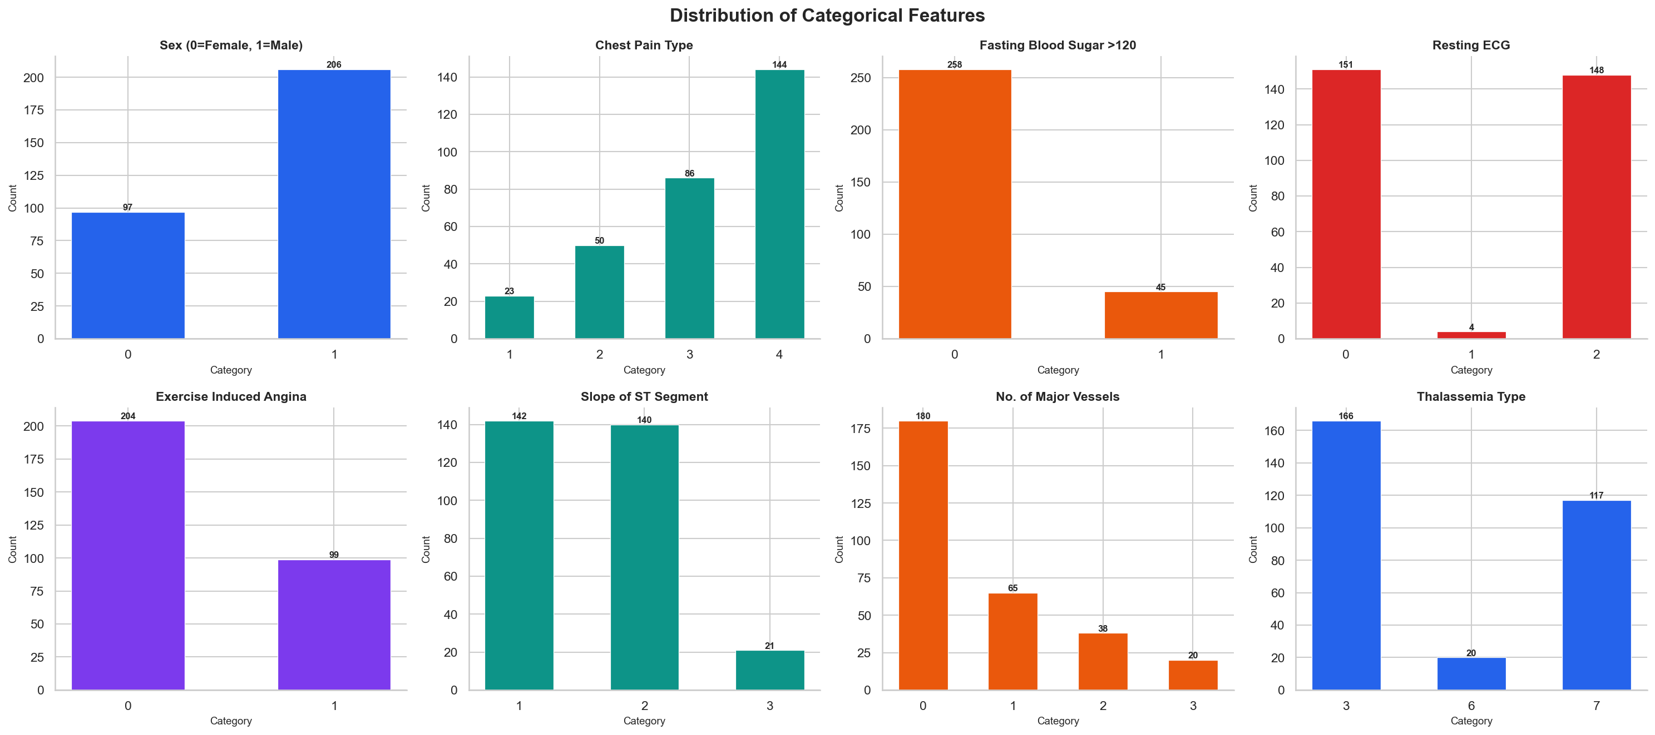
Figure 2: Bar charts for all categorical features

4.3 Target Variable Distribution
The target variable is nearly balanced: 54.1% No Disease and 45.9% Disease. This near-balance is favourable for machine learning classification tasks without requiring aggressive resampling techniques.
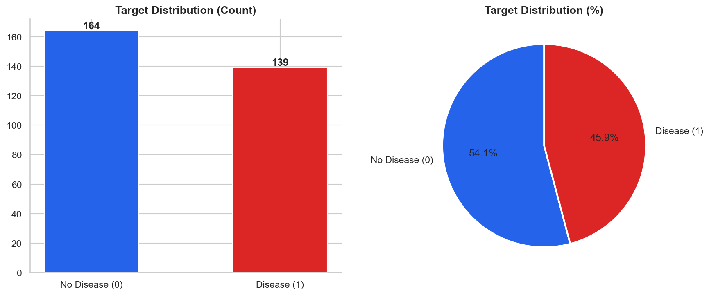
Figure 3: Target class distribution — count and percentage

4.4 Comparative Analysis (Target vs Key Features)
Grouped bar charts compare disease rates across key categorical features. Key findings from the comparative analysis:
- Sex: Males have a higher absolute count of disease cases but females show a higher relative disease rate (75% vs 45%).
- Chest Pain: Type 4 (asymptomatic) has the highest disease count; Type 2 (atypical) has the lowest.
- Thalassemia (thal): Type 7 (reversible defect) is strongly associated with disease presence.
- CA: Patients with 0 major vessels have the most no-disease cases; higher CA values increase disease risk.
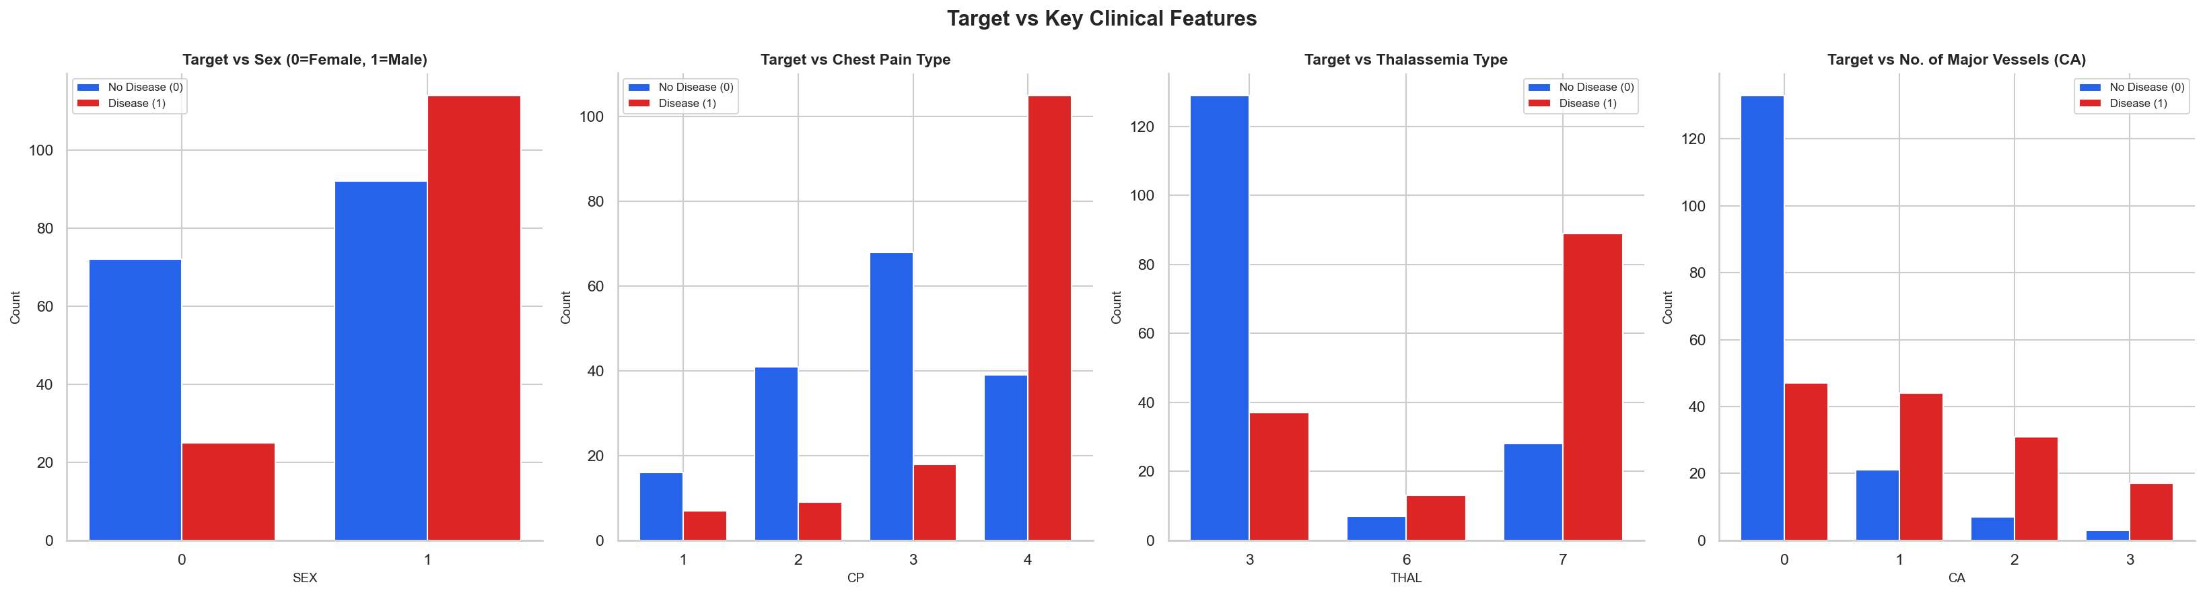
Figure 4: Comparative charts — Target vs Sex, Chest Pain, Thalassemia, CA Vessels

4.5 Correlation Heatmap
A lower-triangle Pearson correlation heatmap was generated for all 14 features. Strong positive correlations with the target include thal, ca, exang and oldpeak. thalach shows a strong negative correlation with target, meaning higher maximum heart rate is associated with lower disease risk.
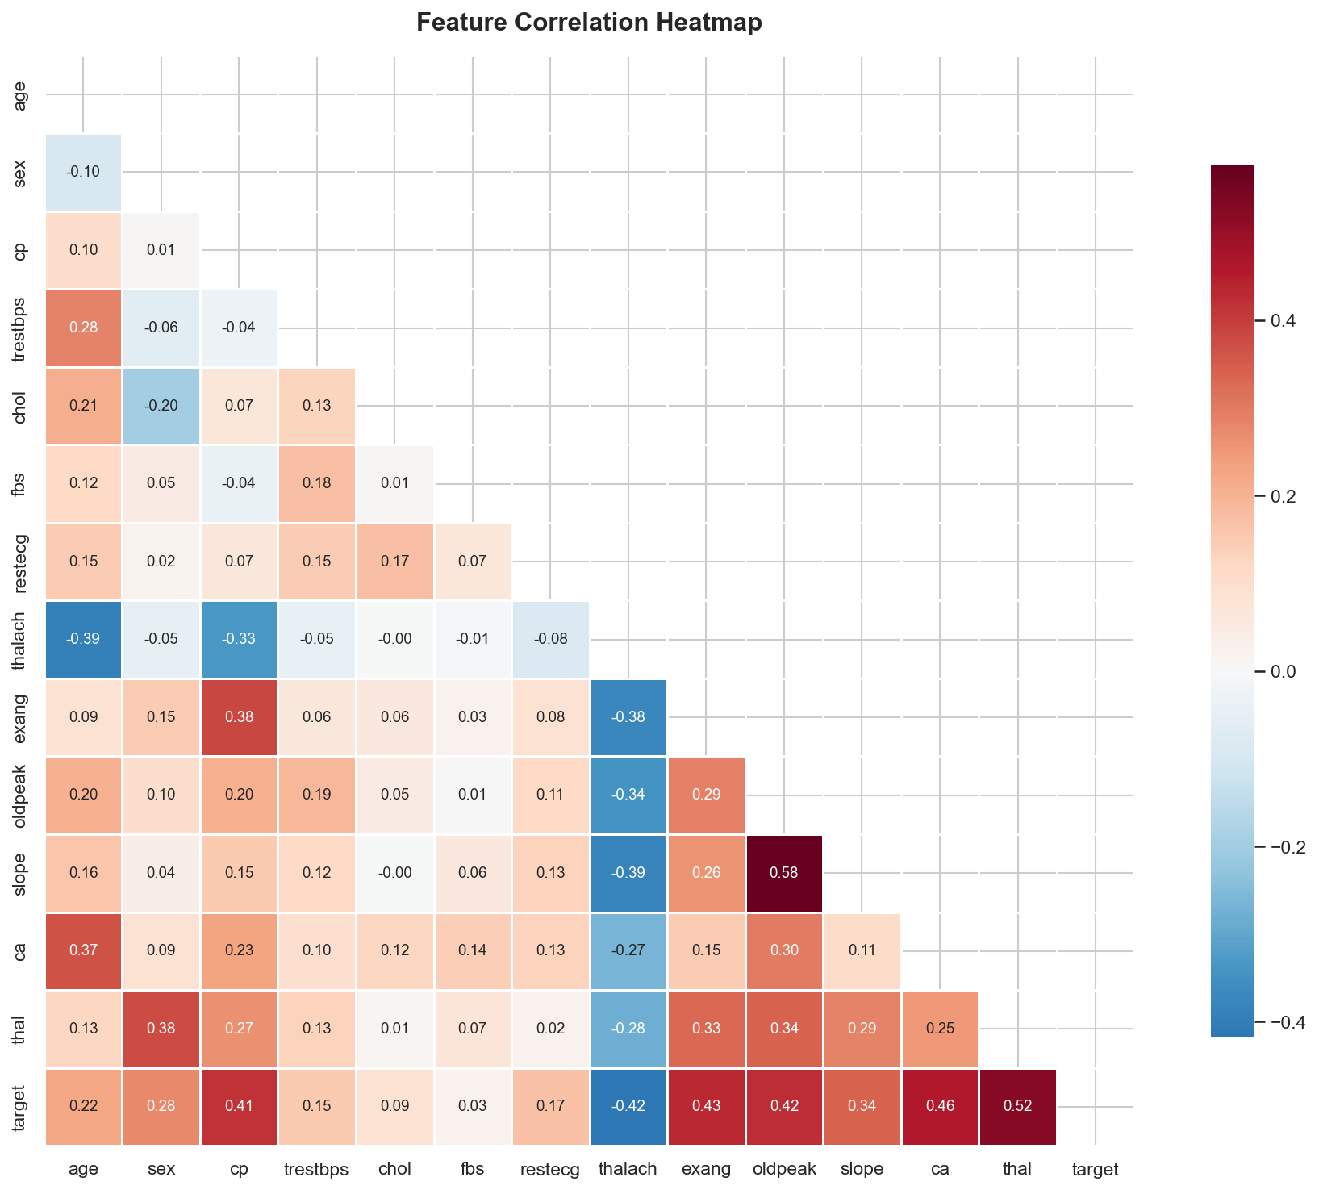
Figure 5: Full feature correlation heatmap (lower triangle)

4.6 Feature Correlation with Target
Ranked by absolute Pearson correlation with the target variable:
Feature | Correlation (r) | Interpretation
thal | +0.524 | Strongest predictor — reversible defect highly linked to disease
ca | +0.460 | More blocked vessels = higher disease probability
exang | +0.432 | Exercise-induced angina is a clear risk signal
oldpeak | +0.425 | Higher ST depression = more ischaemia
thalach | -0.417 | Lower max heart rate = higher disease risk
slope | -0.346 | Downsloping ST segment is a negative sign
cp | -0.407 | Asymptomatic CP paradoxically highest disease rate
age | +0.225 | Older patients at higher risk

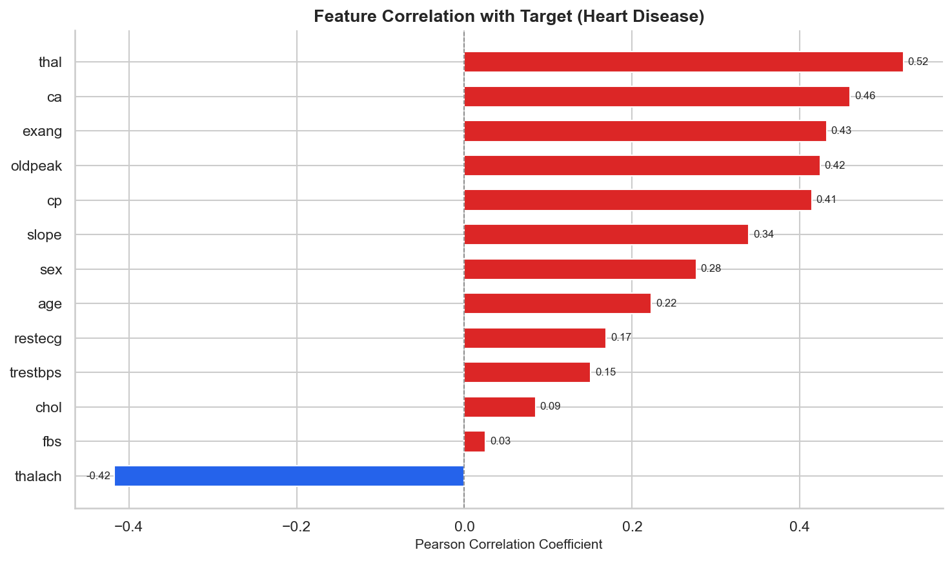
Figure 6: Feature correlations with target (blue = negative, red = positive)

4.7 Age Distribution by Disease Status
Overlapping histograms show that disease patients tend to be slightly older (mean 56.6) compared to no-disease patients (mean 52.6). However, age alone is not a strong predictor (r = 0.225), indicating that clinical features are more discriminative than demographics.
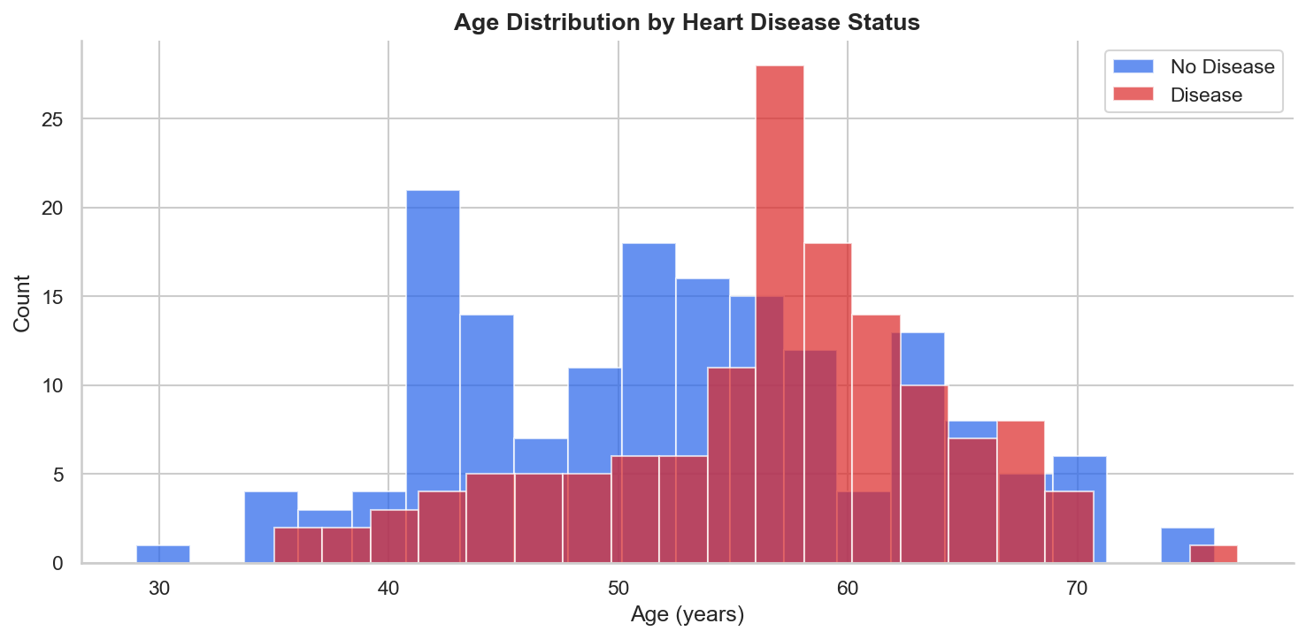
Figure 7: Age distribution overlaid for disease vs no-disease groups

4.8 Boxplots — Continuous Features vs Target
Boxplots confirm several clinical differences between disease and non-disease groups:
- thalach: Median max heart rate is notably lower in the disease group (~138 vs ~158).
- oldpeak: Median ST depression is higher in the disease group (~1.5 vs ~0.0).
- age: Slightly higher median in the disease group.
- trestbps and chol: Distributions largely overlap — weak discriminators individually.
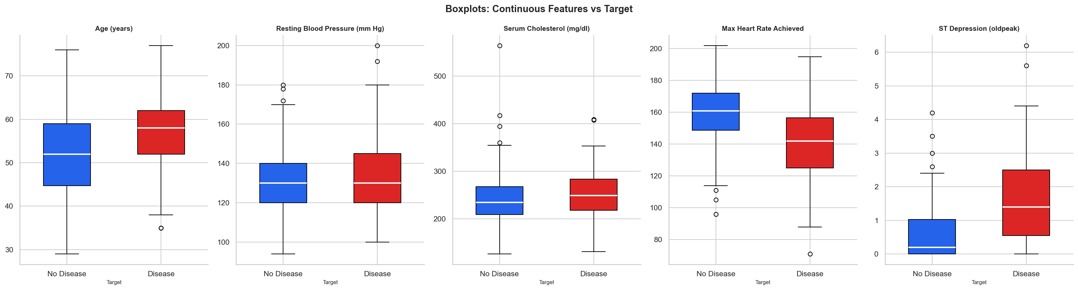
Figure 8: Boxplots of continuous features split by disease status

5. Interactive Dashboard
An interactive Plotly Dash dashboard (app.py) was built with four tabs and a global filter sidebar. The dashboard uses a professional colour scheme:
- Background: #F8FAFC (light slate gray)
- No Disease charts: #2563EB (blue)
- Disease charts: #DC2626 (red)
- Accent — Teal (#0D9488) and Orange (#EA580C) for categorical features

5.1 Dashboard Features
Component | Description
Sidebar Filters | Age range slider, Sex checklist, Chest Pain type checklist — all charts update reactively.
KPI Cards | 4 live summary cards: filtered patient count, disease cases, disease rate, mean age.
Demographics Tab | Age histogram by disease, sex grouped bar, age-group grouped bar, BP/chol/HR histograms.
Clinical Features Tab | Grouped boxplots for 5 continuous features; 8 categorical bar charts.
Target Analysis Tab | Donut chart, scatter (age vs thalach), 4 comparative bar charts.
Correlation Tab | Full heatmap with annotated values, horizontal correlation-with-target bar chart.

To run the dashboard: cd heart_disease_project → python app.py → open http://127.0.0.1:8050

6. Key Insights & Findings
Thalassemia (thal) is the strongest predictor: Patients with reversible defect (thal=7) have a disease rate of ~88% compared to ~36% for normal (thal=3). This makes thal the single most predictive feature (|r|=0.524).
Number of major vessels (ca) strongly indicates risk: Disease rate climbs from ~27% at ca=0 to ~91% at ca=3. Each additional blocked vessel substantially increases risk.
Exercise-induced angina (exang) is a clear signal: Patients with exercise angina (exang=1) have a 76% disease rate vs 31% without.
Low maximum heart rate (thalach) signals disease: Disease patients average a max heart rate of ~138 bpm vs ~158 bpm in healthy patients. This negative correlation (r = -0.417) is clinically significant.
Higher ST depression (oldpeak) indicates ischaemia: Median oldpeak in disease patients is ~1.5 vs ~0.0. Values above 2.0 strongly suggest coronary artery disease.
Asymptomatic chest pain is paradoxically dangerous: Type 4 (asymptomatic) CP has the highest absolute disease count, highlighting that absence of typical symptoms does not rule out disease.
Females have a higher relative disease rate: Despite fewer females in the dataset, 75% of females are diagnosed with disease vs 45% of males, suggesting females may present with more advanced disease.
Cholesterol and BP are weak individual predictors: Neither serum cholesterol nor resting BP show strong correlation with target (|r| < 0.15), but they remain important in multivariate models.

7. Conclusion
This project successfully completed a full exploratory data analysis pipeline on the UCI Cleveland Heart Disease dataset. The analysis confirms that clinical features — particularly thalassemia type, number of major vessels, exercise-induced angina, maximum heart rate achieved, and ST depression — are the strongest indicators of heart disease presence.
The interactive Plotly Dash dashboard provides clinicians and data analysts with a powerful tool to filter, explore and compare patient subgroups in real time. The clean, professional design with consistent blue/red colour coding for disease status makes the insights immediately interpretable.
Future work can extend this project by building predictive ML models (Logistic Regression, Random Forest, XGBoost), performing SHAP explainability analysis, and deploying the dashboard to a cloud platform such as Heroku or AWS.

8. References
- Janosi, A., Steinbrunn, W., Pfisterer, M., & Detrano, R. (1988). Heart Disease Dataset. UCI Machine Learning Repository. https://archive.ics.uci.edu/ml/datasets/heart+disease
- World Health Organization (2023). Cardiovascular diseases (CVDs) Fact Sheet.
- McKinney, W. (2010). Data Structures for Statistical Computing in Python. SciPy Proceedings.
- Hunter, J. D. (2007). Matplotlib: A 2D graphics environment. Computing in Science & Engineering.
- Plotly Technologies Inc. (2015). Collaborative data science. Montreal, QC.
- Waskom, M. (2021). seaborn: statistical data visualization. JOSS, 6(60), 3021.

