Loan Calculator Requirements Specification

Version 1.0

March 2017

# Executive Summary

## Project Overview

The project requires you to come with a loan calculator, which takes the inputs from the user and calculates the monthly payment, the total interest and the total interest.

# Requirements:

Following is the mockup of what is expected:

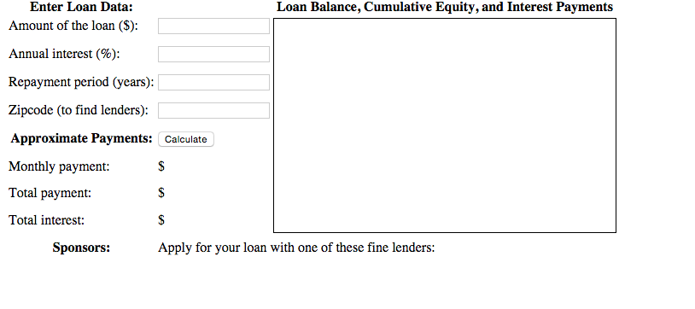

The requirement is that you take the inputs and do all the validations you deem necessary and write a dummy service, which you call through the AJAX and get the sponsors if the user has entered the ZIPCode.

So you need the write the following functions:

|  |
| --- |
| Function Calculate  /* |
|  | * This script defines the calculate() function called by the event handlers |
|  | * in HTML above. The function reads values from <input> elements, calculates |
|  | * loan payment information, displays the results in <span> elements. It also |
|  | * saves the user's data, displays links to lenders, and draws a chart. |
|  | */ |

All the validations should be either on the tab out or through input filtering.

The other function is the getLenders function:

|  |
| --- |
| // Pass the user's input to a server-side script which can (in theory) return |
| // a list of links to local lenders interested in making loans. This example |  |
| // does not actually include a working implementation of such a lender-finding |  |
| // service. But if the service existed, this function would work with it. |  |
| **function getLenders(amount, apr, years, zipcode) {}**  **The last optional feature is if you can include the graph in the page:**   |  | | --- | | // Chart monthly loan balance, interest and equity in an HTML <canvas> element. | | // If called with no arguments then just erase any previously drawn chart. |  | | **function chart(principal, interest, monthly, payments) {}** |  | |  |