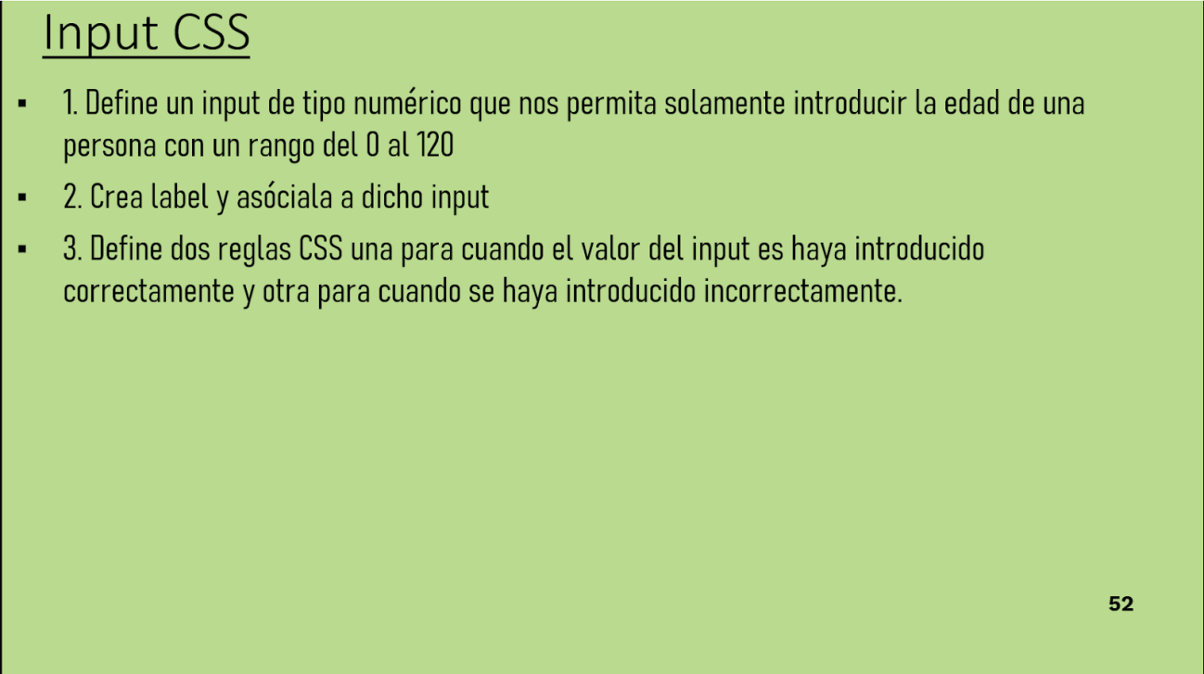

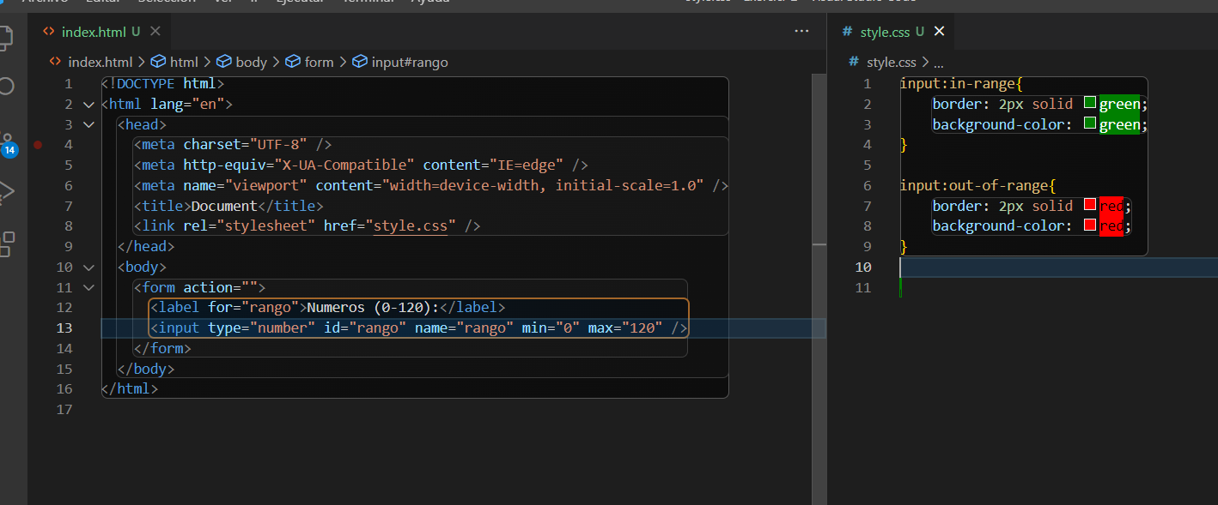



<https://gist.github.com/hegohu/029ddf8e8f2b99016a4710c04778f0fb>