4. [HTML] - Ejercicios de Tablas

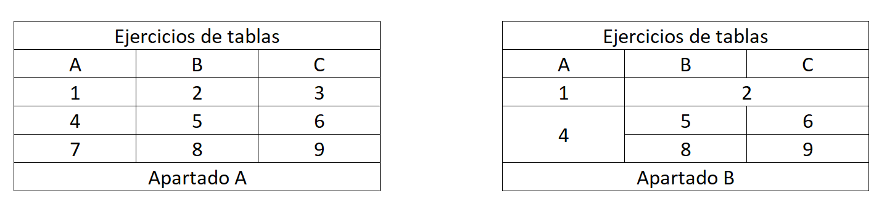

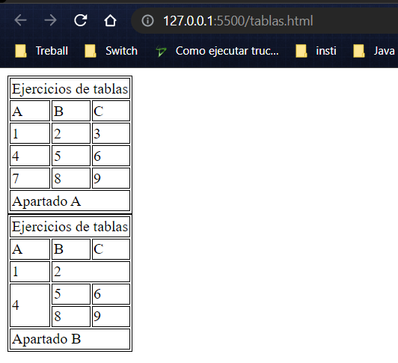

https://gist.github.com/hegohu/3547d290bd71fad3a2401a48dc43bd9e