**Final Project Report**

**Fall 2019 ECE Machine Vision**

**Instructor: Prof. Kristin Dana**

**Zezhou Wang (zw259)**

**Dec. 15th 2019**

# SfM Application and Bundle Adjustment

In this question, I adopted the openMVG SfM routines optimize the 3D reconstruction of a stairway structure (viewed from outside) of my office building. OpenMVG (Multiple View Geometry) is a library specialized in multi-view stereo computations written in C++ and provides Python API for high-level application calls.

The preview of my selected structure is shown in Figure 1 below:

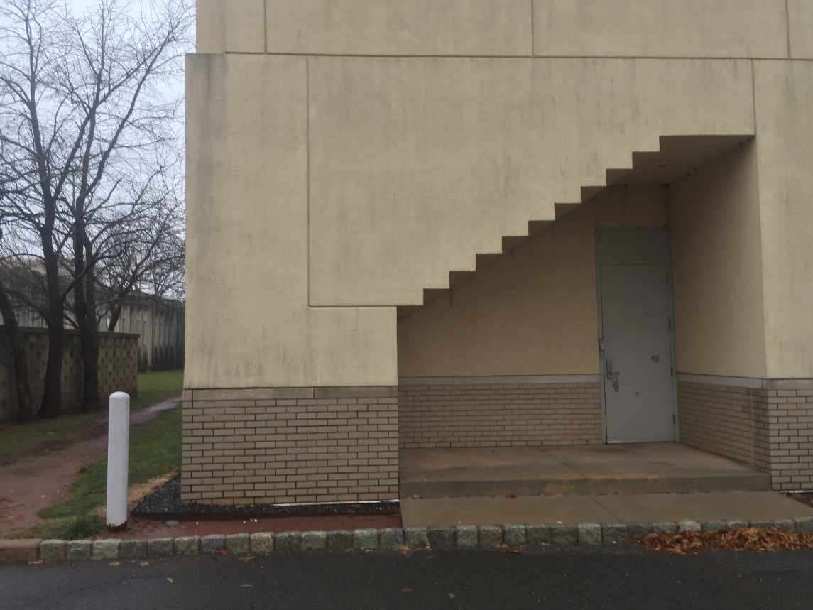

Figure 1 The 3D object to reconstruct (CAIT building of Rutgers University)

OpenMVG provides sufficient software binaries to conduct multi-view stereo image processing and an off-the-shelf Python pipeline is provided by its documents.