PRACTICAL 1:
Introduction to Vulnerabilities and OWASP Top 10:
- Set up a local installation of OWASP Juice Shop or DVWA (Damn Vulnerable Web Application) on a virtual machine.
- Identify vulnerabilities such as SQL Injection or Cross-Site Scripting (XSS).
Tools:
- VirtualBox/VMware, OWASP Juice Shop/DVWA.
1. DVWA Running (inside VM)
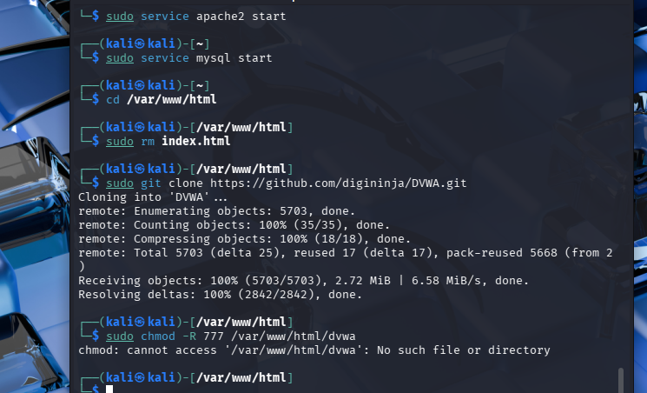
2. Security Level = Low
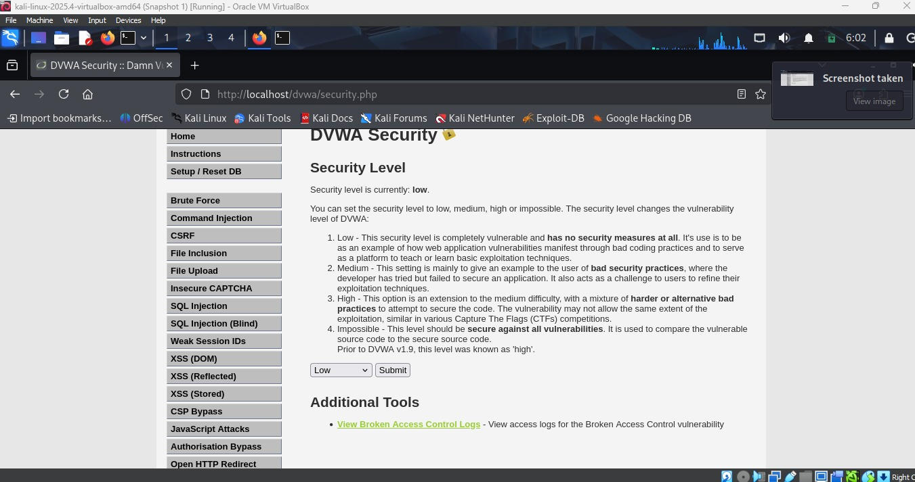
3. SQL Injection Attack: Entered 1' OR '1'='1 in User ID field to bypass authentication and dump all database records.
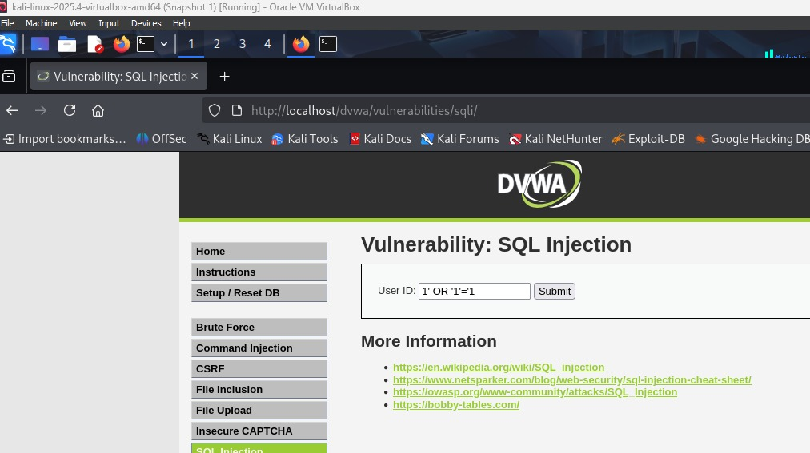
Output: SQL injection successful—extracted all usernames and passwords from the database without valid credentials.
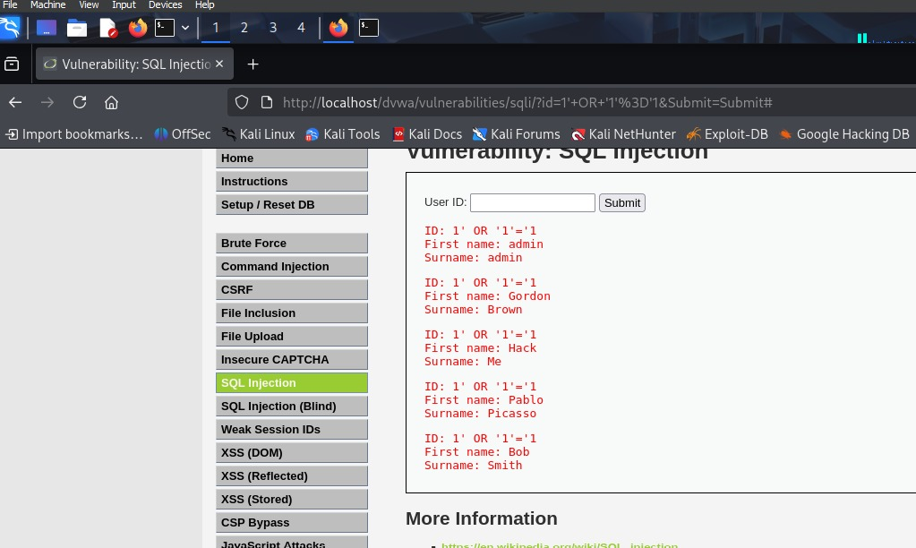
4. XSS: Injected <script>alert('student')</script> in the name field to execute JavaScript in the browser.
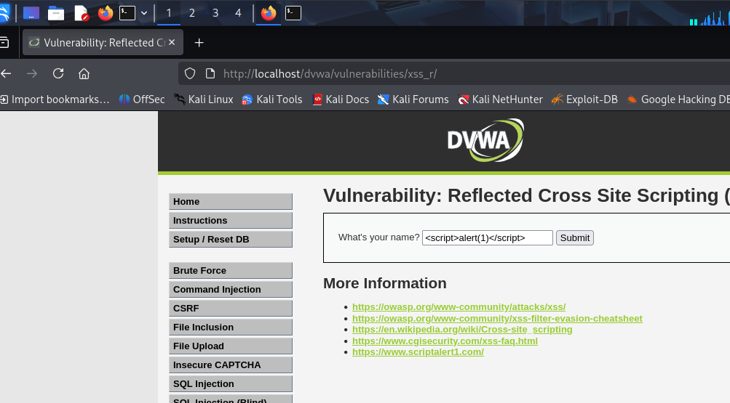
Output: XSS successful—malicious script executed, proving client-side code injection vulnerability.
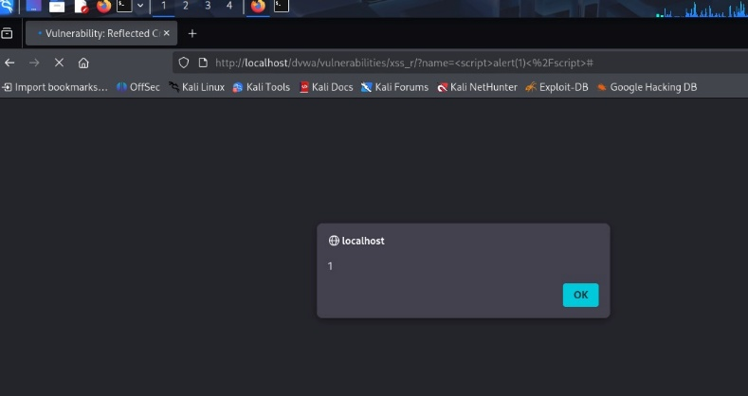

PRACTICAL 2:
Network Scanning and Reconnaissance:
- Use tools like ipconfig, ifconfig, arp, and ping to explore network configurations on a test VM.
- Perform network scanning using Nmap on a local network (ensure permission is obtained).
- Analyze network traffic using Wireshark on pre-captured .pcap files from public sources (no live traffic capture).
• Tools:
- Nmap, Wireshark, Command-line tools, Virtual Machine
1. Ran ifconfig to check network config, arp -a to view MAC mappings, and ping 8.8.8.8 to test connectivity.
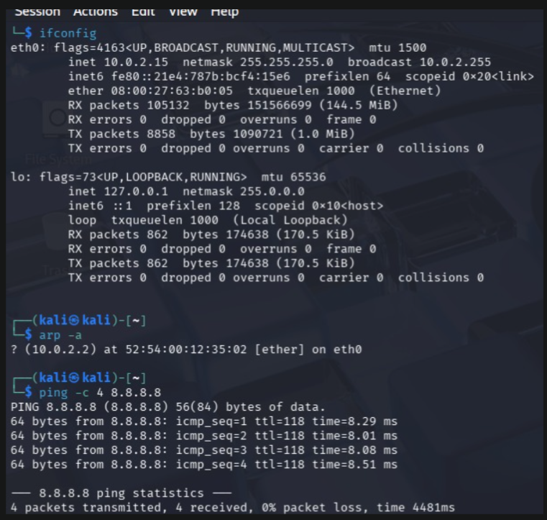
2. Scanned localhost with nmap 127.0.0.1 finding HTTP/MySQL ports, then nmap -A identified Apache 2.4.66 version.
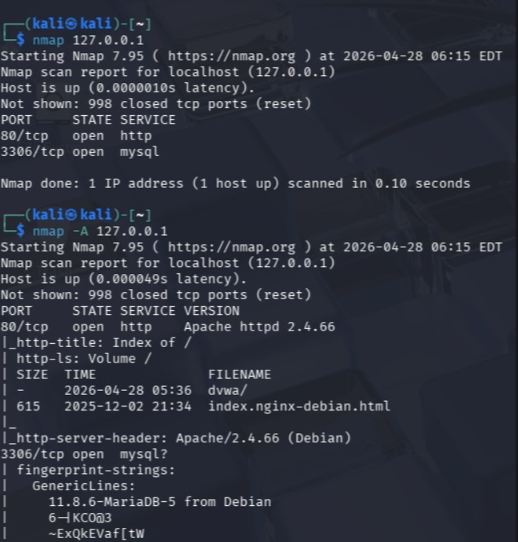
3. Loaded v6-http.cap in Wireshark and filtered HTTP traffic to analyze IPv6 web requests.
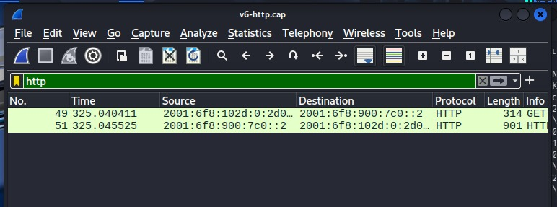
4. Analyzed dns.cap showing DNS queries between 192.168.170.8 and 192.168.170.20 hosts.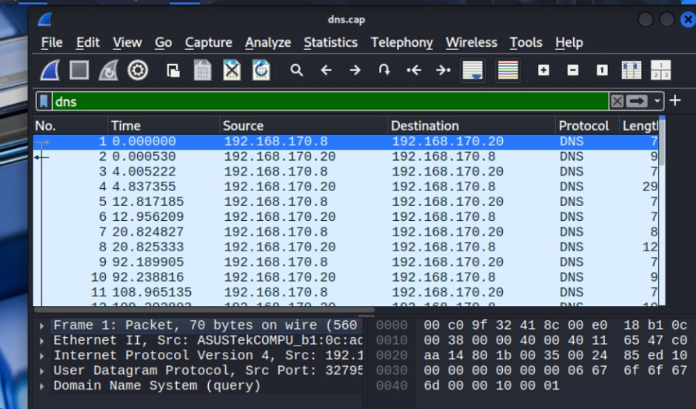

PRACTICAL 3:
Password Cracking (Test Environment):
- Use John the Ripper or Hashcat to crack simple password hashes generated using online tools.
- Avoid targeting real systems—only use sample test data.
Tools:
- John the Ripper, Hashcat.

1. Generated MD5 hash of "password" using echo -n "password" | md5sum producing hash 5f4dcc3b5aa765d61d8327deb882cf99.
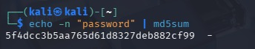
2. Created hash.txt file using nano and saved the MD5 hash for cracking with John the Ripper.
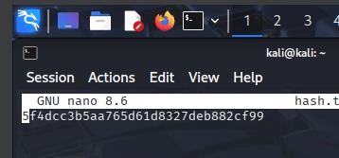
3. Cracked the hash using john --format=raw-md5 hash.txt which successfully recovered plaintext password "password" from the MD5 hash.
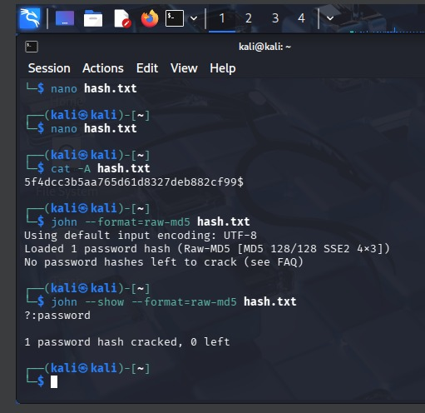

Practical 4:
Metasploit Basics:
- Set up a vulnerable VM (e.g., Metasploitable2) and practice gaining access using Metasploit.
- Focus on understanding the exploitation process rather than causing damage.
Tools:
- Metasploit Framework, Metasploitable2.

1. Target Machine Identification (Metasploitable Linux IP Configuration) 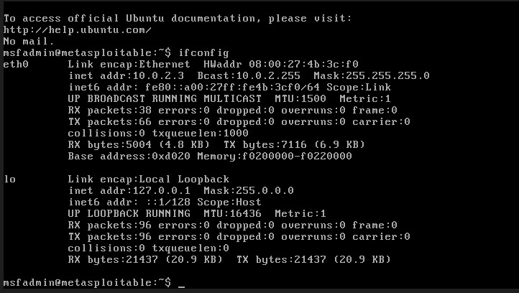
2. Launching Metasploit Framework in Kali Linux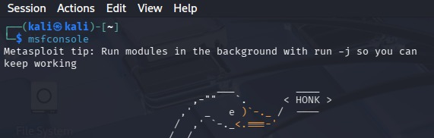
3. Network Reconnaissance Using Nmap Service Scan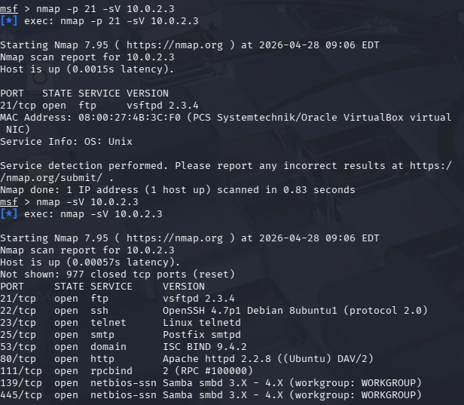
4. Exploitation of Samba Vulnerability Using Metasploit Module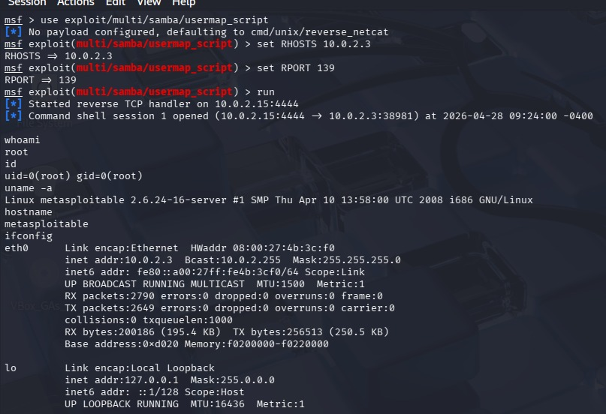
5. Successful Remote Shell Access (Command Shell Session Established)
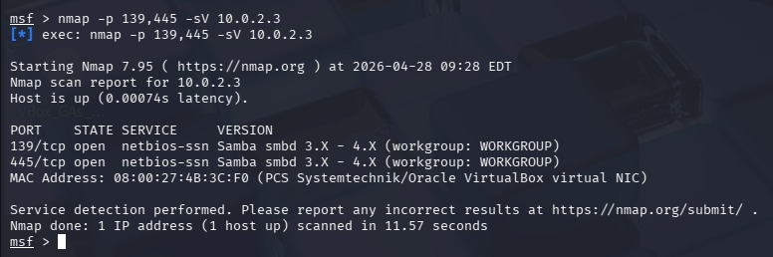

PRACTICAL 5:
Alternate Data Streams (ADS):
- Practice creating ADS on a Windows VM to hide files.
- Explore how to detect and counter such techniques.
Tools:
- Windows VM, Command Prompt.

1. Created alternate data stream using echo This is hidden data > file.txt:hidden.txt to hide content, then verified visible file shows only "Hello World" while hidden stream contains "This is hidden data".
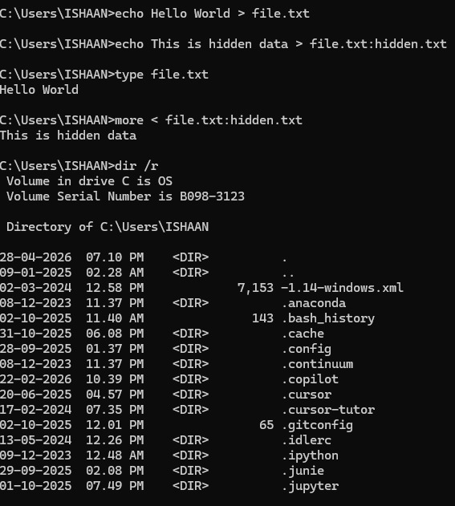
2. Ran dir /r command to detect alternate data streams—shows file.txt:hidden.txt:$DATA stream (22 bytes) that's invisible to normal dir command.
3. Demonstrated ADS persistence by copying file.txt to newfile.txt—ADS is preserved during file operations, proving data hiding technique works across file manipulation.
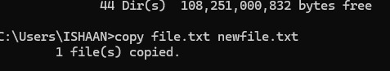

PRACTICAL 6:
SQL Injection (Test Environment):
- Perform SQL Injection on DVWA or Juice Shop to extract sample data.
- Understand how to mitigate such vulnerabilities.
Tools:
- DVWA, OWASP Juice Shop

1. Exploited SQL injection via curl commands—normal query returned 1 user, 1'-- comment bypass dumped admin account, and 1' UNION SELECT 1, VERSION() extracted database version (MariaDB 10.4.17).
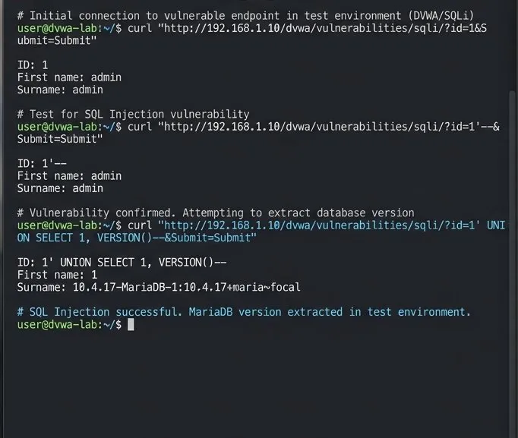
2. Implemented SQL injection mitigation using PHP PDO prepared statements with parameterized queries—$stmt->execute([$userId]) treats user input as data, not executable SQL, preventing injection attacks.
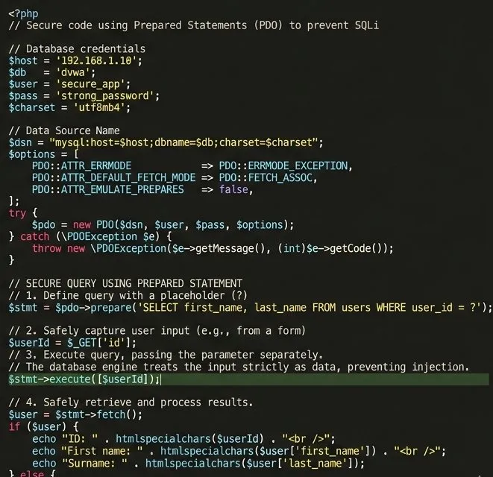
PRACTICAL 7:
  - Framework Mapping:
  - Map a given security incident to the NIST Cybersecurity Framework or Cyber Kill Chain.
  - Prepare a simple report outlining the stages of the attack.

Vulnerability Assessment Report
MOVEit Transfer RCE Exploitation Chain
Report Title: Vulnerability Assessment and Penetration Testing Report
Client/Organization: Enterprise File Transfer Infrastructure
Prepared By: Ishaan Sharma
Report Version: 1.0
Assessment Date: April 2026
Classification: Internal Use Only

Executive Summary
This report documents the MOVEit Transfer Remote Code Execution (RCE) exploitation chain (CVE-2023-34362), a critical vulnerability affecting Progress Software's MOVEit Transfer product. The incident demonstrates a complete attack lifecycle: reconnaissance through exploitation, privilege escalation, lateral movement, and data exfiltration.

Critical Facts
- Severity: Critical (CVSS 9.8)
- Attack Vector: Unauthenticated HTTP POST to public-facing API endpoint
- Impact: Complete system compromise via remote code execution
- Real-World Scope: 2,000+ organizations affected globally; estimated 60M+ records compromised
- Time-to-Exploit: <48 hours from public disclosure to widespread exploitation

Assessment Objective & Scope
Map the MOVEit exploitation chain across two industry-standard security frameworks to demonstrate:
- Where security controls failed (NIST CSF)
- How the attack progressed (Cyber Kill Chain)
- Which technical findings align to pentest standards

Scope
Asset Type | Asset Name / URL / IP | Environment | In Scope (Yes/No)
Web App | moveit.enterprise.com | Production | Yes
Database | mssql-prod.internal | Production | Yes

Asset Type | Asset Name / URL / IP | Environment | In Scope (Yes/No)
API | /guestaccess/guestaccess.aspx | Production | Yes
Server | 192.168.1.100 | Production | Yes
File Share | \\file-server\SharedFiles | Production | Yes
Out of Scope: Network segmentation, EDR/SIEM response (focus: attack stages + control gaps)
Methodology
Approach
- Reconnaissance of public-facing system
- Vulnerability identification
- Exploitation and validation
- Impact assessment
- Framework mapping
Tools Used
- Manual HTTP request testing
- Public vulnerability intelligence

Risk Rating Summary
Severity | Count | Description
Critical | 4 | Complete system compromise
High | 0 | —
Medium | 0 | —
Low | 0 | —
Informational | 0 | —

Finding 1: Unauthenticated API Endpoint + Path Traversal
Severity: Critical
CVSS Score: 9.8
CWE / OWASP Mapping: CWE-22 (Path Traversal)
Affected Asset: MOVEit Transfer Web API
Endpoint: /guestaccess/guestaccess.aspx
Description
The application exposes an unauthenticated API endpoint that fails to validate user input. Attackers can manipulate parameters to access restricted files.
Evidence
POST /guestaccess/guestaccess.aspx
fileid=..\..\..\Windows\win.ini
Impact
- Unauthorized file access
- Enables further exploitation
Remediation
- Enforce authentication
- Implement strict input validation
- Sanitize file paths

Finding 2: Arbitrary File Upload (Webshell Deployment)
Severity: Critical
Affected Asset: File Upload Handler
Description
Attackers can upload malicious ASPX files to the server using path traversal techniques.
Steps to Reproduce
- Craft malicious file
- Upload via vulnerable endpoint
- Execute file remotely
Impact
- Remote code execution
- Persistent access
Remediation
- Restrict file upload types
- Validate file paths
- Use secure upload directories

Finding 3: Privilege Escalation
Severity: Critical
Description
After gaining access, attackers escalate privileges to gain full system control.
Impact
- Administrative access
- System takeover
Remediation
- Apply least privilege principle
- Patch known vulnerabilities

Finding 4: Data Exfiltration
Severity: Critical
Description
Attackers extract sensitive data from compromised systems.
Impact
- Data breach
- Legal and financial consequences
Remediation
- Monitor outbound traffic
- Implement data loss prevention

Attack Flow (Cyber Kill Chain Mapping)
Stage | Attack Activity
Reconnaissance | Scanning public MOVEit servers
Weaponization | Crafting exploit payload
Delivery | HTTP POST request
Exploitation | Path traversal + RCE
Installation | Webshell deployment
Command & Control | Remote access via webshell
Actions on Objectives | Data exfiltration

NIST Framework Mapping
Function | Failure
Identify | No proper asset visibility
Protect | No authentication, no input validation
Detect | No monitoring/logging
Respond | No incident response
Recover | No recovery mechanisms

Consolidated Findings Table
ID | Vulnerability | Severity | Affected Asset | Status | Owner
F-01 | Unauthenticated API | Critical | Web App | Open | App Team
F-02 | File Upload | Critical | Server | Open | Infra Team
F-03 | Privilege Escalation | Critical | System | Open | Security Team
F-04 | Data Exfiltration | Critical | Database | Open | Security Team

Positive Security Observations
- None identified

Key Takeaway
The attack succeeded not because it was technically sophisticated, but because every layer of preventive and detective controls was missing. Organizations must move from reactive patching to proactive security fundamentals: asset management, input validation, privilege minimization, comprehensive logging, and active threat monitoring.

Conclusion
The MOVEit attack demonstrates a complete breakdown of security controls across all stages. The breach was not due to advanced techniques but due to missing fundamental protections such as authentication, input validation, and monitoring.
Immediate remediation is required to prevent similar attacks.

Sign-Off
Prepared By: Ishaan Sharma
Reviewed By: ______________________
Approved By: ______________________
Date: April 2026
Appendix
Appendix A: Test Credentials
Username: N/A
Role: N/A
Appendix B: Evidence Checklist
Screenshots attached: No
Raw scan output attached: No
Request/response samples attached: Yes
Retest required: Yes
Appendix C: Severity Rating Criteria
Severity ratings are based on the CVSS v3.1 scoring system, considering exploitability, impact, and scope. Critical vulnerabilities (CVSS ≥ 9.0) indicate immediate risk of full system compromise and require urgent remediation.
PRACTICAL 8:
  - Vulnerability Assessment Report:
  - Perform a basic vulnerability assessment on a test VM using tools like OpenVAS or Nessus.
  - Prepare a detailed report with findings and recommendations.

  - Tools:
  - OpenVAS, Nessus.

Vulnerability Assessment Report
Nessus-Based Security Assessment of Metasploitable VM

Report Title: Vulnerability Assessment and Security Analysis Report

Client/Organization: Virtual Lab Environment

Prepared By: Ishaan Sharma

Report Version:1.0

Assessment Date: April 2026

Classification: Internal Use Only

Executive Summary
This report presents the results of a vulnerability assessment conducted on a test virtual machine using Nessus. The objective was to identify security weaknesses in exposed services and evaluate the overall security posture of the system.
The scan revealed multiple critical vulnerabilities, primarily due to outdated software, exposed services, and weak configurations. These issues could allow attackers to gain unauthorized access, execute remote commands, and compromise system integrity.

Critical Facts
- Severity: Multiple Critical vulnerabilities detected
- Attack Surface: Open network services
- Impact: Potential remote access and system compromise
- Environment: Virtual machine (Metasploitable)
- Assessment Type: Automated vulnerability scanning

Assessment Objective & Scope
Objective
To identify vulnerabilities in the target system using Nessus and recommend mitigation strategies.

Scope
Asset Type | Asset Name / IP | Environment | In Scope
Target VM | 10.0.2.3 | VirtualBox | Yes
Network Services | FTP, SSH, HTTP, SMB | VirtualBox | Yes
Out of Scope:
- Exploitation
- Incident response
- Advanced penetration testing

Methodology
Approach
- Configured Nessus Essentials in Kali Linux
- Created a Basic Network Scan
- Scanned the target IP address (10.0.2.3)
- Collected vulnerability data
- Categorized findings by severity

Tools Used
- Nessus Essentials
- Kali Linux
- VirtualBox

Risk Rating Summary
Severity | Count | Description
Critical | Multiple | High risk vulnerabilities
High | Few | Significant risk
Medium | Some | Moderate risk
Low | Minimal | Minor issues

Finding 1: Vulnerable FTP Service (vsftpd 2.3.4)
Severity: Critical
Description
The FTP service is running an outdated version known to contain a backdoor vulnerability.
Impact
- Remote command execution
- Unauthorized system access
Remediation
- Update FTP service
- Disable if not required

Finding 2: Open SSH Service
Severity: High
Description
SSH service is exposed and may allow brute-force or unauthorized access.
Impact
- Unauthorized login attempts
Remediation
- Use strong authentication
- Restrict access via firewall

Finding 3: Outdated Apache HTTP Server
Severity: Medium
Description
The web server version contains known vulnerabilities.
Impact
- Potential web-based attacks
Remediation
- Update Apache to latest version

Finding 4: Multiple Open Ports
Severity: Medium
Description
Several unnecessary ports are open, increasing attack surface.
Impact
- Increased exposure to attacks
Remediation
- Close unused ports
- Apply firewall rules

Risk Analysis
The system is highly vulnerable due to:
- outdated services
- exposed network ports
- lack of access controls
These weaknesses significantly increase the risk of exploitation.

Recommendations
- Patch all outdated services
- Disable unnecessary services
- Implement firewall restrictions
- Enforce strong authentication
- Perform regular vulnerability scans

Conclusion
The vulnerability assessment identified multiple critical weaknesses in the target system. Immediate remediation is required to reduce the risk of system compromise. Proper security controls must be implemented to strengthen system defenses.

Screenshots
1. Attempted to install Nessus via apt but package not found, then downloaded Nessus-10.12.0.deb installer manually and began installation with sudo dpkg -i.
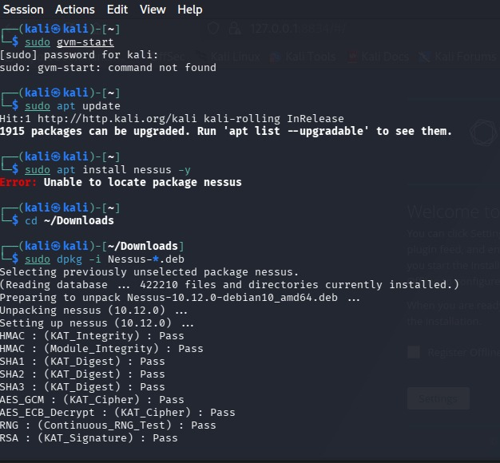
2. Completed Nessus installation with all integrity checks passing (KAT, RSA, HMAC, SHA), then started Nessus service using sudo systemctl start nessusd.
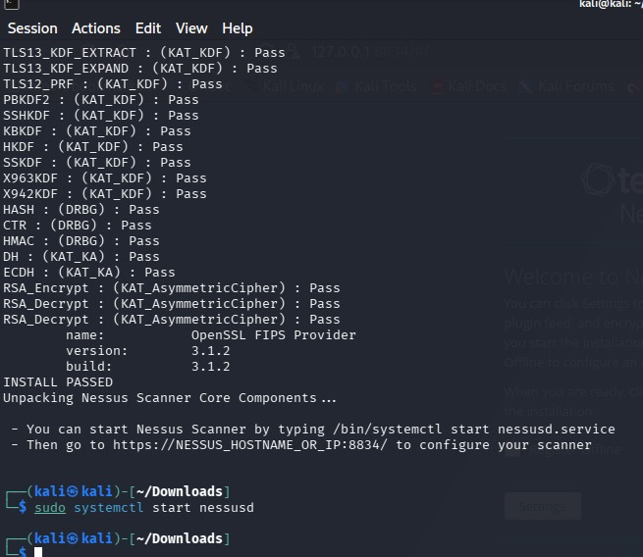
3. Downloaded Nessus 10.12.0 for Linux-Debian-amd64 from Tenable's official website to obtain the scanner installation package. 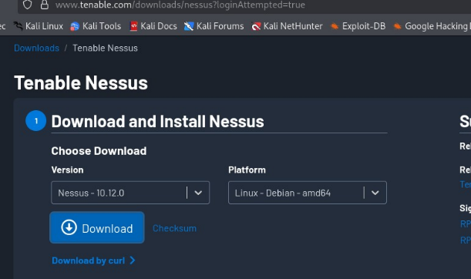
4. Activated Nessus Essentials license with activation code to enable vulnerability scanning capabilities in the web interface.
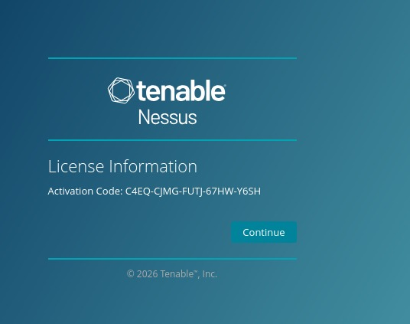
5. LaCreated two scan configurations in Nessus: "Metasploit Scan" for vulnerability assessment and "My Host Discovery Scan" for network reconnaissance.
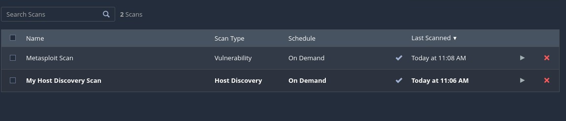
6. Executed Basic Network Scan against Metasploitable VM—scan completed successfully in seconds using CVSS v3.0 severity base and local scanner.
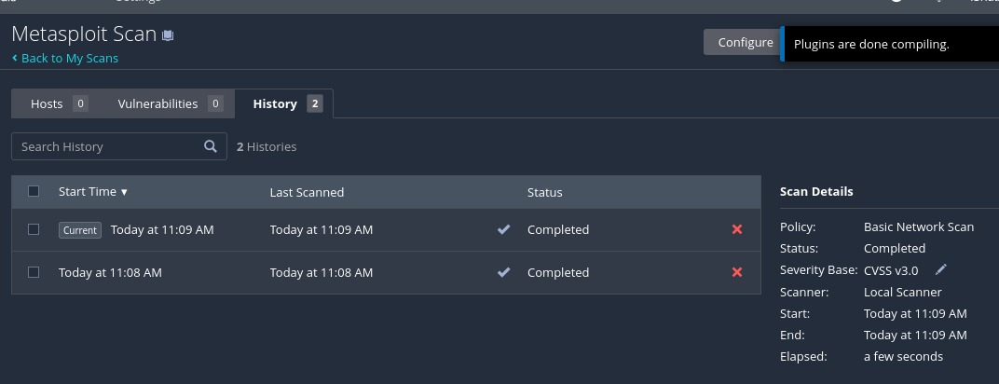

Sign-Off
Prepared By: Ishaan Sharma
Reviewed By: __________________
Approved By: __________________
Date: April 2026

