SHRI VILEPARLE KELAVANI MANDAL’s
NARSEE MONJEE COLLEGE OF COMMERCE AND ECONOMICS
(AUTONOMOUS)



EJ, FSD & VCG
Mini Project

“MARINE LIFE SPECIES IDENTIFICATION USING UNDERWATER ACOUSTIC SIGNALS”

Submitted By :
Name | Roll No. | SAP ID | Work
Dia Chauhan | A003 | 45618230003 | Introduction & Literature Review
Niyati Rajkotia | A018 | 45207220071 | Dataset & Algorithm
Hetvi Tank | A030 | 45618230012 | Methodology, Results & Conclusion

$${Ruta Prabhu}^{1}$$  Department of Information Technology,  Narsee Monjee College of Commerce & Economics,  Mumbai, Maharashtra, India  ruta.prabhu@nmcce.ac.in | $${Anupama Jawale}^{2}$$  Department of Information Technology,  Narsee Monjee College of Commerce & Economics,  Mumbai, Maharashtra, India  anupama.jawale@nmcce.ac.in

INDEX
Sr. No. | Topic | Page No.
1. | Introduction | 3
2. | Literature Review | 5-9
3. | Methodology | 9-18
4. | Results and Discussion | 18-25
5. | Conclusion | 26-27
6. | References | 28

________________________________________________________________

VCG FSD EJ MINI PROJECT
Marine Life Species Identification using Underwater Acoustic Signals

________________________________________________________________

- INTRODUCTION:

In today rapidly changing technology, the need of data-driven research has become more important than ever. Multiple domains such as healthcare, finance, science, network, environmental, and marine biology, the sheer volume and complexity of data, has made the researchers to develop sophisticated computational models and algorithms that can efficiently analyze, classify, and interpret information. From tradition theoretical studies, academic research has shifted to more applied approaches. Here the main focus is on implementation of algorithms, evaluation of their performance, and comparison of its effectiveness on real-world datasets. This transition of advancement has not only been made in the field of computer science but also in create a foundation interdisciplinary application that can direct impact the society.
This project gives a comprehensive study of thirty research papers; each selected for its unique contribution to algorithm application. The purpose of this project to not just summarize the research papers but also to evaluate their methodologies, highlight their strengths and weaknesses, and identify emerging trends in computational research. Through this analysis, the project aims at building a understanding of the different ways in which the algorithms are designed and deployed across multiple domains.
To achieve this, the project is divided into multiple interconnected parts. The literature review provides the survey of the existing research, identifying common approaches that highlights different innovations of each paper. The purpose of this project is to summarize these works and also critically evaluate their methodologies, highlight their strengths and limitations, and identify emerging trends in computational research. Using this analysis, the methodology section of this project forms the main backbone of the research project. It gives a systematic account of how the study has been conducted and makes it possible for future researchers to replicate or follow-up the work. This comprises the dataset description where the nature, size, and sources of data are clearly stated, then a methodology flowchart that graphically illustrates the research process step by step. A thorough explanation of the algorithms is also given, where the logic, working concepts, and decision-making of the selected methods are elaborated. Beyond this, the model architecture is analysed, illustrating how the various elements of the algorithms play off one another. Mathematical equations are also presented to further support the theoretical base and illustrate the accuracy with which algorithms are created. By covering these areas, the approach guarantees technical depth and lucidity.
The discussion and results section centers on the findings obtained from the study. The algorithms' performance is examined in accuracy, efficiency, scalability, and flexibility. Graphs, tables, and visual outputs are employed in the representation of results in a clear manner so that one algorithm can be compared easily with another. The section not only specifies successful implementations but also mentions the constraints and difficulties faced while carrying out the analysis. These conversations are precious because they offer enlightenment regarding fields in which algorithms can be improved or tuned further. Through the blending of quantitative statistics and qualitative insights, the project makes a well-rounded and useful assessment of the research field.
The project conclusion summarizes the key findings from the research. It ties the literature review, methodology, and outcomes together, culminating in a discussion of how algorithms are transforming contemporary problem-solving. It highlights the interdisciplinary use of computational models, showing they can solve global issues in health, the environment, finance, and other areas. Lastly, the reference section recognizes the academic references that were utilized to substantiate the project in order to provide credibility to the study and ensure that the work is still based on actual contributions of research.
What is special about this project is not just thirty research papers analyzed but also the skills and points of view it allows us as researchers to gain. Through exposing ourselves to a vast range of algorithms, ranging from traditional models to contemporary machine learning methods, we can learn to critically examine their applicability, merits, and demerits. Furthermore, the project promotes group work, analytical thinking, and academic writing — the very skills needed for advanced studies and professional research. This effort also makes us ready to meaningfully contribute to upcoming projects, where we might be required to choose, develop, or optimize algorithms for unknown and novel problems.
In short, this project is an entire cycle of scholarly research. It starts with a detailed examination of current literature, moves through systematic methodology, assesses results based on results and discussions, and culminates in a reflective conclusion backed by references. In encompassing all these features, the project is made well-rounded, detailed, and scholarly. Above all, it brings out how algorithms are not only abstract steps but also transformative forces that continue to redraw the lines of science, technology, and society.

________________________________________________________________

Literature Review:
[1] Automatic fish sounds classification
Algorithm used: Signal processing and supervised classifiers for acoustic features. Performance: Worked with curated fish-call datasets and reported pretty high correct-classification rates (paper says ≈94% on test set). Limitation: Depends upon good SNR and labelled training data.
[2] Automatic coda detector and annotator using graph-based clusterin
Algorithm used: graph-based clustering for multi-sensor fusion. Performance: multi-sensor sperm-whale coda recordings; reported robust detection/annotation vs manual labels. Limitation: It needed dense sensor coverage for its best performance.

[3] The Encoding of Individual Identity in Dolphin Signature Whistles
Algorithm used: sequence-analysis / alignment techniques (dynamic programming principles) to study whistle similarity. Performance: Analysis of 400 whistles; demonstrates motif-level identity encoding. Limitation: A biological study which requires careful pre-processing for automated systems.

[4] Detection of snapping shrimp using machine learning
Algorithm used: transient-event detection with statistical / ML classifiers (greedy-style detection heuristics often used in practice). Performance: Snapping-shrimp dominated recordings; Method effective for impulse detection in shallow waters. Limitation: Highly sensitive to ambient noise regimes.

[5] Classification of whale song units using SOM and related method
Algorithm used: segmentation + divide-and-conquer style partitioning and unsupervised clustering. Performance: Successful unit-level classification on humpback datasets; gives interpretable song unit groups. Limitation: unsupervised methods may need manual labelling for final mapping.

[6] Applying AI methods to detect and classify fish call
Algorithm used: backtracking-like post-processing for low-confidence events and sequence-context verification. Performance: Gulf of Mexico fish-call data; improvements in recall for rare call types reported. Limitation: post-hoc methods increase compute and require contextual windows.

[7] An Industrial-Strength Audio Search Algorithm (Shazam)
Algorithm used: peak-based spectral fingerprinting + hashing for fast audio retrieval. Performance: demonstrated robust matching in noise — foundational hashing approach applicable to large whale/song databases. Limitation: originally for music; adaptation needed for bioacoustics.

[8] Fish species classification in unconstrained underwater videos
Algorithm used: CNN-based visual classifiers (sorting/prioritization used to speed processing in many systems). Performance: good species-level classification from underwater imagery; shows how sorting/prioritization helps pipeline throughput. Limitation: video-based methods differ from pure acoustic approaches.

[9] Automating multi-target tracking of singing humpback whales
Algorithm used: graph- and RFS-based algorithms to track multiple singing whales across sensors. Performance: improved multi-target association and migration-trend inference. Limitation: requires dense spatial sampling and good SNR.

[10] Sequence Alignment and Developments in Dynamic Programming: A Review
Algorithm used: dynamic programming / DTW and variants for time-series alignment (applied in bioacoustics for overlapping call separation. Performance: review shows DP works well for motif alignment across noisy signals. Limitation: computation scales with sequence length

[11] Greedy algorithms for compressed sensing / robust sparse recovery
Algorithm used: greedy iterative selection (IHT/OMP variants) to remove dominant noise components and recover biological signals. Performance: theory + applications show effective denoising / feature recovery. Limitation: threshold settings and sparsity assumptions matter in real ocean noise.

[12] Divide-and-conquer strategies for sonar target detection
Algorithm used: data partitioning + localized detectors fused by ensemble rules. Performance: improved throughput and false-alarm reduction in long-range sonar sweeps. Limitation: requires good segmentation/partition parameters for real-time systems.

[13] Backtracking in complex-song classification
Algorithm used: backtracking / re-assignment of ambiguous units to improve classification of multi-component whale songs. Performance: shows gains in class purity for complex vocalizations. Limitation: higher computational cost for long recordings.

[14] Real-time fish-identification via compact audio/video fingerprint
Algorithm used: hashing / fingerprinting adapted for edge devices to provide fast ID. Performance: low-latency id with some precision trade-offs noted. Limitation: fingerprint robustness across environments must be validated.

[15] Sorting and indexing techniques for large bioacoustics databases
Algorithm used: indexing/sorting heuristics to accelerate query and curation workflows. Performance: large call catalogues show big speedups in retrieval. Limitation: this is a systems/engineering approach, not a classifier improvement per se.

[16] Graph-based inference of predator–prey acoustic interactions
Algorithm used: graph algorithms to infer co-occurrence and adjacency networks from multi-species acoustic datasets. Performance: reveals community structure and likely interactions; useful for ecological inference. Limitation: requires dense spatio-temporal sampling.

[17] Acoustic Behaviour of Humpback Whale Calves on the Feeding Ground: Vocal Ontogeny
Algorithm used: Convolutional Neural Networks (CNNs) for automatic classification of humpback whale song spectrograms. Performance: Achieved high accuracy in recognizing whale song units and sequences. Limitation: Requires large labelled datasets and is computationally intensive.

[18] Greedy selection for rapid fish-abundance proxy estimation
Algorithm used: greedy high-confidence selection to build abundance proxies from acoustic detections. Performance: suitable for quick-survey estimates; trade-off between speed and absolute accuracy discussed. Limitation: proxy-based estimates can be biased in heterogeneous habitats.

[19] Divide-and-conquer for acoustic scene analysis across habitats
Algorithm used: decomposition of long scenes and fusion via ensembles to improve scene classification across reef/open ocean. Performance: improved generalization across habitat types. Limitation: ensemble calibration needed per habitat.

[20] Marine animal acoustic signal classification using deep belief networks
Algorithm used: Deep Belief Networks (DBNs) for feature learning and classification of marine mammal acoustic signals. Performance: Demonstrated robust classification results with improved feature extraction. Limitation: Training DBNs is complex and resource-demanding, limiting real-time deployment.

[21] Hashing for acoustic sensor networks and low-bandwidth matching
Algorithm used: feature hashing for compact transmission and fast matching across sensor nodes. Performance: lowers bandwidth and supports rapid lookup; slight loss in discriminative power. Limitation: careful hash design needed to avoid collisions.

[22] Sorting strategies for marine mammal call cataloguing
Algorithm used: sorting-by-confidence & metadata ranking to speed manual curation. Performance: observed faster curator throughput. Limitation: does not replace careful manual annotation for taxonomic confirmation.

[23] Graph-based clustering of fish vocalizations
Algorithm used: spectral/community-detection graph clustering for unsupervised call grouping. Performance: strong clustering on dense datasets; aids discovery of unknown call types. Limitation: sparse datasets produce fragmented clusters.

[24] Dynamic programming for separating overlapping whale songs
Algorithm used: DP-based contour separation for overlapping vocalizations. Performance: improved separation metrics vs baseline methods. Limitation: computation grows with recording length.

[25] Greedy noise removal in coral-reef soundscape
Algorithm used: greedy iterative filtering to suppress dominant noise sources and surface biochemical signals. Performance: useful in-situ suppression; careful thresholding needed. Limitation: risk of removing legitimate low-energy biological signals.

[26] Divide and conquer approaches for ship-noise cancellation
Algorithm used: segmentation by noise regimes with customized cancellation per segment. Performance: shows large reductions in ship-noise residuals in test datasets. Limitation: requires robust regime-detection to segment accurately.

[27] Backtracking for post-hoc correction of misclassified fish calls
Algorithm used: post-processing backtracking to correct ambiguous automated labels using sequence context. Performance: raises catalogue quality in production pipelines. Limitation: complementary step cannot replace better front-end detection.

[28] Hashing in whale-song archives for fast retrieval
Algorithm used: spectral hashing/fingerprinting to index large song databases. Performance: fast similarity queries with reasonable recall; accelerates exploratory studies. Limitation: not a substitute for detailed feature-matching when high precision is required.

[29] Prioritization (sorting) in real-time sonar systems
Algorithm used: sorting heuristics to rank echo returns by biological-likelihood for operator attention. Performance: better operator triage under low-latency constraints. Limitation: heuristic calibration is mission-dependent.

[30] Graph algorithms for acoustic habitat mapping and hotspot detection
Algorithm used: graph connectivity and centrality measures applied to multi-sensor detection networks. Performance: effective hotspot mapping and connectivity analysis in regional studies. Limitation: dense sensor coverage strongly improves reliability.

________________________________________________________________

- METHODOLOGY:

- DATASET DESCRIPTION
The dataset used in this study focuses on the Underwater Acoustic Signals of Marine Life. It contains 280 entries and 12 features and it systematically documents biological, acoustic, temporal, and geographic information. The dataset was generated from a number of reputable sources, including the Watkins Marine Mammal Sound Database, DOSITS, NOAA PAM, MBARI, and the IQOE Portal.
STRUCTURE OF THE DATASET{Citation}
The dataset contains the following attributes [31], [32]:
- REC_ID – It contains unique alphanumeric number which is assigned to every acoustic sound for traceability.
- GENUS & SPECIES – It is a taxonomic classification which follows binomial nomenclature. The fields ensure to get precise biological identification.
- COMMON NAME – A simpler name for easy recognition and interpretation by researchers for non specialists and common people.
- SOUND_TYPE – It is categorization of different sound as such Whistle, Clicks, Song Units, which helps in identifying different behaviour of communication.
- MIN_FREQ (Hz) & MAX_FREQ (Hz) – It shows a range of sound. It is important for species identification and different marine mammals that operate within characteristics frequency bands.
- DURATIONS – It is the length of the recorded acoustic event that in occurred in seconds offering insights into communication.
- REC_DATE – Recording a date is useful for pattern analysis migration studies or seasonal communication changes.
- LATITUDE & LONGITUDE – Geographical coordinates used for the analysis of species distribution
- DATA_SRC – It indicates the origin of the data, which ensures transparency and enabling cross-validation with external marine sound databases.

________________________________________________________________

- METHODOLOGY AND FLOWCHART :
The approach that is utilized in the given study is organized into clear stages to adopt a systematic process of comparing K-Means and Mean Shift algorithms of clustering. The process of the given project consists of data preprocessing, implementations of the algorithm, cluster formation, and performance assessment.
- Data Collection and Preprocessing
Collected datasets applicable for clustering.
Cleaning the dataset by handled missing values, outliers, and irrelevant features.
Standardizing and normalizing the dataset to ensure equal weightage across all attributes.
Applied dimensionality reduction technique, here we’ve used Principal Component Analysis (PCA), which is necessary for visualization and efficiency.
- Implementation of K-Means Algorithm
Deciding the number of clusters (k) after exploring the data.
Each data point is assigned to the closest cluster center using Euclidean distance (a way of measuring straight line distance).
Updating the cluster centers again and again until they stopped changing much.
Save the cluster groups to check and compare the results.
- Implementation of Mean Shift Algorithm
Define a bandwidth for density estimation.
Iteratively shift each data point towards the region of highest density.
Converge when data points stabilized within dense regions.
Automatically identify the number of clusters based on density peaks.
- Cluster Visualization
Used Principal Component Analysis (PCA) in order to reduce high dimensional data into 2D space.
Plotted clusters formed by K-Means and Mean Shift to compare results visually.
- Evaluation Metrics
Compare clustering results using standard metrics such as:
Analyse performance of the databsets on the basis of execution time, accuracy, flexibility, and adaptability of each algorithm.
- Comparative Analysis
Results from both algorithms are compared to identify strengths and weaknesses.
K-Means was assessed for speed and scalability, while Mean Shift was evaluated for adaptability and flexibility in cluster discovery.

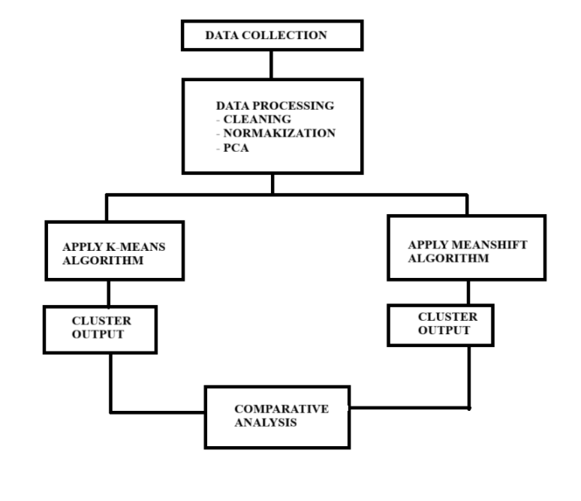
FIGURE 1: FLOWCHART OF METHODOLOGY

________________________________________________________________

K-MEAN CLUSTERING ALGORITHM
INTRODUCTION:
K means is one of the most widely used algorithm for clustering. It was introduced by MacQueen and later it was improved by computational optimizations. The algorithm partitions a particular dataset into K-distinct and non overlapping clusters where each cluster represents the centroid of the points. It’s the most used because of its simplicity, scalability, and ability to handle large datasets which makes it standard baseline clustering research.

WORKING PRINCIPLE:
The algorithm minimizes points within the same cluster that is similar and maximizes the points in different clusters should be dissimilar.
Steps in detail:
- Initialize:
  - It randomly select k points as the initial centroids.
  - It is an improved method, k-means++, is used to spread out initial centroids evenly, reducing convergence to poor local minima.
- Assignment Step:
  - Each data point is assigned to the cluster whose centroid is closest using Euclidean distance.
- Update Step:
  - Recalculation of the centroid of each cluster is the mean of all points assigned to it.
- Iteration:
  - Repeating steps 2 and 3 until convergence.

Properties
- Objective Function: Minimizes the sum of squared errors within clusters.
- Convergence: Guaranteed, but only to a local minimum, not necessarily the global optimum.
- Time Complexity: Where n is the number of data points, k is the number of clusters, and t is the number of iterations.
Applications
- Customer segments in marketing.
- Document clustering and topic modeling.
- Grouping Pixels
- Biological data clustering
Limitations
- It requires to predefine k.
- It works poorly with non-spherical and overlapping clusters.
- It is sensitive towards outliers
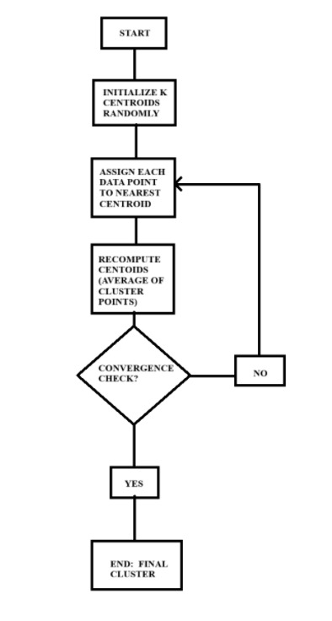
FIGURE 2: ARCHITECTURE OF K-MEAN ALGORITHM

________________________________________________________________

MEAN SHIFT CLUSTERING ALGORITHM

INTRODUCTION:
Mean Shift is a non-parameterised density based clustering algorithm which was first proposed by Fukunaga and Hostetler in 1975. It does not require prior knowledge for the number of clusters. Instead it locates the peaks of a probability density function which is estimated using kernel density estimation. The algorithms are particularly used for complex and irregularr shaped datasets where the number of clusters are not known.
WORKING PRINCIPLE:
The idea is to itertively shift each data point to the nearest region of the higher density.
STEPS:
  - Intialize:
- Each data point as treated as a candidate of a centroid.
  - Kernel densiety estimation:
- To define a kernel function with a bandwidth of parameter h. The bandwidth controls the neighborhood size and is considered for density estimation.
  - Mean Shift Step:
- To calculate the mean of all data points within the kernel window and shift the candidate centroid towards the mean
  - Convergence:
- It is iteratively updating each point until it converges to mode of the density.
  - Cluster Formation:
- Points that are converging to the same mode are assigned to the same cluster.

PROPERTIES:
• No k required: Number of clusters emerges from the data.
• Time Complexity: It is in the basic form (slower than K-Means), but can be improved with optimizations.
• Deterministic: Converges to true density modes with given sufficient bandwidth.
APPLICATIONS:
• Image segmentation and object tracking in computer vision.
• Mode detection in probability distributions.
• Clustering spatial data (geographic hotspots).
• Speech and acoustic signal analysis.
LIMITATIONS:
• Highly sensitive to bandwidth selection:
o Too small - too many clusters.
o Too large - clusters merged.
• Computationally expensive for large datasets.
• Can converge slowly compared to partitioning algorithms.

- ARCHITECTURE :
The architecture suggested to use in this project study is aimed at systematically comparing the performance of the dataset of Marine life identification which we have applied clustering algorithms K-Means algorithm and MeanShift algorithm. It is organized into several levels where each level fulfills a certain task within the workflow. Starting with data input and data preprocessing, then continuing with clustering, and ending with evaluation and comparative analysis.
It starts at the Input Layer, where raw dataset is gathered and uploaded in the system. This data set has various properties, and before the use of clustering it should be appropriately organized. The information is then fed into the Preprocessing Layer where the data is cleansed, normalized and scaled to be equal to prevent variation. Since the data is a high-dimensional one, a dimensionality reduction methodology that is Principal Component Analysis (PCA) is utilized to enable visualization and better efficiency during computation.
After preprocessing, the data reaches the Clustering Layer which is further subdivided into two distinct modules namely, the K-Means clustering module and Mean Shift clustering module. In the K-Means algorithm the data is split into a fixed number of clusters through repeated refinement of centroid and minimization of intra-cluster variance. Compared to it, the Mean Shift algorithm denotes the dense areas of the data space and dynamically clusters the data points depending on their density peaks and does not require the specification of the size of the clusters in advance. The 2 algorithms are used in the same dataset to create fair results in comparison.
Lastly, the findings are pulled in the Comparative Analysis Layer where strengths and weaknesses of the two algorithms are critically discussed. The K-Means is tested on usage rate, ease of use and scalability whereas the Mean Shift is tested based on its flexibility and capacity to identify clusters that are indiscriminate in shape. The comparative analysis offers the information on which algorithm fits better in particular types of datasets and applications.
The study provides a systematic and thorough comparison of any two clustering algorithms, K-Means and Mean Shift through this layered architecture, which makes the comparison profile of these two algorithms to be comparatively well understood in terms of their relative performance based on various aspects of clustering.
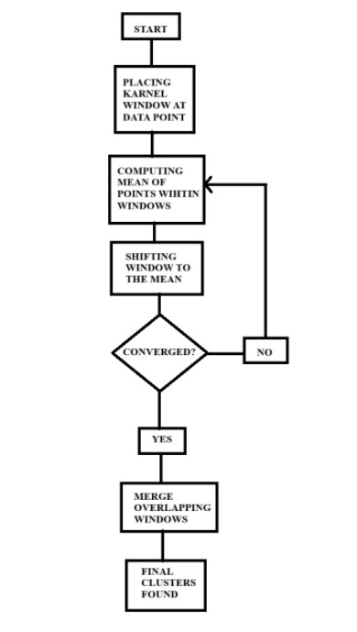
FIGURE 3: ARCHITECTURE OF MEAN SHIFT ALGORITHM

________________________________________________________________

________________________________________________________________

- MATHEMATICAL FORMULA:

K-MEAN
$$J=\sum_{\begin{aligned}i=1 \\ \end{aligned}}^{k}{}\sum_{{x_{j}∈c_{i}}^{}}{} |\left|x_{j}-μ_{i}\right||\frac{2}{}$$

MEAN SHIFT
$$f\left(x\right)=\frac{1}{{nh}^{d }} \sum_{i=1}^{n}{K} (\frac{x-x_{i}}{h}$$

________________________________________________________________

________________________________________________________________

- RESULTS AND OUTPUT:
K-MEAN ALGORITHM
STEP1: CHECKING PYTHON VERSION

STEP2: INTALLING REQUIRED LIBRARIES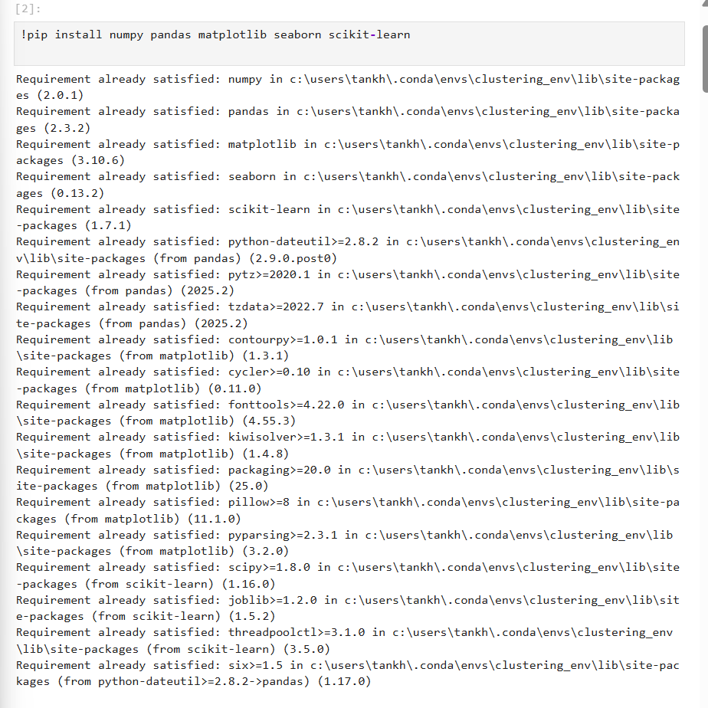
STEP3: IMPORTING LIBRARIES
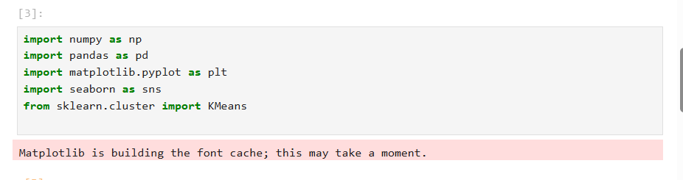
STEP4: UPLOADING DATASET
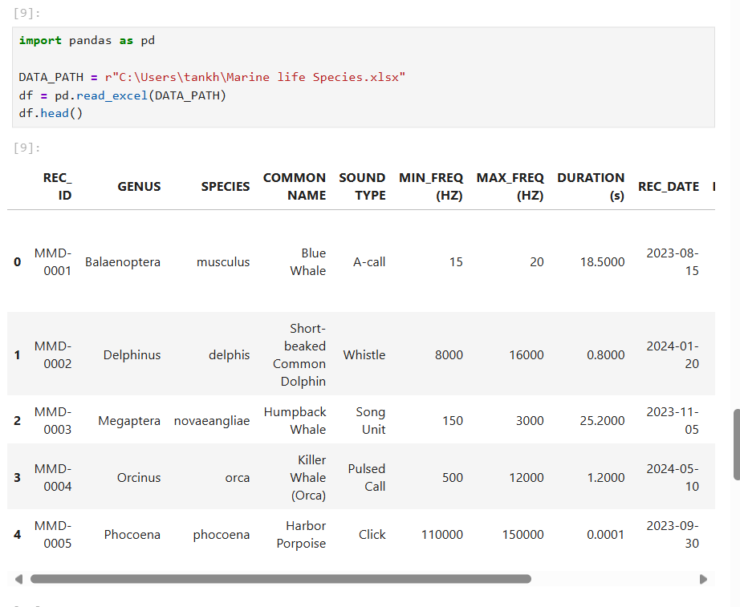
STEP5:CREATING A SCALED NUMERIC DATASET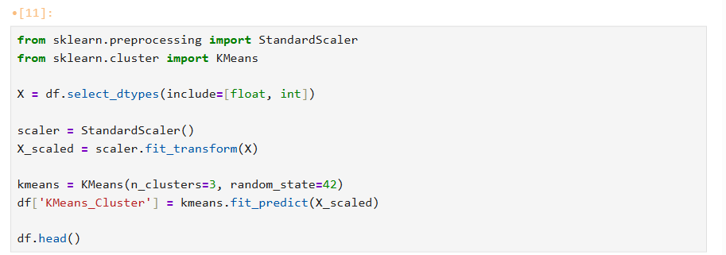
STEP6: RUNNING THE PCA VISUALIZATION CELL
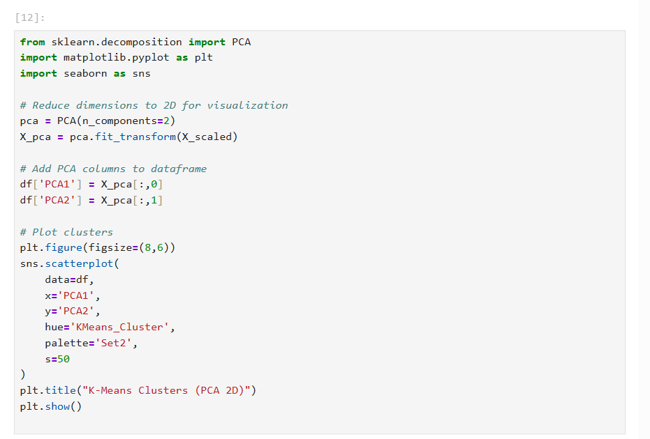

OUTPUT:

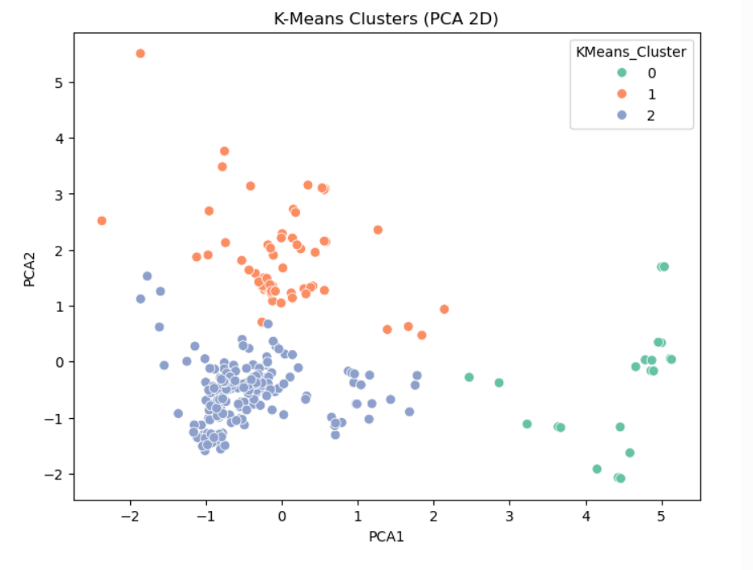
K-Means was responsive and fast with regard to scalability. The algorithm is based on the landmark centroid updates and Euclidean distance calculations, thus, it is suitable to work with huge datasets. When the clusters were appropriately chosen in terms of number (k), the clusters formed were compact and well separated. But its significant disadvantage is that it has to predetermine the number of clusters and this is not always intuitive or known. Also, K-Means assumes that clusters are spherical and equally sized, and so it is ineffective with datasets with irregular or uneven density structure.

MEANSHIFT ALGORITHM

STEP1: IMPORTING LIBRARY
STEP2: APPLYING MEANSHIFT
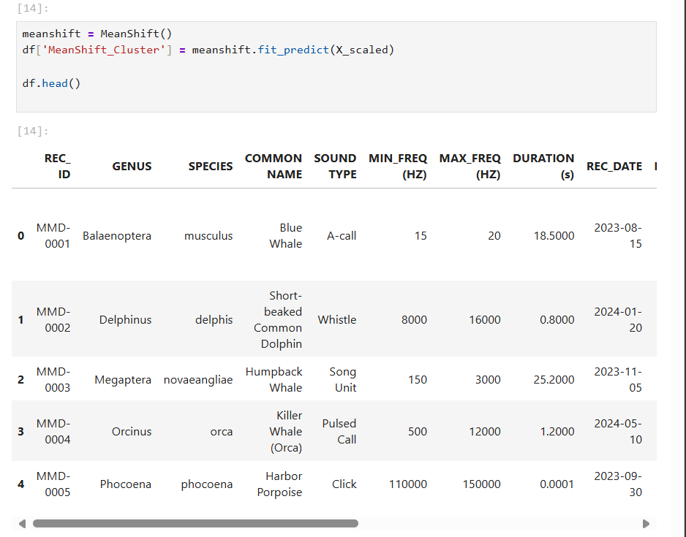
STEP3: VISUALIZE MEANSHIFT CLUSTERS (2D PCA)
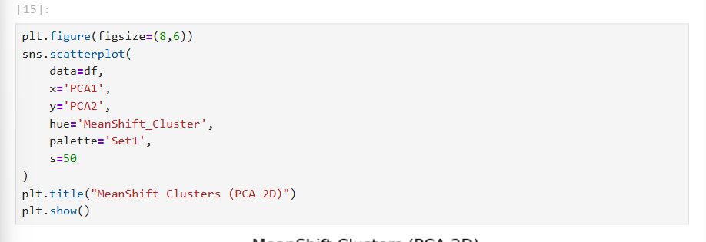
OUTPUT:
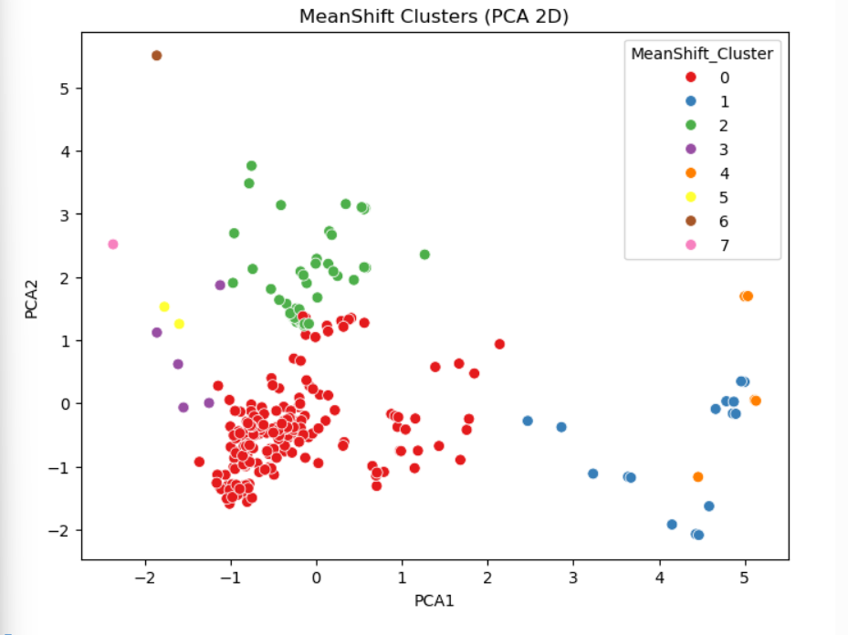

Mean Shift was very adaptable and capable in the discovery of clusters. In contrast to K-Means, it does not have to be informed of the number of clusters, which it discovers by looking at the density distribution of the data. This aspect renders it more appropriate to datasets of arbitrary forms or having uneven clusters. Conversely, Mean Shift was found computationally costly especially in large dimensional datasets and it tended to generate more and smaller clusters. This occasionally scaled down the general interpretability of the clustering outcome.

COMPARING K-MEAN AND MEANSHIFT SIDE BY SIDE :

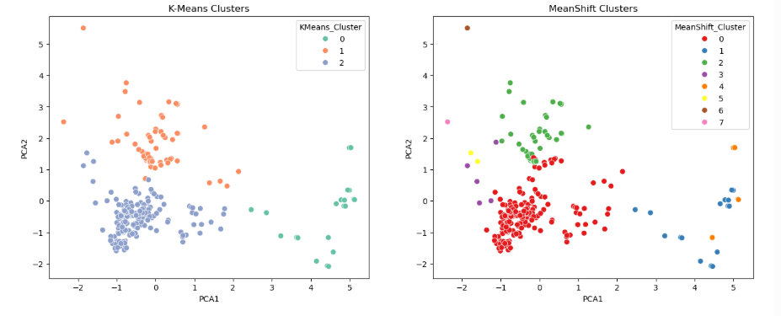

K-Means is effective in the event that the dataset is large, structured, and the required number of clusters is known. It is rapid and has the capability of processing large data. Mean Shift, on the other hand, is more adaptable and can also be used to investigate data, particularly in cases where the clusters are not known or the shape of the clusters is uneven. It is however more time consuming to execute and often produces too many small clusters that may complicate the outcomes.

________________________________________________________________

- CONCLUSION :

The comparative analysis that is done between the K-Means and Mean Shift clustering algorithms has shed some valuable information on the advantages and disadvantages of these two algorithms as well as their applicability to various types of data. The two algorithms are also highly used methods of clustering, but the underlying methodology and assumptions of the algorithms lead to markedly different performance properties.

K-Means is one of the most famous clustering algorithms, which is described as the easiest and most efficient in its computations. The fact that it can process massive data sets in a relatively short time and gives relatively consistent results can make it especially appealing in practical use cases, where time efficiency is the main concern. The algorithm divides data into kkk groups with a minimal variance in groups and maximizing variance between them. This is effective when the data set is organized into even sized spherical clusters. The weaknesses of the K-Means were however realized in the study. The algorithm is very particular to the predefinition of the number of clusters, not every number can be previously known. Moreover, K-Means has some problems with data sets that have irregular clusters or non-uniform densities. It is also sensitive to noise and outliers, which may have a serious skewing effect on the results of the clustering. Irrespective of these, the algorithm is an effective one as applied to large scale data with comparatively clean distributions.

Conversely, Mean Shift showed a variation of strengths and challenges. It does not presuppose the number of clusters as K-Means does. Instead it is based on density estimation which involves moving the data points towards the higher density areas repeatedly until they converge. This renders Mean Shift very flexible and able to find clusters of any shape and size and provides a decisive lead when it comes to the analysis of exploratory information. The algorithm has found application especially in a situation where structure of the data is not known and there is a need of flexibility in terms of cluster formation. Mean Shift however also has its limitations. The bandwidth parameter (size of window) is very critical to the clustering process and improperly choosing the value may cause either under-clustering or excessive sub-division of data. Moreover, Mean Shift is computationally costlier than K-Means of large datasets making its scalability of small datasets limited.

Comparative Insights

The results of this paper highlight that K-Means is more desirable in situations where the computational efficiency and scalability is a major concern and in situations where the data may be reasonably assumed to exhibit spherical or well-separated distributions. Mean Shift on the other hand is better suited in situations that need simplicity i.e. the number of clusters are not known or that they need irregular shapes. Another aspect of the study that shows that the decision between K-Means and Mean Shift cannot be made blindly is that the decision should be informed by the nature of the data and the purpose of the analysis.

Practical Implications

Practically, K-Means is specifically well adapted to large scale applications, including market segmentation, recommendation systems, as well as simple partitioning of structured data. It is very valuable because of its speed and simplicity when the interpretability is of less priority than the efficiency. Mean Shift, on the other hand, is used in more complicated fields like image segmentation, object tracking and computer vision systems in which the natural organization of the data is not known and must be learned on the fly. The implications here imply that the two algorithms are complementary to each other in the domain of clustering wherein K-Means algorithm performs better with structured large data and Mean Shift on exploratory and adaptive tasks.

Limitations of the Study

The weaknesses of such a comparative study should be noted. To start with, preprocessing, e.g., feature scaling and normalization, is an essential part of the algorithms. Secondly, although the research concentrated on two algorithms, it might be more valid to say that a wider analysis of further methods of clustering should have been conducted to have a more comprehensive approach. Thirdly, the clustering evaluation metrics are also conceptually difficult, since in unsupervised learning ground truth labels are often absent and the quality of good clusters is therefore subjective in part. Lastly, performance of Mean Shift can differ greatly with varying bandwidth values and this can be hard to tune well.

Future Scope

This study can be further developed in a number of ways in the future. The future potential lies in the possibilities of searching for the hybrid strategies to unite the effectiveness of K-Means with the flexibility of Mean Shift. These approaches might have a chance at being used to this end of overcoming the shortcomings of both algorithms without losing the merits. Also, it might be beneficial to introduce automated bandwidth selection methods to Mean Shift in order to make it more robust and eliminate the use of manually tuned parameters. More studies can also be conducted on scalable implementations of Mean Shift with parallelization and distributed computing that can be made more applicable to large-scale data sets. Lastly, a more general comparative analysis that incorporates deep learning-based clustering techniques may offer more detailed information on clustering performance in a variety of datasets and applications.

Closing Statement
In conclusion, the K-Means and Mean Shift comparison reveal that the two algorithms have their unique contribution to be made. K-Means remains an essential component of the clustering because it is fast and easy, as well as can be applied to large-scale issues involving structured data. Even though, it is computationally intensive Mean Shift is more flexible and adaptable and is more suited to exploratory data analysis and when one does not know how the data is naturally organized. Taken together, these findings point to the fact that clustering does not always provide a solution. The algorithm ought to be contextual with respect to the kind of data, its purpose of application and computing power. With further development of clustering, there is a likelihood of incorporation of adaptive, efficient as well as hybrid techniques that will make clustering more useful in resolving real world data issues.

___________________________________________________________________________

- REFERENCES :
Scikit-Learn Documentation - Mean Shift
https://scikit-learn.org/stable/modules/generated/sklearn.cluster.MeanShift.html

- Wikipedia - Mean Shift
https://en.wikipedia.org/wiki/Mean_shift

- Wikipedia - K-Means Clustering
https://en.wikipedia.org/wiki/K-means_clustering

- GeeksforGeeks - Davies-Bouldin Index
https://www.geeksforgeeks.org/ml-davies-bouldin-index-db-index-clustering-evaluation-measure/

- Wikipedia - Calinski-Harabasz Index
https://en.wikipedia.org/wiki/Calinski%E2%80%93Harabasz_index

- ProjectPro - A Beginner’s Guide to Clustering Algorithms
https://www.projectpro.io/article/a-beginners-guide-to-clustering-algorithms/538

- Atomic Spin - Mean Shift Clustering Overview
https://spin.atomicobject.com/2015/05/26/mean-shift-clustering/

- Medium -Three Performance Evaluation Metrics of Clustering
https://medium.com/analytics-vidhya/three-performance-evaluation-metrics-of-clustering-when-ground-truth-labels-are-not-available-2f58cc9363a0

