## 3.1 Comparative Advantage in Practice: The Case of Babe Ruth

Everyone knows that Babe Ruth was the greatest slugger in the history of baseball. Only true fans of the sport know, however, that Ruth also was one of the greatest pitchers of all time. Because Ruth stopped pitching after 1918 and played outfield during all the time he set his famous batting records, most people don’t realize that he even could pitch. What explains Ruth’s lopsided reputation as a batter? The answer is provided by the principle of comparative advantage.

As a player with the Boston Red Sox early in his career, Ruth certainly had an absolute advantage in pitching. According to historian Geoffrey C. Ward and filmmaker Ken Burns:



In the Red Sox’s greatest years, he was their greatest player, the best left-handed pitcher in the American League, winning 89 games in six seasons. In 1916 he got his first chance to pitch in the World Series and made the most of it. After giving up a run in the first, he drove in the tying run himself, after which he held the Brooklyn Dodgers scoreless for eleven innings until his teammates could score the winning run…. In the 1918 series, he would show that he could still handle them, stretching his series record to $29\frac{2}{3}$ scoreless innings, a mark that stood for forty-three years.[1]

The Babe’s World Series pitching record was broken by New York Yankee Whitey Ford in the same year, 1961, that his teammate Roger Maris shattered Ruth’s 1927 record of 60 home runs in a single season.

Although Ruth had an absolute advantage in pitching, his skill as a batter relative to his teammates’ abilities was even greater: His comparative advantage was at the plate. As a pitcher, however, Ruth had to rest his arm between appearances and therefore could not bat in every game. To exploit Ruth’s comparative advantage, the Red Sox moved him to center field in 1919 so that he could bat more frequently.

The payoff to having Ruth specialize in batting was huge. In 1919, he hit 29 home runs, “more than any player had ever hit in a single season,” according to Ward and Burns. The Yankees kept Ruth in the outfield (and at the plate) after they acquired him in 1920. They knew a good thing when they saw it. That year, Ruth hit 54 home runs, set a slugging record (bases divided by at bats) that remains untouched to this day, and turned the Yankees into baseball’s most renowned franchise.

## 3.2 The Losses from Nontrade

Our discussion of the gains from trade took the form of a “thought experiment” in which we compared two situations: one in which countries do not trade at all and another in which they have free trade. It’s a hypothetical case that helps us to understand the principles of international economics, but it does not have much to do with actual events. After all, countries don’t suddenly go from no trade to free trade or vice versa. Or do they?



As economic historian Douglas Irwin[2] has pointed out, in the early history of the United States the country actually did carry out something very close to the thought experiment of moving from free trade to no trade. The historical context was as follows: In the early 19th century Britain and France were engaged in a massive military struggle, the Napoleonic Wars. Both countries endeavored to bring economic pressures to bear: France tried to keep European countries from trading with Britain, while Britain imposed a blockade on France. The young United States was neutral in the conflict but suffered considerably. In particular, the British navy often seized U.S. merchant ships and, on occasion, forcibly recruited their crews into its service.

In an effort to pressure Britain into ceasing these practices, President Thomas Jefferson declared a complete ban on overseas shipping. This embargo would deprive both the United States and Britain of the gains from trade, but Jefferson hoped that Britain would be hurt more and would agree to stop its depredations.

Irwin presents evidence suggesting that the embargo was quite effective: Although some smuggling took place, trade between the United States and the rest of the world was drastically reduced. In effect, the United States gave up international trade for a while.

The costs were substantial. Although quite a lot of guesswork is involved, Irwin suggests that real income in the United States may have fallen by about 8 percent as a result of the embargo. When you bear in mind that in the early 19th century only a fraction of output could be traded—transport costs were still too high, for example, to allow large-scale shipments of commodities like wheat across the Atlantic—that’s a pretty substantial sum.

Unfortunately for Jefferson’s plan, Britain did not seem to feel equal pain and showed no inclination to give in to U.S. demands. Fourteen months after the embargo was imposed, it was repealed. Britain continued its practices of seizing American cargoes and sailors; three years later the two countries went to war.

## 3.3 Do Wages Reflect Productivity?

In the numerical example that we use to puncture common misconceptions about comparative advantage, we assume the relative wage of the two countries reflects their relative productivity—specifically, that the ratio of Home to Foreign wages is in a range that gives each country a cost advantage in one of the two goods. This is a necessary implication of our theoretical model. But many people are unconvinced by that model. In particular, rapid increases in productivity in ”emerging” economies like China have worried some Western observers, who argue that these countries will continue to pay low wages even as their productivity increases—putting high-wage countries at a cost disadvantage—and dismiss the contrary predictions of orthodox economists as unrealistic theoretical speculation. Leaving aside the logic of this position, what is the evidence?

The answer is that in the real world, national wage rates do, in fact, reflect differences in productivity. The accompanying figure compares estimates of productivity with estimates of wage rates for a selection of countries in 2011 (except for China, where the data are for 2009). Both measures are expressed as percentages of U.S. levels. Our estimate of productivity is GDP per worker measured in U.S. dollars. As we’ll see in the second half of this text, that basis should indicate productivity in the production of traded goods. Wage rates are measured by wages in manufacturing.

If wages were exactly proportional to productivity, all the points in this chart would lie along the indicated 45-degree line. In reality, the fit isn’t bad. In particular, low wage rates in China and India reflect low productivity.

The low estimate of overall Chinese productivity may seem surprising, given all the stories one hears about Americans who find themselves competing with Chinese exports. The Chinese workers producing those exports don’t seem to have extremely low productivity. But remember what the theory of comparative advantage says: Countries export the goods in which they have relatively high productivity. So it’s only to be expected that China’s overall relative productivity is far below the level of its export industries.

The figure that follows tells us that the orthodox economists’ view that national wage rates reflect national productivity is, in fact, verified by the data at a point in time. It’s also true that in the past, rising relative productivity led to rising wages. Consider, for example, the case of South Korea. In 2011, South Korea’s labor productivity was a bit less than half of the U.S. level, and its wage rate was actually slightly higher than that. But it wasn’t always that way: In the not too distant past, South Korea was a low-productivity, low-wage economy. As recently as 1975, South Korean wages were only 5 percent those of the United States. But when South Korea’s productivity rose, so did its wage rate.

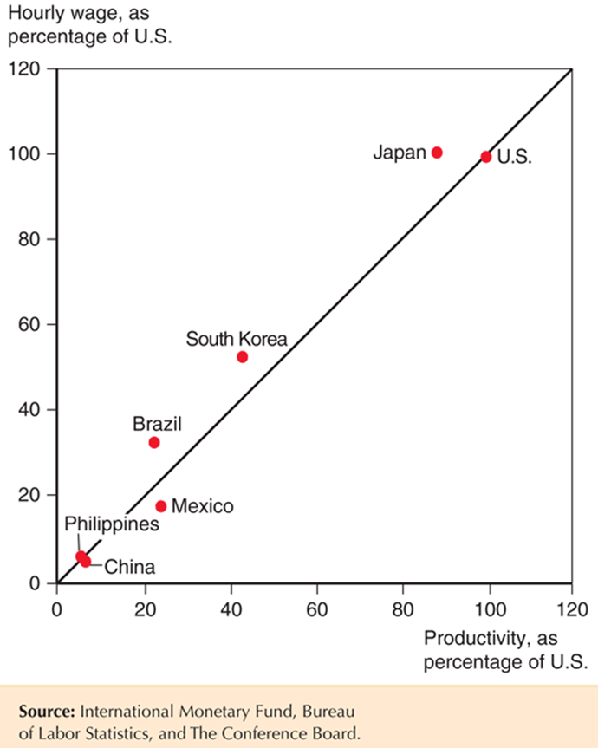

In short, the evidence strongly supports the view, based on economic models, that productivity increases are reflected in wage increases.

1. See Geoffrey C. Ward and Ken Burns, Baseball: An Illustrated History (New York: Knopf, 1994), p. 155. Ruth’s career preceded the designated hitter rule, so American League pitchers, like National League pitchers today, took their turns at bat. For a more extensive discussion of Babe Ruth’s relation to the comparative advantage principle, see Edward Scahill, “Did Babe Ruth Have a Comparative Advantage as a Pitcher?” Journal of Economic Education 21(4), Fall 1990, pp. 402–410.
2. Douglas Irwin, “The Welfare Cost of Autarky: Evidence from the Jeffersonian Trade Embargo, 1807–1809,” Review of International Economics 13 (September 2005), pp. 631–645.