4.1 What Is a Specific Factor?

In the model developed in this chapter, we assume two factors of production—land and capital—are permanently tied to particular sectors of the economy. In advanced economies, however, agricultural land receives only a small part of national income. When economists apply the specific factors model to economies like those of the United States or France, they typically think of factor specificity not as a permanent condition but as a matter of time. For example, the vats used to brew beer and the stamping presses used to build auto bodies cannot be substituted for each other, and so these different kinds of equipment are industry-specific. Given time, however, it would be possible to redirect investment from auto factories to breweries or vice versa. As a result, in a long-term sense both vats and stamping presses can be considered two manifestations of a single, mobile factor called capital.

In practice, then, the distinction between specific and mobile factors is not a sharp line. Rather, it is a question of the speed of adjustment, with factors being more specific the longer it takes to redeploy them between industries. So how specific are the factors of production in the real economy?

Worker mobility varies greatly with the characteristics of the worker (such as age) and the job occupation (whether it requires general or job-specific skills). Nevertheless, one can measure an average rate of mobility by looking at the duration of unemployment following a worker’s displacement. After four years, a displaced worker in the United States has the same probability of being employed as a similar worker who was not displaced.[1] This four-year time-span compares with a lifetime of 15 or 20 years for a typical specialized machine, and 30 to 50 years for structures (a shopping mall, office building, or production plant). So labor is certainly a less specific factor than most kinds of capital. However, even though most workers can find new employment in other sectors within a four-year time-span, switching occupations entails additional costs: A displaced worker who is re-employed in a different occupation suffers an 18 percent permanent drop in wages (on average). This compares with a 6 percent drop if the worker does not switch occupations.[2] Thus, labor is truly flexible only before a worker has invested in any occupation-specific skills.

4.2 Trade and Unemployment

Opening to trade shifts jobs from import-competing sectors to export sectors. As we have discussed, this process is not instantaneous and imposes some very real costs: Some workers in the import-competing sectors become unemployed and have difficulty finding new jobs in the growing export sectors. We have argued in this chapter that the best policy response to this serious concern is to provide an adequate safety net to unemployed workers, without discriminating based on the economic force that induced their involuntary unemployment (whether due to trade or, say, technological change). Here, we quantify the extent of unemployment that can be traced back to trade. Plant closures due to import competition or overseas plant relocations are highly publicized, but they account for a very small proportion of involuntary worker displacements. The U.S. Bureau of Labor Statistics tracks the primary cause of all extended mass layoffs, defined as an unemployment spell lasting more than 30 days and affecting more than 50 workers from the same employer. During 2001–2010, unemployment spells caused by either import competition or overseas relocations accounted for less than 2 percent of total involuntary displacements associated with extended mass layoffs.

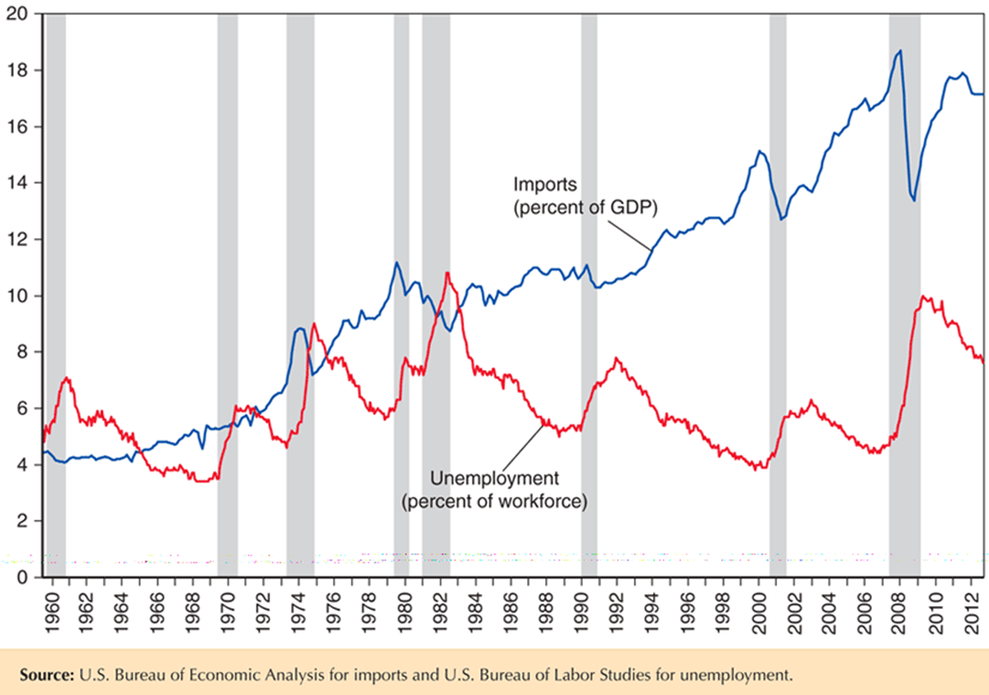Figure 4-12 shows that, over the last 50 years in the United States, there is no evidence of a positive correlation between the unemployment rate and imports (relative to U.S. GDP). (In fact, the correlation between changes in unemployment and imports is significantly negative.) On the other hand, the figure clearly shows how unemployment is a macroeconomic phenomenon that responds to overall economic conditions: Unemployment peaks during the highlighted recession years. Thus, economists recommend the use of macroeconomic policy, rather than trade policy, to address concerns regarding unemployment. Still, because changes in trade regimes—as opposed to other forces affecting the income distribution—are driven by policy decisions, there is also substantial pressure to bundle those decisions with special programs that benefit those adversely affected by trade. The U.S. Trade Adjustment Assistance program provides extended unemployment coverage (for an additional year) to workers who are displaced by a plant closure due to import competition or an overseas relocation to a country receiving preferential access to the United States. While this program is important, to the extent that it can influence political decisions regarding trade, it unfairly discriminates against workers who are displaced due to economic forces other than trade.

4.3 Wage Convergence in the Age of Mass Migration

Although there are substantial movements of people between countries in the modern world, the truly heroic age of labor mobility— when immigration was a major source of population growth in some countries, while emigration caused population in other countries to decline—was in the late 19th and early 20th centuries. In a global economy newly integrated by railroads, steamships, and telegraph cables, and not yet subject to many legal restrictions on migration, tens of millions of people moved long distances in search of a better life. Chinese people moved to Southeast Asia and California, while Indian people moved to Africa and the Caribbean; in addition, a substantial number of Japanese people moved to Brazil. However, the greatest migration involved people from the periphery of Europe—from Scandinavia, Ireland, Italy, and Eastern Europe—who moved to places where land was abundant and wages were high: the United States, Canada, Argentina, and Australia.

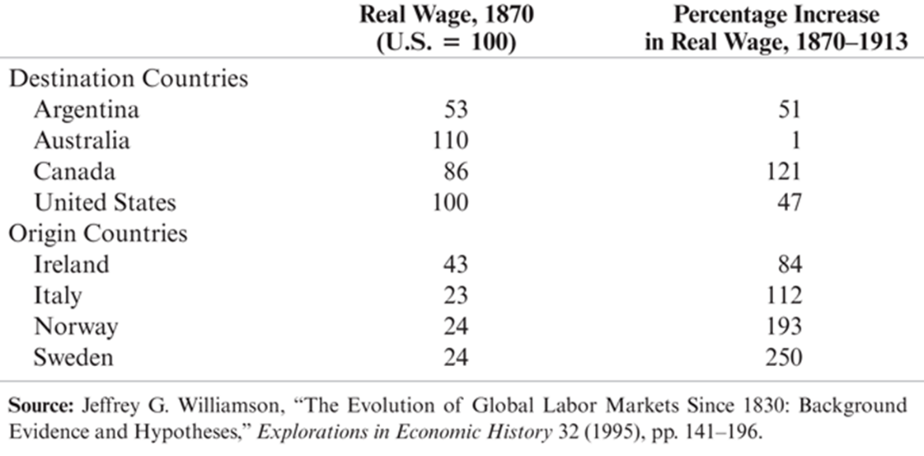Did this process cause the kind of real wage convergence that our model predicts? Indeed, it did. Table 4-1 shows real wages in 1870, and the change in these wages up to the eve of World War I, for four major “destination” countries and for four important “origin” countries. As the table shows, at the beginning of the period, real wages were much higher in the destination than in the origin countries. Over the next four decades real wages rose in all countries, but (except for a surprisingly large increase in Canada) they increased much more rapidly in the origin than in the destination countries, suggesting that migration actually did move the world toward (although not by any means all the way to) wage equalization.

As documented in the case study on the U.S. economy, legal restrictions put an end to the age of mass migration after World War I. For that and other reasons (notably a decline in world trade and the direct effects of two world wars), convergence in real wages came to a halt and even reversed itself for several decades, only to resume in the postwar years.

4.4 Immigration and the U.S. Economy

As Figure 4-14 shows, the share of immigrants in the U.S. population has varied greatly over the past two centuries. At the turn of the 20th century, the number of foreign-born U.S. residents increased dramatically due to vast immigration from Eastern and Southern Europe. Tight restrictions on immigration imposed in the 1920s brought an end to this era, and by the 1960s immigrants were a minor factor on the American scene. A new wave of immigration began around 1970, this time with most immigrants coming from Latin America and Asia. Although the share of immigrants has been steadily increasing ever since, it is still below the levels reached during the first wave of immigration.

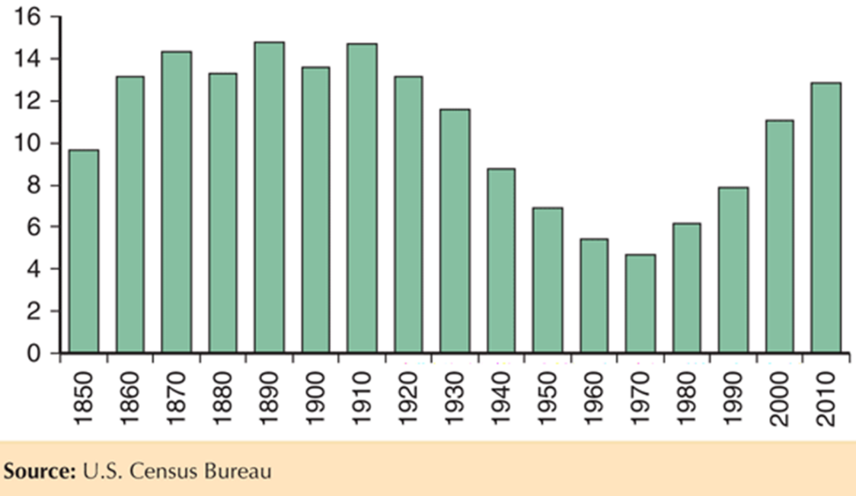How has this new wave of immigration affected the U.S. economy? The most direct effect is that immigration has expanded the work force. As of 2012, foreign-born workers make up 16.1 percent of the U.S. labor force—that is, without immigrants the United States would have 16 percent fewer workers.

Other things equal, we would expect this increase in the work force to reduce wages. One widely cited estimate is that average wages in the United States are 3 percent lower than they would be in the absence of immigration.[3] However, comparisons of average wages can be misleading because immigrants to the United States have a very different education profile relative to the overall U.S. population. Those differences are highlighted in Figure 4-15, which tabulates both the foreign-born and the total U.S. population over 25 years of age by education for 2010 (left-hand scale). The line represents the ratio between the two (the fraction of foreign born within an educational group on the right-hand scale). That ratio shows how foreign-born workers are concentrated in both the lowest and highest educational groups—relative to native-born workers. At one end of the educational scale, foreign-born workers with professional and doctorate degrees provide the U.S. economy with much needed skills, especially in fields such as science, technology, engineering, and mathematics (STEM). Among workers with doctorate degrees in those STEM fields, 60 percent are foreign born.

Foreign-born workers are also concentrated in the lowest educational groups: In 2012, 28 percent of the immigrant labor force had not completed high school or its equivalent, compared with only 5 percent of native-born workers. Because workers with different education levels represent different inputs into production (and cannot easily be substituted for one-another), most estimates suggest that immigration has actually raised the wages of the vast majority of native-born Americans. Any negative effects on wages fall on less-educated Americans. There is, however, considerable dispute among economists about how large these negative wage effects are, with estimates ranging from an 8 percent decline to much smaller numbers. 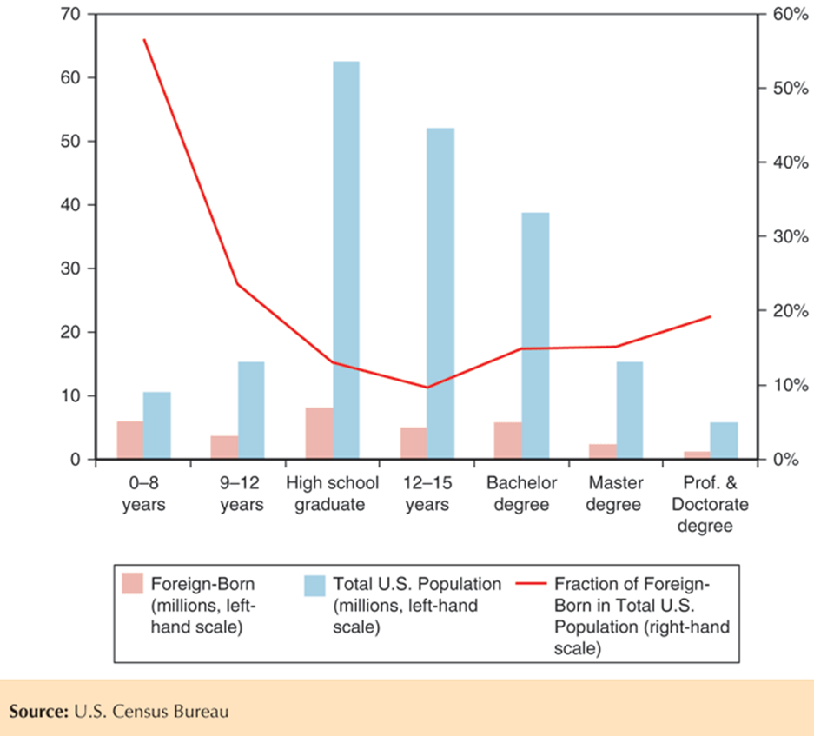

What about the overall effects on America’s income? America’s gross domestic product—the total value of all goods and services produced here—is clearly larger because of immigrant workers. However, much of this increase in the value of production is used to pay wages to the immigrants themselves. Estimates of the “immigration surplus”—the difference between the gain in GDP and the cost in wages paid to immigrants— are generally small, on the order of 0.1 percent of GDP.[4]

There’s one more complication in assessing the economic effects of immigration: the effects on tax revenue and government spending. On one side, immigrants pay taxes, helping cover the cost of government. On the other side, they impose costs on the government because their cars need roads to drive on, their children need schools to study in, and so on. Because many immigrants earn low wages and hence pay low taxes, some estimates suggest that immigrants cost more in additional spending than they pay in. However, estimates of the net fiscal cost, like estimates of the net economic effects, are small, again on the order of 0.1 percent of GDP.

Immigration is, of course, an extremely contentious political issue. The economics of immigration, however, probably doesn’t explain this contentiousness. Instead, it may be helpful to recall what Swiss author Max Frisch once said about the effects of immigration into his own country, which at one point relied heavily on workers from other countries: “We asked for labor, but people came.” And it’s the fact that immigrants are people that makes the immigration issue so difficult.

1. See Bruce Fallick, “The Industrial Mobility of Displaced Workers,” Journal of Labor Economics 11 (April 1993), pp. 302–323.
2. See Gueorgui Kambourov and Iourii Manovskii, “Occupational Specificity of Human Capital,” International Economic Review 50 (February 2009), pp. 63–115.
3. George Borjas, “The Labor Demand Curve Is Downward Sloping: Reexamining the Impact of Immigration on the Labor Market,” Quarterly Journal of Economics 118 (November 2003), pp. 1335–1374.
4. See Gordon Hanson, “Challenges for Immigration Policy,” in C. Fred Bergsten, ed., The United States and the World Economy: Foreign Economic Policy for the Next Decade, Washington, D.C.: Institute for International Economics, 2005, pp. 343–372.