5.1 North-South Trade and Income Inequality

The distribution of wages in the United States has become considerably more unequal since the 1970s. In 1970, a male worker with a wage at the 90th percentile of the wage distribution (earning more than the bottom 90 percent but less than the top 10 percent of wage earners) earned 3.2 times the wage of a male worker at the bottom 10th percentile of the distribution. By 2010, that worker at the 90th percentile earned more than 5.2 times the wage of the worker at the bottom 10th percentile. Wage inequality for female workers has increased at a similar rate over that same timespan. Much of this increase in wage inequality was associated with a rise in the premium attached to education, especially since the 1980s. In 1980, a worker with a college degree earned 40 percent more than a worker with just a high school education. This education premium rose steadily through the 1980s and 1990s to 80 percent. Since then, it has been roughly flat (though wage disparities among college graduates continued rising).

Why has wage inequality increased? Many observers attribute the change to the growth of world trade and in particular to the growing exports of manufactured goods from newly industrializing economies (NIEs) such as South Korea and China. Until the 1970s, trade between advanced industrial nations and less developed economies—often referred to as “North-South” trade because most advanced nations are still in the temperate zone of the Northern Hemisphere— consisted overwhelmingly of an exchange of Northern manufactures for Southern raw materials and agricultural goods, such as oil and coffee. From 1970 onward, however, former raw material exporters increasingly began to sell manufactured goods to high-wage countries like the United States. As we learned in Chapter 2, developing countries have dramatically changed the kinds of goods they export, moving away from their traditional reliance on agricultural and mineral products to a focus on manufactured goods. While NIEs also provided a rapidly growing market for exports from the high-wage nations, the exports of the newly industrializing economies obviously differed greatly in factor intensity from their imports. Overwhelmingly, NIE exports to advanced nations consisted of clothing, shoes, and other relatively unsophisticated products (“low-tech goods”) whose production is intensive in unskilled labor, while advanced-country exports to the NIEs consisted of capital- or skill-intensive goods such as chemicals and aircraft (“high-tech goods”).

To many observers, the conclusion seemed straightforward: What was happening was a move toward factor-price equalization. Trade between advanced countries that are abundant in capital and skill and NIEs with their abundant supply of unskilled labor was raising the wages of highly skilled workers and lowering the wages of less- skilled workers in the skill- and capital-abundant countries, just as the factor-proportions model predicts.

This is an argument with much more than purely academic significance. If one regards the growing inequality of income in advanced nations as a serious problem, as many people do, and if one also believes that growing world trade is the main cause of that problem, it becomes difficult to maintain economists’ traditional support for free trade. (As we have previously argued, in principle, taxes and government payments can offset the effect of trade on income distribution, but one may argue that this is unlikely to happen in practice.) Some influential commentators have argued that advanced nations will have to restrict their trade with low-wage countries if they want to remain basically middle-class societies.

While some economists believe that growing trade with low-wage countries has been the main cause of rising income inequality in the United States, most empirical researchers believed at the time of this writing that international trade has been at most a contributing factor to that growth, and that the main causes lie elsewhere.[1] This skepticism rests on three main observations.

First, the factor-proportions model says that international trade affects income distribution via a change in relative prices of goods. So if international trade was the main driving force behind growing income inequality, there ought to be clear evidence of a rise in the prices of skill-intensive products compared with those of unskilled-labor-intensive goods. Studies of international price data, however, have failed to find clear evidence of such a change in relative prices.

Second, the model predicts that relative factor prices should converge: If wages of skilled workers are rising and those of unskilled workers are falling in the skill-abundant country, the reverse should be happening in the labor-abundant country. Studies of income distribution in developing countries that have opened themselves to trade have shown that at least in some cases, the reverse is true. In Mexico, in particular, careful studies have shown that the transformation of the country’s trade in the late 1980s—when Mexico opened itself to imports and became a major exporter of manufactured goods—was accompanied by rising wages for skilled workers and growing overall wage inequality, closely paralleling developments in the United States.

Third, although trade between advanced countries and NIEs has grown rapidly, it still constitutes only a small percentage of total spending in the advanced nations. As a result, estimates of the “factor content” of this trade—the skilled labor exported, in effect, by advanced countries embodied in skill-intensive exports and the unskilled labor, in effect, imported in labor-intensive imports—are still only a small fraction of the total supplies of skilled and unskilled labor. This suggests that these trade flows couldn’t have had a very large impact on income distribution.

What, then, is responsible for the growing gap between skilled and unskilled workers in the United States? The view of the majority is that the villain is not trade but rather new production technologies that put a greater emphasis on worker skills (such as the widespread introduction of computers and other advanced technologies in the workplace). This is often referred to as a technology- skill complementarity or skill-biased technological change.[2]

We discuss the links between this type of technological change and rising wage inequality in the following case study.

5.2 Skill-Biased Technological Change and Income Inequality

In this case study, we extend our two-factor production model to incorporate technological change that is skill-biased. We discuss how this provides a much better fit for the empirical patterns associated with rising wage inequality in the United States. We also describe some new research that links back portions of this technological change to trade and outsourcing.

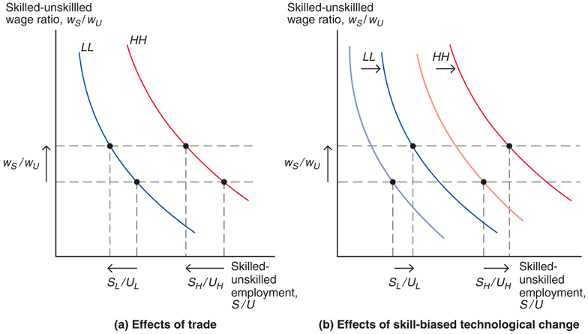Consider the variant of our two good, two factor model where skilled and unskilled labor are used to produce “high-tech” and “low-tech” goods. Figure 5-10 shows the relative factor demands for producers in both sectors: the ratio of skilled-unskilled workers employed as a function of the skilled-unskilled wage ratio (LL curve for low-tech and HH for high-tech).

We have assumed that production of high-tech goods is skilled-labor intensive, so the HH curve is shifted out relative to the LL curve. In the background, an SS curve (see Figures 5-6 and 5-7) determines the skilled-unskilled wage ratio as an increasing function of the relative price of high-tech goods (with respect to low-tech goods).

In panel (a), we show the case where increased trade with developing countries generates an increase in wage inequality (the skilled-unskilled wage ratio) in those countries (via an increase in the relative price of high-tech goods). The increase in the relative cost of skilled workers induces producers in both sectors to reduce their employment of skilled workers relative to unskilled workers.

In panel (b), we show the case where technological change in both sectors generates an increase in wage inequality. This technology change is classified as “skill-biased” because it shifts out the relative demand for skilled workers in both sectors (both the LL and the HH curves shift out). It also induces larger productivity gains in the high-tech sector due to its complementarity with skilled workers. Thus, for any given relative price of high-tech goods, the technology change is associated with a higher skilled-unskilled wage ratio (the SS curve shifts). Even though skilled labor is relatively more expensive, producers in both sectors respond to the technological change by increasing their employment of skilled workers relative to unskilled workers. (Note that the trade explanation in panel (a) predicts an opposite response for employment in both sectors.)

We can now examine the relative merits of the trade versus skill-biased technological change explanations for the increase in wage inequality by looking at the changes in the skilled-unskilled employment ratio within sectors in the United States. A widespread increase in these employment ratios for all different kinds of sectors (both skilled-labor-intensive and unskilled-labor-intensive sectors) in the U.S. economy points to the skill-biased technological explanation. This is exactly what has been observed in the United States over the last half-century.

In Figure 5-11, sectors are separated into four groups based on their skill intensity. U.S. firms do not report their employment in terms of skill but use a related categorization of production and non-production workers. With a few exceptions, non-production positions require higher levels of education—and so we measure the skilled-unskilled employment ratio in a sector as the ratio of non-production employment to production employment.[3] Sectors with the highest non-production to production employment ratios are classified as most skill-intensive. Each quadrant of Figure 5-11 shows the evolution of this employment ratio over time for each group of sectors (the average employment ratio across all sectors in the group). Although there are big differences in average skill intensity across the groups, we clearly see that the employment ratios are increasing over time for all four groups. This widespread increase across most sectors of the U.S. economy is one of the main pieces of evidence pointing to the technology explanation for the increases in U.S. wage inequality.

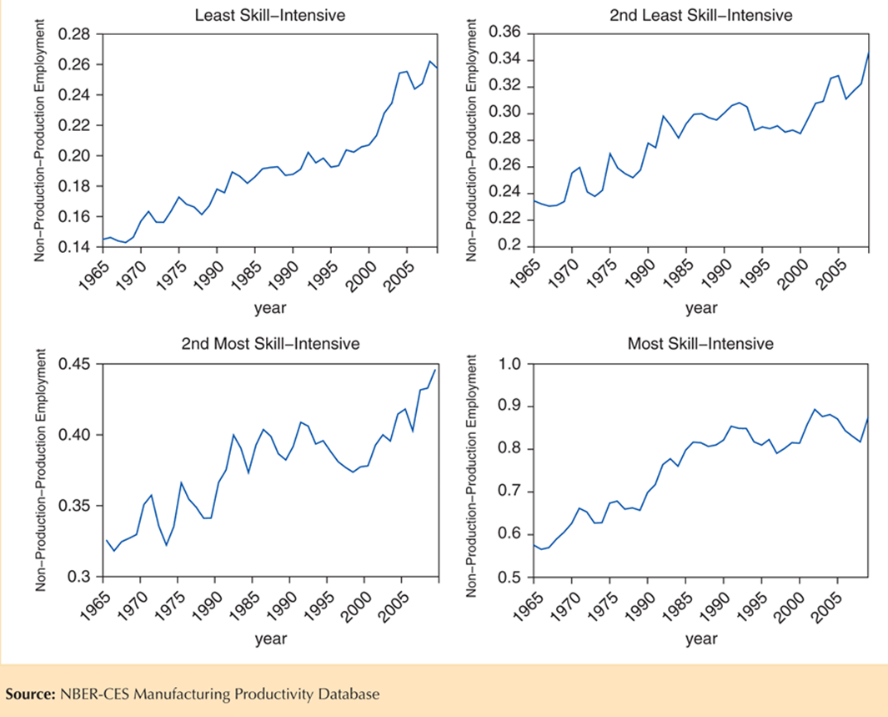Yet, even though most economists agree that skill-biased technological change has occurred, recent research has uncovered some new ways in which trade has been an indirect contributor to the associated increases in wage inequality, by accelerating this process of technological change. These explanations are based on the principle that firms have a choice of production methods that is influenced by openness to trade and foreign investment. For example, some studies show that firms that begin to export also upgrade to more skill-intensive production technologies. Trade liberalization can then generate widespread technological change by inducing a large proportion of firms to make such technology-upgrade choices.

Another example is related to foreign outsourcing and the liberalization of trade and foreign investment. In particular, the NAFTA treaty (see Chapter 2) between the United States, Canada, and Mexico has made it substantially easier for firms to move different parts of their production processes (research and development, component production, assembly, marketing) across different locations in North America. Because production worker wages are substantially lower in Mexico, U.S. firms have an incentive to move the processes that use production workers more intensively to Mexico (such as component production and assembly). The processes that rely more intensively on higher-skilled, non-production workers (such as research and development and marketing) tend to stay in the United States (or Canada). From the U.S. perspective, this break-up of the production process increases the relative demand for skilled workers and is very similar to skill-biased technological change. One study finds that this outsourcing process from the United States to Mexico can explain 21 to 27 percent of the increase in the wage premium between non-production and production workers.[4]

Thus, some of the observed skill-biased technological change, and its effect on increased wage inequality, can be traced back to increased openness to trade and foreign investment. And, as we have mentioned, increases in wage inequality in advanced economies are a genuine concern. However, the use of trade restrictions targeted at limiting technological innovations—because those innovations favor relatively higher-skilled workers—is particularly problematic: Those innovations also bring substantial aggregate gains (along with the standard gains from trade) that would then be foregone. Consequently, economists favor longer-term policies that ease the skill-acquisition process for all workers so that the gains from the technological innovations can be spread as widely as possible.

1. Among the important entries in the discussion of the impact of trade on income distribution have been Robert Lawrence and Matthew Slaughter, “Trade and U.S. Wages: Giant Sucking Sound or Small Hiccup?” Brookings Papers on Economic Activity: Microeconomic 2 (1993), pp. 161–226; Jeffrey D. Sachs and Howard Shatz, “Trade and Jobs in U.S. Manufacturing,” Brookings Papers on Economic Activity 1 (1994), pp. 1–84; and Adrian Wood, North-South Trade, Employment, and Income Inequality (Oxford: Oxford University Press, 1994). For a survey of this debate and related issues, see Chapter 9 in Lawrence Edwards and Robert Z. Lawrence, Rising Tide: Is Growth in Emerging Economies Good for the United States? (Peterson Institute for International Economics, 2013).
2. See Claudia Goldin and Lawrence F. Katz, “The Origins of Technology-Skill Complementarity,” The Quarterly Journal of Economics (1998), pp. 693–732.
3. On average, the wage of a non-production worker is 60 percent higher than that of a production worker.
4. See Robert Feenstra and Gordon Hanson, “The Impact of Outsourcing and High-Technology Capital on Wages: Estimates for the United States, 1979–1990,” Quarterly Journal of Economics 144 (August 1999), pp. 907–940.