6.1 Has the Growth of Newly Industrializing Countries Hurt Advanced Nations?

In the early 1990s, many observers began warning that the growth of newly industrializing economies would pose a threat to the prosperity of advanced nations. In the Case Study in Chapter 5 on North-South trade, we addressed one way in which that growth might prove to be a problem: It might aggravate the growing gap in incomes between high-skilled and low-skilled workers in advanced nations. Some alarmists, however, believed that the threat was still broader—that the overall real income of advanced nations, as opposed to its distribution, had been or would be reduced by the appearance of new competitors. This view was also held by a majority of respondents to a 2008 CBS poll: When asked “Do you think the recent economic expansion in countries like China and India has been generally good for the U.S. economy, or bad for the U.S. economy, or had no effect on the U.S. economy?” 62 percent said bad.

These concerns appeared to gain some intellectual support from a 2004 paper by Paul Samuelson, who created much of the modern theory of international trade. In that paper, Samuelson, using a Ricardian model, offered an example of how technological progress in developing countries can hurt advanced countries.[1] His analysis was simply a special case of the analysis we have just described: Growth in the rest of the world can hurt you if it takes place in sectors that compete with your exports. Samuelson took this to its logical conclusion: If China becomes sufficiently good at producing goods it currently imports, comparative advantage disappears— and the United States loses the gains from trade.

The popular press seized on this result, treating it as if it were somehow revolutionary. “The central question Samuelson and others raise is whether unfettered trade is always still as good for the U.S. as they have long believed,” wrote BusinessWeek, which went on to suggest that such results might “completely derail comparative advantage theory.”[2] Politicians also weighed-in, using Samuelson’s paper and his towering stature within the economics profession to buttress arguments in favor of more protectionist policies.[3]

But the proposition that growth abroad can hurt your economy isn’t a new idea, and it says nothing about whether free trade is better than protection. Also, it’s an empirical question whether the growth of newly industrializing countries such as China has actually hurt advanced countries. And the facts don’t support the claim.

Bear in mind that the channel through which growth abroad can hurt a country is via the terms of trade. So if the claim that competition from newly industrializing countries hurts advanced economies were true, we should see large negative numbers for the terms of trade of advanced countries and large positive numbers for the terms of trade of the new competitors. In the Mathematical Postscript to this chapter, we show that the percentage real income effect of a change in the terms of trade is approximately equal to the percent change in the terms of trade, multiplied by the share of imports in income. Since advanced countries on average spend about 25 percent of their income on imports (the United States’ import share of GDP is lower than this average), a 1 percent decline in the terms of trade would reduce real income by only about 0.25 percent. So the terms of trade would have to decline by several percent a year to be a noticeable drag on economic growth.

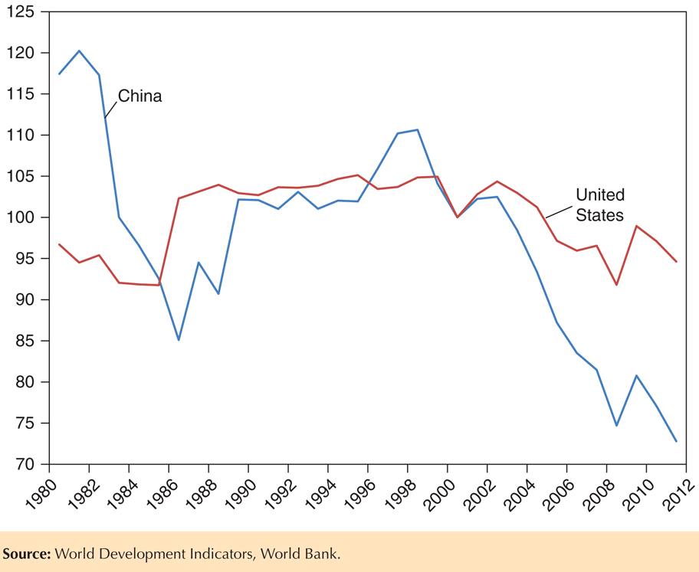Figure 6-8 shows the evolution of the terms of trade for both the United States and China over the last 30 years (normalized at 100 in 2000). We see that the magnitude of the yearly fluctuations in the terms of trade for the United States is small, with no clear trend over time. The U.S. terms of trade in 2011 is essentially at the same level as it was in 1980. Thus, there is no evidence that the United States has suffered any kind of sustained loss from a long-term deterioration in its terms of trade. Additionally, there is no evidence that China’s terms of trade have steadily appreciated as it has become increasingly integrated into the world economy. If anything, its terms of trade have deteriorated over the last decade. This effect was confirmed in a recent paper using much more detail on Chinese industrial production.9 The authors isolated the effects of Chinese manufacturing productivity growth (from 1995 to 2007) on its trading partners’ terms of trade and found that this effect was positive, though small at .7 percent.

1. Paul Samuelson, “Where Ricardo and Mill Rebut and Confirm Arguments of Mainstream Economists Supporting Globalization,” Journal of Economic Perspectives 18 (Summer 2004), pp. 135–146.
2. “Shaking up Trade Theory,” BusinessWeek, December 6, 2004
3. See, for example, “Clinton Doubts Benefits of Doha”, Financial Times, December 3, 2007.