8.1 Intra-Industry Trade in Action: The North American Auto Pact of 1964 and the North American Free Trade Agreement (NAFTA)

An unusually clear-cut example of the role of economies of scale in generating beneficial international trade is provided by the growth in automotive trade between the United States and Canada during the second half of the 1960s. While the case does not fit our model exactly since it involves multinational firms, it does show that the basic concepts we have developed are useful in the real world.

Before 1965, tariff protection by Canada and the United States produced a Canadian auto industry that was largely self-sufficient, neither importing nor exporting much. The Canadian industry was controlled by the same firms as the U.S. industry—a feature that we will address later in this chapter—but these firms found it cheaper to have largely separate production systems than to pay the tariffs. Thus, the Canadian industry was in effect a miniature version of the U.S. industry, at about 1/10 the scale.

The Canadian subsidiaries of U.S. firms found that small scale was a substantial disadvantage. This was partly because Canadian plants had to be smaller than their U.S. counterparts. Perhaps more importantly, U.S. plants could often be “dedicated”—that is, devoted to producing a single model or component—while Canadian plants had to produce several different things, requiring the plants to shut down periodically to change over from producing one item to producing another, to hold larger inventories, to use less specialized machinery, and so on. The Canadian auto industry thus had a labor productivity about 30 percent lower than that of the United States.

The Ambassador bridge connects Detroit in the United States to Windsor, Canada. On a typical day, $250 million worth of cars and car parts cross this bridge.

In an effort to remove these problems, the United States and Canada agreed in 1964 to establish a free trade area in automobiles (subject to certain restrictions). This allowed the auto companies to reorganize their production. Canadian subsidiaries of the auto firms sharply cut the number of products made in Canada. For example, General Motors cut in half the number of models assembled in Canada, however, the overall level of Canadian production and employment was maintained. Production levels for the models produced in Canada rose dramatically, as those Canadian plants became one of the main (and many times the only) supplier of that model for the whole North American market. Conversely, Canada then imported the models from the United States that it was no longer producing. In 1962, Canada exported $16 million worth of automotive products to the United States while importing $519 million worth. By 1968, the numbers were $2.4 and $2.9 billion, respectively. In other words, both exports and imports increased sharply: intra-industry trade in action.

The gains seem to have been substantial. By the early 1970s, the Canadian industry was comparable to the U.S. industry in productivity. Later on, this transformation of the automotive industry was extended to include Mexico. In 1989, Volkswagen consolidated its North American operations in Mexico, shutting down its plant in Pennsylvania. This process continued with the implementation of NAFTA (the North American Free Trade Agreement between the United States, Canada, and Mexico). In 1994, Volkswagen started producing the new Beetle in Puebla, Mexico. This plant now produces all the new model versions of the Golf, Jetta, and Beetle for the entire North American market. In 2011, Volkswagen reentered the U.S. market with a new assembly plant in Chattanooga, Tennessee, where all Passat models for the North American market are produced (they were previously imported from Europe). We discuss the effects of NAFTA in more detail later in this chapter.

8.2 Antidumping as Protectionism

In the United States and a number of other countries, dumping is regarded as an unfair competitive practice. U.S. firms that claim to have been injured by foreign firms that dump their products in the domestic market at low prices can appeal, through a quasi-judicial procedure, to the Commerce Department for relief. If their complaint is ruled valid, an “antidumping duty” is imposed, equal to the calculated difference between the actual and the “fair” price of imports. In practice, the Commerce Department accepts the great majority of complaints by U.S. firms about unfair foreign pricing. The determination that this unfair pricing has actually caused injury, however, is in the hands of a different agency, the International Trade Commission, which rejects about half of its cases.

Economists have never been very happy with the idea of singling out dumping as a prohibited practice. For one thing, setting different prices for different customers is a perfectly legitimate business strategy—like the discounts that airlines offer to students, senior citizens, and travelers who are willing to stay over a weekend. Also, the legal definition of dumping deviates substantially from the economic definition. Since it is often difficult to prove that foreign firms charge higher prices to domestic than to export customers, the United States and other nations instead often try to calculate a supposedly fair price based on estimates of foreign production costs. This “fair price” rule can interfere with perfectly normal business practices: A firm may well be willing to sell a product for a loss while it is lowering its costs through experience or breaking into a new market. Even absent such dynamic considerations, our model highlighted how monopolistically competitive firms have an incentive to lower their markups in export markets due to competition effects associated with trade costs.

In spite of almost universally negative assessments from economists, however, formal complaints about dumping have been filed with growing frequency since about 1970. In the early 1990s, the bulk of anti-dumping complaints were directed at developed countries. But since 1995, developing countries have accounted for the majority of anti-dumping complaints. And among those countries, China has attracted a particularly large number of complaints.

There are two main reasons behind this trend. First and foremost has been China’s massive export growth. No firm enjoys facing stiff increases in competition, and anti-dumping laws allow firms to insulate themselves from this competition by raising their competitors’ costs. Second, proving unfair pricing by a Chinese firm is relatively easier than for exporters from other countries. Most developed countries (including the United States) facing this surge in Chinese exports have labeled China a “non-market” economy. A BusinessWeek story describes the difference that this description makes when a U.S. firm files an anti-dumping complaint against a Chinese exporter: “That means the U.S. can simply ignore Chinese data on costs on the assumption they are distorted by subsidized loans, rigged markets, and the controlled yuan. Instead, the government uses data from other developing nations regarded as market economies. In the TV and furniture cases, the U.S. used India—even though it is not a big exporter of these goods. Since India’s production costs were higher, China was ruled guilty of dumping.”[1]

As the quote suggests, China has been subject to antidumping duties on TVs and furniture, along with a number of other products including crepe paper, hand trucks, shrimp, ironing tables, plastic shopping bags, steel fence posts, iron pipe fittings, saccharin, and most recently solar panels. These duties are high: as high as 78 percent on color TVs and 330 percent on saccharin.

8.3 Patterns of Foreign Direct Investment Flows Around the World

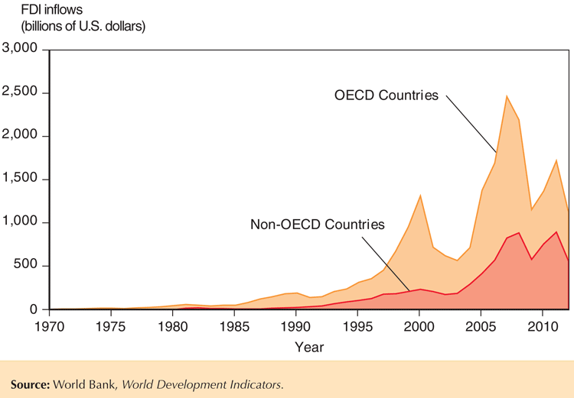Figure 8-9 shows how the magnitude of worldwide FDI flows has evolved over the last 40 years. We first examine patterns for the world, where FDI flows must be balanced: Hence world inflows are equal to world outflows. We see that there was a massive increase in multinational activity in the mid- to late-1990s, when worldwide FDI flows more than quintupled and then again in the early 2000s. We also see that the growth rate of FDI is very uneven, with huge peaks and troughs. Those peaks and troughs correlate with the gyrations of stock markets worldwide (strongly dominated by fluctuations in the U.S. stock market). The financial collapse in 2000 (the bursting of the dot-com bubble) and the most recent financial crisis in 2007–2009 also induced huge crashes in worldwide FDI flows. Most recently, global FDI flows sharply declined in 2012, even though world GDP grew and the largest stock markets all posted significant gains. (Uncertainty related to the fragility of the economic recovery and political stability played a significant role—as well as the repatriation of profits by multinationals.) Most of those FDI flows related to crossborder mergers and acquisitions, whereas greenfield FDI remained relatively stable.

Looking at the distribution of FDI inflows across groups of countries, we see that historically, the richest OECD countries have been the biggest recipients of inward FDI. However, we also see that those inflows are much more volatile (this is where the FDI related to mergers and acquisitions is concentrated) than the FDI going to the remaining countries with lower incomes. Finally, we also see that there has been a steady expansion in the share of FDI that flows to those countries outside the OECD. This accounted for over half of worldwide FDI flows since 2009. The BRICS countries (Brazil, the Russian Federation, China, India, and South Africa) have accounted for a substantial portion of this increase: FDI flows to those countries increased 20-fold in the past decade.

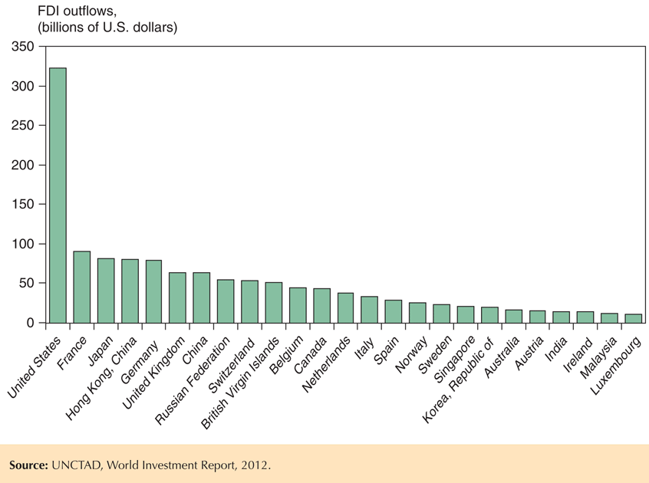Figure 8-10 shows the list of the top 25 countries whose firms engage in FDI outflows. Because those flows are very volatile, especially with the recent crisis, they have been averaged over the past three years. We see that FDI outflows are still dominated by the developed economies; but we also see that big developing countries, most notably China (including Hong Kong), are playing an increasingly important role. In fact, one of the fastest-growing FDI segments is flows from developing countries into other developing countries. Multinationals in both China and India play a prominent role in this relatively new type of FDI. We also see that international tax policies can shape the location of FDI. For example, the British Virgin Islands would not figure in that top-25 list were it not for its status as an international tax haven.[2] Firms from that location that engage in FDI are mainly offshore companies: They are incorporated in the British Virgin Islands, but their productive activities are located elsewhere in the world.

FDI flows are not the only way to measure the presence of multinationals in the world economy. Other measures are based on economic activities such as sales, value added (sales minus purchased intermediate goods), and employment. Sales of FDI affiliates are often used as the benchmark of multinational activity. This provides the relevant benchmark when comparing the activities of multinationals to export volumes. However, the sales of multinationals are also often compared to country GDPs showing, for example, that the big multinationals have higher sales volumes than the GDPs of many countries in the world. For the world as a whole in 2000, the total sales of the largest multinationals (top 200) amounted to more than 27 percent of world GDP.

However striking, this comparison is misleading and overstates the influence of multinationals because country GDP is measured in terms of value added: Intermediate goods used in final production are not double-counted in this GDP measure. On the other hand, the intermediate goods that one multinational sells to another are double-counted in the multinationals’ sales totals (once in the sales of the producer of the intermediate goods and another time as part of the final value of the goods sold by the user of the intermediate goods). As a result, the appropriate comparison between multinationals and GDPs should be based on value added. By this metric, the value added produced by the biggest multinationals accounted for 4.3 percent of world GDP in 2000. This is still a big percentage, but not as eye-catching as the 27 percent measure.

8.4 Shipping Jobs Overseas? Offshoring and Unemployment in the United States

When a company offshores part of its production chain abroad, it is then importing an intermediate good or service. For example, a company may import a part, component, or even an entire assembled product; or it may import business services by using accountants and/or call centers located abroad. As we discuss in the next section, the overall effects of trade in such intermediates are very similar to the trade in final goods that we have focused on up to now. Yet, when it comes to the effects of offshoring on employment, there is one additional dimension: the lower price of the imported intermediates not only benefits a firm’s owners and their consumers, it also benefits the firm’s remaining workers—because the lower price induces firms to increase their purchases of intermediates, which improves the productivity of the remaining workers.[3]

This productivity effect also induces the offshoring firm to hire additional workers dedicated to the remaining parts of the production process. In many cases, the overall employment effect for the offshoring firm is positive: Several studies of U.S. multinationals have found that when they expand their overseas employment, they concurrently also expand their U.S. employment.[4]

What about foreign outsourcers who no longer maintain ownership of their foreign suppliers? A recent study covering the entire U.S. manufacturing sector found that overall, increases in offshoring from 2001–2007 did have a negative impact on U.S. manufacturing employment.[5] However, those losses connected to offshoring accounted for only a tiny fraction (2.3%) of the total employment losses during that period. Those total employment losses were indeed substantial: The decrease in U.S. manufacturing employment totaled 2 million (manufacturing employment has been steadily decreasing over the past 30 years); but offshoring played a very minor role in this trend.

This study also found that the productivity effect for the remaining workers played a very important role: The cost benefits from offshoring lead firms to substantially expand their U.S. operations and hire additional workers. Nonproduction workers benefited most from this increased employment because they were much less likely to directly suffer from the displacement effect of offshoring in the first place. However, production workers also benefited from this expansion effect tied to offshoring: The initial displacement unemployment for those production workers was cut in half by this increased employment response.

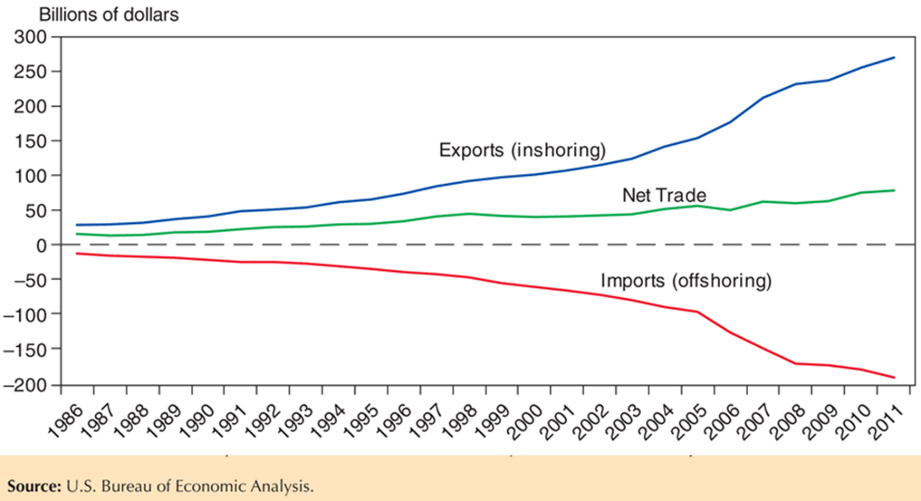Another channel mitigating the worker displacement effects of offshoring is that—just as with trade in final goods—intermediate goods and services are traded in both directions. In the United States, the popular press and many politicians single-out the employment losses associated with offshoring.[6] Of particular concern are the losses of service jobs to offshoring, given the recent technological trends that have vastly expanded the scope of “offshorable’’ business services (see the discussion in Chapter 2). This has lead to headlines such as “More U.S. service jobs go overseas; Offshoring is expected to grow” in the USA Today.[7] Yet, offshoring in one country is inshoring in another country: That is, for every import transaction of an intermediate good or service, there is a corresponding export transaction for the country hosting the offshored part of the production process. And it turns out that for the United States, this inshoring of service jobs (exports of intermediate services) is growing even faster than the offshoring of service jobs out of the United States (imports of intermediate services), leading to a surplus; and one that has been growing over time. Figure 8-11 plots all U.S. cross-border trade over time in service categories related to offshoring (financial, insurance, telecommunications, and business services; that is, all traded services other than tourism, transportation, and royalties).[8] Clearly, there is nothing ominous in the time trend of trade in business services for overall U.S. employment.

Given all these facts on the impact of offshoring for U.S. employment, the view that offshoring simply amounts to “shipping jobs overseas” is misleading. True, when a firm based in the United States moves a call center to India, or moves the assembly of its product to China, then some specific jobs that used to be performed in the United States are now performed in India or China. However, the evidence shows that in terms of overall employment, those jobs are replaced by other ones in the United States: some related to the expansion effect at the offshoring firms and others by firms providing intermediate goods and services to firms located abroad (inshoring). Yet, just as with other forms of trade, trade in intermediates has substantial consequences for the distribution of income. Those call center or manufacturing workers displaced by offshoring are often not the ones who are hired by the expanding firms. Their plight is not made any easier by the gains that accrue to other workers. We discuss these overall welfare consequences in the next section.

1. “Wielding a Heavy Weapon Against China,” BusinessWeek, June 21, 2004.
2. The British Virgin Islands is an even bigger recipient of inward FDI: In 2012, it was the fifth largest recipient in the world.
3. This additional dimension of offshoring, and its effects for low-skilled workers, is emphasized in an influential new paper. See Gene M. Grossman and Esteban Rossi-Hansberg. “The Rise of Offshoring: It’s Not Wine for Cloth Anymore.” The New Economic Geography: Effects and Policy Implications, 2006, pp. 59–102.
4. See Mihir Desai, C. Fritz Foley, and James R Hines. “Domestic Effects of the Foreign Activities of US Multinationals.” American Economic Journal: Economic Policy, (January 2009).
5. See Greg C. Wright, “Revisiting the Employment Impact of Offshoring.” University of Essex, mimeo, 2013.
6. Public Citizen reported a sharp increase in political ads condemning offshoring in the 2012 congressional elections (it tracked 90 ads condemning offshoring in campaigns spanning 30 states).
7. USA Today, December 7, 2012.
8. Those trade flows also include transactions by multinationals with their affiliates abroad. The net balance of exports over imports is positive for the United States, both among multinational transactions, as well as for transactions between unaffiliated parties.