9.1 Tariffs for the Long Haul

We just saw how a tariff can be used to increase producer surplus at the expense of a loss in consumer surplus. There are also many other indirect costs of tariffs: They can lead trading partners to retaliate with their own tariffs (thus hurting exporting producers in the country that first imposed the tariff); they can also be fiendishly hard to remove later on even after economic conditions have completely changed, because they help to politically organize the small group of producers that is protected from foreign competition. (We will discuss this further in Chapter 10.) Finally, large tariffs can induce producers to behave in creative— though ultimately wasteful—ways in order to avoid them.

In the case of the tariff known as the “Chicken Tax,” the tariff lasted for so long (47 years and counting) that it ended up hurting the same producers that had intensively lobbied to maintain the tariff in the first place![1] This tariff got its name because it was a retaliation by U.S. President Lyndon Johnson’s administration against a tariff on U.S. chicken exports imposed by Western Europe in the early 1960s. The U.S. retaliation, focusing on Germany (one of the main political forces behind the original chicken tariff), imposed a 25 percent tariff on imports of light commercial truck vehicles. At the time, Volkswagen was a big producer of such vehicles and exported many of them to the United States. As time went by, many of the original tariffs were dropped, except for the ones on chickens and light commercial trucks. Volkswagen stopped producing those vehicles, but the U.S. “big three” auto and truck producers were then concerned about competition from Japanese truck producers and lobbied to keep the tariff in place. Japanese producers then responded by building those light trucks in the United States (see Chapter 8).

As a result, the latest company to be hit by the consequences of the tariff is Ford, one of those “big three” U.S. producers! Ford produces a small commercial van in Europe, the “Transit Connect,” which is designed (with its smaller capacity and ability to navigate old, narrow streets) for European cities. The recent spike in fuel prices sharply increased demand in some U.S. cities for this truck. In 2009, Ford started selling these vehicles in the United States. To get around the 25 percent tariff, Ford installs rear windows, rear seats, and seat belts prior to shipping the vehicles to the United States. These vehicles are no longer classified as commercial trucks but as passenger vehicles, which are subject to the much lower 2.5 percent tariff. Upon arrival in Baltimore, Maryland, the rear seats are promptly removed and the rear windows replaced with metal panels—before delivery to the Ford dealers.

9.2 Europe’s Common Agricultural Policy

In 1957, six Western European nations—Germany, France, Italy, Belgium, the Netherlands, and Luxembourg—formed the European Economic Community, which has since grown to include most of Europe. Now called the European Union (EU), its two biggest effects are on trade policy. First, the members of the European Union have removed all tariffs with respect to each other, thus creating a customs union (discussed in the next chapter). Second, the agricultural policy of the European Union has developed into a massive export subsidy program.

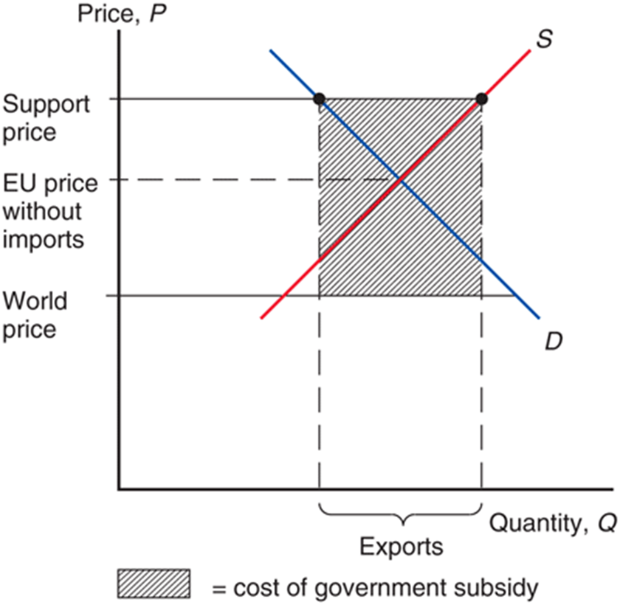The European Union’s Common Agricultural Policy (CAP) began not as an export subsidy but as an effort to guarantee high prices to European farmers by having the European Union buy agricultural products whenever the prices fell below specified support levels. To prevent this policy from drawing in large quantities of imports, it was initially backed by tariffs that offset the difference between European and world agricultural prices.

Since the 1970s, however, the support prices set by the European Union have turned out to be so high that Europe— which, under free trade, would be an importer of most agricultural products—was producing more than consumers were willing to buy. As a result, the European Union found itself obliged to buy and store huge quantities of food. At the end of 1985, for example, European nations had stored 780,000 tons of beef, 1.2 million tons of butter, and 12 million tons of wheat. To avoid unlimited growth in these stockpiles, the European Union turned to a policy of subsidizing exports to dispose of surplus production.

Figure 9-12 shows how the CAP works. It is, of course, exactly like the export subsidy shown in Figure 9-11, except that Europe would actually be an importer under free trade. The support price is set not only above the world price that would prevail in its absence but also above the price that would equate demand and supply even without imports. To export the resulting surplus, an export subsidy is paid that offsets the difference between European and world prices. The subsidized exports themselves tend to depress the world price, increasing the required subsidy. A recent study estimated that the welfare cost to European consumers exceeded the benefits to farm producers by nearly $30 billion (21.5 billion euros) in 2007.[2]

Despite the considerable net costs of the CAP to European consumers and taxpayers, the political strength of farmers in the EU has been so strong that the program has been difficult to rein in. One source of pressure has come from the United States and other food-exporting nations, which complain that Europe’s export subsidies drive down the price of their own exports. The budgetary consequences of the CAP have also posed concerns: In 2013, the CAP cost European taxpayers $78 billion (58 billion euros)—and that figure doesn’t include the indirect costs to food consumers. Government subsidies to European farmers are equal to about 22 percent of the value of farm output, more than twice the U.S. figure of 8.6 percent. (U.S. agriculture subsidies are more narrowly targeted on a subset of crops.)

Recent reforms in Europe’s agricultural policy represent an effort to reduce the distortion of incentives caused by price support while continuing to provide aid to farmers. If politicians go through with their plans, farmers will increasingly receive direct payments that aren’t tied to how much they produce; this should lower agricultural prices and reduce production.

9.3 An Import Quota in Practice: U.S. Sugar

The U.S. sugar problem is similar in its origins to the European agricultural problem: A domestic price guarantee by the federal government has led to U.S. prices above world market levels. Unlike the European Union, however, the domestic supply in the United States does not exceed domestic demand. Thus, the United States has been able to keep domestic prices at the target level with an import quota on sugar.

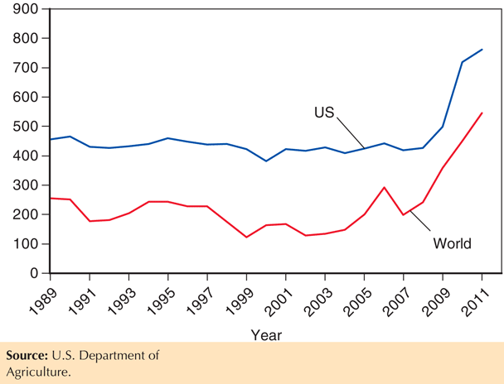A special feature of the import quota is that the rights to sell sugar in the United States are allocated to foreign governments, which then allocate these rights to their own residents. As a result, rents generated by the sugar quota accrue to foreigners. The quotas restrict the imports of both raw sugar (almost exclusively, sugar cane) as well as refined sugar. Figure 9-13 shows the effect of the U.S. import restrictions on the price of raw sugar in the United States relative to the world price. As we can see, these import restrictions have been quite successful in raising the U.S. domestic price above the world price. When the world sugar price sharply increased in 2010–2011, the import restrictions were eased but not enough to limit sharp increases in the U.S. price—which still remained well above the world price.

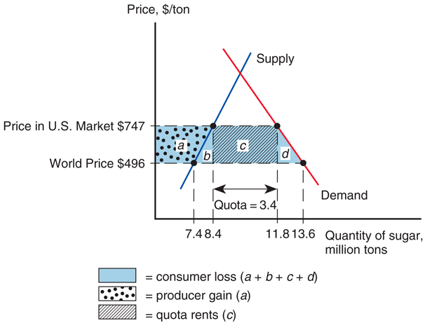We now describe the most recent forecast for the effects of these import restrictions and the associated higher sugar prices.[3] Figure 9-14 shows the raw sugar market equilibrium with and without the quota restriction. Currently, the quota limits imports of raw sugar to $3.4 million tons, while U.S. production totals 8.4 million tons. This leads to a U.S. sugar price that is 34% above the world price. Absent import restrictions, the U.S. price would drop down to the world price level. The figure is drawn assuming the United States is “small” in the world market for raw sugar; that is, removing the quota would not have a significant effect on the world price. According to this estimate, free trade would increase sugar imports by 84 percent and an associated 11 percent contraction in domestic production.

The welfare effects of the import quota are indicated by the areas a, b, c, and d. Consumers lose the surplus a + b + c + d associated with the higher price. Part of this consumer loss represents a transfer to U.S. sugar producers, who gain the producer surplus a. Part of the loss represents the production distortion b and the consumption distortion d. The rents to the foreign governments that receive import rights are summarized by area c.

In order to put dollar figures on these welfare effects, one must take into account how the higher raw sugar price leads to a higher refined sugar price, which then feeds into higher prices for all food products containing sugar. Even though the ultimate food price increases paid by U.S. consumers are modest—on the order of 0–2 percent—the total consumer surplus losses are massive because those price increases apply to such a large basket of widely consumed goods. The estimated consumer loss for 2014 (relative to a hypothetical outcome where the sugar quota is phased out in 2013) is $3.5 billion! In addition, the higher prices for refined sugar also generate producer surplus losses for the food industry (all food producers who use refined sugar as an ingredient). This adds another $909 million to the consumer losses, for a total cost estimate of $4.4 billion associated with the U.S. sugar quota.

Of course, U.S. sugar producers gain from the higher sugar prices. Their estimated gain for 2014 totals $3.9 billion. (Most of those gains go to sugar processors/ refiners, with “only” $486 million going to sugar farmers.) Lastly, foreign sugar exporters who have been allocated the rights to sell sugar into the United States also benefit from those quota rights—as they pocket the difference between the higher U.S. price relative to the world price. (Several of those foreign sugar exporters are owned by large U.S. sugar processors.) This gain makes up most of the differential between the $4.4 billion loss to sugar users (consumers and food producers) and the $3.9 billion gain to sugar producers, as the deadweight losses are relatively minor.

The sugar quota illustrates in an extreme way the tendency of protection to provide benefits to a small group of producers, each of whom receives a large benefit, at the expense of a large number of consumers, each of whom bears only a small cost. In this case, the yearly consumer loss amounts to “only” $11 per capita, or a little under $30 for a typical household. Not surprisingly, the average American voter is unaware that the sugar quota exists, and so there is little effective opposition.

From the point of view of the raw sugar producers (farmers and processors), however, the quota is a life-or-death issue. These producers employ only about 20,000 workers, so the producer gains from the quota represent an implicit subsidy of about $200,000 per worker. It should be no surprise that these sugar producers are very effectively mobilized in defense of their protection. They donated more than $4.5 million in the 2012 congressional races, and the American Sugar Alliance spent an additional $3 million on lobbying expenses in the 12 months period leading up to the 2013 congressional vote on the U.S. farm bill (which reauthorizes the restrictions on U.S. imports of sugar).[4]

Opponents of protection often try to frame their criticism not in terms of consumer and producer surplus but in terms of the cost to consumers of every job “saved” by an import restriction. Clearly, the loss of the $200,000 subsidy per employee indirectly provided by the quota would force sugar producers to contract and reduce their employment. Estimates for this employment contraction vary between 500 and 2000 workers. Even taking this larger employment loss, the sugar quota would still cost the U.S. consumer $1.75 million per job saved. And this cost does not factor in all the job losses that high sugar prices impose on the food industry. If the sugar restrictions were lifted, the drop in the refined sugar price would induce a substantial expansion in the sugar-using food industry. We already mentioned the associated $909 million increase in producer surplus for those sectors; but this expansion would also generate 17,000–20,000 new jobs. In fact, the expansion would be big enough to turn the United States from a net importer to a net exporter of sugar-containing foods. Comparing the figures for jobs saved by sugar producers (500–2,000) with the figures for jobs lost in the food sector (17,000–20,000), we see that the employment dimension of protection is no longer that the consumer cost per job saved is astronomically high; rather, it is plainly that jobs are being lost, and not saved, by the sugar quota.

9.4 A Voluntary Export Restraint in Practice

**Japanese Autos**

For much of the 1960s and 1970s, the U.S. auto industry was largely insulated from import competition by the difference in the kinds of cars bought by U.S. and foreign consumers. U.S. buyers, living in a large country with low gasoline taxes, preferred much larger cars than Europeans and Japanese, and, by and large, foreign firms had chosen not to challenge the United States in the large-car market.

In 1979, however, sharp oil price increases and temporary gasoline shortages caused the U.S. market to shift abruptly toward smaller cars. Japanese producers, whose costs had been falling relative to those of their U.S. competitors in any case, moved in to fill the new demand. As the Japanese market share soared and U.S. output fell, strong political forces in the United States demanded protection for the U.S. industry. Rather than act unilaterally and risk creating a trade war, the U.S. government asked the Japanese government to limit its exports. The Japanese, fearing unilateral U.S. protectionist measures if they did not do so, agreed to limit their sales. The first agreement, in 1981, limited Japanese exports to the United States to 1.68 million automobiles. A revision raised that total to 1.85 million in 1984. In 1985, the agreement was allowed to lapse.

The effects of this voluntary export restraint were complicated by several factors. First, Japanese and U.S. cars were clearly not perfect substitutes. Second, the Japanese industry to some extent responded to the quota by upgrading its quality and selling larger autos with more features. Third, the auto industry is clearly not perfectly competitive. Nonetheless, the basic results were what the discussion of voluntary export restraints earlier would have predicted: The price of Japanese cars in the United States rose, with the rent captured by Japanese firms. The U.S. government estimates the total costs to the United States to be $3.2 billion in 1984, primarily in transfers to Japan rather than efficiency losses.

**Chinese Solar Panels**

Although voluntary export restraints are no longer allowed under WTO rules, this only applies to an agreement negotiated by governments and imposed onto exporters. Recently, a European Union–China trade dispute over a surge in Chinese exports of solar panels was resolved by the Chinese producers “agreeing” to limit their exports to EU countries below 7 gigawatts-worth of solar panels per year—along with a minimum price floor for those units. EU solar panel makers were disappointed, as this agreement forestalled the imposition of 47 percent anti-dumping duties on all Chinese solar panel imports (the threat that generated those concessions by Chinese solar panel producers). However, the imposition of the anti-dumping duties would have triggered a significant retaliation from China, whose officials had already drawn up a list of European products—including luxury fashion goods and wines—that would be subjected to stiff import duties into China. Chinese producers were persuaded to agree to the export limit and price floor instead, since this would allow them to keep the higher prices charged in the European Union. The main losers are European consumers, who will pay substantially more for solar power (and the environment).

9.5 Bridging the Gap

**I**n Chapter 8, we discussed how trade in intermediate goods—just like trade in final goods—generates aggregate welfare gains (though gains that are far from evenly distributed). In addition, access to cheaper imported intermediate goods generates private gains for firms as they expand their scale of production. It may therefore seem surprising that U.S. government agencies (at the local, state, and federal level) are expressly forbidden to take advantage of such opportunities. The U.S. Buy American Act, originally passed in 1933, requires those government agencies to purchase many specific inputs from U.S. firms—unless the foreign bid for that input is more than 25 percent below the lowest bid from a U.S. firm. This provision was written into the American Recovery and Re-Investment Act of 2009 (ARRA), the $831 billion stimulus package that was passed in the wake of the severe economic recession. Any public work project funded by the ARRA must use iron, steel, and manufactured goods made in the United States (subject to that same 25 percent differential).

Typically, the percentage difference between the U.S. and foreign bids is substantially below 25 percent, so the Buy American provision results in a cost increase well below the 25 percent maximum. However, China is developing unique capabilities in the production of some highly specialized steel products dedicated to very large-scale infrastructure projects (due in large part to the experience generated from the high demand for such projects in China). For those specialized steel products, the cost difference between Chinese producers and the tiny handful of U.S. firms with the required production capacity is approaching that 25 percent maximum—a very large differential, especially given the massive scale of several infrastructure projects.

For the construction of the new Bay Bridge linking San Francisco and Oakland, the 23 percent difference between the Chinese bid and the lone U.S. bid for some key steel components amounted to a $400 million cost difference, which was so large that the state of California was pushed to forego federal funds under the ARRA and rely instead on bonds financed by future tolls. This financing option is not available for many other infrastructure projects, which must then incur the substantially higher costs associated with the Buy American provisions.

Those provisions not only raise the cost to U.S. taxpayers, they also induce substantial delays in some essential projects as managers navigate the administrative paperwork required to show that some key components are entirely unavailable in the United States. This happened to the Department of Homeland Security, which was unable to operate its electronic baggage screening systems until its contractor was allowed to buy some key foreign components needed for integration with the airports’ security systems. Lastly, the Buy American provisions have also triggered similar protectionist clauses from other foreign governments, shutting out U.S. firms from those business opportunities.

1. See Matthew Dolan, “To Outfox the Chicken Tax, Ford Strips Its Own Vans,” Wall Street Journal, September 23, 2009.
2. See Pierre Boulanger and Patrick Jomini, Of the Benefits to the EU of Removing the Common Agricultural Policy, Sciences Politique Policy Brief, 2010.
3. These estimates are for 2014, assuming the import restrictions are eliminated in 2013. For further details, see Beghin, John Christopher and Amani Elobeid, “The Impact of the U.S. Sugar Program Redux.” Food and Agricultural Policy Research Institute (FAPRI) Publications, 2013.
4. An amendment to phase out the sugar import restrictions was introduced to the 2013 Farm Bill (Sugar Reform Act of 2013). It was narrowly defeated by votes of 45–54 in the Senate and 206–221 in the House.