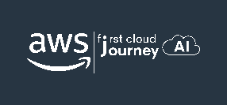

AWS First Cloud AI Journey – Project Plan

[Chubabi Munhanho] – [University] – [Coffee Shop Order Platform]

[1/12/2025]
Table of Contents
1 BACKGROUND and motivation 3
1.1 executive summary 3
1.2 PROJECT SUCCESS CRITERIA 3
1.3 Assumptions 3
2 SOLUTION ARCHITECTURE / ARCHITECTURAL DIAGRAM 3
2.1 Technical Architecture Diagram 3
2.2 Technical Plan 4
2.3 Project Plan 4
2.4 Security Considerations 4
3 Activities AND Deliverables 5
3.1 Activities and deliverables 5
3.2 OUT OF SCOPE 5
3.3 PATH TO PRODUCTION 5
4 EXPECTED AWS COST BREAKDOWN BY SERVICES 5
5 TEAM 6
6 resources & cost estimates 6
7 Acceptance 7

BACKGROUND and motivation

executive summary
The “Coffee Cloud – Coffee Shop Order Platform” project is a web platform that helps customers order coffee online, accumulate points after each order, and redeem promotional vouchers.
The system supports three user groups: Customer, Shipper, and Admin, aiming to optimize the ordering experience, delivery, and operational management of the coffee shop.
The frontend application is built with ReactJS, backend with C#/.NET running on AWS Lambda, connected via API Gateway and deployed entirely on AWS Free Tier with services: Amplify (Hosting + CI/CD), Cognito (Authentication), Lambda .NET (Backend logic), Location Service, S3 Storage, DynamoDB, SNS (Notifications), SES (Email Service), IAM, and CloudWatch Logs.

PROJECT SUCCESS CRITERIA
Business Success:
• Increase coffee shop revenue by 25% through online ordering
• Reduce customer waiting time by 50%
• Achieve 90% customer satisfaction score
• Get return on investment within 6 months
Technical Success:
• Complete project in 12 weeks (3 months)
• Deploy working system on AWS with 99% uptime
• Handle 100+ concurrent orders smoothly
• Keep monthly costs under $5 using AWS Free Tier
• Mobile-friendly design works on all devices
System Features Success:
• Customer can order online and earn points
• Shipper can receive and track deliveries
• Admin can manage orders and inventory
• Real-time notifications work properly
• Secure login system for 3 user types

Assumptions
Technical Assumptions:
• AWS Free Tier services available for development
• Development team knows ReactJS and C#/.NET
• Stable internet connection for cloud development
• AWS services (Lambda, DynamoDB, etc.) work as expected
Business Assumptions:
• Coffee shop provides product info and requirements
• Customers have smartphones to use the app
• Business owner available for feedback during development
• Market demand exists for online coffee ordering
Project Constraints:
• Fixed 12-week timeline
• Must use AWS Free Tier to minimize costs
• Team has beginner-level AWS experience
• No existing systems to integrate with
Main Risks:
• May exceed AWS Free Tier limits (cost risk)
• Integration between AWS services might be complex
• Security of customer data needs careful handling
• Timeline is tight for learning and development

SOLUTION ARCHITECTURE / ARCHITECTURAL DIAGRAM

Technical Architecture Diagram
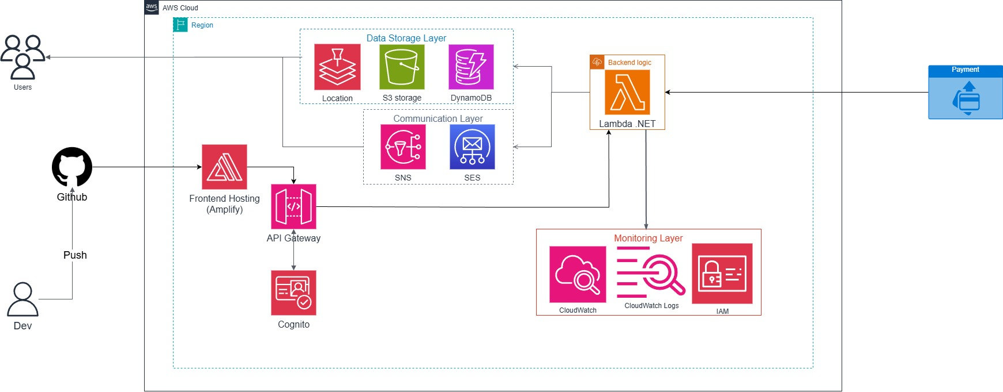
Tools Being Used:
• Visual Studio/VS Code for development
• Github for version control
• AWS CLI for deployment
• Swagger for API testing
• React Developer Tools for frontend debugging

Technical Plan
The development team will create Infrastructure as Code using AWS CDK with C#. This allows for quick and repeatable deployments into AWS accounts. All critical user workflows (ordering, payment, delivery tracking) will include extensive test coverage. Unit tests and integration tests will cover backend Lambda functions and frontend React components.

Project Plan
[Partner] will adopt the Agile Scrum framework over x8 2-week sprints. Stakeholders from team are required to participate in Sprint Reviews and Retrospect. The following team responsibilities is proposed [...]. Communication cadences are based on [...]. Knowledge transfer sessions will be conducted by […]

Security Considerations
1) Access Control:
• AWS IAM roles with least privilege principle
• Multi-Factor Authentication (MFA) for AWS account access
• Amazon Cognito for user authentication with strong password policies
2) Infrastructure Security:
• API Gateway rate limiting to prevent DDoS attacks
• Lambda functions run in isolated execution environments
3) Data Protection:
• Data encryption at rest in DynamoDB
• Data encryption in transit using HTTPS/TLS
• Personal customer data handling following privacy best practices
4) Detection & Monitoring:
• CloudWatch alarms for unusual activity patterns
• Real-time monitoring of system performance and errors
5) Incident Management:
• CloudWatch alerts for system failures
• Backup and recovery procedures for DynamoDB data

Activities AND Deliverables

Activities and deliverables
[Provide project milestones with timeline and respective deliverables, corresponding to the items and activities described in the Scope of Work / Technical Project Plan section. Indicate plans on how to govern the project/ change management; communication plans; transition plans]
Project Phase | Timeline | Activities | Deliverables/Milestones | Total man-day
Assessment & Design | Week 1-2 | - Analyze business requirements  - Create UI/UX wireframes  - Setup AWS account | - UI mockups  - AWS account configured | [10 man-day]
Setup base infrastructure | Week 3-4 | - Configure AWS services  - Setup DynamoDB tables  - Configure Cognito User Pools | - DynamoDB tables created  - Cognito authentication ready  - API Gateway endpoints configured | [8 man-day]
Backend Development | Week 5-8 | - Develop Lambda functions (C#/.NET)  - Implement business logic  - Setup SNS/SES notifications  - API integration testing | - Lambda functions deployed  - Business APIs working  - Notification system functional | [18 man-day]
Frontend Development | Week 9-11 | - Build ReactJS components  - Implement user interfaces  - Integrate with backend APIs | - Customer portal completed  - Shipper interface ready  - Admin dashboard functional | [20 man-day]
Testing & Golive | Week 11-12 | - Unit and integration testing  - User acceptance testing  - Performance testing  - Production deployment | - Test reports completed  - Performance benchmarks met | [3 man-day]

OUT OF SCOPE
• Advanced analytics and business intelligence dashboards
• Advanced inventory forecasting and automated procurement
• Custom mobile native apps (iOS/Android) - web app only
• Payment gateway integration - cash/manual payment processing only
• Loyalty program integration with external partners
• Advanced reporting and export features
• Custom branding beyond basic logo/color changes

PATH TO PRODUCTION
The Coffee Cloud platform will be built as a Minimum Viable Product (MVP) with core ordering functionality outlined in the scope. It will include essential features for online ordering, user management, and basic notifications.
Key Gaps for Full Production:
• Advanced Security: Enhanced security features like fraud detection, advanced monitoring, and compliance certifications may be needed
• Scalability Optimization: Current design handles hundreds of concurrent users. Production may require auto-scaling configurations and performance optimization
• Backup & Disaster Recovery: Enhanced backup strategies and disaster recovery procedures for business continuity
• Advanced Analytics: Production system may need detailed business analytics, sales reports, and customer behavior tracking

Production Optimization Requirements:
• Error Handling: Extended error handling and user-friendly error messages across all scenarios
• Performance Testing: Load testing with realistic traffic patterns and optimization based on results
• Monitoring: Enhanced CloudWatch dashboards, custom metrics, and alerting for business KPIs
• Documentation: Comprehensive operational runbooks and troubleshooting guides
• Compliance: Additional security audits and compliance certifications if required by business regulations

EXPECTED AWS COST BREAKDOWN BY SERVICES

AWS Service | Usage Estimate | Monthly Cost (USD) | Annual Cost (USD)
AWS Amplify | 1000 build minutes, 15GB storage | $0.00 (Free Tier) | $0.00
AWS Lambda | 500K requests/month, 512MB memory | $0.00 (Free Tier) | $0.00
Amazon API Gateway | 500K API calls/month | $0.00 (Free Tier) | $0.00
Amazon DynamoDB | 25GB storage, 25 RCU/WCU | $0.00 (Free Tier) | $0.00
Amazon S3 | 5GB storage, 10K requests | $0.00 (Free Tier) | $0.00
Amazon Cognito | 10,000 monthly active users | $0.00 (Free Tier) | $0.00
Amazon SNS | 50K notifications/month | $0.00 (Free Tier) | $0.00
Amazon SES | 10K emails/month | $0.00 (Free Tier) | $0.00
Amazon Location Service | 10K geocoding requests/month | $0.00 (Free Tier) | $0.00
Amazon CloudWatch | Basic monitoring, 5GB logs | $0.00 (Free Tier) | $0.00
AWS IAM | User and role management | $0.00 (Always Free) | $0.00
TOTAL DEVELOPMENT PHASE |  | $0.00 | $0.00

TEAM
Partner Project Team
Name | Title | Role | Email / Contact Info
Huynh Minh Tam | Sub Leader / Frontend Dev / Backend Dev | ReactJS development, UI/UX implementation, CI/CD, deployment
Vo Dong Dang Khoa | Team Leader / Backend Dev | AWS Lambda, API development, database design
Nguyen Hoang Quan | Backend Dev
Nguyen Phuc Hau | Frontend Dev
Dinh Phuc | Backend Dev
Steve Jones Delivery Manager Project Manager
Philip McDaniels Sr. Solutions Architect Architect; Technical Lead

resources & cost estimates

Resource | Responsibility | Rate (USD) / Hour
Solution Architects [number of assigned headcount]
Engineers [number of assigned headcount]
Other (Please specify)

* Note: Refer to section “activities & deliverables” for the list of project phases
Project Phase | Solution Architects | Engineers | Other  (Please specify) | Total Hours
Total Hours
Total Cost

Cost Contribution distribution between Partner, Customer, AWS:
Party | Contribution (USD) | % Contribution of Total
Customer
Partner
AWS

Acceptance
[To conclude a project, define acceptance process here. For example:
Upon completion of a Phase, PROVIDER will submit the associated tangible Deliverables, to Customer accompanied by an Acceptance Form in the form set forth in Appendix B to this SOW. Upon such submission, Customer will review, evaluate and/or test, as the case may be, the applicable Deliverable(s) within eight (8) business days (the “Acceptance Period”) to determine whether or not each Deliverable(s) satisfies the acceptance criteria for the particular Deliverable in all material respects. If the Deliverable satisfies its acceptance criteria in all material respects, Customer will furnish a written acceptance confirmation to PROVIDER via the Acceptance Form prior to the end of the Acceptance Period. For a Deliverable that is not accepted due to a non-conformity or defect, Customer will indicate the detailed reasons for such rejection on the Acceptance Form and return the Acceptance Form together with the associated tangible rejected Deliverables, if any, to PROVIDER (a “Rejection Notice”) within the Acceptance Period. Upon receipt of a Rejection Notice, PROVIDER will promptly correct any defects or non-conformities to the extent required so that each Deliverable satisfies the requirements of this SOW and its acceptance criteria in all material respects. Thereafter, PROVIDER will resubmit a modified Deliverable to Customer, accompanied by the Acceptance Form and the process set forth above will be repeated. However, Customer will limit its review, evaluation and/or test of each resubmitted Deliverable to determining whether or not PROVIDER has corrected the defects or non-conformities identified in the Rejection Notice and to the effects or impact which PROVIDER’s corrections or modifications have on other Deliverables or other portions of the same Deliverable. If Customer fails to provide PROVIDER with the above described Rejection Notice prior to the end of the applicable Acceptance Period, then the corresponding Deliverable(s) are deemed accepted.]

