**Image Service**

**Manager Manual**

Kaihua Zhou 999482983  
Ya Han Yang 1004550700

Introduction

The manager UI of Image Service mainly has four different features: view and destroy specified instance, create and destroy random instance, configure auto scaling parameters, and delete everything in user UI instances. This document provides instructions on how to use each of these features.

# View and Destroy Specified Instance

You need to first navigate to our Instance List page by clicking on the ‘SEE LIST OF EC2’ button.





The number of available user ui instances means the number of running or pending user ui instances.

## View Instance Detail

Once you’ve reached to the Instance List page, you are able to see ‘Details’ button beside each of the running instances. This button is not available for pending/stopping/stopped/shutting-down/terminated instances.

Once clicking on the ‘Details’ button, you will be redirected to the detail page which includes the instance’s ID, AMI ID, key pair name, public IP address, state, CPU usage graph, Network In and Network Out graph. You can return to Instance List page by clicking on the ‘Back’ button.

If the instance is running but still initializing, you will see a message ‘Instance is still initializing’ in red on top of the detail page.

## Destroy Specified Instance

On the Instance List page, you will also be able to see ‘Destroy’ button beside instances that is not shutting-down or terminated and is not the original manager UI or original user UI instance.

Clicking on the ‘Destroy’ button will terminate that specified instance.

# Configure Worker Pool

You can navigate this page by clicking on the “CONFIGURE WORKER POOL” button on the Instance List page.



In case if no configuration needed, you can return to the Instance List page by clicking on the “RETURN TO LIST OF EC2” button at the bottom of the page.

## Create New Instance and Destroy Random Instance

On the configuration page, you will be able to see ‘create’ and ‘destroy’ buttons



Clicking on the create button will create a new instance that is basically a copy of the original user UI instance. If we have reached the maximum of 20 instances then you will be redirected to a message page with "You've reached maximum number of instances!”.

Clicking on the destroy button will destroy a running or running user UI instance, which is not the original one. If there’s no user UI instance that can be destroyed then you will be redirected to a message page with "No instance can be terminated!”.

## Modify Auto Scaling Parameters

All the parameters should numbers. The expand ratio should be an integer within the range of 2 to 5. The shrink ratio should be an integer within the range of 2 to 10. The expand and shrink threshold should be within 0 to 99. If the input number does not satisfy the above requirement, you will not be able to submit the values.

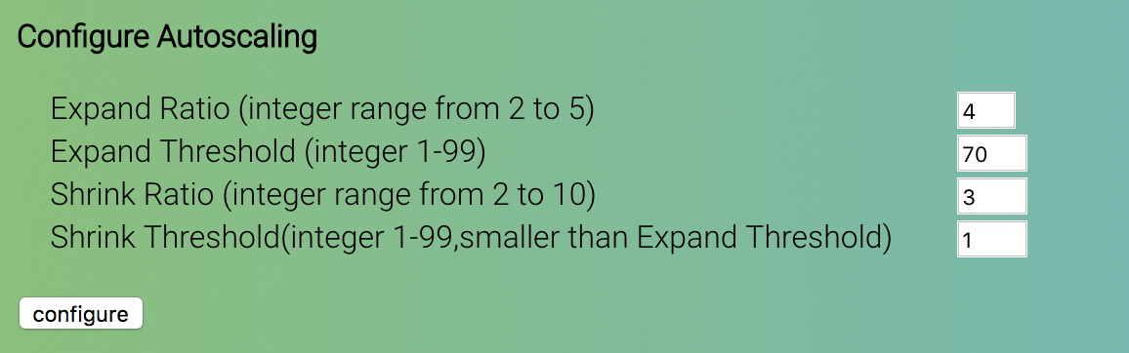

Also, the shrink threshold should always be smaller than expand threshold, otherwise you will see an error message "Shrink Threshold must be smaller than Expand Threshold!” above the configure button once you’ve clicked on it.

If the values are successfully saved to database, the page will refresh and the form will have the newly saved values in the input boxes.

## Delete Everything

Finally, you have the option to delete all data in User UI database and S3. To do this, click on the box then click on ‘BOOM’. Submit this form will resulting in erasing all user data and images storage.

