**Image Service**

**User Manual**

Kaihua Zhou 999482983  
Ya Han Yang 1004550700

Introduction

Our website, the Image Service, mainly has three different features: account creation, image storage and image transformation. This document provides instructions on how to use each of these features.

# Account Creation

You will be able to register, log in and log out.

## Register

To register, simply click on the register button on our home page and you will be redirected to the register page.

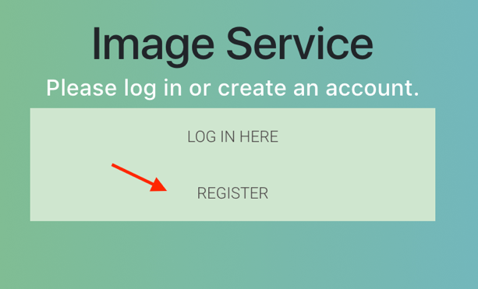

On the register page, fill in the form with your information and submit. Please note that your password should contain at least four characters.

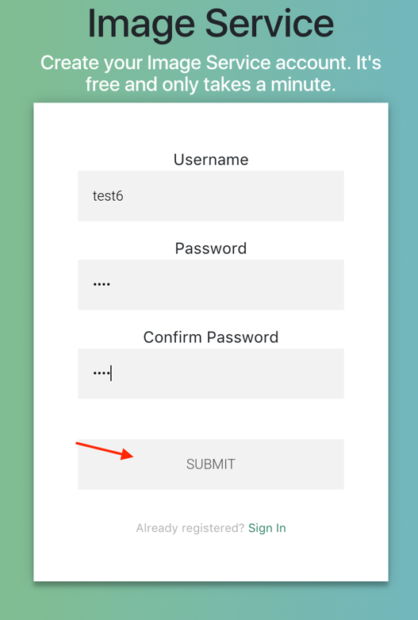

If successfully registered, you will be automatically logged in and redirected to the dashboard page.

In case if your entered username is already registered, you will be redirected to a message page. You can try register again with different username.

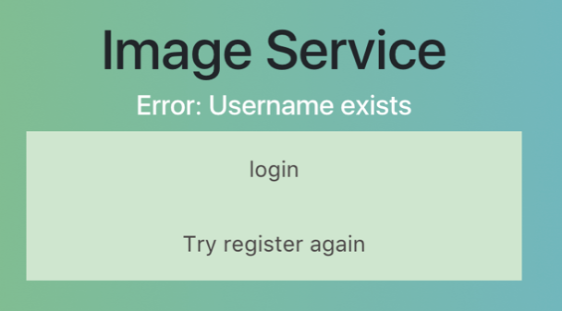

## Log in

To log in, simply click on the login button on our home page and you will be redirected to the login page.

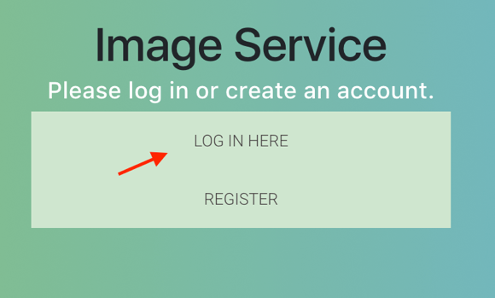

Fill out the login form with your account information and submit. You will be redirected to the dashboard page if successfully logged in.

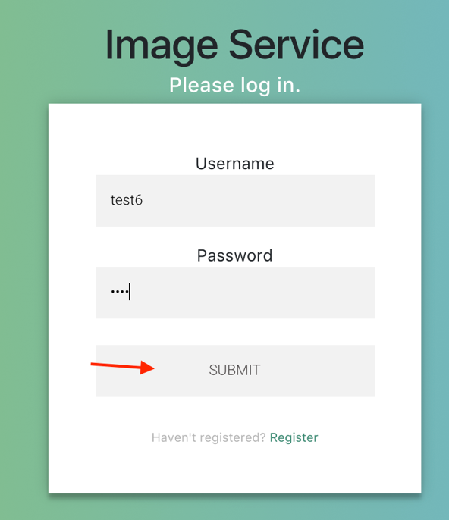

In case of wrong username or password, you will be redirected to a message page. Try log in again with correct information



## Log out

Once you have successfully logged in, you will be able to see a log out button on all pages.

Click on the log out button and you will be redirected to our home page.

# Image Storage

You can upload images and have your own image gallery on our website.

## Image Uploading

On the dashboard, click on upload button and you will be redirected to the upload page.

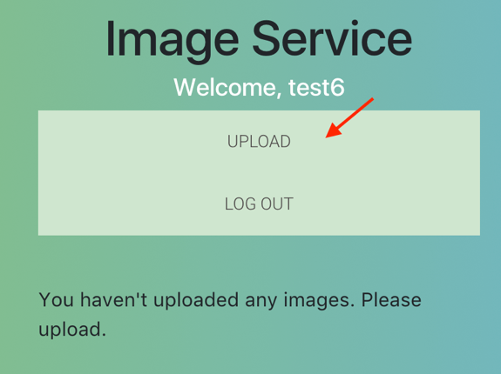

Choose an image to upload. The supported formats are jpg, jpeg, png and gif.

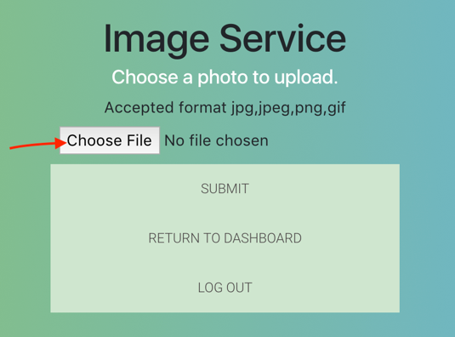

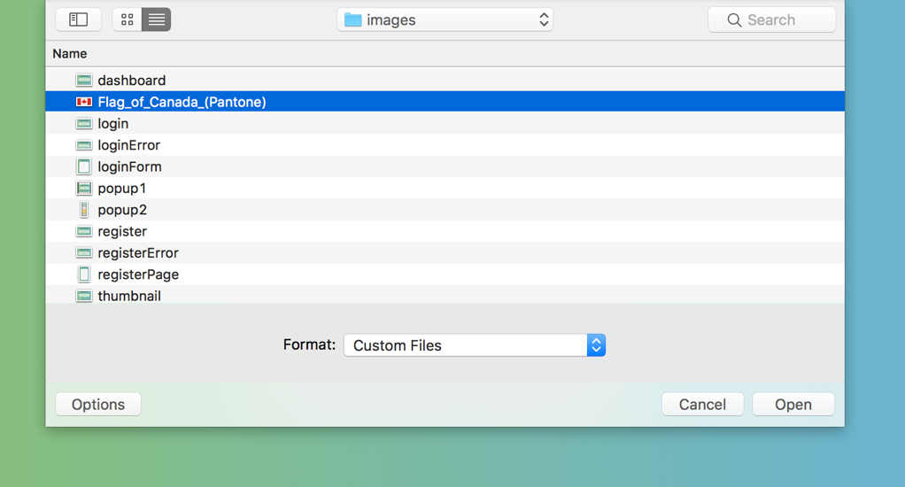

Once you have selected an image, the image name should be displayed. Click on submit to upload the image.

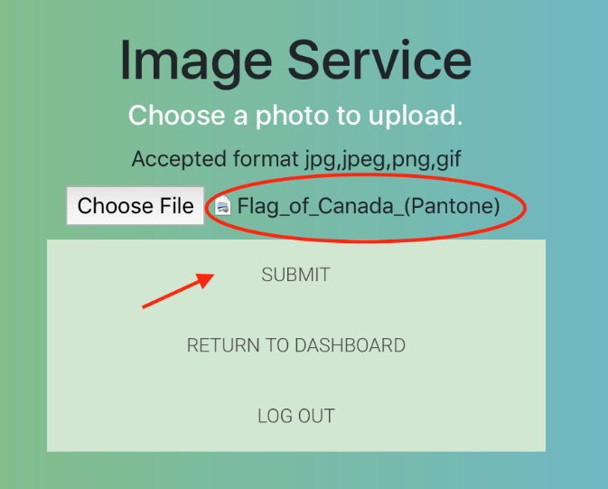

If your image is successfully uploaded, you will be redirected to a message page and you have the option to either go back to upload page and upload more images, or return to dashboard.

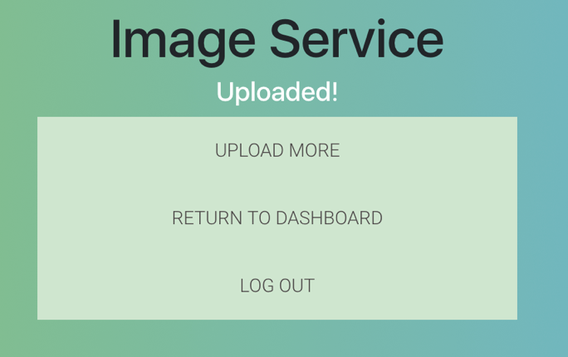

## Image Gallery

The image gallery is on the dashboard page where you can see the thumbnail of your uploaded images.

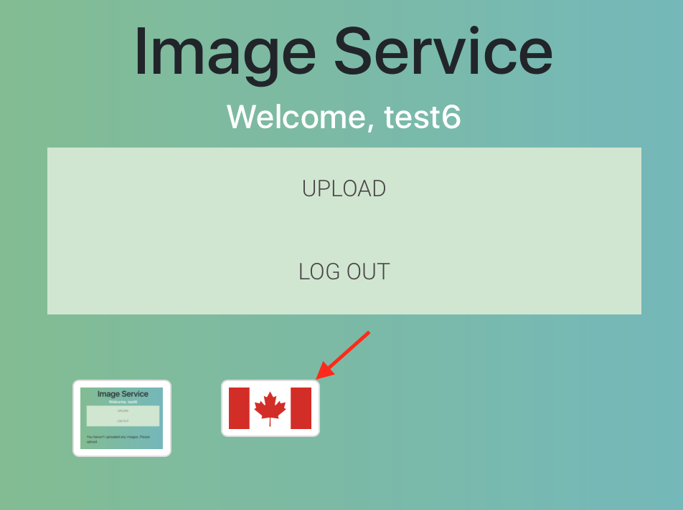

You can click on the thumbnail to see a popup with the selected image. Clicking on the image in the popup will open a new tab displaying the image in full size.

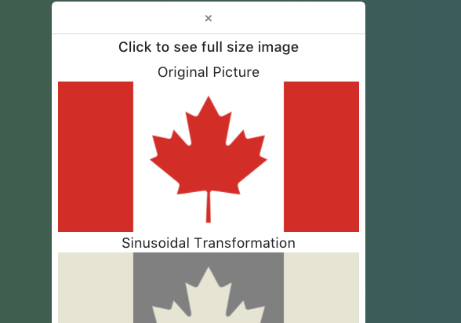

# Image Transformation

Our website offers three types of image transformation: greyscale, redshift and sinusoidal transformation. These transformed images are automatically generated when you upload the original image.

The transformed versions are displayed in the popup following your original image. You can see them in full size by clicking on them.

