- github link:https://github.com/hehhuang/bookService

- Readme:
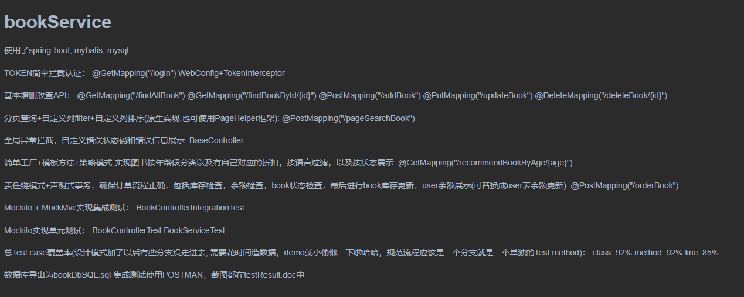
- localhost:8080/findAllBook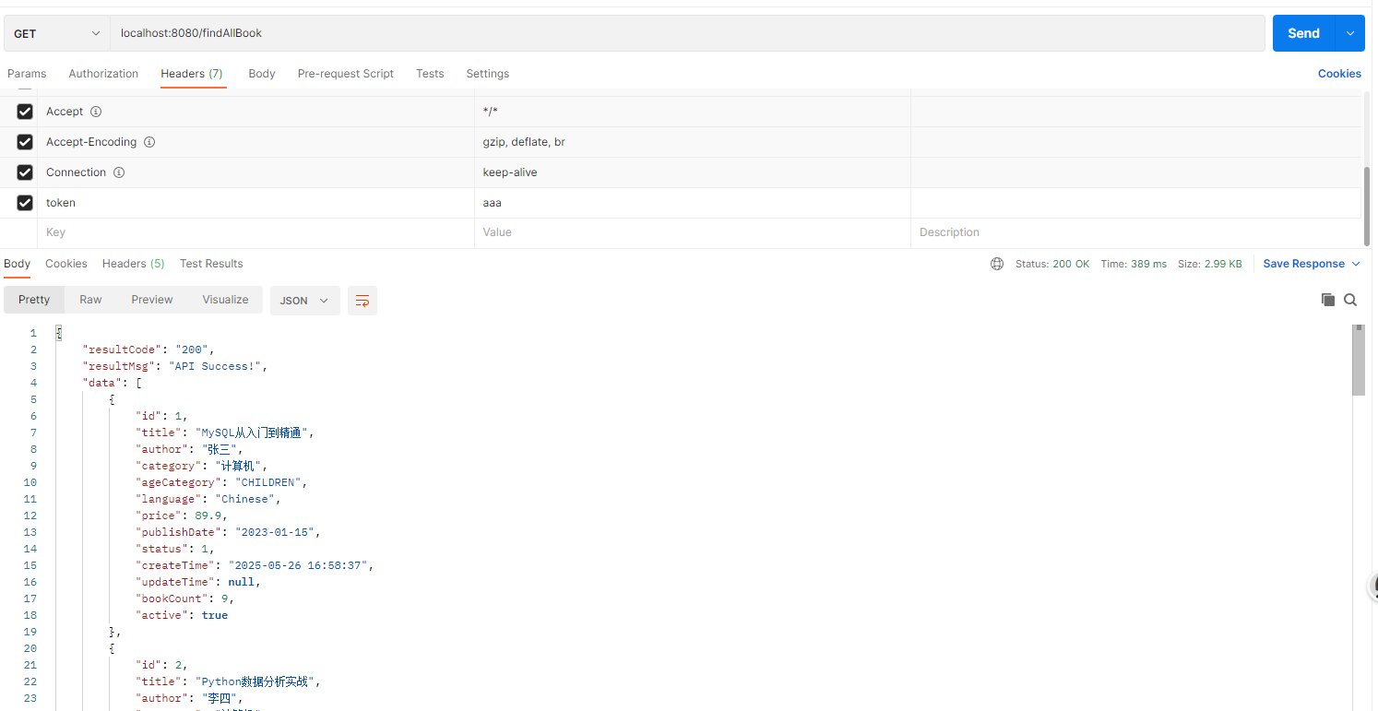
- localhost:8080/findBookById/5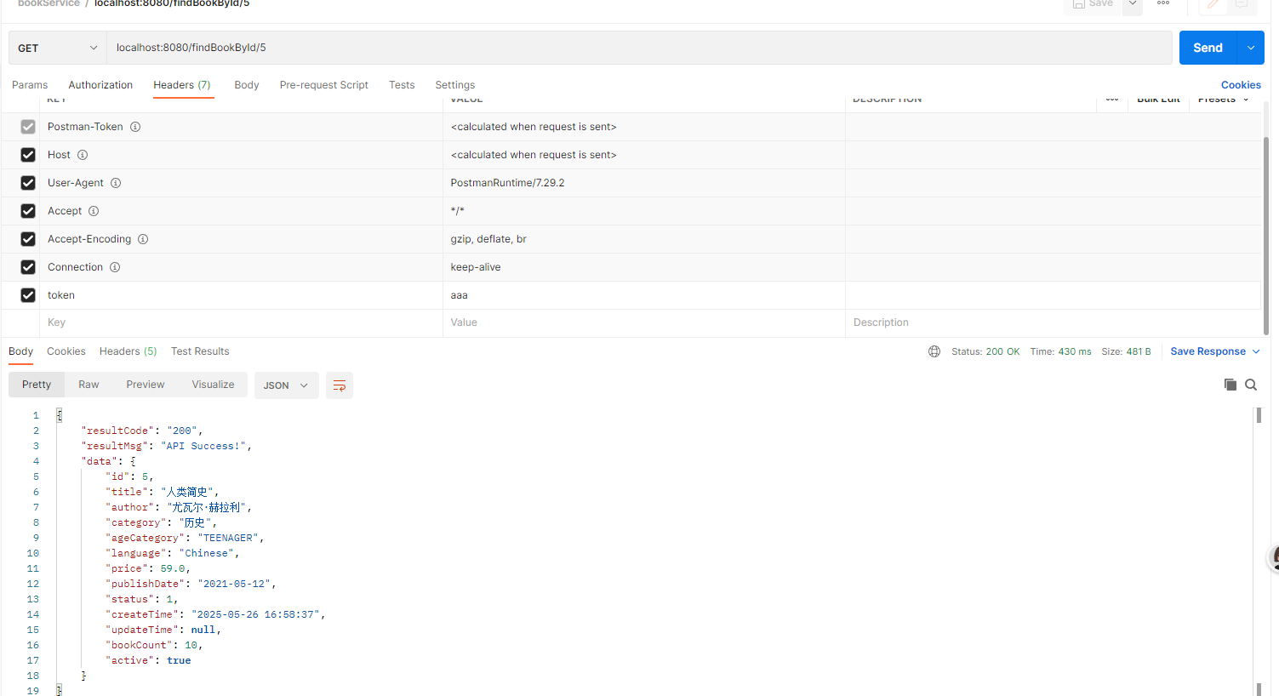
- localhost:8080/addBook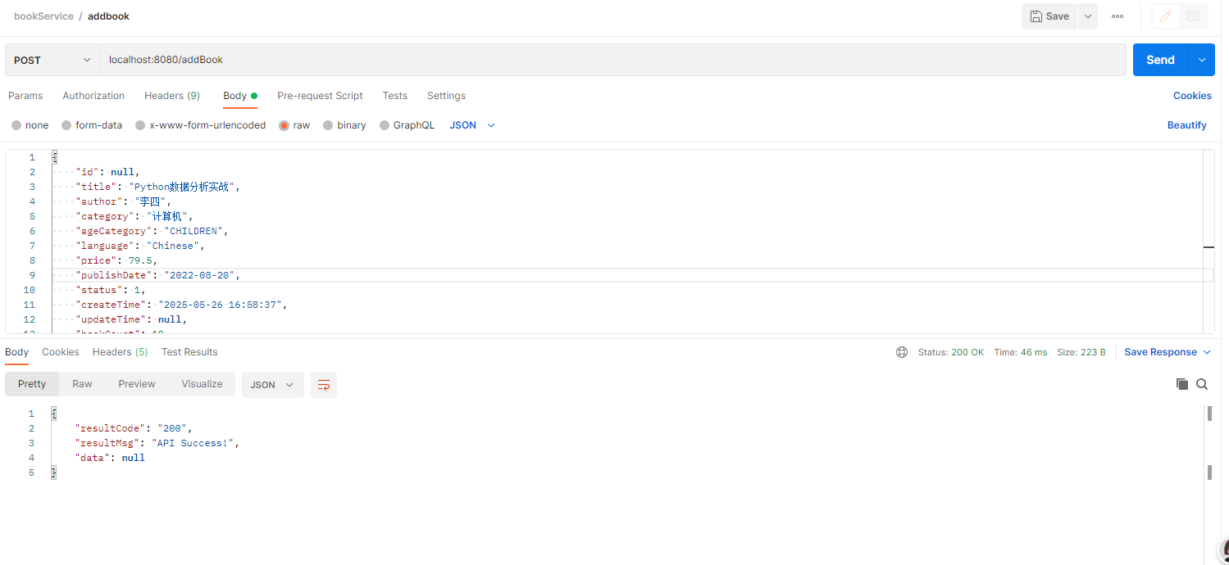
- /addBook 校验失败，@Validated+异常捕获返回
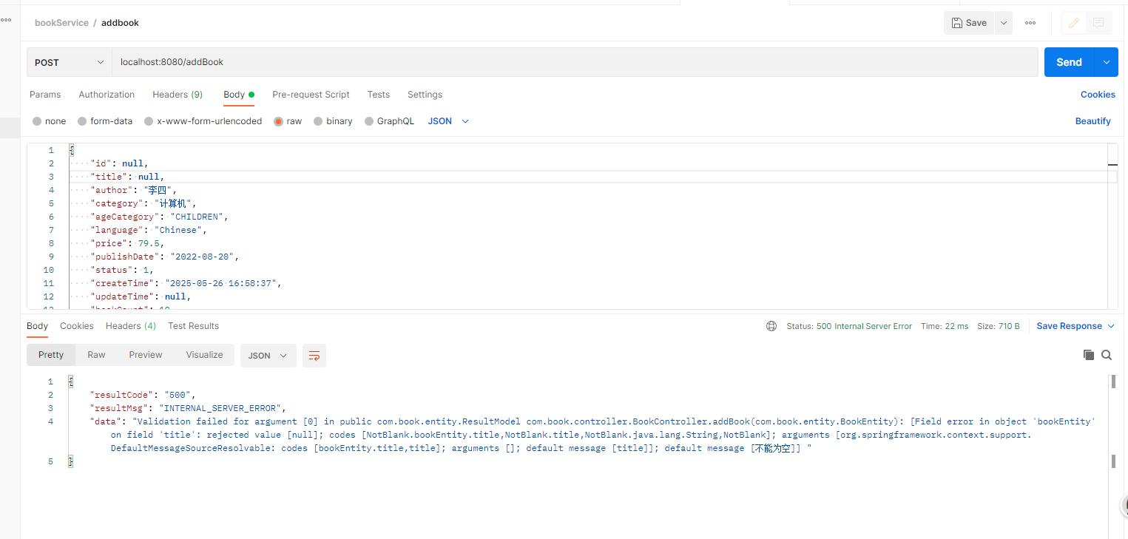
- localhost:8080/deleteBook/1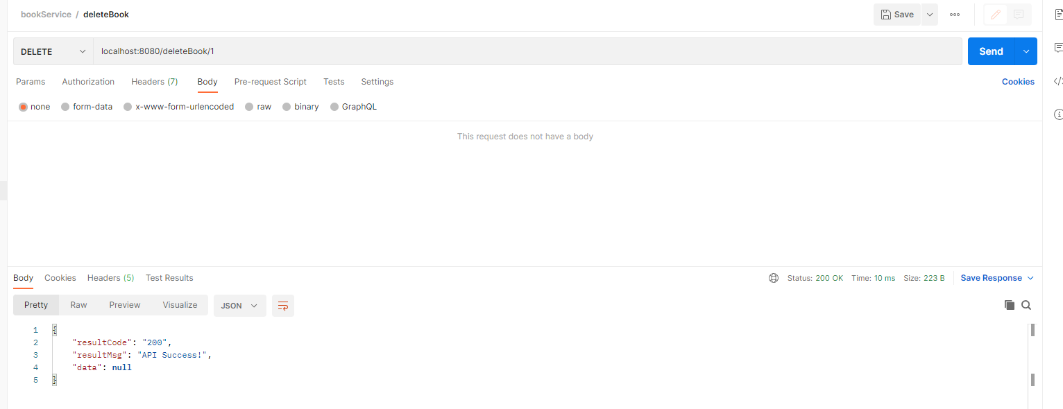
- delete book 失败返回错误提示
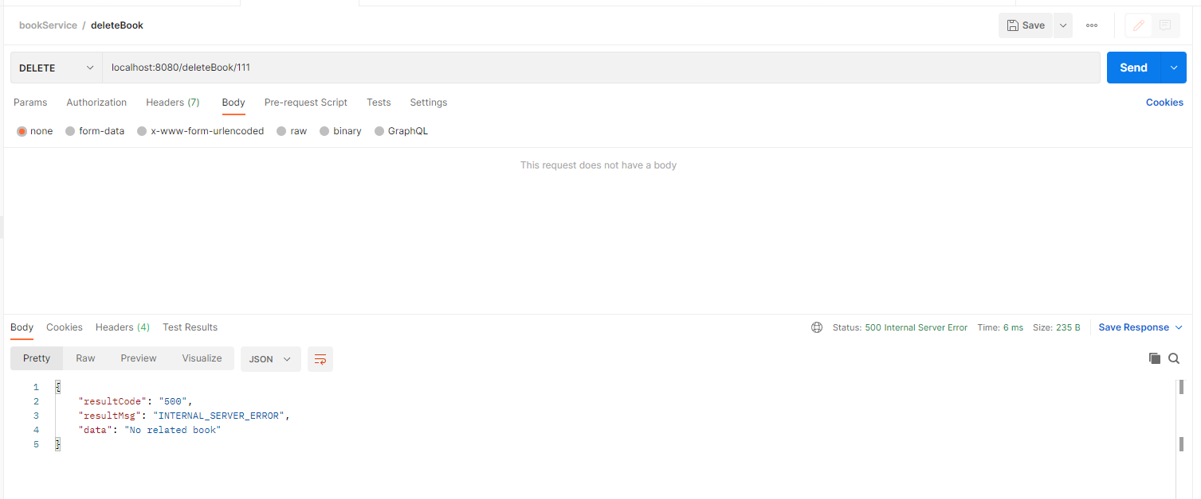
- localhost:8080/orderBook
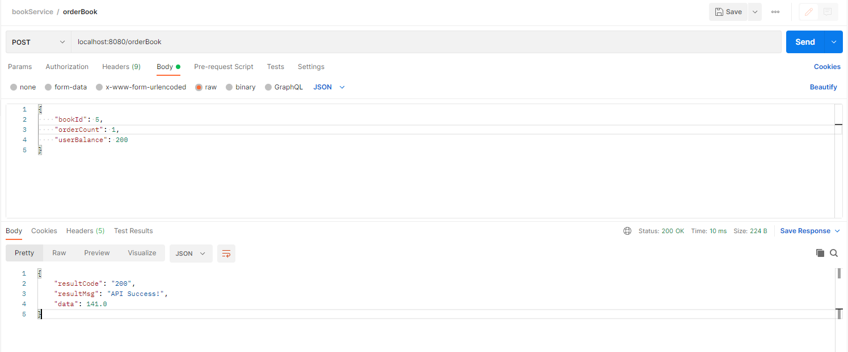
- localhost:8080/orderBook 责任链返回错误提示
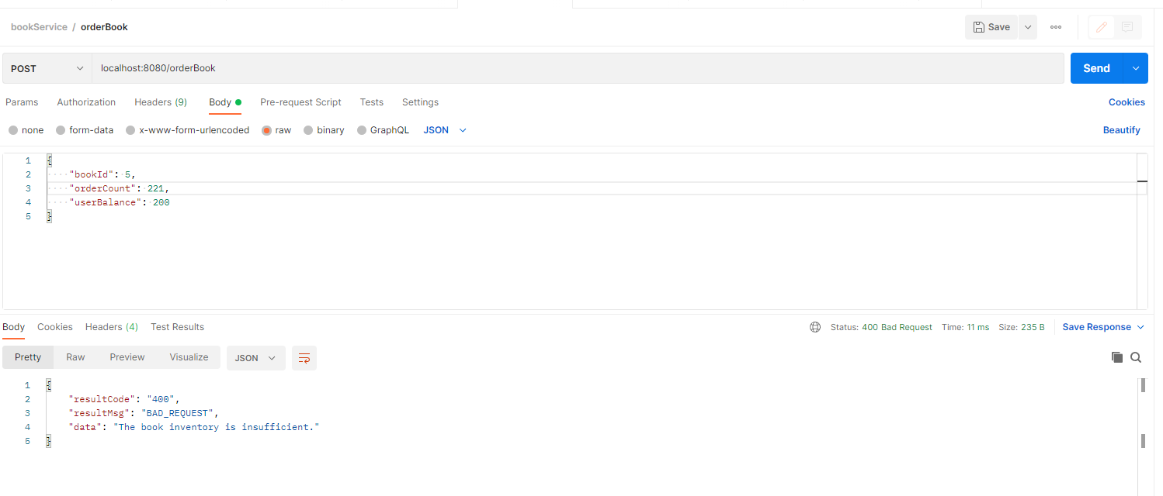
- localhost:8080/pageSearchBook
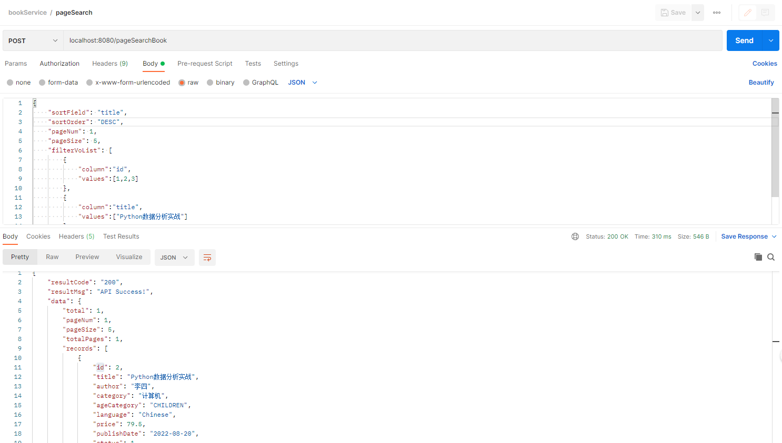

- localhost:8080/recommendBookByAge/5?language=CHINESE
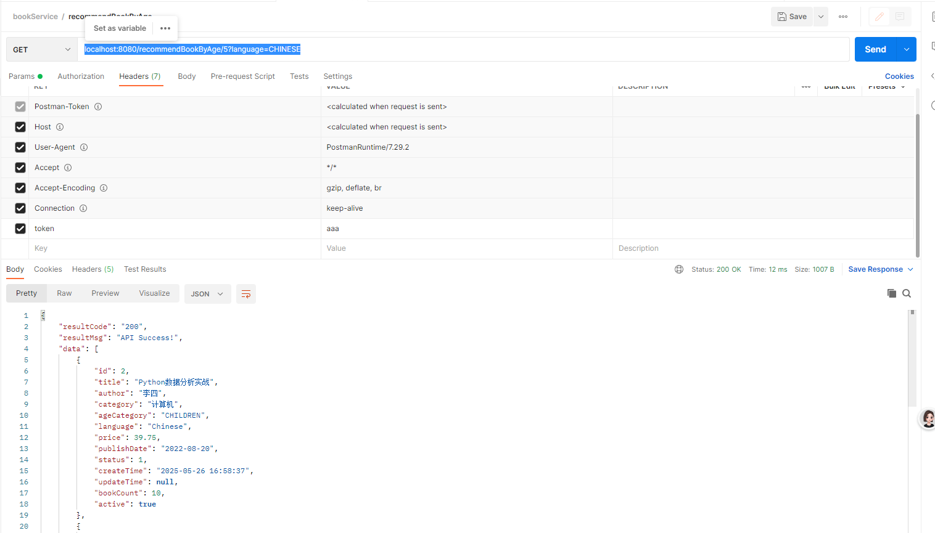
- 单元测试覆盖率
