**Recommendations for Big Mountain Resort**

Big Mountain Resort has recently installed a new chair lift to increase the distribution of visitors across the mountain, which increased the operating costs by $1.54M this season. How can Big Mountain Resort keep a business profit margin of 9.2% this season with the increased operation costs? One recommendation would be increasing the ticket price. Using the data retrieved from the database manager, we predicted the weekend ticket price for an adult based on information of a variety of variables. The dataset contains information from 330 resorts in the US that can be considered part of the same market share as Big Mountain Resort. As such, if we set our new adult weekend ticket price using the predicted adult weekend ticket price for Big Mountain Resort, we can assume Big Mountain Resort would keep a business profit margin as before. Based on the modeling results, we recommend to increase the adult weekend ticket price from current $81.0 to $89.5.

Linear regression model was used to fit the data and predict adult weekend ticket price. Specifically, the adult weekend ticket price was used as a response variable, and 20 variables including vertical_drop, trams, fastEight, fastSixes, fastQuads, quad, triple, double, surface, total_chairs, Runs, TerrainParks, LongestRun_mi, SkiableTerrain_ac, Snow Making_ac, daysOpenLastYear, yearsOpen, averageSnowfall, ProjectedDaysOpen, and NightSkiing_ac as predictor variables. The best model has an explained variance of 0.93, and mean absolute error of 5.38. The coefficients of top 10 variables were listed below:

|  |  |
| --- | --- |
| **Variable** | **Coefficient** |
| AdultWeekday | 20.13 |
| averageSnowfall | 1.80 |
| quad | 1.47 |
| triple | 1.35 |
| vertical_drop | 1.31 |
| Runs | 1.22 |
| surface | 1.17 |
| daysOpenLastYear | 1.15 |
| base_elev | 1.02 |
| fastQuads | 0.68 |

The relationship of adult weekend price and variables including average snow fall, vertical_drop, and daysOpenLastYear were visualized in the figures below:

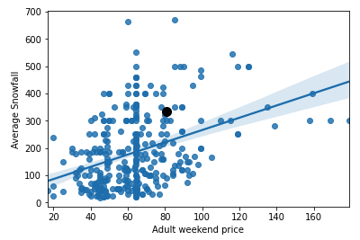

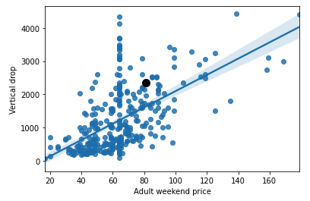

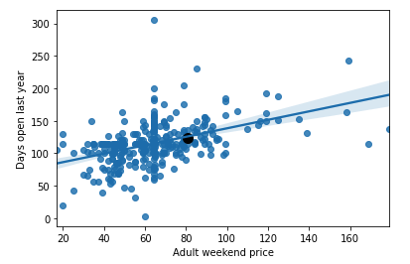

To sum up, we recommend to increase the adult weekend ticket price to $89.5, which would allow Big Mountain Resort to keep a business profit margin of 9.2% this season with the increased operation costs, based on our model prediction. This increasement is acceptable based on the average levels of average snowfall, and vertical drop of other resorts in the database. However, constrains may exist, e.g. the actual number of days open in the upcoming season may be less than the projected. Therefore, we may gather more data, and add additional strategies.