Example URS, User Request Specification – What? - to do.
URS ID | Description
1.1 | The user shall be able to store temperature, humidity and pressure in a csv file.
1.2 | The first line of the CSV file shall contain the header of the values.

Example FS, Functional Specification – How? - to do urs.
FS ID | Description
1.1.1 | Three values coming from 3 different sources are combined to form a json object.
1.1.2 | A parser transforms the json object to a csv string.
1.1.3 | A node write add the string to a file.
1.2 | A reset message inits the parser to write the header.

Example DS, design specifications, it means a kind of diagram.
Here you could simply insert the design of what you intend to implement with Node-RED, even if it's not the final version, as long as it provides an indication of the final structure. This can be commented if necessary.
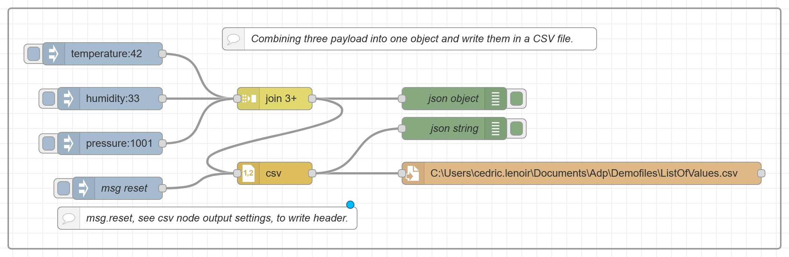

Example IQ, Installation Qualification, Does DS works?
Here you will test your design, for example with insert and debug. You could for example test that if you write 42, 33 and 1001, you will really get the values 42;33;1001 in your csv file.
IQ ID | Description
1 | The engineer insert the values …42…;…33.;… 1001. for temperature, humidity and pressure.  In the csv file with name: nameOfFile.csv  Value of first column is : 42…  Value of second column is: 33  Value of third column is : 1001  The test passes: (yes/no): yes. Your visa
Very important: In the example above, the values ​​written in script font must be completed by hand + visa.

Example OQ, Operational Qualification. Test FS
Here, we test the design with a real example.
OQ ID | Description
1.1 | Value of temperature on User Interface is : 42 …
1.2 | Value of humidity on User Interface is : 33 …
1.3 | Value of pressure on User Interface is : 1001 …
1.4 | The file nameOfFile.csv. contains measures 42;33;1001
1.5 | The test passes: (yes/no): yes. Your visa

Example PQ, Performance Qualification. Test URS
Here, we test the user specification.
OQ ID | Description
1.1 | The test engineer presses the button store.
1.2 | A CSV file with name nameOfFile.csv. exist in folder: path  The CSV file is well formed with headers temperature, humidity, pressure (yes/no): yes.  The CSV file is well formed with value_01;value_02;value_03: (yes/no): yes.  The test passes: (yes/no): yes. My visa

Note: In performance qualification we can trust what has been tested in OQ and IQ and assume that the recorded values ​​are correct.

