Mini Project
Control station with a robot controlled by PLC
Team members  Last name First name Last name First name | Students
Prepared by:  Name Signature Date | One team member
Controlled by:  Name Signature Date | Second team member
Approved by:  Name Signature Date | Supervisor
 | Sion, April 08, 2022
Software Design Specification

Unit Control, PackML Execute State
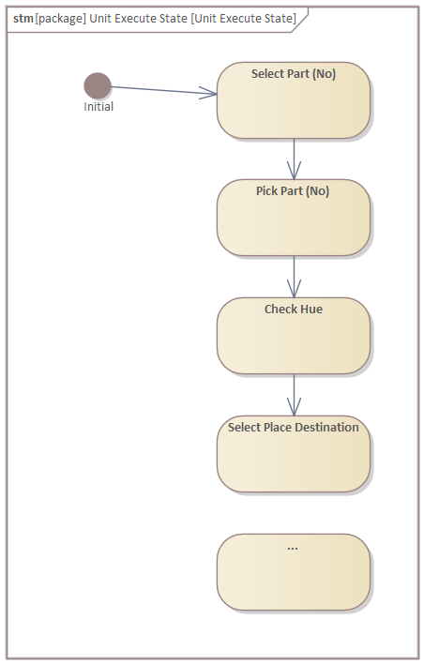

Equipment Modules and Control Modules
SDS ID | Hardware element | Software element
1 | Robot UR3 | EM02 CM01 Robot
2 | O300 DL | EM03 CM01 O300 DL
3 | … | …

Alarm list
EM | CM | Event | Software element
EM02 | CM01 Robot | Abort | Robot Emergency Stop
EM03 | CM02 U300 D50 | Hold | Obstacle detected while Robot picking
EM… | … | … | …

