|  |  |
| --- | --- |
| Mini Project  Control station with a robot controlled by PLC |  |
| Team members   |  |  |  |  | | --- | --- | --- | --- | | Last name | First name | Last name | First name | |  |  |  |  | | Students |
| Prepared by:   |  |  |  | | --- | --- | --- | | Name | Signature | Date | |  |  |  | | **One team member** |
| Controlled by:   |  |  |  | | --- | --- | --- | | Name | Signature | Date | |  |  |  | | **Second team member** |
| Approved by:   |  |  |  | | --- | --- | --- | | Name | Signature | Date | |  |  |  | | **Supervisor** |
|  | Sion, April 08, 2022 |
| Software Design Specification |  |

# Unit Control, PackML Execute State

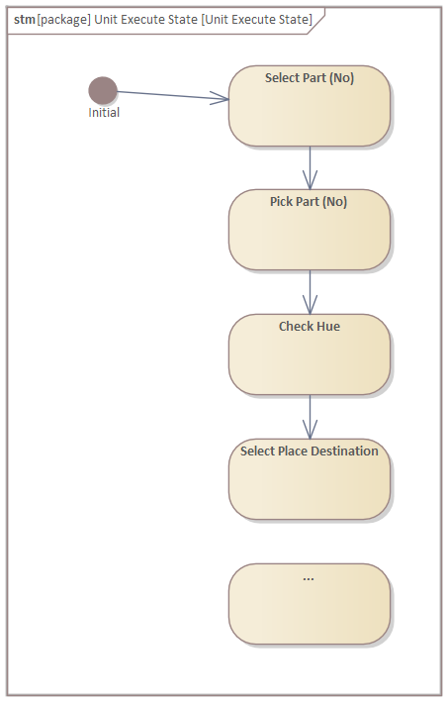

# Equipment Modules and Control Modules

|  |  |  |
| --- | --- | --- |
| **SDS ID** | **Hardware element** | **Software element** |
| 1 | Robot UR3 | EM02 CM01 Robot |
| 2 | O300 DL | EM03 CM01 O300 DL |
| 3 | … | … |

# Alarm list

|  |  |  |  |
| --- | --- | --- | --- |
| **EM** | **CM** | **Event** | **Software element** |
| EM02 | CM01 Robot | Abort | Robot Emergency Stop |
| EM03 | CM02 U300 D50 | Hold | Obstacle detected while Robot picking |
| EM… | … | … | … |