1. Service reliability specification

1.1 Scope
Regional API availability and recovery behavior.
Approved availability target: 99.95%
See rollback checklist for deployment details.
Target rationale: monthly requests are measured across both regions.
Regional limits
Region | Availability target
North | 99.97%
South | 99.95%
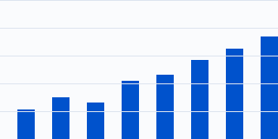
Figure 1. Weekly request volume.

