**Flume集群搭建**（2台机器：hadoop12、Hadoop13）

集群的意思是多台机器，最少有2台机器，一台机器从数据源中获取数据，将数据传送到另一台机器上，然后输出。接下来就要实现Flume集群搭建。集群如下图所示。

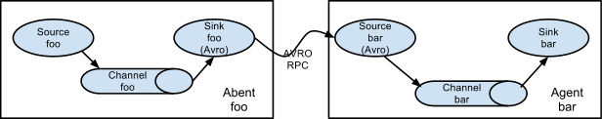

**hadoop12下载flume安装包**

wget <http://mirrors.tuna.tsinghua.edu.cn/apache/flume/1.7.0/apache-flume-1.7.0-bin.tar.gz>

解压flume安装包

tar -zxvf /usr/app/flume1.6/apache-flume-1.7.0-bin.tar.gz

**部署Flume**

部署的是集群，需要在2台机安装Flume，hadoop12作为push推送数据，hadoop13作为pull获取数据后显示出来

修改配置文件

*cd* /usr/app/flume1.6*/apache-flume-1.7.0-bin/conf/*

*cp flume-env.sh.template flume-env.sh*

*cp flume-conf.properties.template flume-telent.conf*

*vim flume-env.sh*

export JAVA_HOME=/usr/app/jdk1.8.0_77

**hadoop13主机部署Flume**

scp -r /usr/app/flume1.6 hadoop13: /usr/app/flume1.6

**验证flume**

cd /usr/app/flume1.6/apache-flume-1.7.0-bin/bin

./flume-ng version

Flume 1.7.0

Source code repository: https://git-wip-us.apache.org/repos/asf/flume.git

Revision: 511d868555dd4d16e6ce4fedc72c2d1454546707

Compiled by bessbd on Wed Oct 12 20:51:10 CEST 2016

From source with checksum 0d21b3ffdc55a07e1d08875872c00523

**Flume集群配置**

创建spoolDir目录

mkdir /usr/app/flume1.6/flume-1.7.0/logs

配置push.conf (hadoop12)

cd /usr/app/flume1.6/apache-flume-1.7.0-bin/conf

vim push.conf

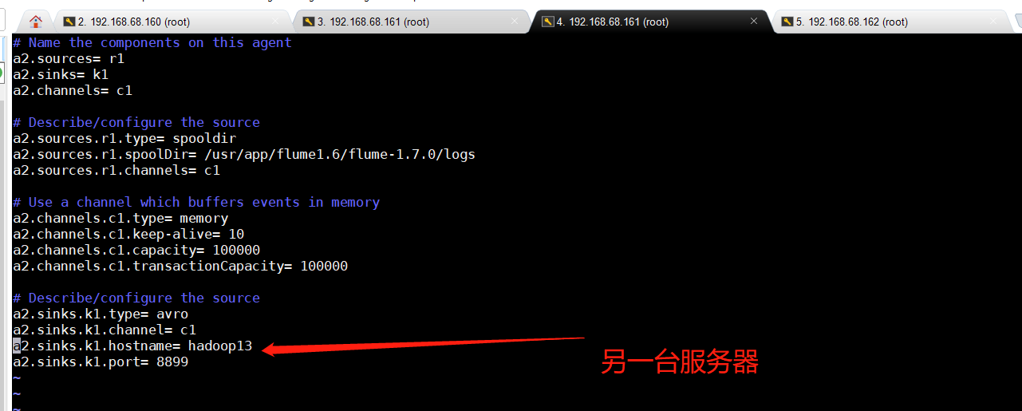

配置pull.conf (hadoop13)

cd /usr/app/flume1.6/apache-flume-1.7.0-bin/conf  
vim pull.conf

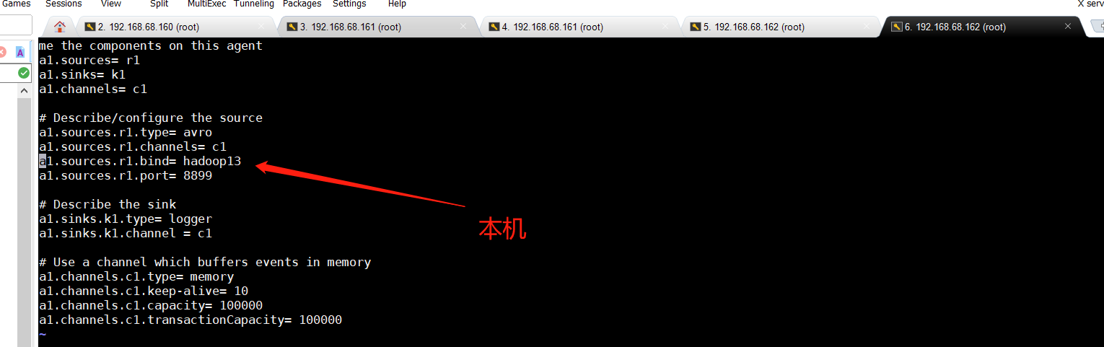

**Flume集群启动**

启动pull主机

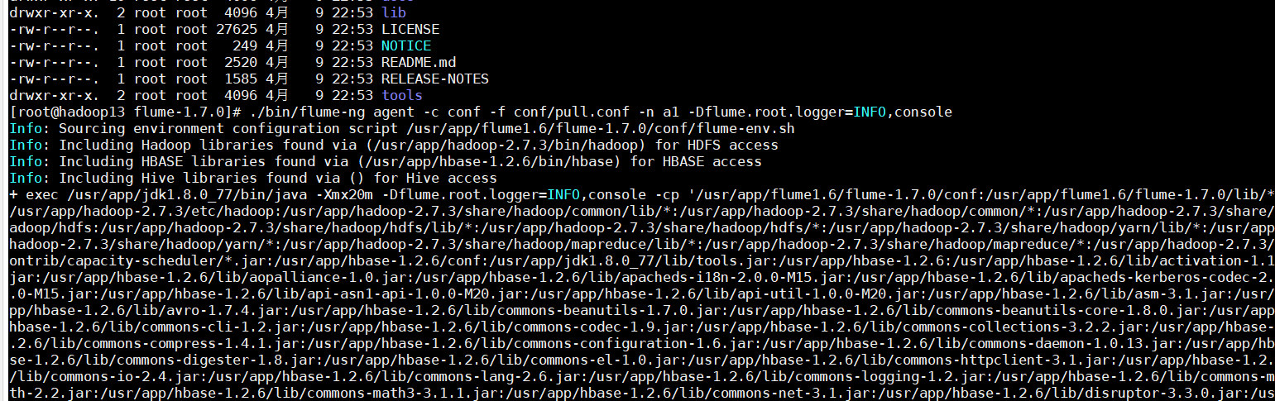

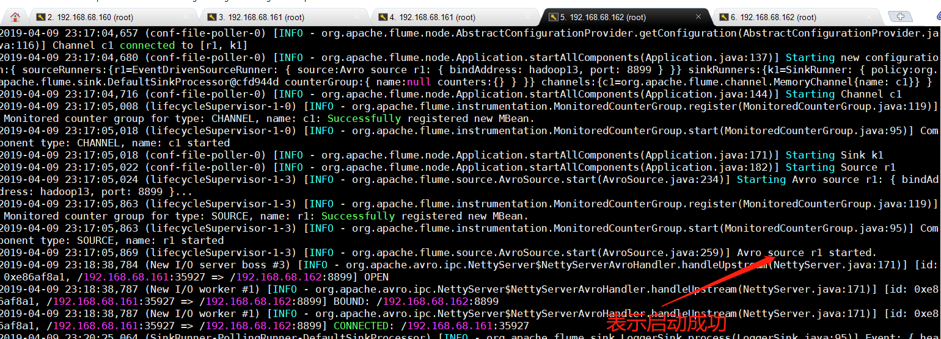

启动push主机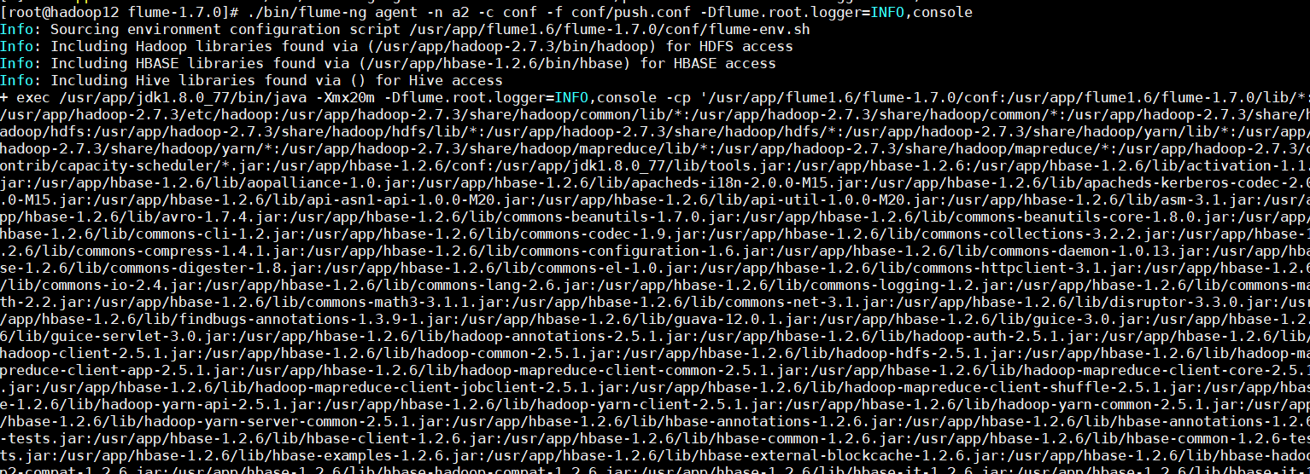

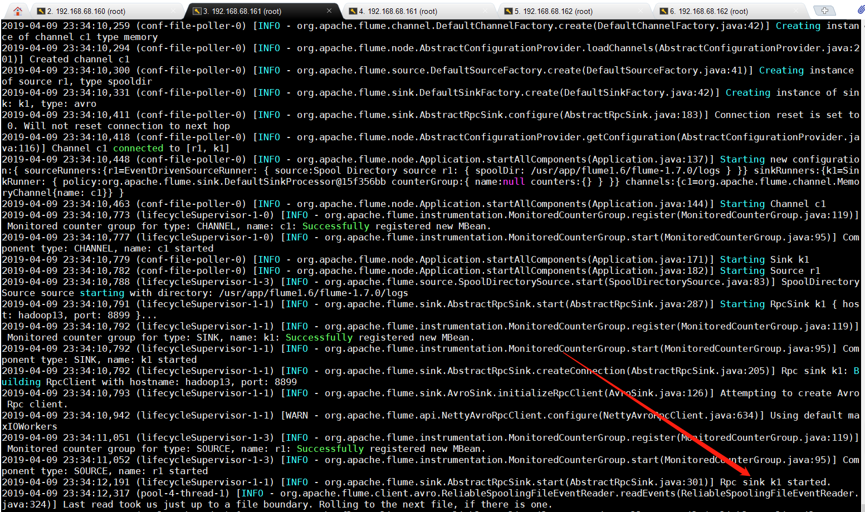

**Flume测试**

cd /usr/app/flume1.6/logs/

vim flume-use-case-test.log



**验证测试**

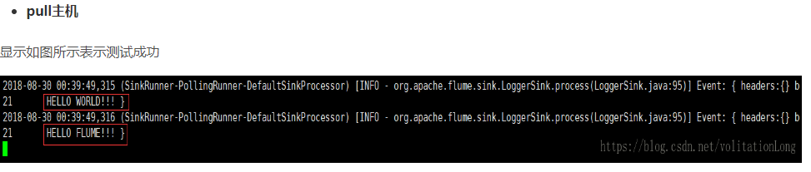

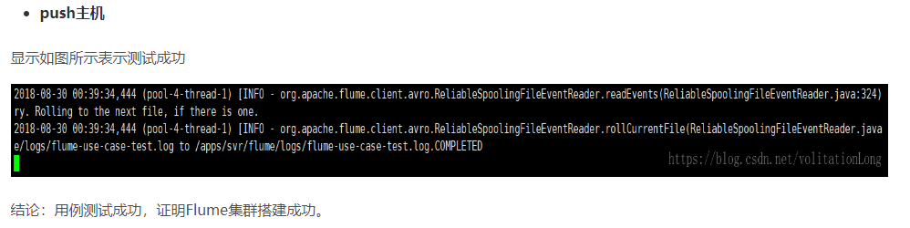

参考资料：

<https://1csh1.github.io/2016/04/21/Flume%E9%9B%86%E7%BE%A4%E6%90%AD%E5%BB%BA/>

<https://blog.csdn.net/volitationlong/article/details/82186379>