DISK ANALYZER UI
RECONSTRUCTION SPECIFICATION
Implementation-grade reference for an AI/LLM design and frontend agent

Fidelity target
Reproduce the supplied reference screenshots as a cohesive disk-analyzer application shell. The screenshots should be treated as the visual source of truth for spacing, hierarchy, surface treatment, view controls, visualization behavior, and inspector content. Where exact implementation details are not visible (font file, icon library, internal algorithms), this document labels them as inferred rather than pretending they were observed.

Reference | Observed image size | Primary state
lists.png | 1080 x 677 | List view, root Macintosh HD
agemap.png | 1080 x 677 | Age Map, root Macintosh HD
topSize.png | 1080 x 677 | Top Sizes, root Macintosh HD
minmap.png | 1080 x 677 | Mind Map, root Macintosh HD
bubbles.png | 1080 x 677 | Bubbles, root Macintosh HD
flames.png | 1080 x 677 | Flame, Google selected
sunburst.png | 1080 x 677 | Sunburst, Google selected
folders.png | 1080 x 677 | Folders, root Macintosh HD
tree.png | 1200 x 752 | Treemap, Google selected

Scope: visual and interaction reconstruction only. This is not a statement about the original product's internal code, proprietary algorithms, or exact font/icon assets.

Contents
1. Executive summary and fidelity rules
2. Screenshot evidence and coordinate model
3. Global shell and responsive geometry
4. Design tokens
5. Component architecture
6. Top navigation
7. Left sidebar
8. Main workspace header and shared privacy banner
9. Right inspector panel
10. View modes
10.1 List
10.2 Age Map
10.3 Top Sizes
10.4 Mind Map
10.5 Bubbles
10.6 Flame
10.7 Sunburst
10.8 Folders
10.9 Treemap

11. Cross-view interaction model
12. Data model and scan-state semantics
13. Visualization implementation guidance
14. Typography, iconography, spacing and micro-details
15. QA and pixel-fidelity acceptance criteria
16. Machine-readable build instructions for an AI/LLM agent
Appendix A. Exact screenshot text and sample values
Appendix B. Embedded reference screenshots

1. Executive summary and fidelity rules
The reference UI is a desktop disk-space analyzer with a persistent three-pane shell: a left navigation/summary rail, a central exploration/visualization workspace, and a right contextual inspector. The visual language is macOS-like: white canvas, very light neutral surfaces, thin gray borders, softly rounded cards and controls, compact typography, and one dominant coral-orange accent.
- Treat the shared shell as the primary reusable component. All nine screenshots use the same navigation, left rail, warning banner, and right inspector patterns, with view-specific content in the center.
- Use 1080 x 677 as the baseline reconstruction viewport for eight screenshots. Use 1200 x 752 only as a larger-width verification case; it is the same responsive system, not a separate design.
- Do not normalize away screenshot-to-screenshot data changes. Different screenshots clearly represent different scan snapshots. Build the UI around a scan-state object so numbers, counts, selected item, and cleanup availability can vary.
- Preserve the visual density. The reference is information-rich without feeling cramped: most row heights are around 29-33 px, controls are compact, and the right inspector uses stacked cards.
- Do not invent prominent branding, logos, or a product name that is not visible in the references. The screenshots are intentionally product-generic from an identity standpoint.

Observed vs inferred
Category | Observed directly | Inferred implementation choice
Colors | Coral-orange active state; white/very light gray UI; multi-hue visualization palette | Use design tokens with the extracted palette below
Typography | Compact system-like sans serif; large bold page title; smaller metadata | Use macOS/system stack such as -apple-system, BlinkMacSystemFont, 'SF Pro Display', 'SF Pro Text', Inter, sans-serif
Icons | Small monochrome line/fill icons; no large illustrations | Use a consistent 16 px icon set with 1.5-2 px stroke
Three-pane shell | Persistent left, center, right regions are clear | CSS grid/flex shell with proportional widths and minimum widths
Visualization algorithms | Hierarchy/size/age relationships are evident | Use established algorithms: treemap, circle packing, radial graph, sunburst, flame chart, calendar heatmap
Exact original code | Not visible | Do not assume framework/library; match behavior and pixels rather than copying an unknown implementation

2. Screenshot evidence and coordinate model
The following geometry is measured/visually derived from the screenshots and is intended as a baseline for a responsive implementation.
Element | 1080 px reference | 1200 px reference | Implementation note
Left rail | ~250 px | ~289 px | Approximately 24% of viewport width; contains all persistent scan/quick-win controls
Center workspace | ~550 px | ~600 px | Approximately 51% of viewport width; main title + toolbar + visualization
Right inspector | ~280 px | ~311 px | Approximately 26% of viewport width; fixed contextual inspector
Global top navigation | ~52 px high | ~58 px at proportional scale | Top strip spans the entire window
Center content left padding | ~13-15 px | ~14-16 px | Keeps title/toolbar aligned inside center pane
Right inspector horizontal padding | ~11-13 px | ~12-14 px | Cards sit inside a narrow padded rail
Main card radius | ~9-11 px | ~9-11 px | Use 10 px default
Control radius | ~8-12 px | ~8-12 px | Pills/compact buttons vary; active mode pill is especially rounded
Hairline border | 1 px | 1 px | Neutral #ECECF0-ish

Coordinate normalization
For a 1080 x 677 reference, use x_norm = x / 1080 and y_norm = y / 677 for annotation overlays. Recreate at a larger viewport by preserving pane proportions and padding ratios. Do not scale text purely as a bitmap transform; reflow the real UI at CSS pixel dimensions.

Baseline pane grid
grid-template-columns: minmax(235px, 23.2vw) minmax(520px, 50.9vw) minmax(270px, 25.9vw);
/* Practical baseline at 1080 px: 250px | 550px | 280px */

3. Global shell and responsive geometry

3.1 Shell structure
App
├─ TopNavigation (spans viewport)
├─ Workspace
│ ├─ SidebarLeft
│ │ ├─ ScanCTA
│ │ ├─ LocationButtons
│ │ ├─ Recent
│ │ ├─ DiskStorageCard
│ │ ├─ CurrentView
│ │ ├─ ActionButtons
│ │ └─ QuickWinsList
│ ├─ MainPane
│ │ ├─ BreadcrumbHeader
│ │ ├─ ViewModeToolbar
│ │ ├─ PrivacyWarning
│ │ └─ Visualization
│ └─ InspectorRight
│ ├─ SelectedItemHeader
│ ├─ DetailsCard
│ ├─ LargestInsideCard
│ └─ InspectorActions

3.2 Surface hierarchy
- App background: white (#FFFFFF).
- Secondary surfaces: very light gray (#F5F5F7) and subtle variants (#F8F8F9, #F3F3F6).
- Separators: 1 px near-neutral gray (#E4E4E8 / #F0F0F3).
- Cards: white fill, thin neutral border, 9-11 px corner radius, very subtle or no shadow.
- Primary accent: coral-orange #FF6B4A. The reference uses this for active navigation, primary CTA, active visualization mode, and some selection/attention states.
- Danger/attention is not aggressive red. The unread-folder banner uses a dark red lock icon and small red accent text, while the main action accent remains coral.

3.3 Vertical rhythm
Rhythm level | Reference behavior | Recommended tokens
Micro | Icon-to-label gaps, metadata gaps | 4-6 px
Control | Text/icon inside a button or row | 8-12 px
Row | List row / quick-win row | 28-34 px
Card | Internal card padding | 12-14 px
Section | Between major sidebar/inspector sections | 16-20 px
Pane | Between header/toolbar/banner/content | 8-14 px

4. Design tokens

4.1 Core colors
Token | Hex | Usage | Confidence
--accent-coral | #FF6B4A | Active tabs, scan button, primary CTA, active visualization pill | High (pixel-observed)
--text-strong | #131315 | Main title / prominent text | High
--text | #28282A | Primary body text | High
--text-muted | #98989B | Metadata / secondary labels | Medium-high
--surface | #FFFFFF | Main app background and cards | High
--surface-subtle | #F5F5F7 | Inspector top background and secondary control surfaces | High
--surface-soft | #F8F8F9 | Sub-panels / quiet controls | Medium-high
--border | #E4E4E8 | Panel and card borders | High
--divider | #F0F0F3 | Pane divider / hairline separators | High
--success | #22C55E-ish | Green savings/compression and selected positive values | Medium
--danger | #D94C43-ish | Unread/privacy warning icon and attention | Medium

4.2 Visualization palette
Color family | Representative observed RGB | Role
Blue | (146, 197, 253) / #92C5FD | Users, recent/age bands, cool hierarchy blocks
Light blue | (192, 220, 254) / #C0DCFE | Age map secondary cells
Lavender | (178, 160, 248) / #B2A0F8 | private branch / purple hierarchy
Cyan | (125, 211, 252) / #7DD3FC | Applications / cool leaf groups
Mint | (95, 235, 213) / #5FEB D5 | Applications/mint subgroups
Green | (169, 244, 208) / #A9F4D0 | Folders / lower-level application groups
Yellow | (254, 244, 204) / #FEF4CC | Library / folder-card family
Peach | (253, 177, 162) / #FDB1A2 | Small folders / warm secondary family
Pink | (254, 187, 193) / #FEBBC1 | Age/branch accent for small groups

The exact visualization hue assignment varies by hierarchy branch, not by a single global semantic category. Keep a deterministic branch palette and use opacity/tint changes for depth.

4.3 Typography
Element | Observed treatment | Suggested CSS
Page title | Large, bold, black; around 23-26 px | font-size: 24px; font-weight: 700; letter-spacing: -0.02em
Metadata | Small, muted; around 11-13 px | font-size: 12px; font-weight: 500
Top nav labels | Small, compact; around 12 px | font-size: 12px; font-weight: 600
Section label | Uppercase/compact gray labels in sidebar | font-size: 10-11px; font-weight: 700; letter-spacing: .06em
Data values | Semibold; aligned right | font-size: 11-13px; font-weight: 600
Inspector headline | Large bold number, ~24-28 px | font-size: 26px; font-weight: 700
Card body | 9-12 px depending on density | font-size: 11-12px

5. Component architecture

5.1 Reusable components
Component | Contract / visual role
TopNav | Global tabs, search field, window/display controls, breadcrumb capsule
PaneDivider | 1 px neutral vertical rule between shell columns
PrimaryButton | Coral rounded CTA such as Scan Full Mac
SecondaryButton | White background, thin border, dark icon/text
ViewModePill | Segmented visualization selector with orange active pill
WarningBanner | Lock icon + warning headline + body + action button + close icon
StorageDonut | Circular usage gauge with 90%+ orange arc and large percentage in center
QuickWinRow | Icon + label + item count + size + chevron
InspectorCard | White card with title/value rows and subtle border
LargestInsideList | Ranked child items with colored dot, progress hairline, size value
ListRow | Expandable folder/file row with icon, progress, percent, size
FolderTile | Folder-shaped card with label, item count, size
ChartToolbar | Filter chips, age/type/folder toggles, depth/scale slider, A control
SelectedState | Dark outline or emphasized border on chosen visualization entity
VisualizationCanvas | Full-width central chart region, pointer interactions, zoom/pan where applicable

5.2 State machine
app.viewMode = 'list' | 'ageMap' | 'topSizes' | 'mindMap' | 'bubbles' |
'flame' | 'sunburst' | 'folders' | 'treemap'
app.selectedNode = NodeId
app.scanState = {
totalBytes, usedBytes, freeBytes, scannedBytes,
fileCount, folderCount, unreadFolderCount, scanDuration
}
app.privacyAccess = { canReadFullDisk: boolean }
app.cleanup = { canAddSelection: boolean, selectedItems: NodeId[] }

5.3 Interaction rule
Every visualization selection should be able to drive the same InspectorRight component. This is the main architectural trick that explains why the screenshots can show the same inspector for both a folder (Library) and an application-data folder (Google).

6. Top navigation

6.1 Layout
- One horizontal strip at the very top, spanning all panes.
- The active top-level tab is a coral rounded pill labeled Explore with a small icon on the left.
- Other top-level tabs are Duplicates, Applications, Monitor, and Snapshots, each rendered as neutral text with small icons.
- A subtle vertical divider separates Snapshots from the back/breadcrumb cluster.
- Near the middle/right, a left chevron/back affordance precedes a rounded breadcrumb capsule labeled Macintosh HD.
- At the far right is a pill-shaped search input with a magnifying-glass icon and placeholder 'Filter by name...'.
- Three compact square/rounded icon buttons appear after the search field: a dark/light or display-like control, a sun-like/theme control, and a split-pane/sidebar-style control.

6.2 Behavior
- Explore should be visually active and is not a separate route from the central explorer state.
- Search filters the visible tree/list/chart labels; it should not cause the shell to resize.
- Breadcrumb selection changes the current root node and refreshes center content + left 'Current View' + inspector context.

7. Left sidebar

7.1 Persistent scan/navigation region
Block | Visual specification | Observed values/text
Scan CTA | Full-width coral rounded button; white icon + semibold text | Scan Full Mac
Location actions | Two equal secondary buttons side by side | Home; Folder...
Recent | Tiny section heading + single recent item with history/clock icon | Macintosh HD
Disk Storage | Label row + device label + donut + Total/Used/Free stats | 245 GB total; 221 GB used; 24.4 GB free; ~90.1% used
Current View | Section label, root name, slash path, scan duration | Macintosh HD; /; 7.1s or 10.9s depending scan snapshot
Action row | Two equal secondary buttons | Reveal; Copy Path
Quick Wins | Section heading + total reclaimable amount + rows | Caches & logs; Large media; node_modules; Build artifacts; Downloads; iOS Simulators; Xcode DerivedData

7.2 Storage donut
- Circular ring is mostly coral-orange with a small neutral/empty arc.
- Centered label is two-line: large percentage (about 90.1%) and small uppercase 'USED'.
- To the right are three aligned statistics: Total, Used, Free. Value colors differentiate used (orange/green depending screenshot) and free (green).
- The device/volume name 'Macintosh HD' appears at the top-right of this block in muted text.

7.3 Quick Wins row geometry
row ~= 40-44 px tall; icon column ~= 28 px; label column flexes; size right-aligned; chevron at far right;
secondary count text sits under the label in a smaller gray font.

7.4 Data variant note
The Folders screenshot shows a later/alternate scan state: Quick Wins total is 45.9 GB rather than 54.6 GB, and individual values/counts change. The agent must bind these to scan data rather than hard-code one screenshot's numbers.

8. Main workspace header and shared privacy banner

8.1 Header
- The page title is 'Macintosh HD' in bold black.
- Inline metadata follows the title on the same baseline: '162 GB' (or '147 GB' in the Folders snapshot), then a centered dot separator, then file count, then another dot, then folder count.
- The title area has a small square action icon at the far right of the center header, aligned with the title row.
- Under the title row sits the visualization mode toolbar.

8.2 View-mode toolbar
The toolbar is a compact row of icons/labels. Only the active mode receives the coral pill background. The nine active labels visible across the supplied references are:
Reference | Active mode | Extra controls visible in same row
lists.png | List | No filter strip
agemap.png | Age Map | Right-aligned helper text 'Where your bytes sit on a timeline' + circular 'A' control
topSize.png | Top Sizes | No filter strip; tabs below the banner
minmap.png | Mind Map | No filter strip
bubbles.png | Bubbles | Compact utility icons to the right
flames.png | Flame | By type / By folder / By age + depth slider + 'A'
sunburst.png | Sunburst | By type / By folder / By age + depth slider + 'A'
folders.png | Folders | Helper text 'Browse folder by folder, sized as you go'
tree.png | Treemap | By type / By folder / By age + depth slider + 'A'

8.3 Shared privacy warning banner
Headline: "205 folders couldn't be read - sizes may be incomplete"
Body: "macOS denied access. Granting Full Disk Access includes privacy-
protected locations; folders owned by other users stay..." // screenshot truncates
Action: "Open Privacy Settings"
Dismiss: small X at far right
- Banner is white with a thin neutral border and 10 px corner radius.
- A small red/coral lock icon anchors the left edge.
- Headline is dark, semibold; body is smaller and muted.
- Open Privacy Settings is a compact white button with border and a settings/gear icon.
- Close is a small 'X' icon at far right; it dismisses only the banner, not the underlying permission state.

9. Right inspector panel

9.1 Overall structure
- The right rail has a very light gray background (#F5F5F7-ish) distinct from the white main canvas.
- The selected entity header includes a centered/left-aligned folder icon, entity name, and subtype label 'Folder'.
- A small path line appears beneath: e.g. '/Library' or '/Users/hariprasad/Library/Application Support/Google'.
- The primary size number is large and black, followed by a small gray percentage phrase such as '3.2% of scan' or '7.6% of scan'.
- Two stacked cards follow: Details and Largest Inside.
- Two rows of secondary action buttons sit below the cards: Reveal / Quick Look and Focus / Copy Path.
- Cleanup-enabled selection adds an orange 'Add to Cleanup' button at the bottom; a root/non-cleanable state renders it in a pale disabled peach.

9.2 Inspector details card
Row | Library selected example | Google selected example
Size on disk | 5.20 GB | 12.4 GB
Logical size | 8.47 GB | 12.2 GB
Compressed by | 3.27 GB (green) | 0 B
Files | 82,037 | 69,278
Folders | 25,066 | 3,932
Of parent | 3.2% | 36.7%
Modified | 3 minutes ago | 1 minute ago
Created | 2 months ago | 1 year ago

9.3 Largest Inside card
Title row says 'LARGEST INSIDE' on the left and the child-count on the right ('65 items' for Library, '6 items' for Google). Each child line has a small colored dot, label, a thin horizontal meter/guide line, and a right-aligned size.
Library selected sample | Size | Google selected sample | Size
Developer | 2.26 GB | Chrome | 11.6 GB
Application Support | 1.73 GB | GoogleUpdater | 796 MB
Updates | 943 MB | RLZ | 4.10 KB
Audio | 80.8 MB | Chrome for Testing | 4.10 KB
Apple | 73.0 MB | GoogleUpdate.app | 0 B
Trial | 28.3 MB | Chrome-headless | 0 B
Logs | 24.7 MB
PrivilegedHelperTools | 15.6 MB

10.1 List
The central content is a compact folder outline. The first row is Users, followed by Applications, private, Library, usr, opt, bin, sbin, .resolve, .file, .vol, and .nofollow. Each expandable folder row has a disclosure chevron, folder/file icon, label, horizontal size bar, percentage, and right-aligned size.
- First-level rows visible: Users; Applications; private; Library; usr; opt; bin; sbin; .resolve; .file; .vol; .nofollow.
- Reference values: Users 76.5% / 124 GB; Applications 15.4% / 24.9 GB; private 4.1% / 6.65 GB; Library 3.2% / 5.20 GB; usr 0.5% / 834 MB; opt 0.3% / 428 MB; bin <0.1% / 4.90 MB; sbin <0.1% / 2.50 MB.
- Zero-byte rows are still rendered and remain visible, including .resolve, .file, .vol, and .nofollow.
- Rows use a disclosure chevron, small folder/file glyph, label, muted proportional bar, percent, and right-aligned size.
- Primary interaction: clicking disclosure expands/collapses children; clicking the row selects the node and refreshes InspectorRight.
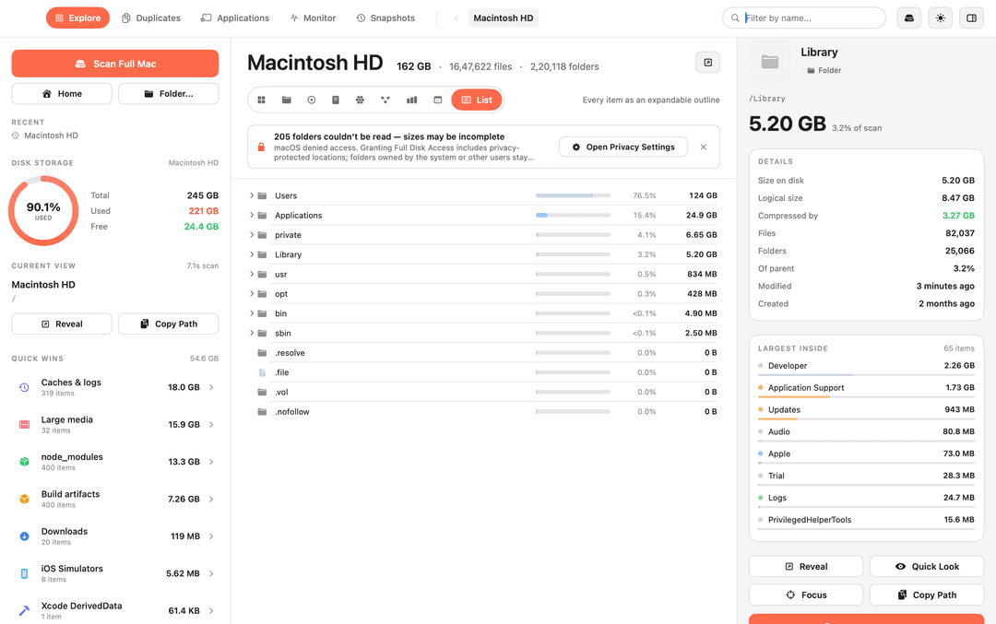
Reference figure: lists.png (List).

10.2 Age Map
Shows file-age buckets as horizontal bars followed by a month-by-month heatmap. The main narrative is recency/age, not hierarchy.
- Panel heading: HOW OLD ARE THESE BYTES? and total 162 GB.
- Buckets exactly visible: Last 7 days 21.0 GB 13.0%; 8-30 days 30.1 GB 18.5%; 1-3 months 20.2 GB 12.5%; 3-12 months 71.0 GB 43.8%; 1-2 years 15.1 GB 9.3%; Over 2 years 4.62 GB 2.9%.
- Each bucket uses a rounded horizontal track. The fill is a cool sequential hue that transitions from blue to lavender to pink/red as age increases.
- Second card title: BYTES BY LAST-MODIFIED MONTH. Columns are J F M A M J J A S O N D.
- 2026 visibly contains strong values around May-Sep: 20.9 GB, 18.3 GB, 10.8 GB, 32.7 GB, 26.4 GB. 2025 visibly has 12.7 GB near December.
- Heatmap cells are rounded; empty/no-data cells remain pale neutral blue-gray.
- Helper copy in the top-right: Where your bytes sit on a timeline, plus a circular A control.
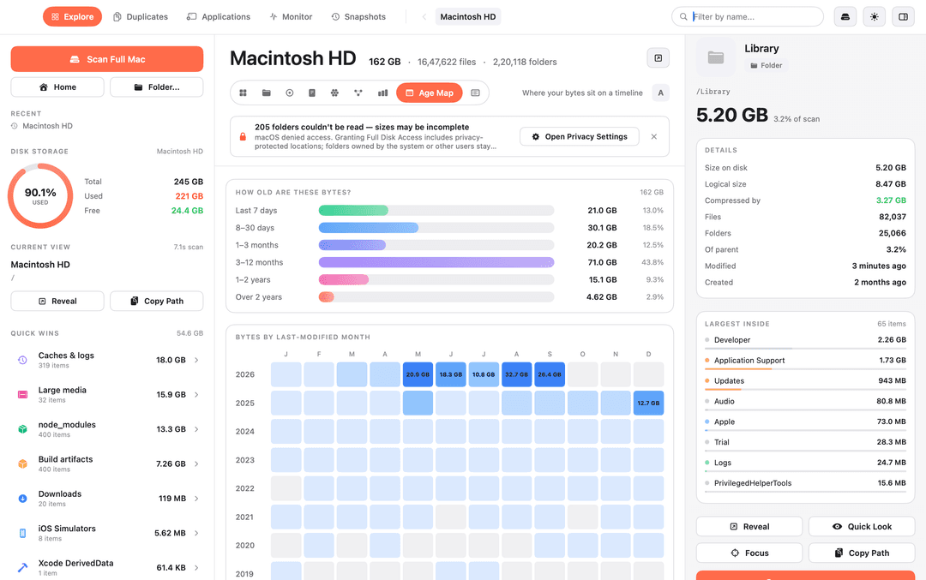
Reference figure: agemap.png (Age Map).

10.3 Top Sizes
Ranks the largest objects and offers three tabs: In this folder, Biggest files anywhere, Biggest folders anywhere.
- Ranking header contains three tabs; In this folder is active.
- A small '12 shown' indicator sits at the upper-right.
- Rows 1-12: Users, Applications, private, Library, usr, opt, bin, sbin, .resolve, .file, .vol, .nofollow.
- Observed values: Users 76.5% / 124 GB; Applications 15.4% / 24.9 GB; private 4.1% / 6.65 GB; Library 3.2% / 5.20 GB; usr 0.5% / 834 MB; opt 0.3% / 428 MB.
- Small values are shown as <0.1% and 0 B where appropriate.
- Rows look like soft gray rounded tracks with a tiny colored indicator at the left and right-aligned metadata.
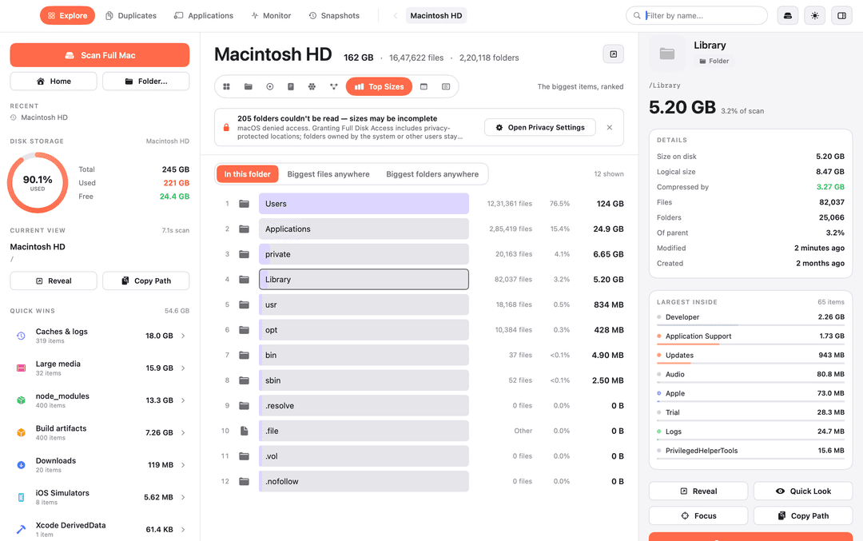
Reference figure: topSize.png (Top Sizes).

10.4 Mind Map
Radial hierarchical graph with Macintosh HD at the center and major root folders as first-level branches.
- Central root is a large coral circle labeled Macintosh HD and 162 GB, with a subtle outer emphasis ring.
- Major first-level nodes: Users, Applications, private, Library, usr, opt, bin, sbin.
- Observed branch families: Users is blue; Applications is mint/teal; private is lavender; Library is warm yellow/orange; usr is pink/red; opt is green.
- Edges are thin and curved, splitting repeatedly toward small leaf nodes. Node size is proportional to represented bytes.
- Library is selected in the reference and receives an outlined/halo treatment.
- Large nodes receive text labels; very small leaves remain unlabeled to avoid overlap.
- Interactions should support hover, selection, focus/zoom, and opening the selected folder.
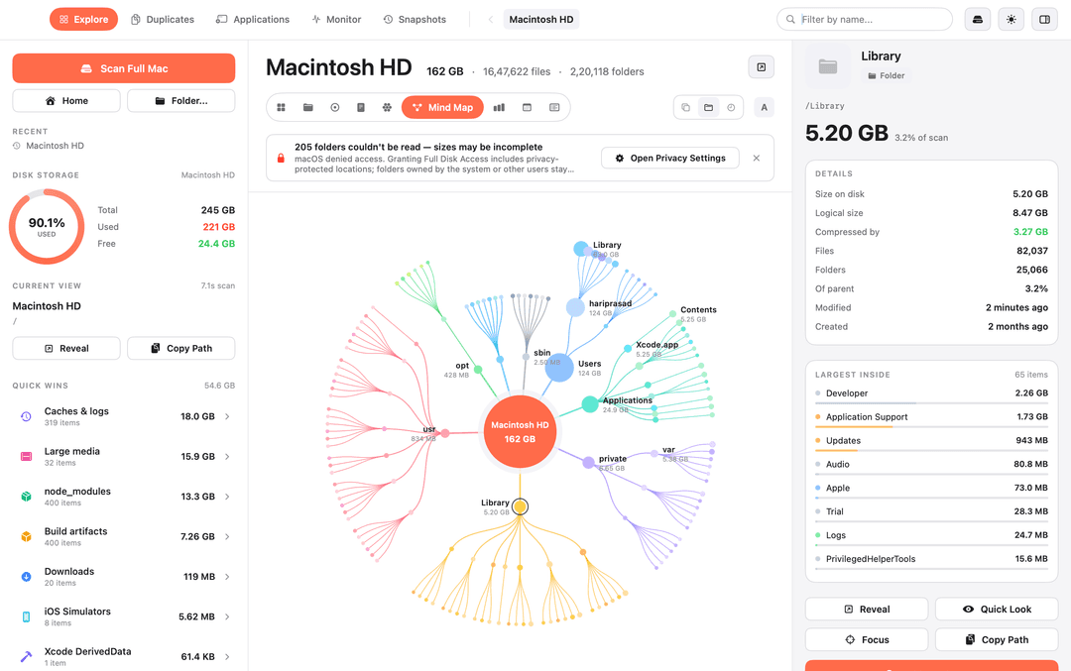
Reference figure: minmap.png (Mind Map).

10.5 Bubbles
Circle-packing hierarchy where Macintosh HD is the outer context and folders become nested size-proportional bubbles.
- Outer circle is the Macintosh HD context; the label sits near the top of the circle.
- Users / hariprasad is the dominant blue hierarchy occupying most of the canvas.
- Within the Users hierarchy, recognizable large groups include Library, Application Support, Caches, Documents, and Code.
- Applications is a large mint/teal cluster at right with many nested circles.
- Library is a warm yellow cluster above/right of center; private is a smaller lavender cluster lower/right.
- Radius is proportional to bytes. Labels appear only for sufficiently large groups.
- Selection should apply a restrained outline and update the shared inspector.
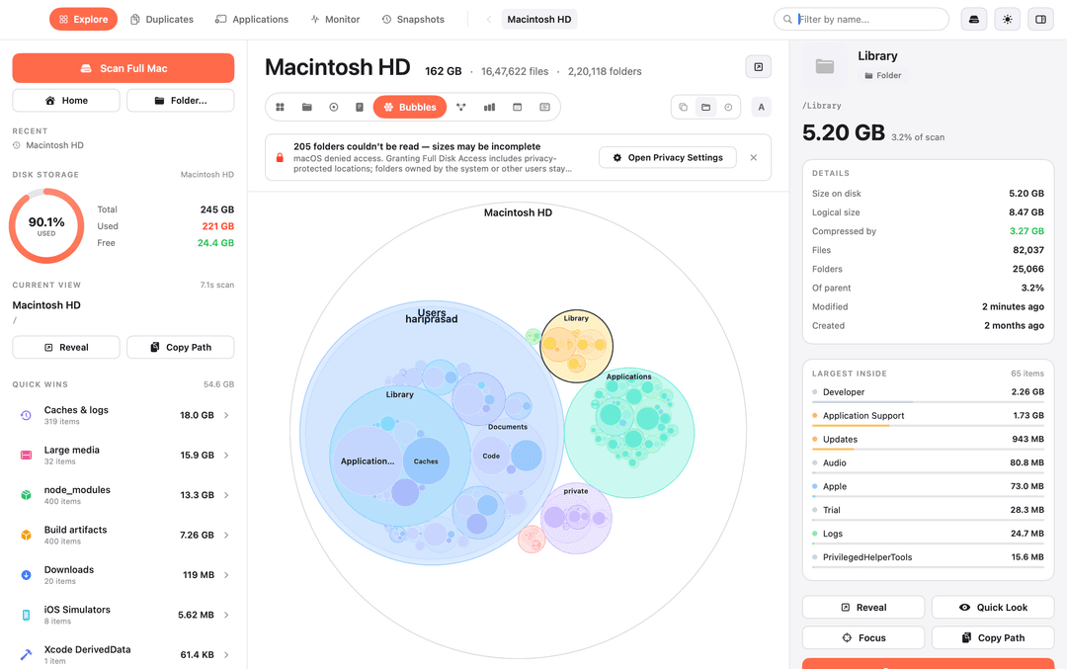
Reference figure: bubbles.png (Bubbles).

10.6 Flame
Hierarchical rectangular partitioning: large rectangles represent size and nesting represents the path.
- Toolbar includes By type / By folder / By age. By folder is active.
- A depth/scale slider appears on the right with value around 5 and a circular A control.
- Root strip is '/'. Major areas include Users, Applications, private, Library and smaller system folders.
- Visible large descendants include Google 12.4 GB, Claude 11.8 GB, Caches 4.03 GB, yarn 3.85 GB, Arduino15/packages 3.13 GB, plus Code, Containers, .npm, _cacache, etc.
- Applications contains Xcode.app and media/developer application data; labels truncate where blocks are too narrow.
- Selected Google rectangle has a dark outline and drives the right inspector.
- Add to Cleanup is enabled in this screenshot.
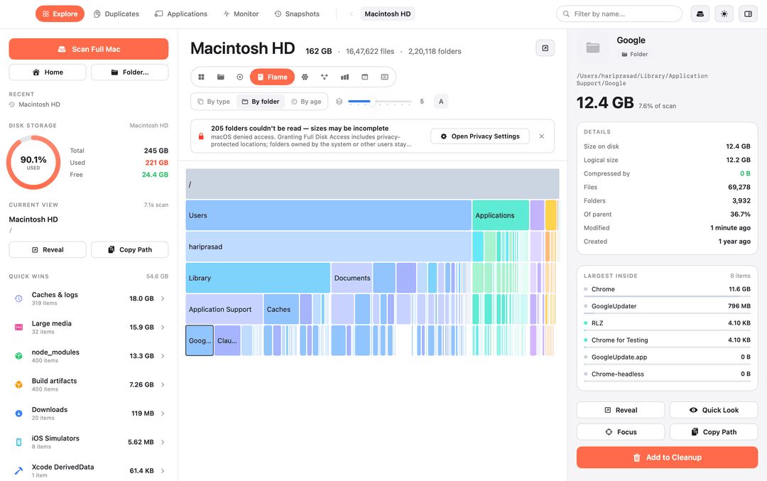
Reference figure: flames.png (Flame).

10.7 Sunburst
Circular multi-ring hierarchy. The center hole contains the root label and total.
- Center reads Macintosh HD and 162 GB.
- Each ring corresponds to hierarchy depth; angular span represents size.
- Major branches retain consistent hues with Mind Map, Bubbles and Treemap.
- Labels follow the arc/tangent direction and are omitted or clipped at tiny sizes.
- Selected paths can use a dark outline and remain synchronized with the inspector.
- The toolbar depth control suggests the number of visible hierarchy levels can be adjusted.
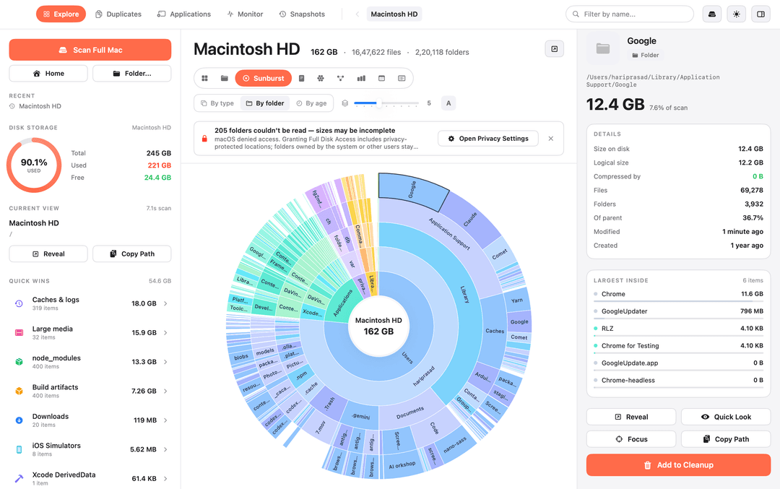
Reference figure: sunburst.png (Sunburst).

10.8 Folders
A card/grid navigation mode for browsing folders sequentially, with card area proportional to size.
- Helper copy: Browse folder by folder, sized as you go.
- Root snapshot in this screenshot is 147 GB, 16,05,076 files, 1,94,972 folders.
- Folder indicator says 11.
- Visible cards: Users 109 GB / 11,88,912 items; Applications 24.9 GB / 2,85,419 items; private 6.56 GB / 20,114 items; Library 5.17 GB / 81,989 items; usr 834 MB / 18,168 items; opt 428 MB / 10,384 items.
- Cards have a stylized folder-tab silhouette, soft tint, rounded corners, and three tiny colored dots near the bottom-left.
- Clicking a card moves the current root and repopulates the folder grid.
- Root selection shows a disabled pale-orange Add to Cleanup action in the inspector.
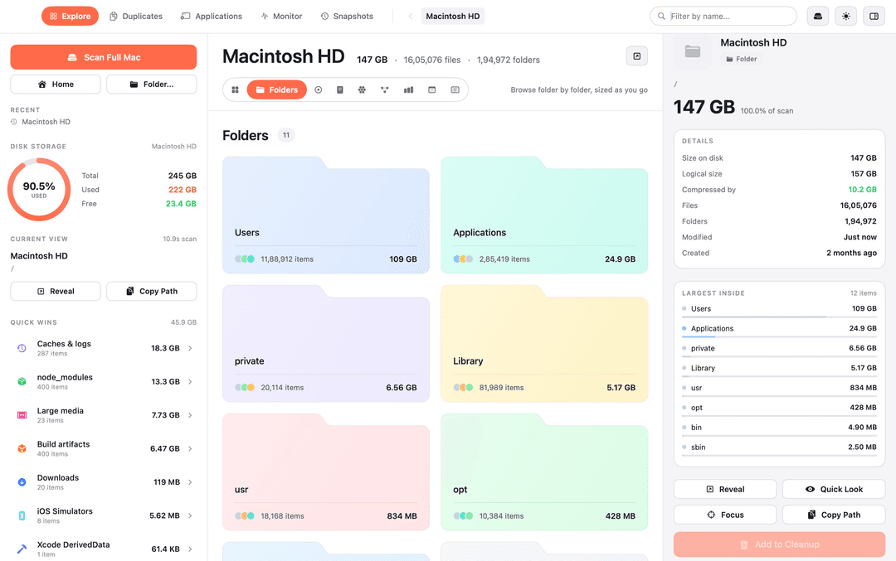
Reference figure: folders.png (Folders).

10.9 Treemap
Large nested rectangle packing view. This is the wider 1200 x 752 reference showing the same shell at a larger width.
- Toolbar: By type / By folder / By age. By folder is active. A depth/scale slider shows a value around 5 and A control.
- Root '/' appears as a wide top band, with the remainder partitioned into hierarchical rectangles.
- Major regions include Users, hariprasad, Applications, private, Library, and system folders.
- Visible large descendants include Google, Claude, Code, nano-sass, AI workshop, Caches, yarn, Arduino15, Containers, .npm, _cacache and .Trash.
- Google is selected inside Application Support and has a dark outline. The inspector path reads /Users/hariprasad/Library/Application Support/Google.
- Label text is clipped/abbreviated when the rectangle is too narrow, as seen in application names.
- Add to Cleanup is enabled.
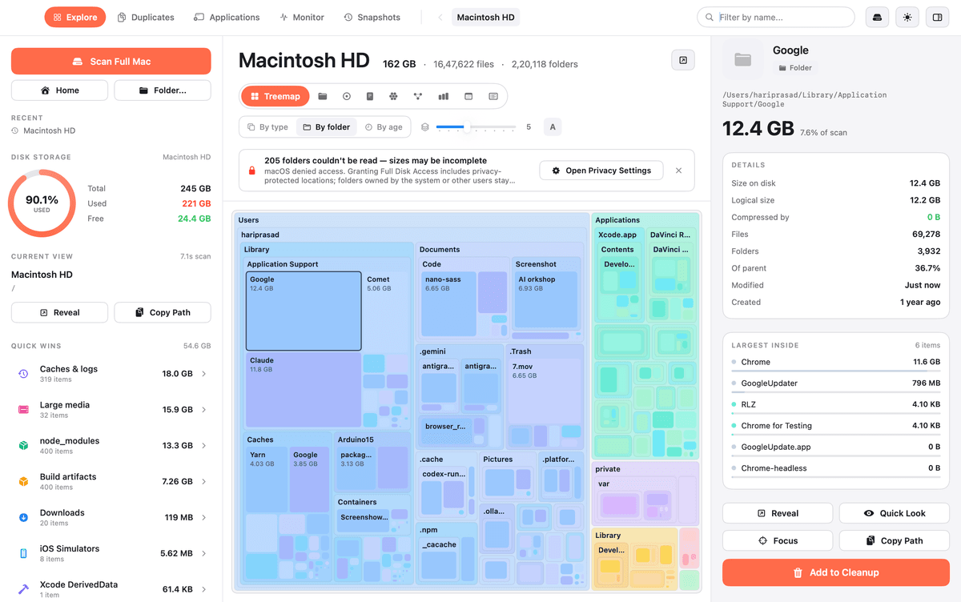
Reference figure: tree.png (Treemap).

11. Cross-view interaction model
Interaction | Expected effect
Select folder/file | Highlight the node, set selectedNode, update inspector header/path/details/largest-inside
Open folder | Change current root to selected node and recompute the active visualization
List disclosure | Expand/collapse children inline
Reveal | Open filesystem location in the host file manager
Copy Path | Copy exact path and provide subtle success feedback
Quick Look | Open native preview where supported
Focus | Re-center or zoom the active visualization around the selected node
Add to Cleanup | Queue the selection for cleanup; disabled for root/protected/non-cleanable nodes
Search | Filter or highlight matching names without changing shell geometry
View mode switch | Preserve current root and selection when valid
Close warning | Dismiss only the visible warning banner

11.1 Centralized selection state
Every visualization is a renderer over the same filesystem graph. The selected node is an ID/path, not a chart-specific index. This is required for the supplied state where the central visualization selects Google while the inspector presents the same Google path and values.

12. Data model and scan-state semantics

12.1 Filesystem node model
type FsNode = {
id: string
name: string
path: string
kind: 'folder' | 'file' | 'application'
parentId: string | null
sizeOnDisk: number
logicalSize: number
compressedBytes: number
fileCount: number
folderCount: number
modifiedAt: string
createdAt: string
ageBucket: '7d' | '8-30d' | '1-3m' | '3-12m' | '1-2y' | '2y+'
canCleanup: boolean
children: string[]
}

12.2 Scan summary
type ScanSummary = {
rootName: string
rootPath: string
scanBytes: number
totalVolumeBytes: number
usedVolumeBytes: number
freeVolumeBytes: number
fileCount: number
folderCount: number
unreadFolderCount: number
scanDurationSeconds: number
privacyAccessState: 'partial' | 'full'
}

12.3 Derived formulas
- Percent of scan = nodeSize / scanBytes * 100.
- Of parent = nodeSize / parentSize * 100.
- Age bucket shares should sum to approximately 100%, allowing for displayed rounding.
- Compressed by can be represented as logicalSize - sizeOnDisk when the raw filesystem metrics are compatible; preserve raw values because screenshots can show 0 B.
- Quick Wins is a candidate cleanup aggregate, not simply the sum of every folder in the scan.
State fixture requirement
Create named fixtures for at least: ROOT_162GB_LIBRARY_SELECTED, ROOT_162GB_GOOGLE_SELECTED, and ROOT_147GB_ROOT_SELECTED. Each fixture should reproduce the visible inspector, sidebar totals, counts, percentages, quick wins and mode-specific data shown in its corresponding screenshot.

13. Visualization implementation guidance
Mode | Implementation guidance
List | Use a compact CSS grid with disclosure/icon/name/bar/percent/size columns. Virtualization is fine for long lists, but visible row height and alignment must match the reference.
Age Map | Use a two-part layout: age bucket horizontal bars plus a 12-column monthly heatmap. Use a sequential blue-to-purple intensity scale and pale no-data cells.
Top Sizes | Use a deterministic sorted table. Keep tab stateful and preserve shell geometry. The row background should read as a soft track rather than a full-contrast table row.
Mind Map | Use a radial tree or hierarchical force graph with deterministic seeding. Constrain edge lengths and node collisions to keep the major branches in predictable quadrants.
Bubbles | Use deterministic circle packing. Parent circles are visible containers; child circles are packed inside. Preserve branch color by path.
Flame | Use hierarchical partitioning with size-proportional widths/areas. The screenshot resembles an icicle/flame hybrid; prioritize broad nested rectangles and dense labels.
Sunburst | Use radial partition: angle proportional to bytes, radius/depth proportional to hierarchy. White center hole, thin separators, tangent labels.
Folders | Use a 2-column card grid at the reference width, with responsive widening before typography scaling. Folder-tab silhouette is part of the visual identity.
Treemap | Use squarified or slice-and-dice nesting with deterministic ordering. Maintain large parent regions and selected-node outlines. The screenshot's labels imply adaptive truncation.

14. Typography, iconography, spacing and micro-details

14.1 Font stack
The reference appears to use a macOS/system sans. A close web implementation is: -apple-system, BlinkMacSystemFont, 'SF Pro Text', 'SF Pro Display', Inter, 'Segoe UI', sans-serif. Treat this as an approximation because the original font asset is not supplied.

14.2 Typography hierarchy
Element | Approximate reference treatment
Page title | 24 px, 700, slight negative tracking
Inspector main size | 26 px, 700
Top nav | 12 px, 600
Section labels | 10-11 px, 700, subtle letter spacing
Metadata | 11-12 px, 500, muted gray
Row/body text | 11-12 px, 400-500
Numeric values | 11-13 px, 600; right aligned

14.3 Radius and controls
Surface/control | Approximate radius
Search field | 14-16 px pill
Active top-nav tab | 16-18 px
Mode pill | 14-18 px
Standard card | 9-11 px
Standard button | 8-10 px
Scan Full Mac CTA | 8-10 px

14.4 Color usage
- Use #FF6B4A as the only dominant UI accent.
- Use neutral grays for borders, tracks, metadata and non-selected UI.
- Visualization hues are pastel and branch-coded; they should feel softer than the coral CTA.
- Green is used sparingly for positive/compact secondary metrics such as compressed bytes and free storage.
- Avoid saturated chart colors that overpower the UI.

14.5 Flatness and density
Avoid large shadows, giant typography, oversized spacing, and modal-heavy interaction. The reference feels like a dense native utility app, not a marketing dashboard.

15. QA and pixel-fidelity acceptance criteria
- [ ] At 1080 x 677, vertical pane dividers match the reference within about +/- 2 px.
- [ ] At 1200 x 752, the same shell widens proportionally without changing information architecture.
- [ ] Active view pills, Scan Full Mac, and enabled Add to Cleanup use the same coral accent.
- [ ] Warning banner width, padding, icon, action button and close affordance match the reference hierarchy.
- [ ] Right inspector structure stays stable across view modes.
- [ ] All fixture values, counts, units, paths, percentages and action states match the target screenshot.
- [ ] Selection is obvious but restrained: dark border/halo, not a heavy filled overlay.
- [ ] Zero-byte and tiny entries remain visible where present in the reference.
- [ ] Visualization labels truncate or disappear at small geometry rather than forcing overlaps.
- [ ] No default chart-library padding, legends or colors visibly leak into the reproduction.
- [ ] View changes preserve root and selection where possible.
- [ ] Screenshot captures are deterministic across runs.

15.1 Regression protocol
- Load the exact fixture for the target screenshot.
- Set the viewport to the target size.
- Capture the mode with the target selected node.
- Compare against the supplied reference using perceptual + pixel diff.
- Ignore only anti-aliasing noise after manual visual inspection; do not hide real layout differences.
- Repeat for all nine states and the 1200 x 752 Treemap case.

16. Machine-readable build instructions for an AI/LLM agent
Primary objective
Build one deterministic desktop disk-analyzer UI whose pixels, hierarchy, density and selection behavior closely reproduce the nine supplied screenshots. The screenshots define the visual target; any unknown internal implementation details should be solved with conventional, deterministic frontend techniques.

16.1 Non-negotiable instructions
ROLE
You are a frontend reconstruction agent.
SOURCE OF TRUTH
Treat the nine screenshots as fixed visual regression targets.
DO
- Build the 3-pane shell first.
- Centralize filesystem node + selection state.
- Keep the right inspector persistent.
- Use the exact visible copy and fixture values.
- Keep view layouts deterministic.
- Match the coral accent, white canvas, subtle gray surfaces, thin borders,
compact typography, and rounded controls.
- Preserve label truncation/visibility rules.
- Recreate enabled and disabled cleanup states.
DO NOT
- Invent a logo/brand mark that is not shown.
- Replace the inspector with a drawer at desktop widths.
- Normalize the 147 GB screenshot into the 162 GB state.
- Use default chart-library legends/paddings/colors.
- Randomize graph layouts between renders.
- Turn the UI into a marketing dashboard.

16.2 Suggested component surface
<DiskAnalyzerShell
scan={scan}
root={root}
selectedNodeId={selectedNodeId}
viewMode={viewMode}
privacy={privacy}
cleanup={cleanup}
/>
<SidebarLeft ... />
<MainHeader ... />
<PrivacyWarning ... />
<VisualizationRenderer mode={viewMode} ... />
<Inspector node={selectedNode} ... />

16.3 Build order
1. Shared shell and pane geometry
2. Left sidebar and storage/quick-win widgets
3. Right inspector
4. List
5. Top Sizes
6. Age Map
7. Folders
8. Treemap
9. Flame
10. Sunburst
11. Bubbles
12. Mind Map
13. Deterministic reference fixtures
14. Screenshot regression and final polish

16.4 Definition of done
- Each supplied screenshot can be reached as a named state.
- Selection and inspector remain synchronized in every view.
- All visible copy and numerical examples have deterministic fixture data.
- The shell remains stable while view modes switch.
- Pixel regression shows no meaningful differences in geometry, spacing, colors, or selection state.
- The implementation remains maintainable because all views consume the same normalized filesystem graph.

Appendix A. Exact visible copy and reference values

A.1 Shared visible labels
- Explore
- Duplicates
- Applications
- Monitor
- Snapshots
- Macintosh HD
- Filter by name...
- Scan Full Mac
- Home
- Folder...
- RECENT
- DISK STORAGE
- CURRENT VIEW
- Quick Wins
- Reveal
- Copy Path
- Quick Look
- Focus
- Add to Cleanup
- Open Privacy Settings
- 205 folders couldn't be read - sizes may be incomplete
- HOW OLD ARE THESE BYTES?
- BYTES BY LAST-MODIFIED MONTH
- In this folder
- Biggest files anywhere
- Biggest folders anywhere
- By type
- By folder
- By age
- Where your bytes sit on a timeline
- Browse folder by folder, sized as you go

A.2 Library inspector fixture
Field | Reference
Path | /Library
Size | 5.20 GB
% of scan | 3.2%
Size on disk | 5.20 GB
Logical size | 8.47 GB
Compressed by | 3.27 GB
Files | 82,037
Folders | 25,066
Of parent | 3.2%
Modified | 3 minutes ago
Created | 2 months ago

A.3 Google inspector fixture
Field | Reference
Path | /Users/hariprasad/Library/Application Support/Google
Size | 12.4 GB
% of scan | 7.6%
Size on disk | 12.4 GB
Logical size | 12.2 GB
Compressed by | 0 B
Files | 69,278
Folders | 3,932
Of parent | 36.7%
Modified | 1 minute ago
Created | 1 year ago

A.4 Age Map fixture
Bucket | Bytes | Share
Last 7 days | 21.0 GB | 13.0%
8-30 days | 30.1 GB | 18.5%
1-3 months | 20.2 GB | 12.5%
3-12 months | 71.0 GB | 43.8%
1-2 years | 15.1 GB | 9.3%
Over 2 years | 4.62 GB | 2.9%

A.5 Folders snapshot fixture
Field | Reference
Root | Macintosh HD
Scan size | 147 GB
Files | 16,05,076
Folders | 1,94,972
Size on disk | 147 GB
Logical size | 157 GB
Compressed by | 10.2 GB
Modified | Just now
Created | 2 months ago
Users | 109 GB / 11,88,912 items
Applications | 24.9 GB / 2,85,419 items
private | 6.56 GB / 20,114 items
Library | 5.17 GB / 81,989 items
usr | 834 MB / 18,168 items
opt | 428 MB / 10,384 items

Appendix B. Supplied reference screenshots
Original supplied images are embedded below for direct visual comparison during implementation. Do not infer additional UI from image names alone; use the annotated sections above.
lists.png

agemap.png

topSize.png

minmap.png

bubbles.png

flames.png

sunburst.png

folders.png

tree.png

