WGSN Barometer W/E 2nd March 2018 – Release Notes

PREVIOUS RELEASE NOTES: W/C 12th January 2018
This latest set of release notes includes a roll-up of functionality and fixes since the previous set.

User Interface & Visualisations

The two headline changes here are scorecards, and mobile support. The former exposes key brand information to users in a more digestible format, whilst the latter increases the number of situations in which Barometer can be used by adding support for smaller form factors.

- Implemented first version of Scorecards visualisations, which can be found beneath the Overview page. These cover Brand Health, Brand Visibility, along with Consideration & Usage:

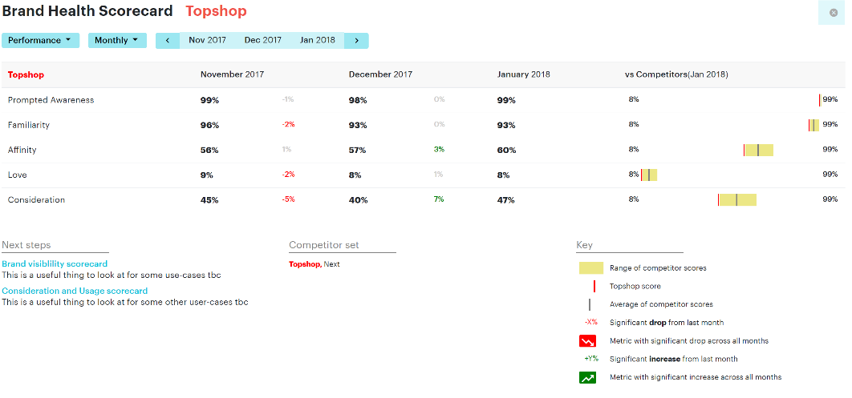
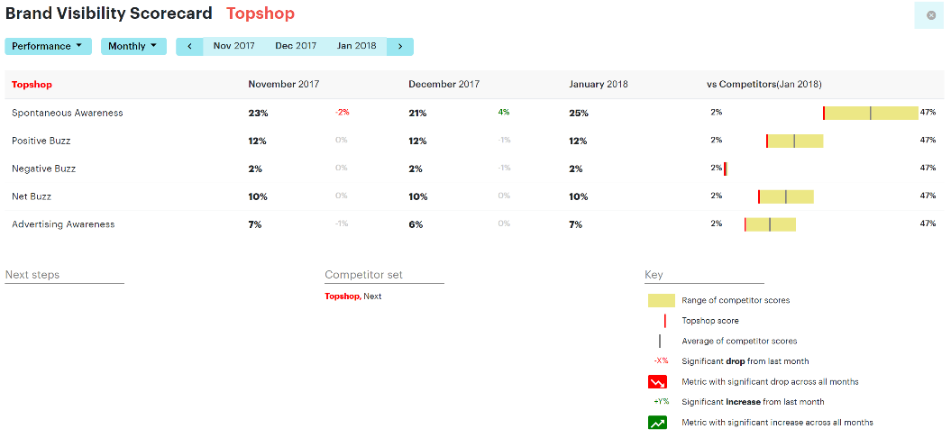
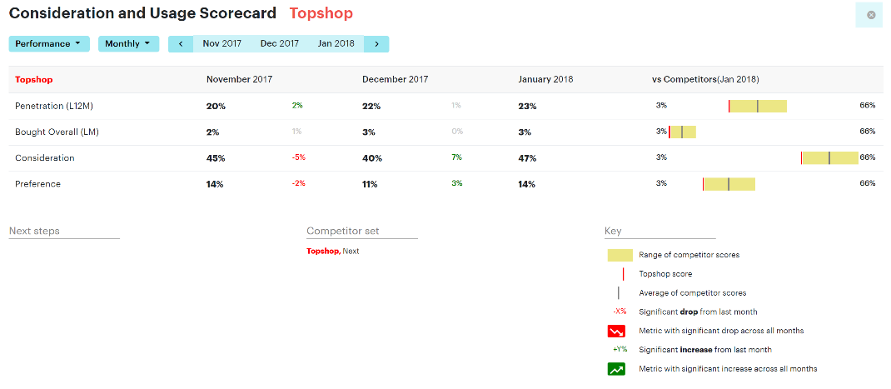

- Improved Barometer’s behaviour on smaller form factor devices such as tablets and mobile phones: this is really the first step towards a fully responsive design. There are still some teething issues, but you can now certainly use Barometer on a mobile phone

- Fixed name of How clean and tidy the store was measure under Service CPM

- Fixed overlapping of longer measure names with graphs

- Clarified that the Overview page refers to the Focus Brand

- Fixed bug where new measures (Product Specific CPM, Service CPM, Prices CPM, etc.) chaotically showed multiple different types of graph in a single view

Data & Analysis

A variety of improvements to Barometer’s analysis and export functionality, along with the addition of key Spontaneous Awareness measures, much in demand amongst insight professionals working for client brands.

- Added support for free text brand measures, leading to the addition of two specific measures to the dashboard: Top of Mind and Spontaneous Awareness
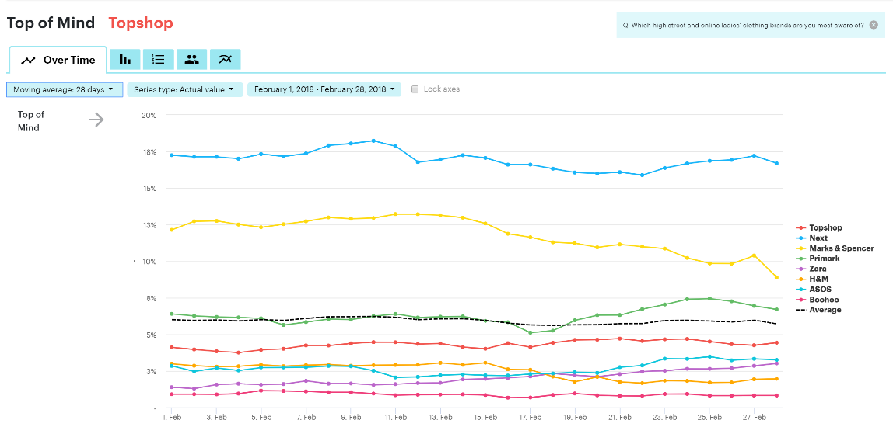
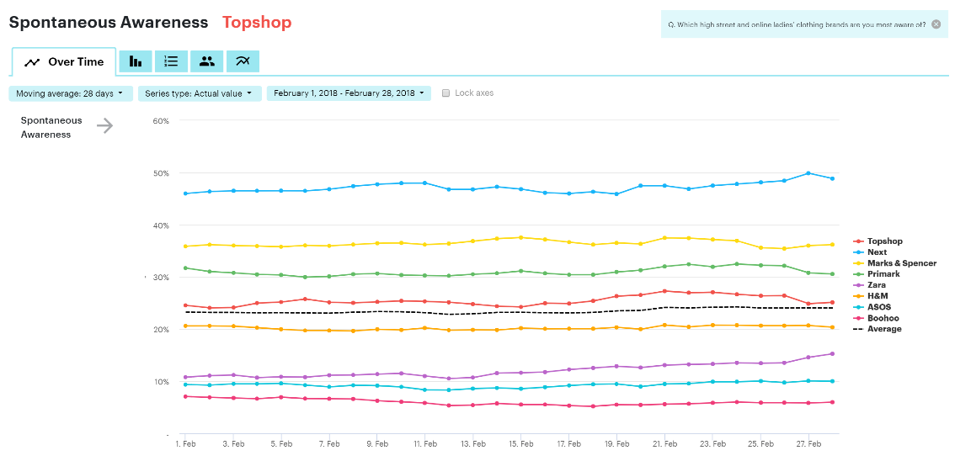

- Download Excel now works for Product Specific CPM, Service Specific CPM, and Prices CPM, along with all multi-metric charts used for overviews in general

- Fixed problem with Excel downloads for multi-metric charts (used in summary views) where percentage values that were two orders of magnitude too large

- Fixed bug where metrics whose names contain commas – for example, The quality of their products (i.e., materials, stitching, etc.) caused a failure to render any metric chart

- Fixed calculation of quarterly values, which had been showing charts with all zero values due to a deployment issue

- Added base size figures for “relative change” and “value change” (i.e., absolute change) comparision series types
- Fixed and improved Customer filter, which now includes options for 0-3 months, 4-12 months, 0-12 months, lapsed (>12 months), at any time, and never

- Months are now weighted individually when calculating quarterly values, consistent with quarterly Powerpoint reports provided by MIG

- Added support for many new measures, including those under Visit Reason, Product Specific CPM, Service CPM, Prices CPM

- Added breakdown by quota cell to WGSN’s weekly data export for all measures and brands

- Can now include measures whose names contain characters that cannot be used as part of a filename in WGSN’s weekly data export

- Including respondent level data in WGSN’s data export, along with brand and measure metadata necessary for its interpretation

- Fixed “polarity” of some measure filters (e.g., Awareness, Yes, had been matching those who were not aware of a brand)

Pipeline & Miscellaneous

- Tightened clean-up policy for old data feed and application deployments to avoid running out of disk space during deployments in future

- Second escrow submission sent to NCC Group

- Implemented safeguards to ensure corrupted/test data is not inadvertently uploaded to WGSN’s SFTP area

