WGSN Barometer Roadmap

Background

As I will outline in my email, the Vue team’s workload has increased substantially since Christmas 2017. Up to that point Barometer was really our only priority, and we were able to make rapid progress using a fairly laissez faire Kanban approach to manage our workload.

Subsequently we have ramped up – or taken over – MIG’s other dashboard projects, meaning that we now have 9 projects on the go, of which Barometer is one.

This has necessitated that we take a much more actively managed approach to delivery: we are trialling a quite heavily structured Agile approach. I hesitate to say Scrum, because it’s something of a dirty word, and we’ve adapted the process to our needs to a degree where it really isn’t accurate to describe it as Scrum. Nevertheless, we have switched to a formal two week iteration period, with regular prioritisation and planning sessions built in.

Within our prioritisation and planning sessions, decisions on our commitment for the coming iteration are based on weighing conflicting priorities across all our projects.

This makes it unrealistic for me to continue with the week by week breakdown of functionality we expect to ship, and I’m unwilling to be held account to a work of fiction. You have no doubt already noticed the increasing divergence of the roadmap from reality (another factor here is the increased demands on my time).

With that being said, you can see from the latest release notes that we’ve continued to ship key functionality in Barometer, and will carry on in this vein.

Instead of a week by week breakdown, then, what I’d like to do here is outline functionality we intend to implement. I’ll do this by category but, within those categories, I’ll attempt some rough prioritisation. We are obviously very open to a discussion of priorities for Barometer, so it’s a given that the ordering here will change.

Beyond the Priorities by Category section, I’ve included a number of Looking Further Ahead, and Under Consideration sections, which detail areas of functionality that may prove to be valuable, that may need more research and planning, and in general are expecting to work on over the longer term.

Priorities by Category

User Interface & Visualisation

- Further scorecard visualisations, which Richard Branch has shared with Sarah and Michael – the aim here is to show people the key information they need at a glance, and they can then drill into more detail if they need to. These views really provide a jumping off point – a clear place to start analysis and to gain top line insight.
- Sample threshold warning/visualisation (We haven’t yet decided how to do this, perhaps by fading data? The main thing is to avoid doing something roughly equivalent to covering the UI in yellow warning triangles. I might shift this again if it proves troublesome.)
- Assign a default peer group and focus brand according to client organisation (so, e.g., Topshop employees see a different peer group and focus brand to New Look employees). We’ve had a fruitful discussion with Oleg where a solution was proposed that would allow WGSN to administer these brand sets on clients’ behalf without having to rely on us – it’s really just a case of finding the time to make this happen.
- Allow users to create custom brand sets

Data & Analysis

- Launch menswear survey dashboard – although we agreed it was worth postponing this until we can unify the menswear and ladieswear surveys into a single dashboard. The complexity here relates to how we choose to handle brands that cater to only one gender when comparing with brands that cater to both (one option is that we don’t allow this, although that does feel a little inelegant).
- Add measure filters for most other brand measures (I say most because there are some which don’t make sense as filters: Net Buzz would be an example).
- Add support for profile measures (i.e., non-brand specific measures, such as dress size; requires upstream work, which is why it keeps slipping).
- Add measure filters for profile level filters: again, dress size is a great example here.

Performance

This change further improves the perceived, as well as the actual, performance of Barometer across many usage scenarios.

- Reduce amount of requests for data user interface sends to server, thus making it more responsive to user input

Looking Further Ahead: Communicating New Functionality

We are aware that, with continual updates being made to the user interface, both WGSN and customers may wish to be kept abreast of the latest changes to Barometer. We therefore propose to launch a blog that describes changes, along with an in-product notification mechanism that will let people know when new posts have been added, corresponding to changes in the product.

The blog format has the advantage that we can also use it for:

- Product support: if the answer to a customer’s question is covered by a blog post, simply send them a link to the post, rather than composing a long-form answer specifically for them (consider also creating posts in answers to support questions not otherwise covered).

- Sales and marketing: these are materials that we can use to showcase capabilities available in Barometer, and a useful resource for marketing, along with pre-sales enquiries.

Note that this is the same in-product notification mechanism that we might use to let users know that a new report, or version of a report, is available for download, in concert with other notifications mechanisms, such as email.

Looking Further Ahead: Reporting

Much of our focus in later this year will shift to reporting. This means generation of both ad hoc reports, but also scheduled reports, and in all case a notification mechanism. The emphasis here is on pushing reports and information to those who want them, rather than forcing them to go hunting all the time.

We haven’t tied down exactly how this will work, and it clearly needs more research, but one plausible scenario is that we have an abstract concept of a report, to which charts and data can be added, with various output formats that can be used for any report:

- PowerPoint
- Excel
- CSV
- Even possibly PDF and Word

We haven’t yet decided which order to tackle these in, although intuitively the top 3 seem like the most important.

Given that reports can be large we will generate them asynchronously and send users a notification when they are ready for download. This will be in one or more of the following ways:

- An email notification, containing a download link[1]
- SMS notifications (although it’s unclear whether these would or should contain a link; would you want to download a 40MB Excel file on your phone? Maybe, maybe not.)
- In app notifications (i.e., something like the little red bells, or red numbers you see in the top bar of web applications such as Netflix and Facebook)
- If we were ever to ship a mobile app version of Barometer, we’d also use push notifications

[1] We would not in general attach the report directly to the email because it could be intercepted by an unrelated third party looking to gain access to confidential information; this is much more difficult with an HTTPS link to download the report because we can protect that link by requiring the user to authenticate with the Barometer site before downloading.

Users would also be able to schedule reports to run on a regular basis: daily, weekly, monthly, quarterly, or whenever is convenient. When the reports are run they would receive notifications, as above.

Eventually we would like to provide users with the ability to customise reports by adding titles, annotations, and suchlike.
The following diagram shows an outline of how we think the reporting mechanism might work:

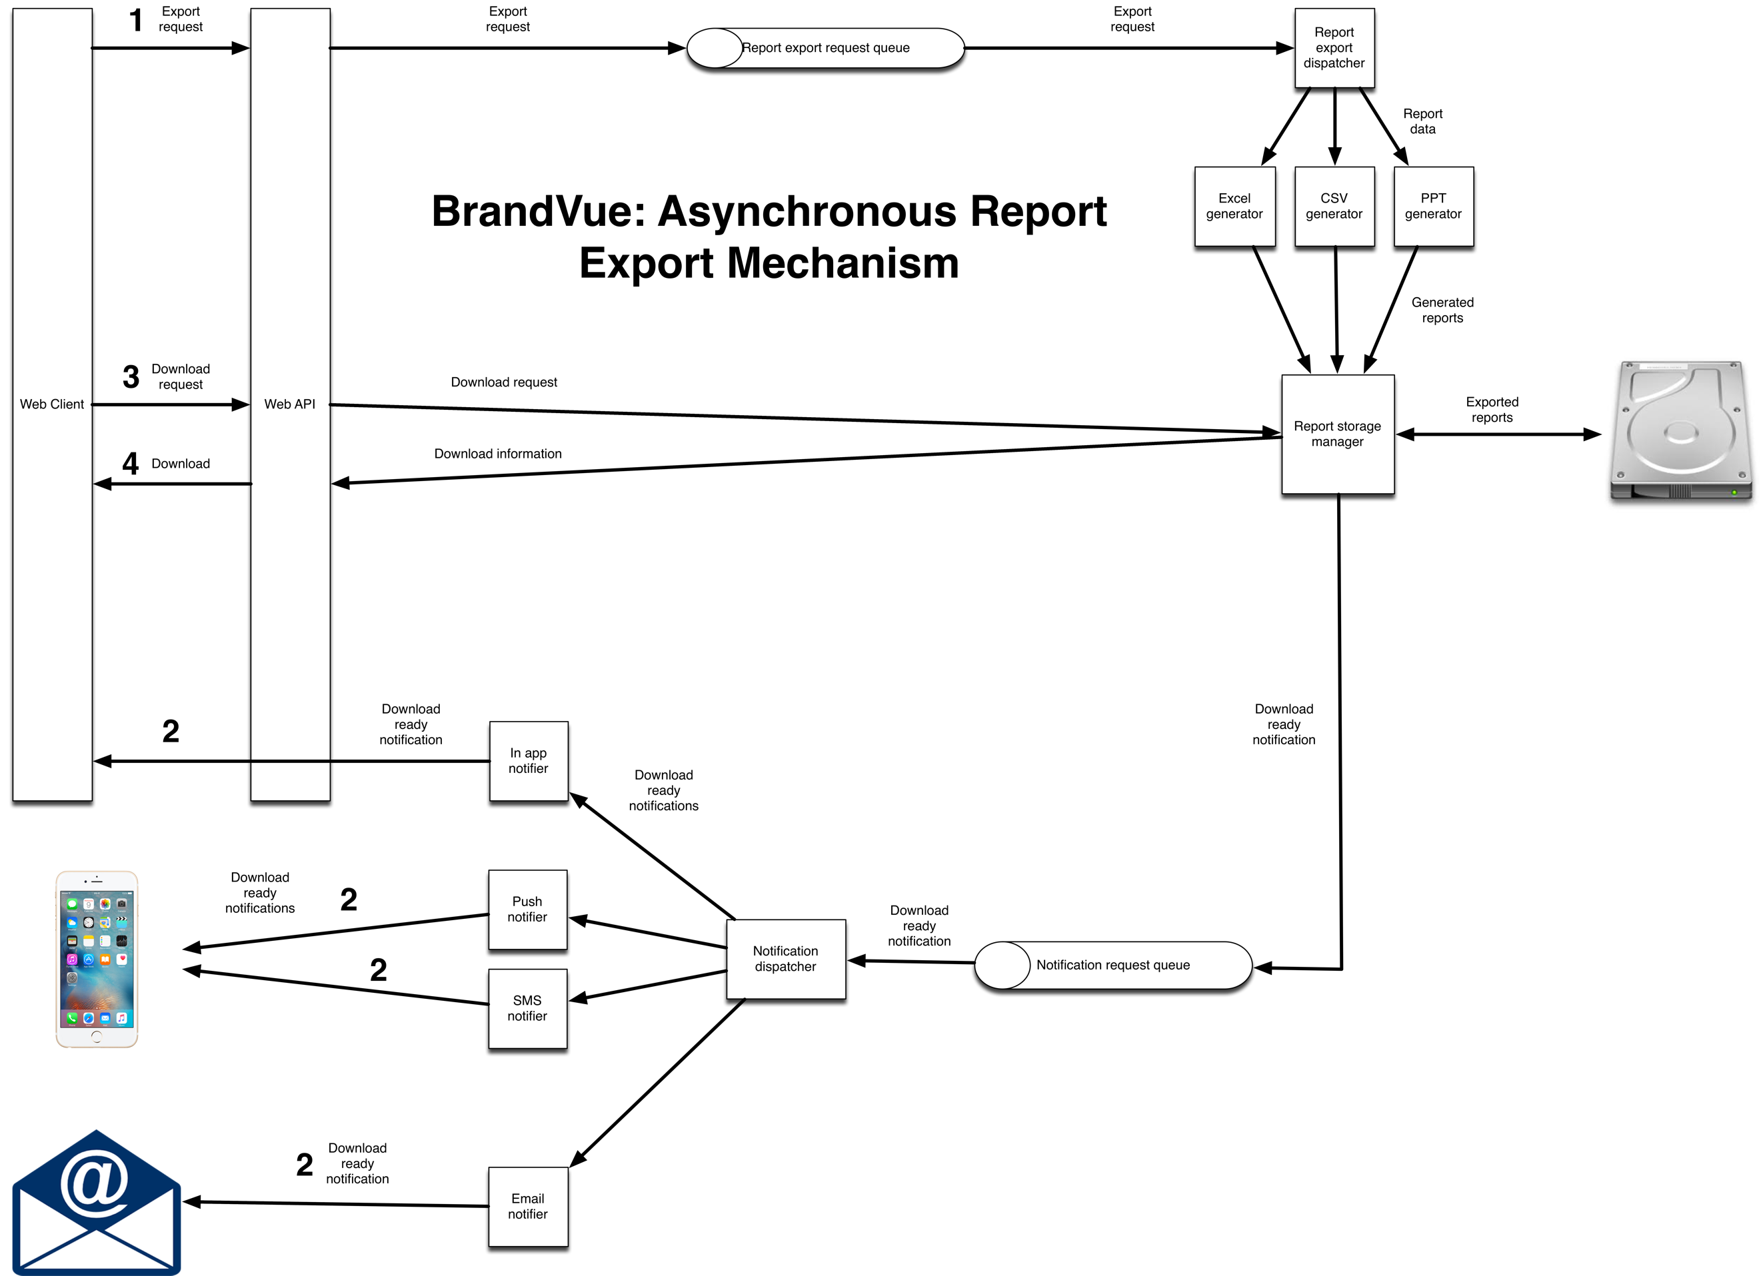

Looking Further Ahead: Automated Insight

I say automated: initially this looks like something WGSN/Ascential will pull together manually based on the data export from Barometer and start sending out fairly quickly without needing us to go ahead and build it. This is great because it’ll provide a (relatively) inexpensive feedback and validation mechanism, which will show us where to head.

Some great info from Michael Emanuel on this topic here:
Q1 2018 reporting (p.12)

Objective of “push” emails is to deliver actionable insights and “so what’s” to busy customers, most already inundated with data. They want to be told “so what’s” (“so what should we do”) rather than provided with access to a data dump.

Sending them links to big data reports (i.e. 40MB) unlikely to be most effective way of achieving this objective.

Some core design principles we should look to adopt:
- Frictionless
- Delights users
- “So what’s”

On “frictionless”, zero clicks is better than one click. One click is better than two clicks. Having to click on a link and then potentially provide log-in details to access data is a no-no (click thru rates drop off a cliff when this is required, and it rules out mobile access during commute to and from work which is optimal time for most customers.)

Here’s a strawman I’d like to propose:

Email containing:
- KPI table with 10 or so most important measures (number of measures TBD) – for each measure showing change vs. previous period, benchmarked against targets (best-in-class peer and peer average)
- Below table, one chart for each measure, showing how customer brand has tracked against competitors over time and against best-in-class and peer average targets
- Attached in Powerpoint and PDF a version of this proposed email – i.e. KPI table as exec summary, key ten or so charts on subsequent pages
- Customers can see all the key data on their mobile in a tube without mobile or wifi coverage.
- Could include hyperlinks to underlying data in dashboard

I’ve pasted here an example of how OCR do it. No fancy graphics or tricks. Just clear, simple text showing key measures, their changes and what it means. They get open rates on these of around 94%! (Industry average is about 15-20%)

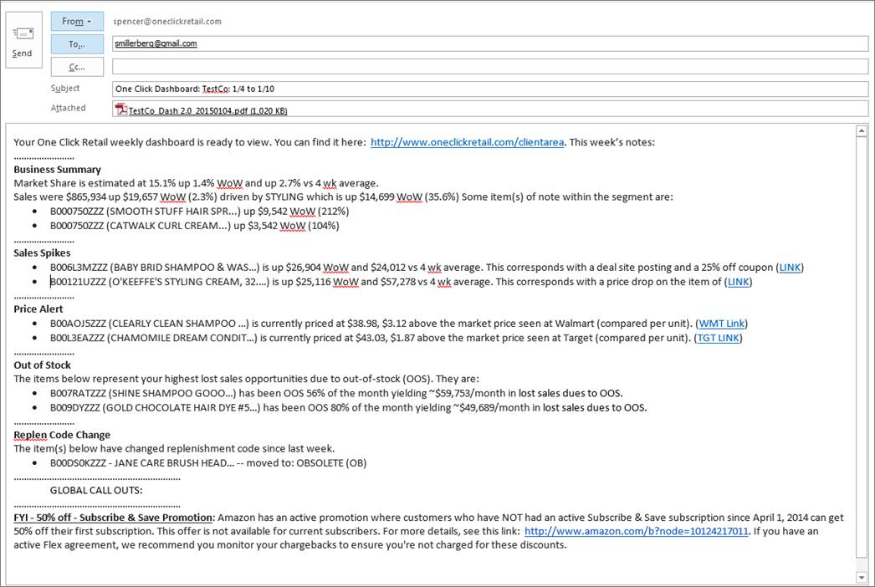

Feedback from me on practicalities

We do need to be aware of the following issues:

- Corporate anti-virus solutions often strip attachments
- Corporate mail servers often implement size limits on incoming messages
- Mobile email clients often do not download attachments by default
- Email is fundamentally insecure, and content can be intercepted using mechanisms such as DNS hijacking
- Given the above we need to be sure that any data we send is not covered by GDPR (I have seen an example in the last week where this would not have been the case)

From a purely practical perspective, to deal with attachment stripping, we’ll need to provide a download mechanism as a backup anyway, but this doesn’t need to be there for MVP.

None of the above should prevent us from heading in the direction of automated insight though!

Injecting intelligence into the machine

This goes beyond simple report generation on a schedule and into automated analysis and alerting when changes or events of interest occur.

It might mean providing an automatically generated executive summary of the most salient points from reports that are being generated, perhaps as part of the notification. This is obviously similar, and may even be covered by, the automated insight emails discussed above.

It might mean providing the user with hints whilst using the product: “People who saw this pattern in Advertising Awareness and Consideration went on to look at X, Y, and Z, which helped them discover A, B, C.” Or, at a simpler level, “People in your sector who looked at Advertising Awareness also looked at X and filtered by Y.”

Some of this insight could, in theory, come from recommendations build on patterns of input and usage by our own consultants, insight managers, etc., and could be customised by role (for example, if relevant).

This is all getting very speculative at this point, but there are plenty of interesting things we could do here. Our understanding of whether and how such an “intelligent” system will undoubtedly grow over the coming months, particularly as we grow the userbase and start getting more useful feedback from them.

Looking Further Ahead: Custom Dashboards

We anticipate that eventualy we will add functionality to allow users to build customised dashboard views. These might be custom purchase funnels for themselves or other brands, dashboards containing measures that reflect or provide insight into how they are performance against key organisational values or commercial goals, etc.

This plays to MIG’s overall dashboard strategy, which is to put customers in control and offer them an overall self-service experience. This applies not just to the dashboard itself, but to reporting and insight emails.

Under Consideration: Possible Further Work on Ad Hoc Querying/Analysis

We still do not have a great understanding of the use case for ad hoc querying within the dashboard. We could obviously build such a mechanism, but you quite quickly get to the point where you’re effectively trying to compete with Excel, Tableau, PowerPivot, and suchlike, which is something of a black-hole in terms of resources and effort.

Our suspicion is we could more valuably expend effort elsewhere, and that actually many of the use cases for which one might use an ad hoc query feature can be well (and perhaps even better) covered by the provision of appropriate filtering and data export options.

Other Matters Under Consideration

As we look further into the future the hard details of what we’d like to do become more sketchy because these are all areas that need research and validation to ensure that they are in demand from customers.

However, the broad theme here is “other data sources”. This means including events, perhaps information about advertising campaigns, as an example, as well as potentially:

- Social media postings
- Data from review sites
- Other relevant sources of public data

It also may involve companies uploading their own data (that would obviously only be available to them!), such as their financial performance. We’d need to provide some sort of API for them to do this, along with one or more standard formats that we’d accept.

Other important things we’d have to think about:

- Pricing models
- Covering storage costs
- Storage models (flat quota, amount per diem/week/month)

These things would be necessary because, from experience of running a not dissimilar service at Red Gate, some companies would hardly use it whilst the odd one or two might hammer the API with GB of data every day.

Another potentially problematic area is GDPR and PII. The definition of PII is pretty broad and so if we were, for example, hoovering up social media data, we’d have to think very carefully about how we intended to use, store, and present that information.

WGSN Barometer Roadmap Themes for Q3/Q4 2018 and Beyond

The key theme for Q3 2018 and beyond is automated insight.

This goes beyond simple report generation on a schedule and into automated analysis and alerting when changes or events of interest occur.

It might also mean providing an automatically generated executive summary of the most salient points from reports that are being generated, perhaps as part of the notification.

It might also mean providing the user with hints whilst using the product: “People who saw this pattern in Advertising Awareness and Consideration went on to look at X, Y, and Z, which helped them discover A, B, C.” Or, at a simpler level, “People in your sector who looked at Advertising Awareness also looked at X and filtered by Y.”

Some of this insight could, in theory, come from recommendations build on patterns of input and usage by our own consultants, insight managers, etc., and could be customised by role (for example, if relevant).

This is all getting very speculative at this point, but there are plenty of interesting things we could do here: the key point is it needs further research and validation.

