Software Requirements Specification
for
Informatic distributed system for the management of art club activities
Version 1.0 approved
Prepared by Paun Gabriel 3.2B
Popescu Georgiana Gabriela 3.2B
Flori Heidi 3.2A
<organization>
06.03.2021
Table of Contents
1. Introduction 1
1.1 Purpose 1
1.2 Document Conventions 1
1.3 Intended Audience and Reading Suggestions 1
1.4 Product Scope 1
1.5 References 2
2. Overall Description 2
2.1 Product Perspective 2
2.2 Product Functions 2
2.3 User Classes and Characteristics 2
2.4 Operating Environment 3
2.5 Design and Implementation Constraints 3
2.6 User Documentation 4
2.7 Assumptions and Dependencies 4
3. External Interface Requirements 4
3.1 User Interfaces 4
3.2 Hardware Interfaces 6
3.3 Software Interfaces 6
3.4 Communications Interfaces 6
4. System Features 6
4.1 Member content can be accesses based on a username and a password. 6
4.2 Calendar 6
4.3 Resource booking 7
4.4 Inviting member to events 7
5. Other Nonfunctional Requirements 8
5.1 Performance Requirements 8
5.2 Safety Requirements 8
5.3 Security Requirements 8
5.4 Software Quality Attributes 8
5.5 Business Rules 8
6. Other Requirements 9

Revision History
Name | Date | Reason For Changes | Version
Paun Gabriel | 06.03.2021 | Began working on the document  Added content for 2.2  Added content for 2.4 | 1.1
Flori Heidi | 07.03.2021 | Added content for 1.2  Added content for 2.5  Added content for 2.7 | 1.2
Popescu Georgiana | 08.03.2021 | Added content for 1.1  Added content for 1.4  Added content for 2.3  Added content for 2.6  Added content for 3.1  Added content for 4.2  Added content for 5.3 | 1.3
Flori Heidi | 08.03.2021 | Added content for 4.1  Added content for 4.3  Added content for 4.4 | 1.4
Paun Gabriel | 08.03.2021 | Added content for 1.3  Added content for 2.1
Flori Heidi | 11.03.2021 | Added content for 5.1  Added content for 5.4 | 1.5
Paun Gabriel | 11.03.2021 | Added content for 3.3  Added content for 3.4  Added content for 5.2 | 1.6

Introduction

Purpose
Whether the reader is an experimented developer or simply a customer with big dreams, this SRS will serve as a complete guide to aid them in understanding the functionalities of the application.

Document Conventions
Term | Definition
User | Someone who interacts with the web application
Member | User that is registered with an account and a membership
Admin/Administration | System administrator who is given specific permission for managing and controlling the system
Event | Meeting organized by a user, a member, or an admin, that uses resources and requires fees. They are managed through the functionality of a calendar.
Resources | Materials or places needed for an event. They can be booked the organizer of the event (a user, a member, or an admin).
Fees | Costs required for an event. 200 lei/day/resource. 400 lei/day for booking a resource if the user is not a member.

Intended Audience and Reading Suggestions
Depending on the intent of each reader of the document we suggest the following:

For developers and project managers we suggest reading: 1. Introduction, 2. Overall Description, 3. External Interface Requirements and 4. System Features.

For the marketing staff we suggest reading: 1. Introduction 5. Other Nonfunctional Requirements.

For testers we suggest reading the entire document.

For users we suggest reading 1. Introduction, 2.2. Product Functions, 2.7. Assumptions and Dependencies, 3.1. User Interface.

Product Scope
The web application for the art club “Deep Purple”, still at its first version, allows its members to access various events through a simple account creating method. Once the user becomes one of us, they can create events using any available resource for a fair amount of money.

References
Operating environments:
https://www.accessfirefox.org/Fx_System_Requirements.php
https://support.google.com/chrome/a/answer/7100626?hl=en
https://www.opera.com/download/requirements
https://docs.microsoft.com/en-us/deployedge/microsoft-edge-supported-operating-systems

Design conventions:
https://www.orbitmedia.com/blog/web-design-standards/

Due diligence:
https://onebrickcourt.com/how-to-sell-a-website/

Overall Description

Product Perspective
This web application will allow our users to access the services of the business that this app is designed for (create events, resources). Our web app will require a good internet connection in order to function correctly.

Product Functions
The web application’s main functions are:
- create/login to account with username and password
- create/edit events
- select invited members
- booking resources for certain events
- viewing invitations for events
- pay subscription
- add/edit members
- add fees/donations
- modifying available resources
- resources reservation schedule
- managing resources

User Classes and Characteristics
- admin – manages the members list and the resources, sets the price for any resource, answers to any question an eventual user might have, manages the social media pages.
- members – are able to create events, invite members and reserve resources, with a discount
- users – have all the benefits of a member, but for the full price

Operating Environment
Our web application will run on all major browsers: Google Chrome, Microsoft Edge, Mozilla Firefox, Opera and Safari. Each of these browsers support Windows 7 or higher with a Pentium 4 Processor, except for Safar that is dedicated for Apple devices. On Linux, Google Chrome runs the following versions: 64-bit Ubuntu 14.04+, Debian 8+, openSUSE 13.3+, or Fedora Linux 24, Opera runs on 64-bit Ubuntu 16.04 or later. Mozilla Firefox will not run on Linux without the following libraries or packages: GTK+ 2.18 or higher, GLib 2.22 or higher, Pango 1.14 or higher, X.Org 1.0 or higher (1.7 or higher is recommended), libstdc++ 4.3 or higher, NetworkManager 0.7 or higher,
DBus 1.0 or higher, HAL 0.5.8 or higher, GNOME 2.16 or higher. On Android to use Google Chrome you will need Android Lollipop 5.0 or higher, for Firefox you will need Android 4.1 or above.

Design and Implementation Constraints
Hardware limitations:
- Memory requirements
  - minimum 4 GB RAM, recommended 8 GB RAM

The following developing programs and tools must be provided:
- Visual Studio 2019
- Visual Studio Code
- Microsoft SQL
- Sublime text
- Krita

Language requirements:
- C#
- HTML
- CSS
- SQL

Communication protocols:
- http / https

Issues that will limit developers’ work:
- missing licenses or requested programs not being provided
- one or each developer being provided a different version of the programs than the other developers
- provided programs versions being outdated

Design conventions:
- logo in the top left
- contact in the bottom left
- main navigation across the top
- the Call to Action for Log In/Sign Up is in the top right
- social media icons in the footer
- responsive design (mobile-friendly)

User Documentation
Along with this SRS and archive containing the web site, the user will receive a web host and a due diligence covering all the questions a potential buyer might have( such as proof of the website’s traffic,its earning,a complete profit and loss statement for the last two years,etc.)

Assumptions and Dependencies
Dependencies:
- modern OS (Windows, Linux, or MAC)
- one of the following browsers: Google Chrome, Mozilla Firefox, Opera, Safari, Microsoft Edge, for accessing our web application
- internet connection

We assume that the client:
- has a PC with internet connection
- has an internet connection speed of at least 25 Mbit/s
- has one of the browsers mentioned above installed and will access our application through it

External Interface Requirements

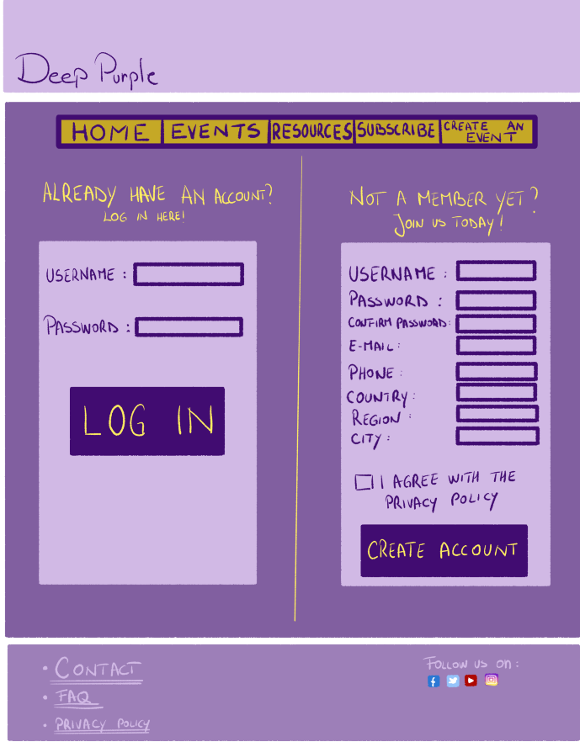
User Interfaces

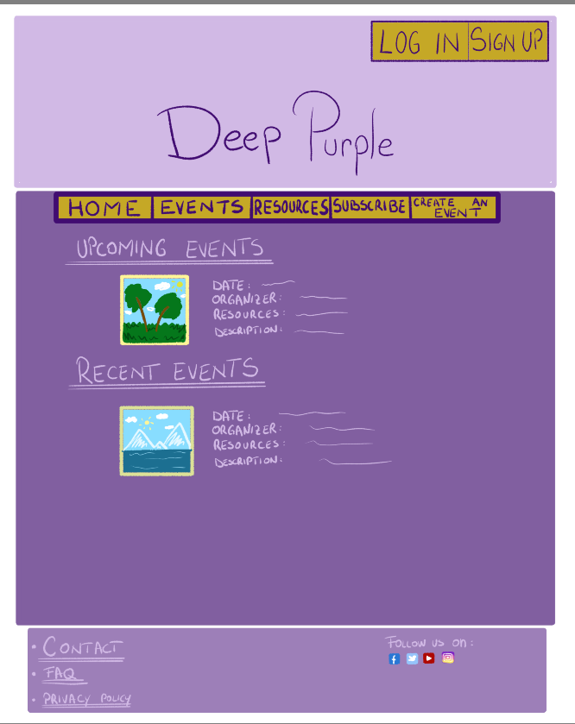

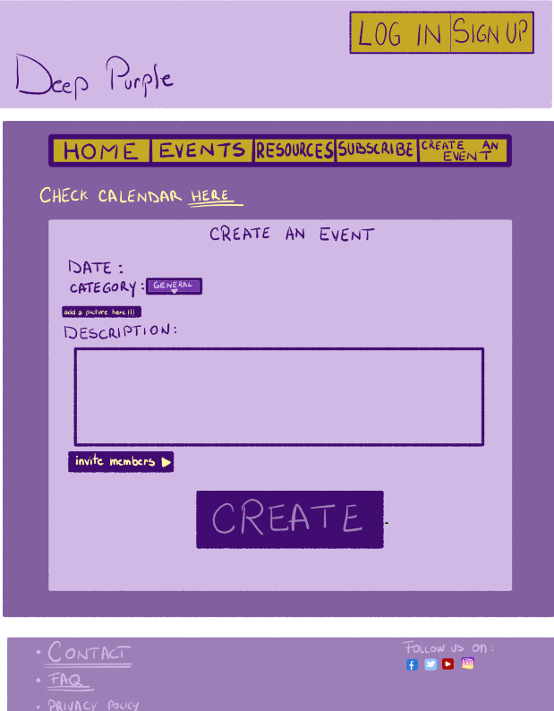
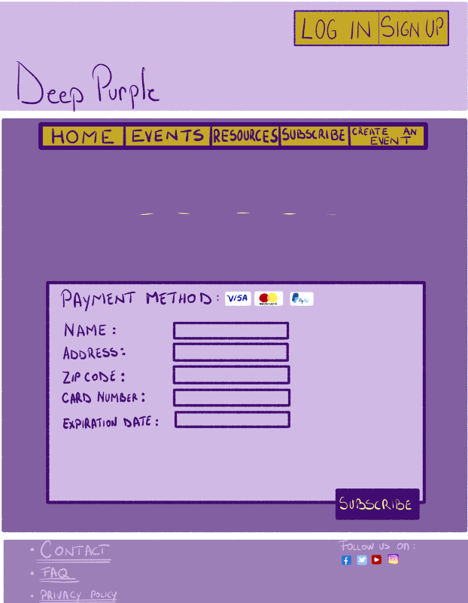

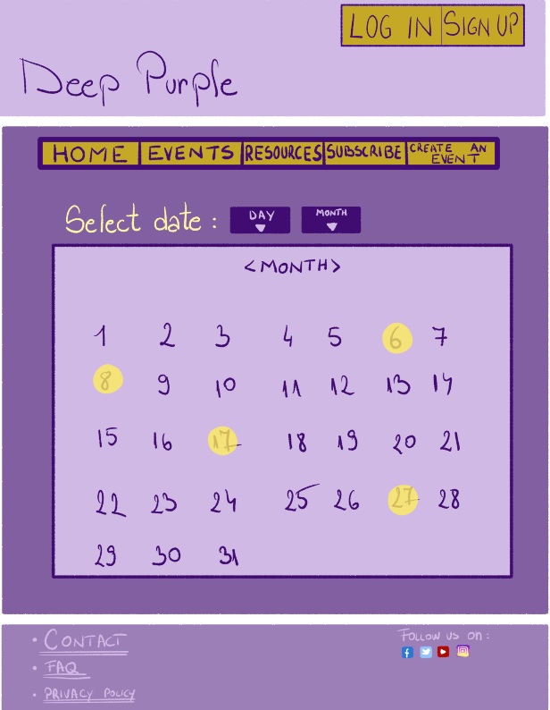

Hardware Interfaces
Not appliable.

Software Interfaces
SQL Server database will be required in order to store data and also the app will need a browser from the ones mentioned in the 2.4 Operating Environment section.

Communications Interfaces
Deep Purple needs internet connection so that the user will be able to connect to the website. The connection will be made through the HTTP protocol.

System Features

Member content can be accesses based on a username and a password.

4.1.1 Description and Priority

Priority High

4.1.2 Stimulus/Response Sequences

Input: username and password
Output: access granted or denied
4.1.3 Functional Requirements

REQ-1: read 2 parameters from the interface
REQ-2: compare them to the ones in the database
REQ-3: if they match, access will be granted

Calendar
4.1.1 Description and Priority

Priority Low

4.1.2 Stimulus/Response Sequences

Input: date for an event
Output: access to the page of the event
4.1.3 Functional Requirements

REQ-1: read 2 parameters from the interface
REQ-2: compare them to the ones in the database
REQ-3: if they match, the event page will pop up

Resource booking
4.1.1 Description and Priority

Priority High

4.1.2 Stimulus/Response Sequences

Input: resource location and name
Output: booked or not available
4.1.3 Functional Requirements

REQ-1: read the time and date parameters from the interface
REQ-2: check in the data base if the resources is available
REQ-3: check in the database if the user is a member
REQ-4: if the user is not a member, he/she hast to pay a fee of 400 lei
REQ-5: if the resource is available, it will be booked, otherwise it will say it is not available

Inviting member to events
4.1.1 Description and Priority

Priority High

4.1.2 Stimulus/Response Sequences

Input: member name
Output: invitation sent
4.1.3 Functional Requirements

REQ-1: read the parameter from the interface
REQ-2: check in the data base if the person whose name was input is a member
REQ-3: if the person is a member, send the invitation

Other Nonfunctional Requirements

Performance Requirements
The web application should use a maximum of 1GB of RAM memory.
The computer the application will be ran on should have a CPU of at least 1GHz and an operating system with a browser installed (see 2.4 for compatibility). An internet connection with the speed of at least 25 Mbit/s is also required.

Safety Requirements
In order to prevent the user of loses of that due to crashes or bugs the app will be regulary updated. To keep track of the bugs we will set up a special email and we might event develop a bug report section on the web site to know what to update and fix.

Security Requirements
The user identity authentication requires a unique username and a password, which are encrypted into the data base.

Software Quality Attributes
Some of the coding style rules followed in the development of this web application are:
- write only one statement per line
- write only one declaration per line
- if lines are not automatically indented, indent them one tab (four spaces)
- place the comment on a separate line, not at the end of a line or code
- comments should be on the same level of indentation as the code
- insert one space between the comment delimiter (//) and the comment text
- avoid using single characters as variable names, except in FOR loops
- use suggestive names for variables
- use a noun or a noun phrase for classes names

Business Rules
- The user needs an account to login
- The user must be logged in to be able to create an event
- The user must have a subscription in order to obtain the discount
- During the event creation, the user must choose an available date and resource for the event to be created successfully
- The user needs an account to login
- The user must be logged in to be able to create an event
- The user needs a credit card to subscribe
- The user must have a subscription in order to obtain the discount
- During the event creation, the user must choose an available date and resource for the event to be created successfully
- The admins should be able to edit events and resources
- The admins should be able to book a resource without any payment if the resource is available
- If the profit is lower than the loss, there can be no resource booking during a certain month
- The resources are unavailable a day prior and after a certain event

Other Requirements
Appendix A: Glossary
Appendix B: Analysis Models
Appendix C: To Be Determined List
Other requirements

