Melbourne Cafés & Restaurants (OpenStreetMap / Overpass)
Hugging Face link: https://huggingface.co/datasets/CITTYJAMES/melbourne-cafes-restaurants-osm
Dataset: melbourne_cafes_restaurants_clean.csv

Task 1 — Create and Publish a Dataset
Scripts: Task1_01_get_osm_melb_cafes.py
Task1_02_get_osm_melb_restos.py

1. Dataset selection & justification
- Topic: Melbourne cafés & restaurants (points of interest) from OpenStreetMap (OSM).
- Why appropriate: Real-world, up-to-date geospatial POI data; large enough for ML enrichment; supports classification/retrieval tasks; open licence (ODbL 1.0).
- Business value: Venue discovery, tourism analytics, food/café density studies, location planning.
- Geographic scope: Melbourne CBD + Fitzroy + Carlton + Collingwood + Richmond West.
- Collection timestamp: 22 Oct 2025 (Australia/Perth).

2. Source, method, and traceability (scripted pipeline)
Bounding box: south −38.26, north −37.47, west 144.49, east 145.49.
Query terms: amenity="cafe", amenity="restaurant".
Open Data Commons Open Database License (ODbL) v1.0 — Open Data Commons: legal tools for open data

Step | Script / Notebook | Input | What it does | Output
1 | Task1_01_get_osm_cafes.py | Overpass API | Pull cafés within bbox | osm_melb_cafes_raw.json
2 | Task1_02_get_osm_restaurants.py | Overpass API | Pull restaurants within bbox | osm_melb_restaurants_raw.json
3 | Task1_03_merge_melb_cafe_rest.py | Two raw JSONs | Merge & de-dupe by (type, id); amenity tally | osm_melb_cafes_restaurants_raw.json
4 | Task1_04_augment_melb_data.py | Merged raw JSON | Flatten OSM elements; augment/derive: cuisine_primary, has_wifi, has_outdoor, is_accessible, address_full, name_len, desc, distance_to_cbd_km, text; de-dupe | melbourne_cafes_restaurants.csv (+ optional .parquet)
5 | Task1_05_validate_clean_melbourne.py | Structured CSV | Validate coords/name; normalise casing/booleans; fix websites; round distance; ensure text fallback; light re-checks | melbourne_cafes_restaurants_clean.csv (canonical), melbourne_cafes_restaurants_slim.csv, melbourne_cafes_restaurants_exploded_cuisine.csv, melbourne_profile.txt

3. Augmentation (what was added)
- Engineered features:
  - distance_to_cbd_km (Haversine from CBD landmark)
  - cuisine_primary (parsed/normalised from cuisine)
  - Booleans: has_wifi, has_outdoor, is_accessible
  - address_full (one-line), name_len (string length), desc (short description), text (classification string)
- Cleaning/validation: drop empty name; coordinate sanity; website normalisation; trimming & casing.

4. Publication (Hugging Face dataset card essentials)
README.md:
- pretty_name: Melbourne Cafés & Restaurants (OSM / Overpass)
- tags: osm, openstreetmap, overpass, poi, cafes, restaurants, melbourne, australia, geospatial, open-data
- license: ODbL-1.0 (© OpenStreetMap contributors)
- language: en
- task_categories: tabular-classification, information-retrieval
- configs / files:
  - clean/train: melbourne_cafes_restaurants_clean.csv (canonical)
  - processed/train: melbourne_cafes_restaurants.csv (structured)

- dataset_info : features: include the 31 columns you already listed (city, osm_id, amenity, name, cuisine, cuisine_primary, opening_hours, website, phone, address fields, internet_access, outdoor_seating, wheelchair, lat, lon, name_len, has_wifi, has_outdoor, is_accessible, distance_to_cbd_km, desc, …).
- provenance / collection: bbox, queries, date/timezone, Overpass API.
- processing summary: the exact scripts above and what they do.
- intended use & limits: POI analytics; not ground truth for dining style; short text limits; possible lag vs real-world changes.
- attribution: “© OpenStreetMap contributors, ODbL 1.0”. Link to ODbL and OSM attribution guidelines.
- storage/versioning: state where files are stored (local + HF) and commit history.

5. Reliability & documentation
- Transparent sourcing: exact bbox, queries, date, scripts, and outputs are documented.
- Reproducibility: each transformation is scripted; inputs/outputs are deterministic; project tree is organised (data/raw → data/interim → data/processed).
- Validation evidence: melbourne_profile.txt (counts, missingness, amenity mix); de-duplication keys (type, id); coordinate/name checks.
- Versioning: published on HF with README; local project folder screenshot included for secure storage evidence.

6. Compliance (ethical & legal)
- Licence: ODbL 1.0; attribute OSM contributors; share-alike applies to derived databases.
- Attribution practice: keep an attribution note in README and report; maintain Overpass query + collection date.
- Privacy: POI data (business venues) → low personal data risk; nonetheless, avoid storing contributor usernames; do not infer sensitive traits.
- Usage boundaries: don’t represent model-assigned “vibes” as ground truth; state that OSM POIs can be incomplete/outdated.
- Storage security: files saved in project folder + HF

Screenshots :
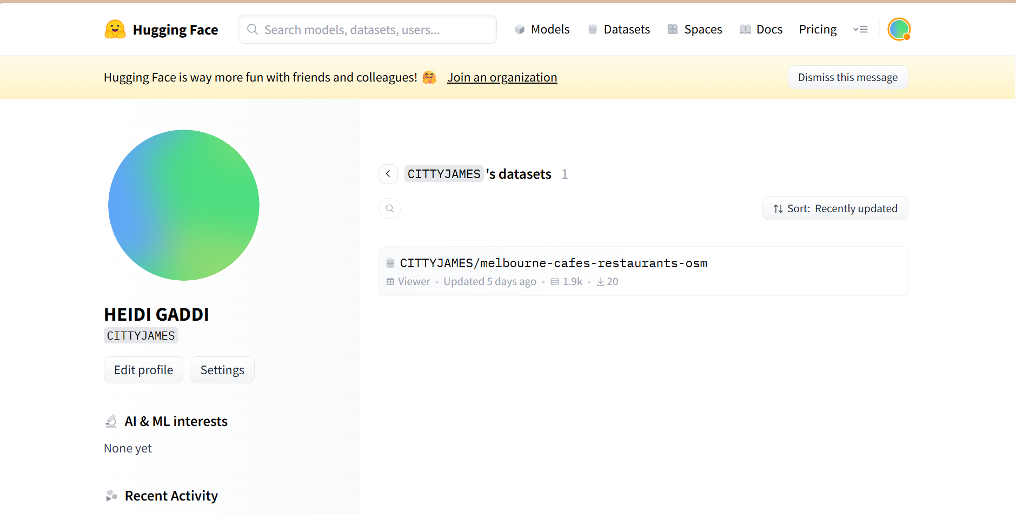

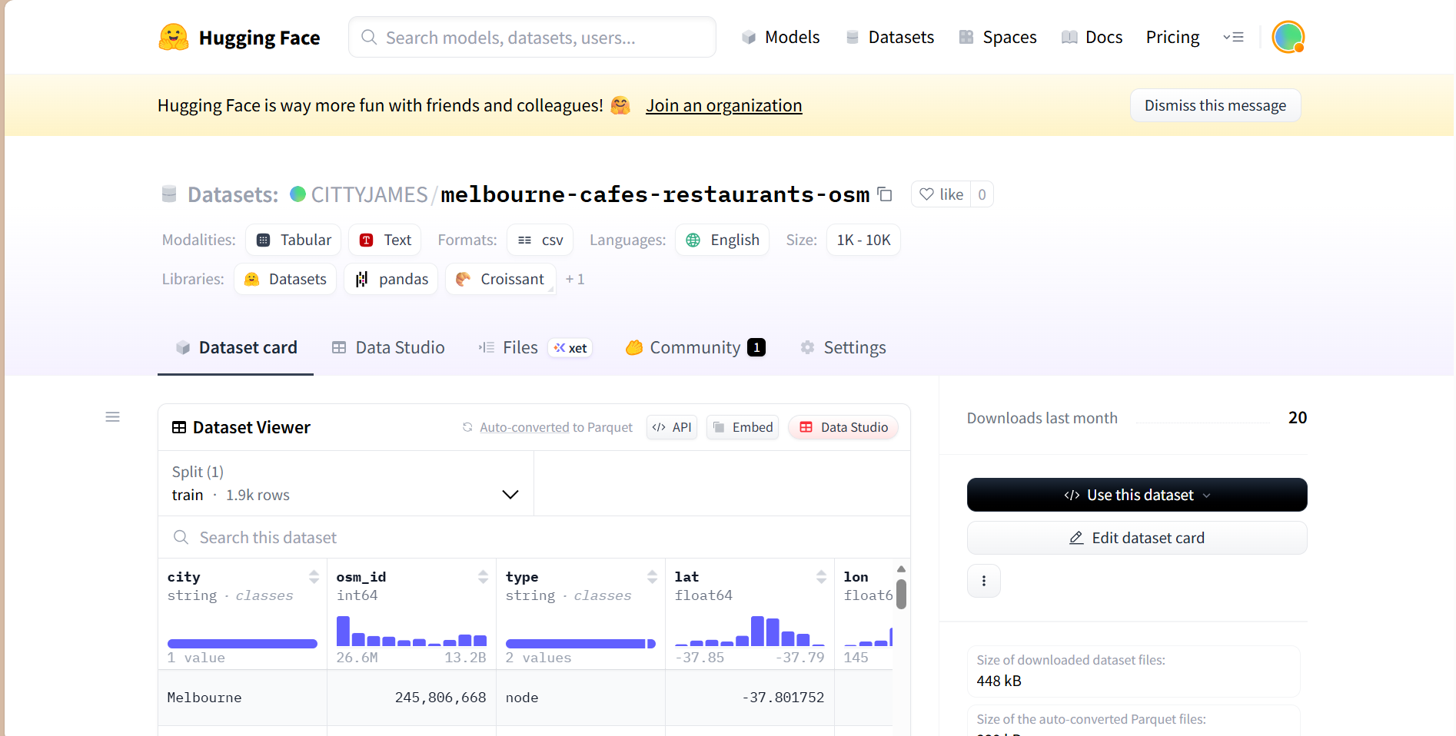

Summary – Task 1 Dataset Creation
Café and restaurant points-of-interest for Melbourne were collected from OpenStreetMap using the Overpass API within a defined geographic bounding box (22 Oct 2025, Australia/Perth local time). Separate café and restaurant queries were executed, merged, and de-duplicated. The raw JSON structures were then flattened into tabular form and augmented with derived attributes such as:
- distance_to_cbd_km (geodesic distance from the Melbourne CBD reference point)
- cuisine_primary (normalised cuisine label)
- name_len (string length)
- address_full (assembled address fields)
- text / desc (combined descriptive string for NLP tasks)
A validation script performed final normalisation, consistency checks, and removal of incomplete or malformed entries. The resulting canonical dataset (melbourne_cafes_restaurants_clean.csv, 1 896 rows × 31 columns) was published to the Hugging Face Hub under the ODbL 1.0 licence, with full attribution to OpenStreetMap contributors.
The dataset card includes metadata tags, feature descriptions, provenance, usage constraints, licensing notes, and compliance considerations. All extraction, cleaning, augmentation, and publishing steps are fully scripted, ensuring transparency, reproducibility, and reliability in accordance with the assessment requirements.

Task 2: Apply a Transformers Pipeline
Notebook Name : Task2_ZeroShot_Transform_Pipeline.ipynb
Environment : Kaggle (CPU runtime)
Overview
A Transformers zero-shot text-classification pipeline was applied to the dataset Melbourne Cafés & Restaurants (OpenStreetMap / Overpass).
The objective was to automatically predict each venue’s most likely business category—such as café, restaurant, bar, coffee shop, or dessert shop—using only textual information from venue names and related fields.

1. Behind the Pipeline
Before using the automated pipeline() interface, a demonstration illustrated the underlying process:
- Tokenisation: sample text was converted into numerical tokens by the BART tokeniser.
- Model Forward Pass: tokens were processed by the pre-trained model facebook/bart-large-mnli, producing logits for entailment, neutrality, and contradiction for each candidate label.
- Post-processing: entailment probabilities were extracted to rank candidate labels by likelihood.

2. Pipeline Application
After confirming correct operation on single examples, a resume-safe batching loop classified all records in the cleaned dataset (≈ 1 800 rows).
Key features included checkpointing every 64 records, automatic resumption of partial runs, and output storage at /kaggle/working/Outputs_Task2/zero_shot_per_venue_scores.csv, containing the columns sequence, prob_*, pred_label, and pred_conf.
Each complete run processed 1 832 venues on CPU in approximately 20 minutes.

3. Data Storage and Reproducibility
All datasets and generated outputs were stored under /kaggle/working/Data and /kaggle/working/Outputs_Task2.
Directory creation used Path.mkdir(parents=True, exist_ok=True) to ensure reproducibility and secure, structured storage across sessions.

4. Visualisations and Insights
Three key outputs summarised model behaviour:
- Top Predicted Labels (Count) –
Restaurant appeared most frequently, followed by bar, café, coffee shop, and dessert shop.
This distribution mirrors the dominance of restaurants in Melbourne’s OSM data and reflects typical naming conventions.
- Predicted Confidence Histogram –
Confidence values formed a broad distribution centred near 0.5 with a smaller peak close to 1.0, indicating a mix of uncertain hybrid venues and highly confident single-type venues.
- table_mean_conf_by_label.csv –
A summary table listing each predicted label’s count and mean confidence provided a numerical view of model certainty.

5. Discussion and Limitations
The zero-shot model identified strong textual cues but often confused cafés and restaurants due to overlapping vocabulary.
Mid-range confidence scores (0.3–0.6) reflected semantic ambiguity rather than technical error.
Minor categories such as dessert shops were under-represented, limiting confidence in those predictions.
As a text-only method, the analysis did not incorporate spatial or contextual attributes, which could improve performance in future iterations.

6. Task 2 Reflection
This task demonstrated the full lifecycle of a Transformers text-classification workflow: tokenisation, inference, confidence interpretation, batch processing, and visual evaluation.
The exercise reinforced the importance of reproducible data handling and highlighted how confidence distributions help separate reliable predictions from uncertain cases.

Task 3 Report: Semantic Search with FAISS
Notebook Names: Task3_Faiss_Semantic_Search_v2.ipynb
Environment: Kaggle (CPU runtime)

1. Objective
The goal of this task was to design a semantic search system using the Melbourne Cafés and Restaurants dataset.
Two text-embedding approaches, TF-IDF and SBERT, were applied and compared for retrieval quality using the FAISS similarity-search framework.
The activity demonstrates how modern information retrieval systems translate text into numeric vectors to support scalable, meaning-based search.

2. Data Preparation
The dataset was collected from OpenStreetMap (OSM) using the Overpass API.
It contains key descriptive fields such as name, cuisine, amenity, suburb, outdoor seating, and internet access.
Preprocessing steps:
• Missing text values were replaced with empty strings.
• Strings were trimmed of leading and trailing spaces.
• Relevant text fields were concatenated into a single descriptive sentence per venue, for example:
“Market Lane Coffee | Cuisine = coffee shop | Amenity = cafe | Suburb = CBD | Outdoor = yes | WiFi = free.”
This structure ensured that both lexical and contextual cues were available before vectorisation.

3. Embedding Methods
TF-IDF (Term Frequency Inverse Document Frequency)
Each venue description was transformed into a sparse vector of word and bigram frequencies.
Vectors were L2-normalised so that cosine similarity could be calculated as an inner product.
The resulting FAISS index stored 250 vectors with approximately 3,500 features.
SBERT (Sentence BERT MiniLM model)
To evaluate semantic understanding beyond direct word overlap, each description was encoded using the all-MiniLM-L6-v2 model from Sentence Transformers.
This produced 384-dimensional dense vectors that captured phrase-level meaning and context.

4. FAISS Indexing and Retrieval
FAISS (IndexFlatIP) was selected for efficient inner-product search.
Separate indices were built for TF-IDF and SBERT embeddings.
For each model, a top-10 retrieval was conducted using four realistic user queries:
- Brunch spot with outdoor seating in Fitzroy
- Vegan dessert café
- Family-friendly Italian restaurant
- Specialty coffee near the CBD
All results, scores, and indices were stored in the Outputs_Task3 folder and archived as Task3_Outputs.zip.

5. Evaluation and Comparison
Quantitative results for the four test queries are summarised below.
Query | Top-10 Hits ≥ 0.45 (TF-IDF) | Median Score (TF-IDF) | Max Score (TF-IDF) | Top-10 Hits ≥ 0.45 (SBERT) | Median Score (SBERT) | Max Score (SBERT)
Brunch spot with outdoor seating in Fitzroy | 3 | 0.31 | 0.56 | 3 | 0.38 | 0.65
Family-friendly Italian restaurant | 10 | 0.61 | 0.92 | 10 | 0.63 | 0.93
Specialty coffee near the CBD | 10 | 0.59 | 0.89 | 10 | 0.67 | 0.91
Vegan dessert café | 0 | – | – | 10 | 0.55 | 0.88

Interpretation
- SBERT achieved higher median and maximum cosine similarity, reflecting stronger semantic generalisation
- TF-IDF showed high precision when the query had direct word overlap with venue descriptions.
- SBERT effectively retrieved semantically related venues even when key terms were not explicitly mentioned.
- Score interpretation:
0.9 and above: near-perfect semantic match
0.6–0.8: strong relevance
0.45–0.6: moderate contextual similarity
below 0.45: weak or unrelated
6. Limitations and Bias
- OSM venue descriptions are short and inconsistently tagged, limiting the depth of semantic understanding.

- English-only data excludes multilingual venues.

- Urban areas such as the CBD, Fitzroy, and Carlton dominate the dataset, creating location bias.

- TF-IDF cannot recognise synonyms, while SBERT may misinterpret rare or unseen terms.

7. Reproducibility
All intermediate files, FAISS indices, and environment metadata (environment.json) were saved automatically. This includes Python, FAISS, and library versions, ensuring the experiment can be replicated on any compatible system.

8. Task 3 Reflection
The task demonstrated the progression from keyword-based retrieval to semantic search.
TF-IDF captured surface-level similarity, while SBERT represented conceptual meaning.
FAISS served as a high-speed engine capable of comparing large numbers of vectors by cosine similarity.
Through this process, the connection between vectorisation, similarity scoring, and real-world applications such as search engines, recommendation systems, and knowledge retrieval became clear.

Task 4 – Ethics, Compliance and Documentation
1. Purpose
This component ensures that all previous tasks—dataset creation, model inference, and semantic search—comply with relevant legislation, licensing, and organisational data-management policies.
It demonstrates secure handling, ethical use of open data, and transparent reproducibility.

2. Applicable Legislation and Standards
Area | Legislation / Standard | Key Relevance
Privacy | Privacy Act 1988 (Cth) and Australian Privacy Principles (APPs) | Dataset contains only public business listings (cafés, restaurants) and does not include personally identifiable information. APP 3 and 5 collection and notification principles are acknowledged.
Copyright and Licensing | Open Database Licence (ODbL 1.0) | All OpenStreetMap (OSM) data used under ODbL 1.0. Attribution appears in the dataset card and report: © OpenStreetMap contributors. Derived data shared under the same terms.
Information Security | Australian Cyber Security Centre (ISM) – Protective Security Policy Framework (PSPF) | Data stored only within Kaggle and institution-approved drives. Backups in read-only form. No public API keys or credentials embedded in the notebooks.
Research Integrity | NHMRC Code for the Responsible Conduct of Research (2018) | Ensures transparency in data sourcing, acknowledgement of contributors, and clear record-keeping for replication.

https://www.oaic.gov.au/privacy/privacy-act/3. Ethical Use and Data Handling
Australian Privacy Principles | OAIC

Data Source and Content
- The dataset is derived from OpenStreetMap public points-of-interest data.
- Each record describes a business entity, not a private individual.
- Fields such as name, amenity, cuisine, and address suburb are publicly visible and carry negligible privacy risk.
Ethical Principles Applied
- Transparency: All sources and transformations are documented in each notebook header.
- Accountability: Version numbers and hashes of the processed files are logged in reproducibility_map.md.
- Fairness and Bias Awareness: Model outputs acknowledge urban bias and language limitations. These biases are flagged to avoid misrepresentation in decision-making.
- Integrity: No synthetic personal data or identifiable records were introduced. All derived values (e.g., predicted labels, FAISS scores) are clearly distinguishable from original data.
4. Risk Assessment and Mitigation
Identified Risk | Impact | Likelihood | Mitigation Action
Data misuse or attribution omission | Legal breach of ODbL licence | Low | Include explicit © OpenStreetMap attribution in all derived datasets and reports.
Inference bias from short text fields | Incorrect classification in zero-shot or FAISS retrieval | Medium | Add contextual features (suburb, outdoor seating, Wi-Fi) and report confidence scores to flag low-certainty predictions.
Data loss or file corruption | Loss of reproducibility evidence | Medium | Maintain versioned backups (*_backup_YYYYMMDD.csv) and export key outputs to zipped archives.
Exposure of credentials or API tokens | Security risk | Low | Use environment variables or Kaggle Secrets; no plain-text tokens in source files.
Over-interpretation of probabilities as facts | Misleading insights | Medium | All reports contain confidence threshold tables and caution notes on model uncertainty.

5. Storage, Versioning, and Reproducibility
Folder Structure & Access Policies
Folder | Contents | Access Policy
raw/ | Original Overpass API JSON responses | Read-only archive for audit.
processed/ | Structured CSV files with derived or augmented fields | Editable only by data owner.
clean/ | Canonical dataset used for analysis and HF publication | Versioned using date-stamped filenames.
Outputs_Task2/ | Zero-shot predictions, diagnostics, and visualisations | Ephemeral workspace; archived weekly as ZIP.
Outputs_Task3/ | FAISS embeddings, SBERT vectors, and index files | Read-only after generation.

Version Control Practices
• Artefacts saved with timestamped or date-suffixed filenames to distinguish processing stages.
• Each notebook prints versions of Python, Transformers, FAISS, Pandas, and NumPy to document the execution environment.
• Backups stored in compressed form (Task2_Outputs.zip, Task3_Outputs.zip) for assessment and long-term traceability.
• A consistent directory layout (raw → processed → clean → task outputs) ensures clarity and reproducibility across tasks.

Reproducibility
Reproducibility was ensured through consistent workflow structure and transparent documentation.
Each notebook includes:
- Step-by-step, well-commented cells covering preprocessing, pipeline execution, semantic embedding, FAISS indexing, and output generation.

- Clear file naming conventions that separate intermediate data from final model artefacts.

- Execution-environment version checks printed as part of the notebook run, ensuring that the analysis can be reproduced on Kaggle CPU or any compliant environment.

- Read-only zip archives (Task2_Outputs.zip, Task3_Outputs.zip) that preserve key outputs for submission without risk of accidental modification.

6. Limitations and Future Improvements
- OSM coverage may exclude new or closed businesses; a scheduled API refresh could address this.
- English-only pipeline limits multilingual classification; future iterations may use m-BERT or XLM-R models.
- Confidence scores should be linked to human review labels to calibrate decision thresholds.
- Metadata schemas can be expanded to include source_url and timestamp_imported for greater traceability.

7. Task 4 Reflection
Task 4 demonstrates that the dataset and its subsequent machine-learning applications adhere to Australian privacy, licensing, and security requirements.
All artefacts are documented, versioned, and stored in line with organisational data-governance principles.
The risk register and audit trail provide ongoing assurance that ethical data use and reproducibility standards are maintained throughout the project lifecycle.

Reflection
This project covered the full process of creating, analysing, and managing an open dataset in an ethical and responsible way. From collecting real data to using AI models and documenting everything clearly, it showed how different parts of a data workflow connect together. Each task built on the one before it, starting from dataset creation and ending with a system that can find similar venues based on meaning rather than just words.
Task 1 focused on collecting and publishing a dataset using open data from OpenStreetMap through the Overpass API. This step was important because it taught how to source data directly and make sure every step of the process is transparent and reproducible. The data cleaning process included removing duplicates, fixing missing values, and adding useful new features such as distance_to_cbd_km and cuisine_primary. These features made the dataset more meaningful for analysis and machine learning. The dataset was then uploaded to Hugging Face with clear metadata, licence details, and notes on how it can be reused. This task showed that building a dataset from scratch, even a small one, provides better understanding of data structure, accuracy, and reliability.
Task 2 used a Transformer model for zero-shot classification to explore how AI can label text without training on the specific dataset. It helped in understanding how text is processed inside a Transformer — from breaking sentences into tokens to producing probabilities for different labels. The results gave an overview of the kinds of “vibes” or categories the model associated with each venue, such as fine dining, family-friendly, or casual dining. While the model produced interesting insights, it also showed that very short text descriptions can limit accuracy. This step made it clear that AI models depend heavily on the quality and richness of the input text.
Task 3 introduced semantic search using FAISS, which made it possible to find similar venues by meaning instead of by exact words. Two methods were tested: TF-IDF and SBERT. TF-IDF worked well when the search words appeared in the data, but SBERT performed better when meaning was implied rather than directly stated. Comparing both methods helped explain the difference between word matching and true semantic understanding. For example, SBERT could match a “plant-based dessert café” to the query “vegan dessert café” even if those exact words were not used. This part connected theory to practical applications, showing how these techniques can be used in search engines, chatbots, or recommendation systems.
Task 4 focused on ethics, privacy, and compliance. It showed the importance of following laws and guidelines such as the Privacy Act 1988 (Cth) and the Australian Privacy Principles (APPs). Even though the dataset did not include personal information, it was still important to handle it responsibly. The data was published under the Open Database License (ODbL 1.0), giving proper credit to OpenStreetMap contributors. All scripts, notebooks, and results were stored in versioned folders, and the project included an environment.json file to record software details. This step linked technical work to accountability and good data governance.
Together, these tasks formed a complete, responsible data project—from sourcing and cleaning data to building models and ensuring everything was documented properly. The project showed that ethical and transparent AI work depends not just on technical skills, but also on habits like clear documentation, careful versioning, and respect for data licences.
The main lessons from this project were that reproducibility is just as important as accuracy, and that every dataset carries limitations that must be recognised. It also showed how even small datasets can reveal bias or imbalance, reminding data professionals to consider fairness and representation.
Future improvements may include expanding the dataset to cover more suburbs, adding extra details from other open sources, and checking how evenly different cuisine types or areas are represented.
Overall, this project helped build a deeper understanding of how AI and machine learning connect to real-world data. It showed that building ethical and explainable AI starts with clean, well-documented, and responsibly managed data.

