Midterm Report

2023-03-30

## Minnesota Timberwolves 1999-00 shot data  
## Minnesota Timberwolves 2000-01 shot data  
## Minnesota Timberwolves 2001-02 shot data  
## Minnesota Timberwolves 2002-03 shot data  
## Minnesota Timberwolves 2003-04 shot data  
## Minnesota Timberwolves 2004-05 shot data  
## Minnesota Timberwolves 2005-06 shot data  
## Minnesota Timberwolves 2006-07 shot data  
## Minnesota Timberwolves 2007-08 shot data  
## Minnesota Timberwolves 2008-09 shot data  
## Minnesota Timberwolves 2009-10 shot data



## Acquired Chicago Packers, Chicago Zephyrs, Baltimore Bullets, Capital Bullets, Washington Bullets, Washington Wizards history  
## Acquired New Orleans Jazz, Utah Jazz history  
## Acquired Toronto Raptors history  
## Acquired San Antonio Spurs history  
## Acquired Rochester Royals, Cincinnati Royals, Kansas City-Omaha Kings, Kansas City Kings, Sacramento Kings history  
## Acquired Portland Trail Blazers history  
## Acquired Phoenix Suns history  
## Acquired Syracuse Nationals, Philadelphia 76ers history  
## Acquired Orlando Magic history  
## Acquired Seattle SuperSonics, Oklahoma City Thunder history  
## Acquired New York Knicks history  
## Acquired New Orleans Hornets, New Orleans/Oklahoma City Hornets, New Orleans Pelicans history  
## Acquired Minnesota Timberwolves history  
## Acquired Milwaukee Bucks history  
## Acquired Miami Heat history  
## Acquired Vancouver Grizzlies, Memphis Grizzlies history  
## Acquired Minneapolis Lakers, Los Angeles Lakers history  
## Acquired Buffalo Braves, San Diego Clippers, Los Angeles Clippers, LA Clippers history  
## Acquired Indiana Pacers history  
## Acquired San Diego Rockets, Houston Rockets history  
## Acquired Philadelphia Warriors, San Francisco Warriors, Golden State Warriors history  
## Acquired Ft. Wayne Zollner Pistons, Detroit Pistons history  
## Acquired Denver Nuggets history  
## Acquired Dallas Mavericks history  
## Acquired Cleveland Cavaliers history  
## Acquired Chicago Bulls history  
## Acquired Charlotte Hornets, Charlotte Bobcats history  
## Acquired New York Nets, New Jersey Nets, Brooklyn Nets history  
## Acquired Boston Celtics history  
## Acquired Tri-Cities Blackhawks, Milwaukee Hawks, St. Louis Hawks, Atlanta Hawks history

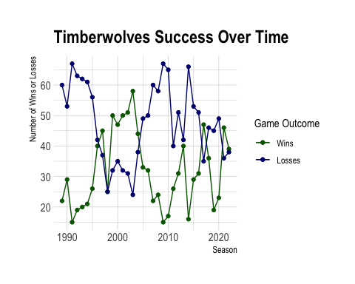

### Shots

* Shooting patterns appear as higher density (darker) areas on the court where shots are taken
  + Along the three-point line
  + Half circle slightly inside of the three-point line
  + Surrounding the hoop and along the back edge of the court
* Location on court doesn’t seem to affect accuracy rate
* It appears than earlier years had fewer shots from the three-point line
* The highest density spot on the court for shots taken is surrounding the net for most years

### Wins and Losses

* The Timberwolves peaked from the mid-1990’s to mid-2000’s in terms of win-loss percentage
* Their worst years in terms of win-loss percentage were 1991, 2009, and 2014
* They have lost more games than won for the majority of the seasons they have played total

### Summary

The animated shot plot for the Timberwolves depicts all shots taken on the opponents side of the court, over the course of 11 seasons. Within this plot, we can see multiple patterns of where shots are taken. In general, there is usually a greater amount of shots clustered around the hoop. This shot pattern also extends across the bottom edge of the court which is seen with with the plot being darker (more points) in this area. The other two patterns observed take the shape of semi circles further out from the hoop. There is one distinct cluster of shots that follow the three-point line, and another cluster with the same shape but slightly closer, in between the three-point line and the hoop.

There is no clear spot on the court in which shots are more often made (more green) or more often missed (more blue). This would suggest that the shot being made likely has more to do with a players skill level than where on the court they are. It is interesting to note that of few shots made beyond the three-point line, most of them were made despite it being the furthest away. There were some shots taken from the other side of the court, however this was not included in the graphic because these are not typical game shots and we wanted to keep the focus on the opponents end of the court.

The line graph for the Timberwolves depicts the number of wins and losses that they had for each season, starting when they joined the NBA up to 2022. It is clear that they peaked from 1997 - 2004 with their best season (based on wins alone) being 2003. This is based on the fact that the winning line (green) is above the losing line (blue) for eight consecutive years here, minus 1998 in which wins and losses appear to be equal. 2003 was the year that the Timberwolves won the most games as well as lost the fewest. Besides this short time period, the team has only had three other seasons in which they won more games than they lost. In total the team has lost more games than won for 23 out of the 34 seasons they have played, or about 68% of the time. Despite this, they are currently playing better in terms of W-L percentage than they have been in the past decade.