hw4

Student 1 and Student 2

2024-11-21

# 0. Contribution Statement

## Student 1

Student 1 mainly worked on questions 1, 3, 5, and the advanced analysis.

## Student 2

Student 2 mainly worked on questions 2, 4, 6, and the introduction and conclusion.

# Introduction

### Data

The data represents the measurements of a gamma transmission snow gauge and the densities of polyethylene blocks from calibration experiments in order to accurately measure the density of snow. There are 10 measurements of gain taken for 9 different densities of polyethylene blocks.

### Objective

In order to calibrate the gauge to accurately predict snow density from a gamma transmission snow gauge, we must first fit a function that maps density to gamma ray intensity and get the inverse to map gamma ray density to snow density. In this report, we explore the non-linear relationship between these two mesurements and attempt to calibrate this model ourselves.

# Basic Analysis

## Question 1: RAW DATA

### Methods

We will plot the data points and fit the regression line.

|  | Estimate | Std. Error | t value | Pr(>|t|) |
| --- | --- | --- | --- | --- |
| **(Intercept)** | 318.7 | 10.79 | 29.53 | 1.906e-47 |
| **density** | -532 | 26.95 | -19.74 | 4.519e-34 |

Fitting linear model: gain ~ density

| Observations | Residual Std. Error | $R^{2}$ | Adjusted $R^{2}$ |
| --- | --- | --- | --- |
| 90 | 57.54 | 0.8157 | 0.8136 |

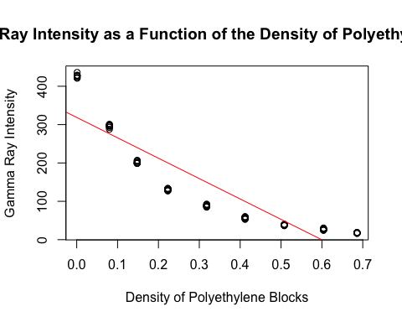

We will extract residuals from the model and observe the residual vs. fitted plot (the predicted values) to understand whether our model has a good fit.

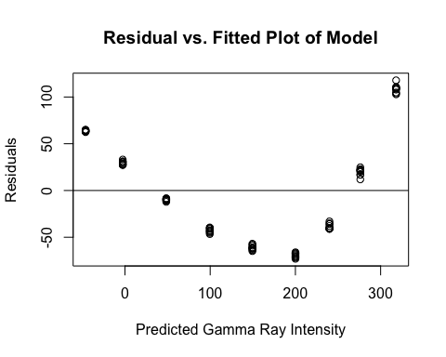

There is a very clear nonlinear pattern between the predicted values from the model and the residuals, which suggests the current model is inappropriate for the data since the relationship between the response variable and the residuals are not linear. There is also homoscedasticity present since the residuals do not vary constantly; some are further or closer away than others, as shown in the graph.

Additionally, we can plot a QQ plot to check if the residuals are normally distributed.

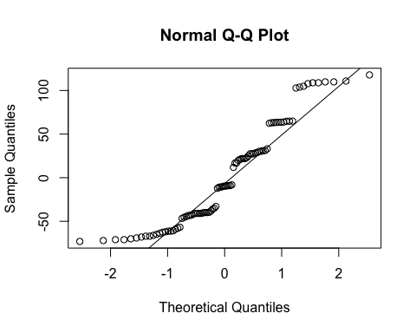 In general, the points on the plot do not fall closely to the line. The points form an ‘S-shape’, are staggered, and clearly deviate from the 45-degree reference line, which indicates the residuals not normally distributed.

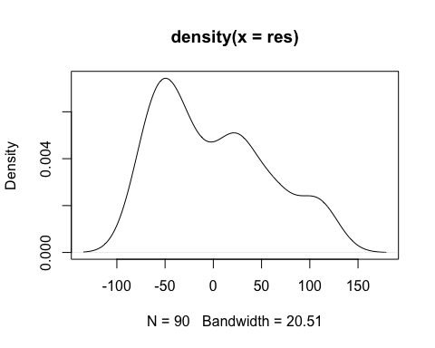

A density plot of our residuals shows that the density of our residuals is skewed right, meaning most of our observed results were below the predicted value (overestimate). We can confirm this by checking our regression line plotted with the observed values. Since the data was concaved up, our regression line was higher than most of the points in the center of the plot.

### Analysis

We will need to transform our data if our data is skewed and does not resemble a bell curve. We can test whether our data comes from a normally distributed population with a Shapiro-Wilk test. Our null hypothesis is that our data does come from a normally distributed population.

Shapiro-Wilk normality test: data$gain With a p-value of 4.599 * 10^(-9) < 0.05, we reject the null hypothesis. This suggests our data is *not* normally distributed.

| Test statistic | P value |
| --- | --- |
| 0.8212 | 4.599e-09 * * * |

### Conclusion

A transformation may be necessary because a visual graph shows our fitted model *overestimates* many of our data points since our data is nonlinear and concaved up. A plot of the residuals with the predicted gamma ray intensity also shows that our plot is not homoscedastic, and a QQ plot highlights that our residuals are also not normally distributed. This means our data failed the linearity, heteroscedasticity, and normality conditions. Since a Shapiro-Wilk test confirmed that our data is not normal, we must transform our data to help normalize it.

## Question 2: TRANSFORMED DATA

### Methods

To find a fitting transformation for our data, we experimented with a log transformation on gain and graphed lines of best fit.

|  | Estimate | Std. Error | t value | Pr(>|t|) |
| --- | --- | --- | --- | --- |
| **(Intercept)** | 5.997 | 0.01274 | 470.8 | 1.843e-151 |
| **density** | -4.606 | 0.03182 | -144.8 | 1.857e-106 |

Fitting linear model: lggain ~ density

| Observations | Residual Std. Error | $R^{2}$ | Adjusted $R^{2}$ |
| --- | --- | --- | --- |
| 90 | 0.06792 | 0.9958 | 0.9958 |

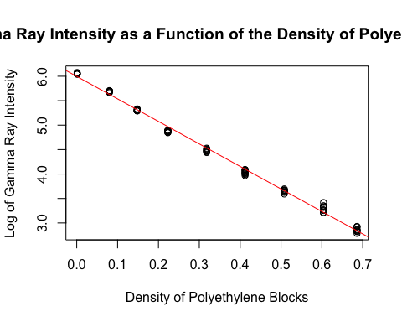

After performing a log transformation on the measured gamma ray intensity, the data becomes linear and a linear model is able to fit the data very closely with a negative slope of -4.605.

Next, we plotted the residuals of the model to visualize the distribution of each data point.

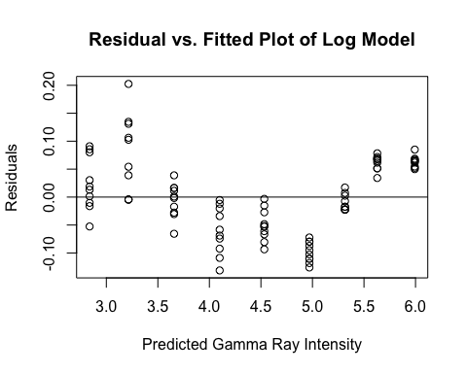

Addtionally, we plotted a QQ plot of these residuals to ensure that they are normally distributed.

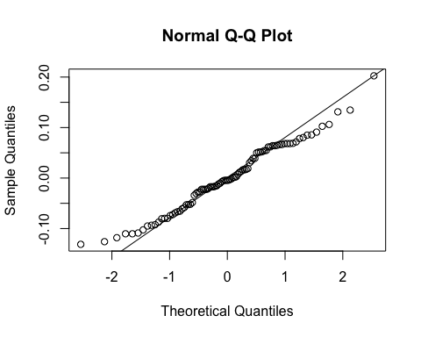

The plot of the residuals and the QQ plot also support the idea that the data is now linear after the log transformation, as the resisuals are more randomly scattered and they fall close to the normal line on the QQ plot.

### Analysis

Based on our visualizations, the log transformation is a fitting transformation for our data to fit a linear model. To reinforce this idea, we can test whether our data comes from a normally distributed population with a Shapiro-Wilk test. Our null hypothesis is that our data does come from a normally distributed population.

##   
## Shapiro-Wilk normality test  
##   
## data: data$lggain  
## W = 0.93581, p-value = 0.0002461

With a p-value of 0.0002461< 0.05, we reject the null hypothesis. Although this suggests that the residuals our data is *not* normally distributed, it is a vast improvement from the previous p-value of 4.599 * 10ˆ(-9).

### Conclusion

The log transformation on predicted gamma ray density is appropriate for fitting the data to a linear model. The visualizations of the model itself, its residuals, as well as a QQ plot show us that the log transformation allowed the data to fit a linear model very well. Although the log transformation failed to completely transform the distribution of predicted gamma ray density into a normal distribution, it significantly reduced the non-linearity of its distribution.

## Question 3: ROBUSTNESS

### Methods

If the densities of the polyethylene blocks are not reported exactly, we can use the error term in the prediction interval to take into account the variability in the gamma ray intensity (the gain).

We have generated synthetic data that includes noise for the densities, fit a model to predict gains based on the densities with noise, and created predictions of the gains using the newly fitted model.

## Warning: Using `size` aesthetic for lines was deprecated in ggplot2 3.4.0.  
## ℹ Please use `linewidth` instead.  
## This warning is displayed once every 8 hours.  
## Call `lifecycle::last_lifecycle_warnings()` to see where this warning was  
## generated.

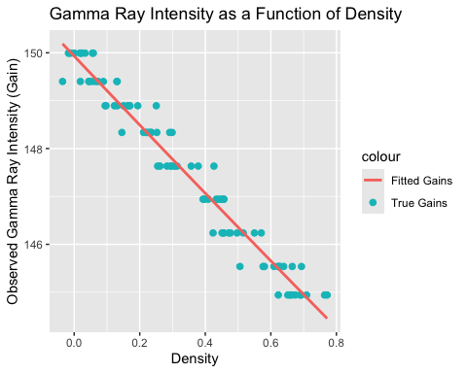

Based on the graph above, our new model that accounts for noise in density closely predicts the true gains from our dataset! Below, we will plot the residuals of the model.

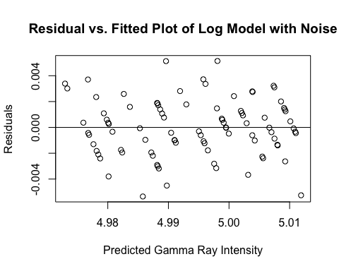 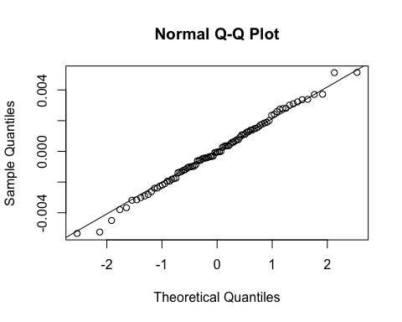

After accounting for noise, it seems as though our residuals follow the line y = x more closely; our residuals are closer to being normally distributed than in our previous model.

### Analysis

We will extract the residuals from our model that accounts for noise in density and use the {r} shapiro.test() function on the residuals. Our null hypothesis is that the residuals are normally distributed.

Shapiro-Wilk normality test: res_noise

| Test statistic | P value |
| --- | --- |
| 0.9944 | 0.9707 |

Since the p-value = 0.9707 > 0.05, we fail to reject the null hypothesis. The residuals are normally distributed, so accounting for variations in the densities of the polyethylene blocks *does* result in a more accurate fit.

### Conclusion

We created a new model under the assumption that densities of the polyethylene blocks were not reported exactly. Since the residuals closely align the 45-degree line in the QQ plot and a Shapiro-Wilk test confirms the residuals are normally distributed, our new fitted model that accounts for variation in densities performs *better* than without accounting for variations.

## Question 4: FORWARD PREDICTION

### Methods

Below is the basic summary of our data.

| gain | density |
| --- | --- |
| Min. : 16.20 | Min. :0.0010 |
| 1st Qu.: 37.80 | 1st Qu.:0.1480 |
| Median : 88.25 | Median :0.3180 |
| Mean :142.57 | Mean :0.3311 |
| 3rd Qu.:203.50 | 3rd Qu.:0.5080 |
| Max. :436.00 | Max. :0.6860 |

We will reuse our model from Question #1 and now include confidence intervals in our visualization to represent the uncertainty bands.

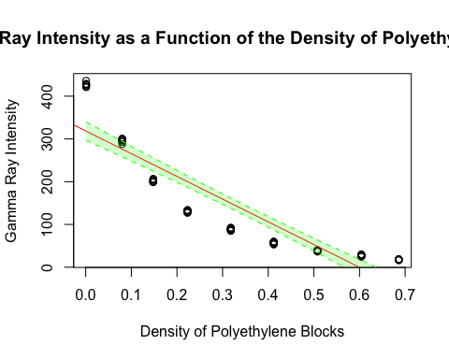

### Analysis

From our visualization with the confidence intervals included, it is clear that there are two specific densities whose gain measurements are accurately predicted by the model: 0.1 and 0.5. The predicted gain measurements include the actual gain measurements of those values. Additionally, the recorded densities between these measures fall relatively close to to the linear model in comparison to densities that fall outside of this interval. This can also be visualized in the residual plot of this model, where the predicted gains of densities in this interval are [0, 300]. The residuals within this interval are much closer to 0 than residuals outside this interval.



### Conclusion

Based on both the linear model as well as the residual plot, it is reasonable to conclude that some gains can be predicted more accurately than others. This is best represented by the density interval [0.1, 0.5]. On the linear model plot, the data points within this interval fall within the confidence interval or very close to it compared to data points that are outside the interval. The residual plot reinforces this idea, as the predicted gains of densities within this interval are closer to 0 than the predicted gains of densities outside of this interval.

## Question 5: REVERSE PREDICTION

### Methods

We will start by inverting our model from Question 1, which has the original untransformed scale. 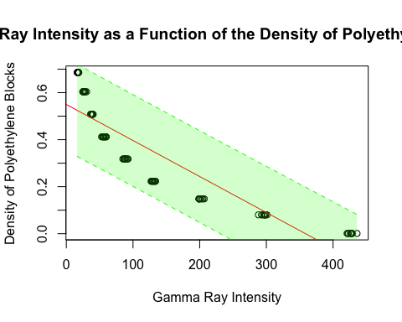 Above, we have our regression line for the inverse graph plotted with a prediction interval for estimating *specific* densities of polytheylene blocks from gamma ray intensity (gain) while incorporating the individual variability.

### Analysis

**Predictions for Gamma Ray Intensity (Gain) OF 38.6 and 426.7**

The inverted model predicts polyethylene blocks with a gain of 38.6 have a density that falls in the range of [0.344, 0.686] with a point estimate at 0.511. It also predicts polyethylene blocks with a gain of 426.7 have a density that falls in the range of [-0.458, 0.01] with a point estimate at -0.278.

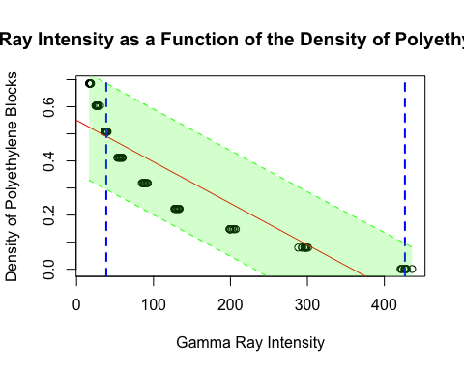 In the graph above, the predictions for the gamma ray intensities of 38.6 and 426.7 are denoted by where the dashed blue lines intersect with the red line, our regression/ prediction line. The green bar is our prediction interval, which represents the range where a single observation is expected to fall. Note that for the gamma ray intensity of 38.6, our prediction is fairly close to the observed density value; indeed, our point estimate of 0.511 is very close to the true value of 0.508 and the true value does lie in our prediction interval. However, for the gamma ray intensity of 426.7, we predict a density of -0.278. This is extrapolation, and does not make sense in our context, since we cannot have negative gamma ray densities. The true density for a gamma ray intensity of 426.7 was 0.001. The reason why our model is unable to estimate high values accurately is because the data does not follow a linear pattern, but we are using a linear model to make inferences on it.

### Conclusion

The reverse prediction was fairly accurate for the lower estimate where the gamma ray intensity was 38.6. However, for a higher value, such as 426.7, the model failed to make a reasonable prediction such it yielded a negative number. Since our graph is nonlinear, it is evident that most accurate predictions made occur between low and moderately-high gamma ray intensity levels. Our graph’s concaved up curve means that data in the middle sector will most likely be overestimated, and extreme high values will wrongfully be estimated as negative. Likewise, extreme low values will incorrectly be underestimated.

## Question 6: CROSS-VALIDATION

### Methods

In order to test the reverse prediction model, we first omit the set of measurements corresponding to the block of density 0.508 and train the forward model on the subset.

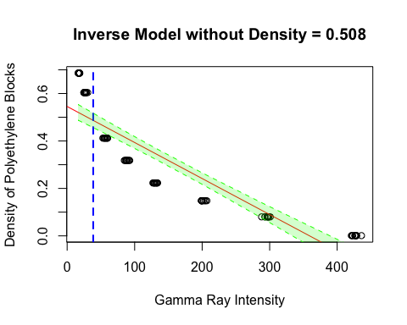

The confidence interval for the estimation of a block with an average reading of 38.6 for this model is as follows.

| fit | lwr | upr |
| --- | --- | --- |
| 0.4867 | 0.4562 | 0.5172 |

We also performed this test on a subset of the data without the block of density 0.001.

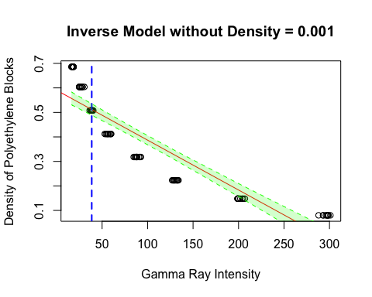

The confidence interval for the estimation of a block with an average reading of 38.6 for this model is as follows.

| fit | lwr | upr |
| --- | --- | --- |
| 0.5117 | 0.4885 | 0.5349 |

### Analysis

There are some differences between the two models. The first model has a higher y-intercept compared to the second one, while the second model has a steeper slope. The confidence intervals for a gamma ray measurement of 38.6 include the actual density of 0.508 of for both models. They lie in the middle of both intervals.

### Conclusion

The exclusion of densities equal to 0.508 and 0.001 respectively allowed the model to more accurately predict the density of data points that lie outside the range [0.001, 0.508]. This can be seen in the visualizations as well as reflected in the confidence interval for the gain of 38.6.

# Advanced Analysis

In the basic analysis, we fit our data to a linear model and explore why a linear model is not fully representative of the data. In the following section, we will create a fit our data to a nonlinear model using nls(). We are interested in exploring accurately how a **nonlinear least squares** model predicts gamma ray intensity. ### Methods 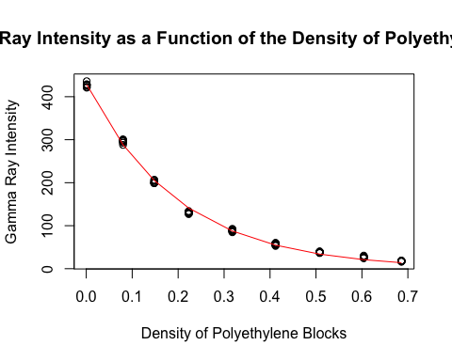 Above, we can see the nonlinear least squares model almost fits the data perfectly!

### Analysis

Fitting nonlinear regression model: gain ~ nls_fx(density, A, beta)

Parameters

|  | Estimate | Std. Error | t value | Pr(>|t|) |
| --- | --- | --- | --- | --- |
| **A** | 430.1 | 1.721 | 250 | 2.764e-127 |
| **beta** | -5.002 | 0.03571 | -140.1 | 3.278e-105 |

Residual standard error: 6.012 on 88 degrees of freedom After looking at the summary statistics of our NLS Model, we can see we have an R^2 value of 0.998 and an MSE of 35.345.

### Conclusion

The nonlinear least squares model is a great fit for our data! The R^2 value of 0.998 means that **99.8% of the variance** in the intensity of gamma rays (gain) can be explain by the model. The MSE value of 35.346 is also good; since our Gain values range from min(data$gain) = 16.2 to max(data$gain) = 436, the model’s predictions are generally close to the actual values. The errors are not excessively large. The average squared error is relatively small compared to the entire range.

# Conclusion & Discussion

In conclusion, the calibration of this gain-to-density model is accurate in its predictions. However, this method of calibration is inherently flawed, as the relationship between gain and density is non-linear, while the models created by this method of calibration are linear. As such, the predictions of this calibration can be inaccurate, especially for data points that our outliers relative to the other data points.

Some limitations to this data set are that it only shows the measurements for 9 densities, with only 10 gains listed per density. This lack of data could impact the accuracy of the calibration models, as it is a relatively small sample of all possible snow densities.