# Q1:

SELECT * FROM RNA

WHERE len >12 and timestamp > '2008-12-31'

limit 1000;

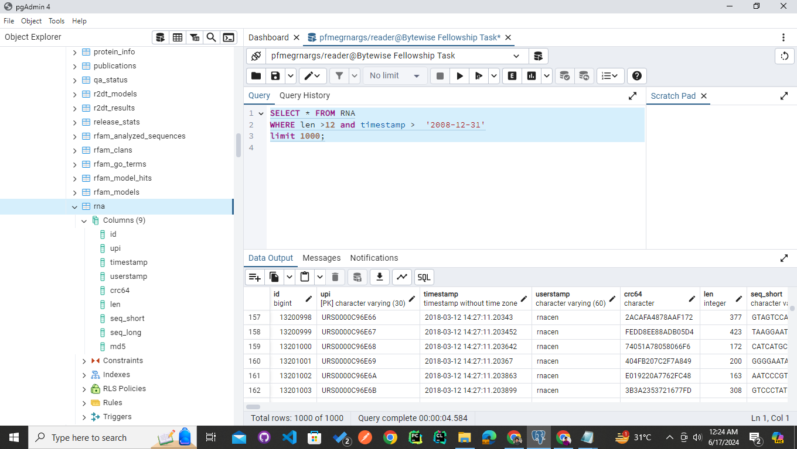

# Q2:

SELECT COUNT (*)

FROM rnc_rna_precomputed

WHERE update_date < '2022-01-01' AND is_active = 'true'

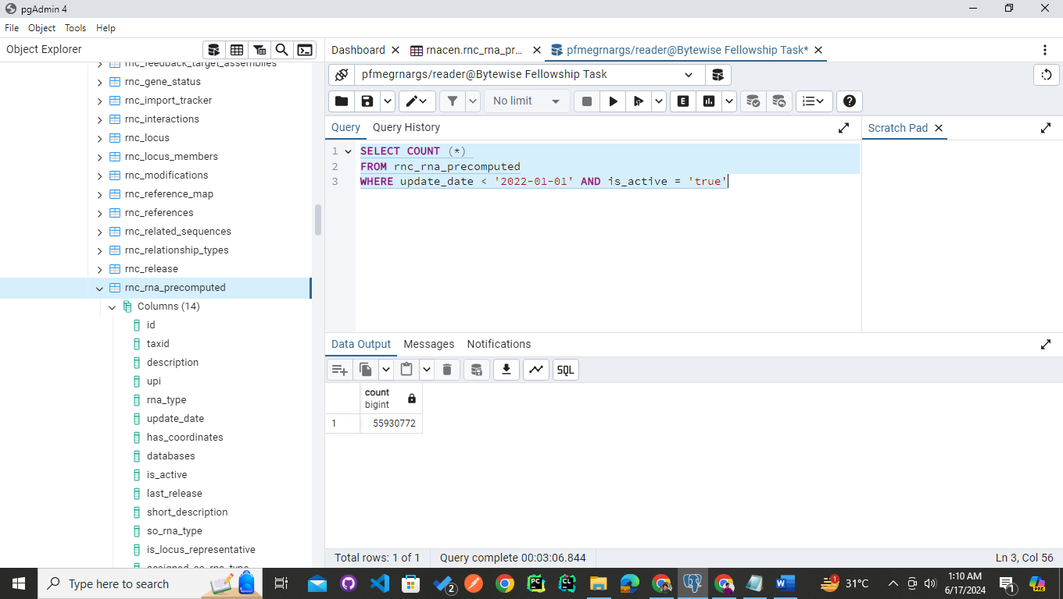

# Q3:

SELECT COUNT(*)

FROM rnc_rna_precomputed

WHERE (rna_type = 'snoRNA' OR rna_type = 'tRNA')

AND EXTRACT(YEAR FROM update_date) IN (2011, 2014, 2016, 2020);

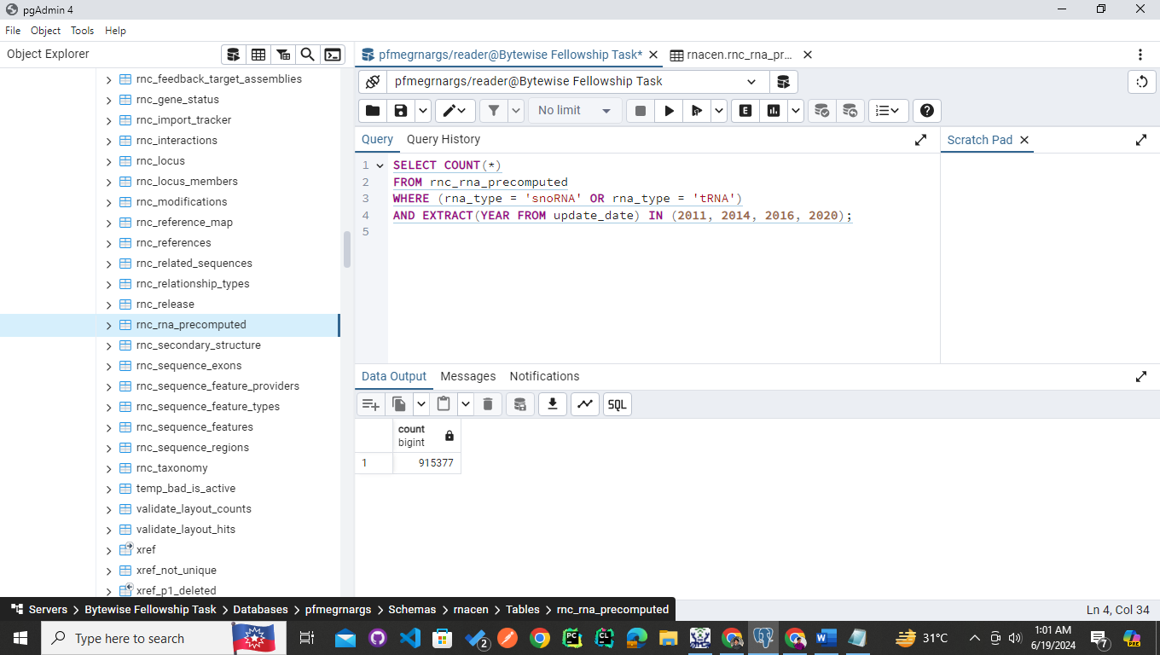

# Q4:

SELECT display_name as names_of_databases

FROM rnc_database

WHERE min_length NOT IN (100,200,300,400,15)

LIMIT 100;

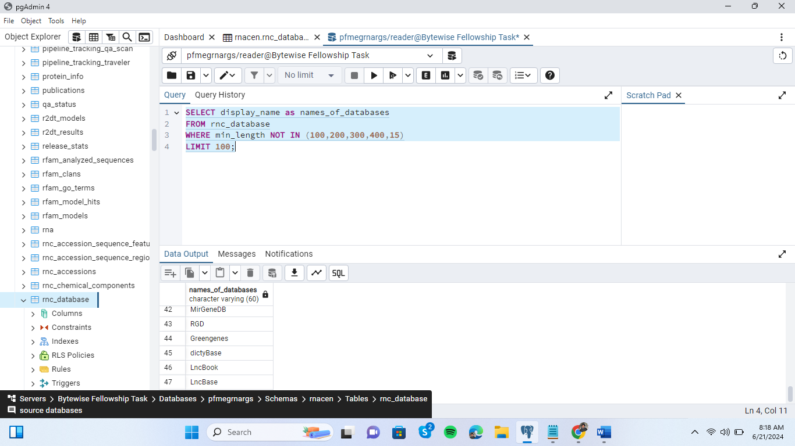

# Q5: