Pedestrian Detection By
Light Detection And Ranging Sensor
in Autonomous Driving System

Juncheng Hu
Fakultät für Informatik
Technische Universität Chemnitz
Chemnitz, Germany
juncheng.hu@s2015.tu-chemnitz.de

Abstract—The purpose of this study is to introduce the algorithm of detecting pedestrians in Autonomous Driving System by the use if LiDAR. The implementation of how to use neural network to recognize a pedestrian is also explained. It also covers several traditional methods to realize the purpose and compares the advantage and disadvantages of these algorithm. The principle of the algorithm is also addressed. Besides this report address several the applications in Autonomous Driving. The limitation of using LiDAR is also discussed in this report.
Keywords—pedestrain detection; LiDAR; Autonomous Driving; pattern recognition

Introduction
In nowadays transportation system, the rate for the accident every day is a huge problem, which takes a big amount for human lives. Besides the traveling time spend on the road from your home to the working place has become a huge waste of time. So, there is a requirement of autonomous driving system, which can save both the lives and time for human beings, because the autonomous driving cars has a much lower accident rate and a reliable traveling time. For autonomous driving car, it need to have a perceptron of the environment. To realize this purpose, different sensors are need. Sensors like, millimeter wave radar sensor, light detection and ranging sensor, ultrasonic sensor are usually used to detect the distance, which can all the autonomous driving car to tell how far the target is from itself. Only the distance is not enough for autonomous driving, it also requires identifying what the target is, so a group of other sensors are needed., like camera and LiDAR. In this report, we mainly discuss algorithms with the use of LiDAR.

Classification Methods
In this section fours algorithm will be simply introduced, the Nearest Neighbor Classifier, the Approximate Nearest Neighbor (KNN), the Spatial Pyramid Matching, and Histogram of Gradients (HoG) algorithms are included. These are the traditional algorithms, but which are also classical.

Nearest Neighbor Classifier
This algorithm is the most classical algorithm in pattern recognition. The aim for this algorithm is to make a classification for the target objects. To evaluate if the target belongs to the corresponding classification, the difference between each other is calculated. The problem of calculation of the distance between the same position in each image. The distance is then closely related to the problems of selecting parameters in the series of regressions. [1] After the regression, the, the loss of the distance need to be calculated, like in the figure 1, there is a threshold, compared to which the result can be released.
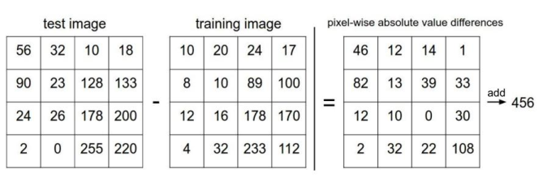
Figure 1: L1 distance calculation

Approximate Nearest Neighbor (KNN)
The Approximate Nearest Neighbor, which is also known as KNN methods, is derivate from the previous nearest neighbor algorithm. It makes the improvement by calculate K nearest neighbors instead of exact one pixel in the image. This can improve the tolerance of the slight difference in object classification. The decision of which label the pixel belong to is made by the mean value of the K nearest neighbors. The difference is shown in Figure 2.
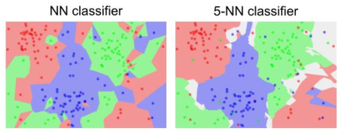
Figure 2: Comparison of NN clsddifier and 5-NN classifier

Spatial Pyramid Matching
Spatial pyramid matching (SPM) is an algorithm for image matching, recognition and classification using the method of spatial pyramid. SPM is an improvement of Bag of Features (BOF) algorithm. Because BOF is to calculate the distribution of feature points in the whole image, and then generate the global histogram, so it will lose the local details of the image, thus unable to identify the image accurately. For the SPM, the image of level (i) is divided into pow (4, i) cells, it calculates the statistical histogram features on each cell, then connect the histogram features of all levels to form a vector which act as the feature of the image. [2] The following figure is an example to show the algorithm at the three levels.
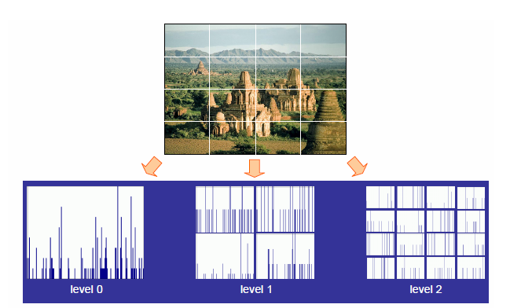
Figure 3: Spatial pyramid matching example

Histogram of Gradients (HoG)

Prepare Your Paper Before Styling
Before you begin to format your paper, first write and save the content as a separate text file. Keep your text and graphic files separate until after the text has been formatted and styled. Do not use hard tabs, and limit use of hard returns to only one return at the end of a paragraph. Do not add any kind of pagination anywhere in the paper. Do not number text heads-the template will do that for you.
Finally, complete content and organizational editing before formatting. Please take note of the following items when proofreading spelling and grammar:

Abbreviations and Acronyms
Define abbreviations and acronyms the first time they are used in the text, even after they have been defined in the abstract. Abbreviations such as IEEE, SI, MKS, CGS, sc, dc, and rms do not have to be defined. Do not use abbreviations in the title or heads unless they are unavoidable.

Units
- Use either SI (MKS) or CGS as primary units. (SI units are encouraged.) English units may be used as secondary units (in parentheses). An exception would be the use of English units as identifiers in trade, such as “3.5-inch disk drive.”
- Avoid combining SI and CGS units, such as current in amperes and magnetic field in oersteds. This often leads to confusion because equations do not balance dimensionally. If you must use mixed units, clearly state the units for each quantity that you use in an equation.
- Do not mix complete spellings and abbreviations of units: “Wb/m2” or “webers per square meter,” not “webers/m2.” Spell units when they appear in text: “...a few henries,” not “...a few H.”
- Use a zero before decimal points: “0.25,” not “.25.” Use “cm3,” not “cc.” (bullet list)
Identify applicable sponsor/s here. If no sponsors, delete this text box (sponsors).

Equations
The equations are an exception to the prescribed specifications of this template. You will need to determine whether or not your equation should be typed using either the Times New Roman or the Symbol font (please no other font). To create multileveled equations, it may be necessary to treat the equation as a graphic and insert it into the text after your paper is styled.
Number equations consecutively. Equation numbers, within parentheses, are to position flush right, as in (1), using a right tab stop. To make your equations more compact, you may use the solidus ( / ), the exp function, or appropriate exponents. Italicize Roman symbols for quantities and variables, but not Greek symbols. Use a long dash rather than a hyphen for a minus sign. Punctuate equations with commas or periods when they are part of a sentence, as in
a  b             
Note that the equation is centered using a center tab stop. Be sure that the symbols in your equation have been defined before or immediately following the equation. Use “(1),” not “Eq. (1)” or “equation (1),” except at the beginning of a sentence: “Equation (1) is ...”

Some Common Mistakes
- The word “data” is plural, not singular.
- The subscript for the permeability of vacuum μ₀, and other common scientific constants, is zero with subscript formatting, not a lowercase letter “o.”
- In American English, commas, semi-/colons, periods, question and exclamation marks are located within quotation marks only when a complete thought or name is cited, such as a title or full quotation. When quotation marks are used, instead of a bold or italic typeface, to highlight a word or phrase, punctuation should appear outside of the quotation marks. A parenthetical phrase or statement at the end of a sentence is punctuated outside of the closing parenthesis (like this). (A parenthetical sentence is punctuated within the parentheses.)
- A graph within a graph is an “inset,” not an “insert.” The word alternatively is preferred to the word “alternately” (unless you really mean something that alternates).
- Do not use the word “essentially” to mean “approximately” or “effectively.”
- In your paper title, if the words “that uses” can accurately replace the word using, capitalize the “u”; if not, keep using lower-cased.
- Be aware of the different meanings of the homophones “affect” and “effect,” “complement” and “compliment,” “discreet” and “discrete,” “principal” and “principle.”
- Do not confuse “imply” and “infer.”
- The prefix “non” is not a word; it should be joined to the word it modifies, usually without a hyphen.
- There is no period after the “et” in the Latin abbreviation “et al.”
- The abbreviation “i.e.” means “that is,” and the abbreviation “e.g.” means “for example.”
An excellent style manual for science writers is [7].

Using the Template
After the text edit has been completed, the paper is ready for the template. Duplicate the template file by using the Save As command, and use the naming convention prescribed by your conference for the name of your paper. In this newly created file, highlight all of the contents and import your prepared text file. You are now ready to style your paper; use the scroll down window on the left of the MS Word Formatting toolbar.

Authors and Affiliations
The template is designed so that author affiliations are not repeated each time for multiple authors of the same affiliation. Please keep your affiliations as succinct as possible (for example, do not differentiate among departments of the same organization). This template was designed for two affiliations.

For author/s of only one affiliation (Heading 3): To change the default, adjust the template as follows.

Selection (Heading 4): Highlight all author and affiliation lines.

Change number of columns: Select the Columns icon from the MS Word Standard toolbar and then select “1 Column” from the selection palette.

Deletion: Delete the author and affiliation lines for the second affiliation.

For author/s of more than two affiliations: To change the default, adjust the template as follows.

Selection: Highlight all author and affiliation lines.

Change number of columns: Select the “Columns” icon from the MS Word Standard toolbar and then select “1 Column” from the selection palette.

Highlight author and affiliation lines of affiliation 1 and copy this selection.

Formatting: Insert one hard return immediately after the last character of the last affiliation line. Then paste down the copy of affiliation 1. Repeat as necessary for each additional affiliation.

Reassign number of columns: Place your cursor to the right of the last character of the last affiliation line of an even numbered affiliation (e.g., if there are five affiliations, place your cursor at end of fourth affiliation). Drag the cursor up to highlight all of the above author and affiliation lines. Go to Column icon and select “2 Columns”. If you have an odd number of affiliations, the final affiliation will be centered on the page; all previous will be in two columns.

Identify the Headings
Headings, or heads, are organizational devices that guide the reader through your paper. There are two types: component heads and text heads.
Component heads identify the different components of your paper and are not topically subordinate to each other. Examples include ACKNOWLEDGMENTS and REFERENCES, and for these, the correct style to use is “Heading 5.” Use “figure caption” for your Figure captions, and “table head” for your table title. Run-in heads, such as “Abstract,” will require you to apply a style (in this case, italic) in addition to the style provided by the drop down menu to differentiate the head from the text.
Text heads organize the topics on a relational, hierarchical basis. For example, the paper title is the primary text head because all subsequent material relates and elaborates on this one topic. If there are two or more sub-topics, the next level head (uppercase Roman numerals) should be used and, conversely, if there are not at least two sub-topics, then no subheads should be introduced. Styles named “Heading 1,” “Heading 2,” “Heading 3,” and “Heading 4” are prescribed.

Figures and Tables

Positioning Figures and Tables: Place figures and tables at the top and bottom of columns. Avoid placing them in the middle of columns. Large figures and tables may span across both columns. Figure captions should be below the figures; table heads should appear above the tables. Insert figures and tables after they are cited in the text. Use the abbreviation “Fig. 1,” even at the beginning of a sentence.
- Table Styles
Table Head | Table Column Head
Table Head | Table column subhead | Subhead | Subhead
copy | More table copyª
- Sample of a Table footnote. (Table footnote)

- Example of a figure caption. (figure caption)
Figure Labels: Use 8 point Times New Roman for Figure labels. Use words rather than symbols or abbreviations when writing Figure axis labels to avoid confusing the reader. As an example, write the quantity “Magnetization,” or “Magnetization, M,” not just “M.” If including units in the label, present them within parentheses. Do not label axes only with units. In the example, write “Magnetization (A/m)” or “Magnetization (A ( m(1),” not just “A/m.” Do not label axes with a ratio of quantities and units. For example, write “Temperature (K),” not “Temperature/K.”

Conclusion
In conclusion, in autonomous driving LiDAR is an essential part for pedestrian detection and distance measurement. Although the disadvantage of it, like the extremely high cost and sensible to environment, makes it much difficult to implement to autonomous driving cars. It still has its advantages, it plays a role of a redundancy system for the perceptron system. To fulfill the requirement as a redundancy system, the calibration between the camera perceptron system and LiDAR perceptron system is needed.
The algorithm for pedestrian detection keeps update, the accuracy has been keeping improved in the last several years. The recent issue is about the real time 3D depth measurement according to the video stream. Also, the research on the single camera perceptron system is being under research.
The perceptron system in autonomous driving cars is always more than one solutions to ensure the reliabilities. Other solutions like the multiple sensors and HD map (high definition map) also keeps the autonomous driving being functional in different scenarios .

References
The template will number citations consecutively within brackets [1]. The sentence punctuation follows the bracket [2]. Refer simply to the reference number, as in [3]—do not use “Ref. [3]” or “reference [3]” except at the beginning of a sentence: “Reference [3] was the first ...”
Number footnotes separately in superscripts. Place the actual footnote at the bottom of the column in which it was cited. Do not put footnotes in the reference list. Use letters for table footnotes.
Unless there are six authors or more give all authors’ names; do not use “et al.”. Papers that have not been published, even if they have been submitted for publication, should be cited as “unpublished” [4]. Papers that have been accepted for publication should be cited as “in press” [5]. Capitalize only the first word in a paper title, except for proper nouns and element symbols.
For papers published in translation journals, please give the English citation first, followed by the original foreign-language citation [6].

- N. S. Altman , An Introduction to Kernel and Nearest-Neighbor Nonparametric Regression, The American Statistician, Vol. 46, No. 3. (Aug., 1992), pp. 175-185.
- Lazebnik S, Schmid C, Ponce J. Beyond bags of features: Spatial pyramid matching for recognizing natural scene categories, CVPR 2006.
- G. Eason, B. Noble, and I.N. Sneddon, “On certain integrals of Lipschitz-Hankel type involving products of Bessel functions,” Phil. Trans. Roy. Soc. London, vol. A247, pp. 529-551, April 1955. (references)
We suggest that you use a text box to insert a graphic (which is ideally a 300 dpi resolution TIFF or EPS file with all fonts embedded) because this method is somewhat more stable than directly inserting a picture.
To have non-visible rules on your frame, use the MSWord “Format” pull-down menu, select Text Box > Colors and Lines to choose No Fill and No Line.
- J. Clerk Maxwell, A Treatise on Electricity and Magnetism, 3rd ed., vol. 2. Oxford: Clarendon, 1892, pp.68-73.
- I.S. Jacobs and C.P. Bean, “Fine particles, thin films and exchange anisotropy,” in Magnetism, vol. III, G.T. Rado and H. Suhl, Eds. New York: Academic, 1963, pp. 271-350.
- K. Elissa, “Title of paper if known,” unpublished.
- R. Nicole, “Title of paper with only first word capitalized,” J. Name Stand. Abbrev., in press.
- Y. Yorozu, M. Hirano, K. Oka, and Y. Tagawa, “Electron spectroscopy studies on magneto-optical media and plastic substrate interface,” IEEE Transl. J. Magn. Japan, vol. 2, pp. 740-741, August 1987 [Digests 9th Annual Conf. Magnetics Japan, p. 301, 1982].
- M. Young, The Technical Writer’s Handbook. Mill Valley, CA: University Science, 1989.

