Kick off meeting
11.07.2016
1, Software required:
OBS:
https://obsproject.com/
Potplayer:
http://potplayer.daum.net/

MonaServer:

https://sourceforge.net/projects/monaserver/files/
2, Function Realized:
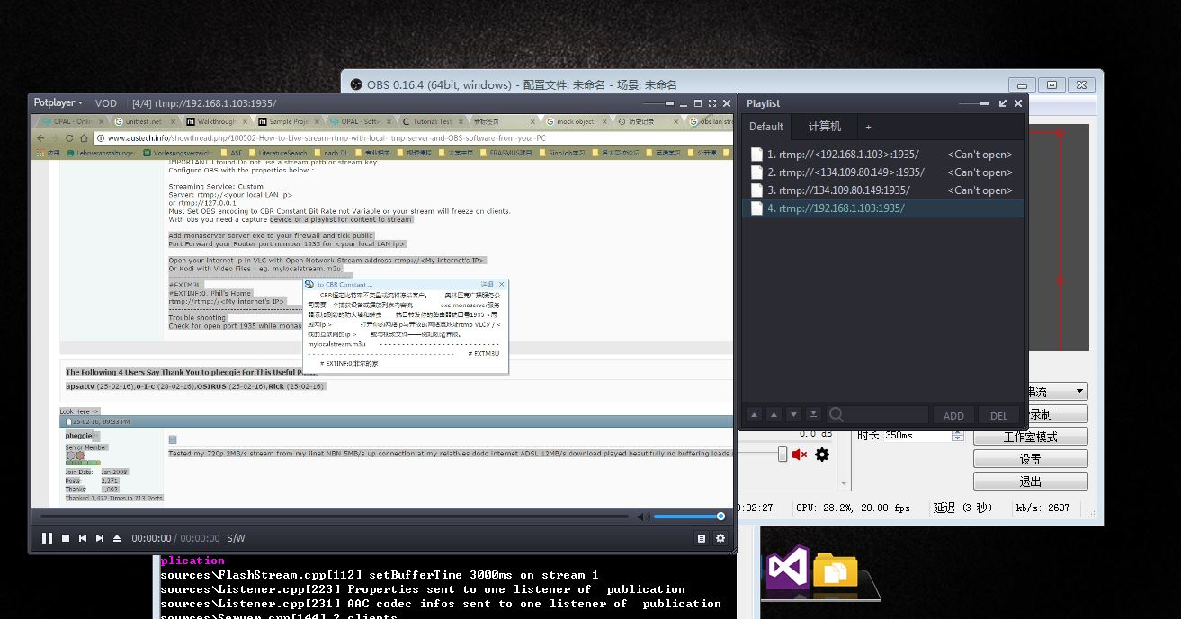
Broadcast in LAN
Transmit by RTMP protocol
Step 1,
Set MobaServer;
Step 2,
Set configuration of OBS
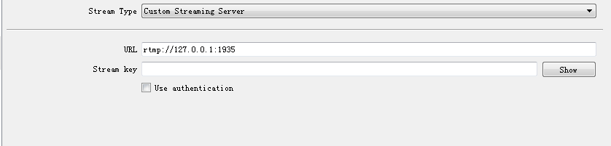
Step 3, Connect two laptops to your Routers,
Check the IP address of the Sender (which will be the computer which runs the OBS).
Step 4, Set the Potplayer for receiving the stream data by RTMP.
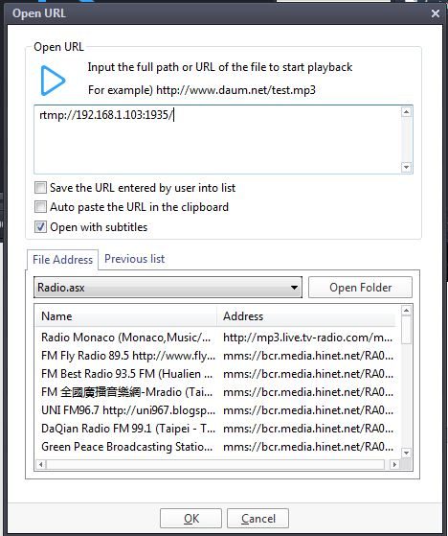
rtmp://192.168.1.103:1935/
192.168.1.103 will be the IP address of the sender.

