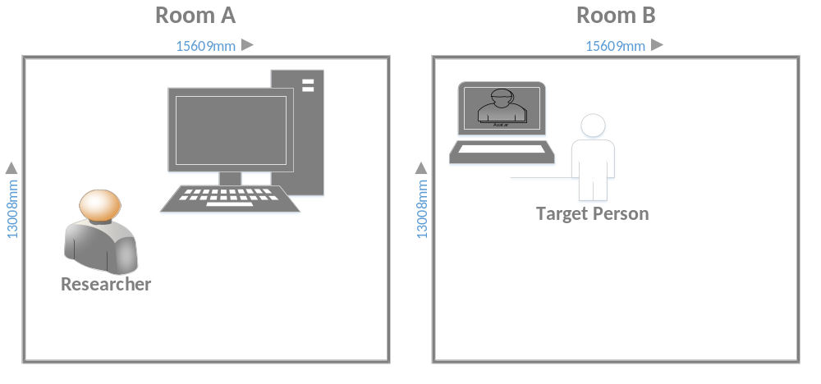
In this topic, I have found the following six problems:
# Also a camera on the side
# Two computers
# UStream testing on my own PC

- The way to separate the 2 source of audio to different speakers on one computer. Because the HDMI can transfer both video and audio signal.
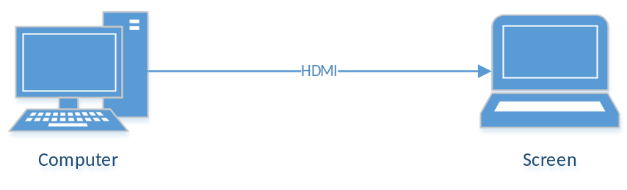
- The tool to capture the video and audio of the “Avatar” and then transfer it to another screen. (Like the live broadcast)
- Using a voice changer to process the voice from the researcher. //Nice to have
- The setting and configuration of the “VHtoolKit”. It must be built on your own computer.
- Add a delay in the route from Researcher to the target. // Using OpenCV

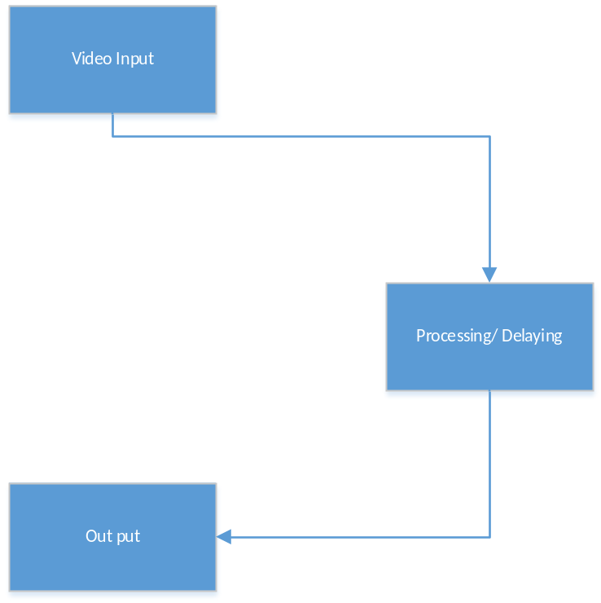
- The most difficult point is the problem of the motion of the mouth doesn’t match the voice of the researcher.

Project Meeting 2:
01.Nov.2016
1, Broadcast applications:
Ustream: https://www.ustream.tv/producer
Xsplit: https://www.xsplit.com/download
OBS: https://obsproject.com/

