Realizing Video Capture and Stream Delay

1, Implement the delay by using a “Queue”, store an amount of frames in the queue and then show the frame one by one.
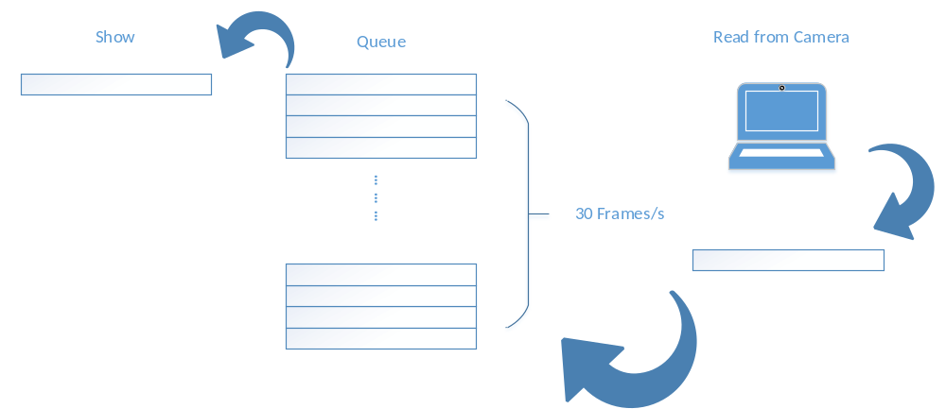
2, Calculate the delay by frames.
1 second : 30 frames
2 seconds: 60 frames
…..
T = f / 30 ; f means the number of frames in the queue.

To be improved:
1, Modify the program to be more readable and make up the format.
2, Simplify the procedure if it is possible.

Juncheng Hu

