胡俊成
电话 : 13264178737 (Beijing, China)
(+49) 015205937726 (Germany)
微信： +4915205937726
E-mail：juncheng.hu@s2015.tu-chemnitz.de
heihuhuray@gmail.com

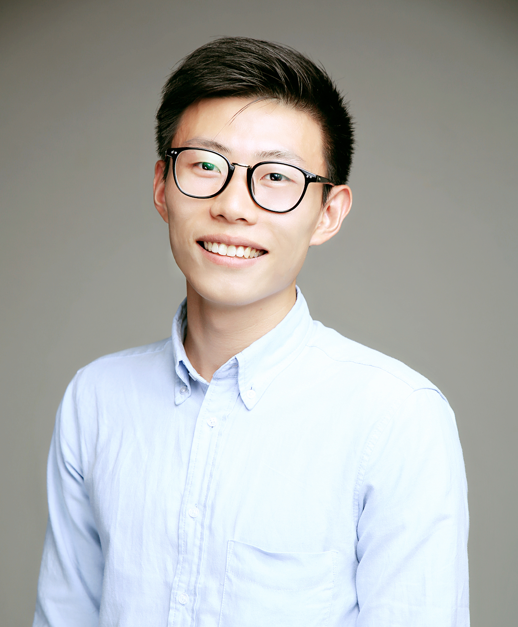
 |  | Education
2011~2015 | Bachelor |  | Electronic Information Engineering |  |  |  | Central China Normal University
 | (Second Degree) |  | English Linguistics |  |  |  |  | Wuhan University
2015 ~ | Master |  | Automotive Software Engineering |  |  |  |  | TU Chemnitz

 |  | Internship Experience
Speech Team, BMW China R&D Center |  |  |  |  |  | March, 2016~ October, 2016
 |  | - As an Intern in Speech team, working on testing and validation of voice control system. This internship is graded as “1.3” .
 |  | - Create more than 250 test cases for Speech team to cover 6 domains
 |  | - Upload Test cases to ALM server using VBA and Python
 |  | - Update the latest version of software from Nuance to the HMI of HU
 |  | - Exact specific files from the HU (Linux OS) with Python scripts
 |  | - Implement the Service number into JSON file
 |  | Campus Experience
Robotic Lab, Informatik, TU-Chemnitz
 |  | - Work as a Research Student for Dr. John Nassour, program the Nao robot to recognize voice input and respond with specific answers in Python.
 |  | - Train the Robot to walk using the Multi-layer multi-patter CPG model.
 |  | - Detected color and keep track of the object with Nao’s heading turning around to track the ball.
 |  | - Calculate the forward and inverse kinematics matrix to reach a specific point in the space.
ASE Lab, Informatik, TU-Chemnitz
 |  | - The target is a given dot cloud generated by LiDAR.
 |  | - The aim is to recognize the slide walk in the dot cloud in ADTF.
 |  | - Recognize the plain which the slide walk lies and then split the plain to get the slide walk.
Machine Learning Lab, Informatik, TU-Chemnitz
 |  | - Using the Perceptron algorithm and logistic algorithm to separate two data sets.
 |  | - Using MLP to train a model to recognize hand written numbers.
 |  | - Using SVM algorithm to find a hyperplane to separate the data set.
Image Understanding Lab, Informatik, TU-Chemnitz
 |  | - Using different kinds of filters to extract the edges of a picture, like the Sobel filter, and Canny edge detection
 |  | - Swapping magnitude and phase using Fourier transform.
 |  | - Using Principal component analysis (PCA) to face encoding
Informatik Research Project, TU-Chemnitz |  |  |  |  |  | November, 2016~
 |  | - As a Research Student for Dr. Schmidt working on a project of Artificial Intelligence with Philosophy school.
 |  | - Program the dialog system for the project in Python
 |  | - Exact the video and audio and then add a delay to the output stream with OpenCV and Pyaudio, Synchronize the audio and video files with FFmepg.
 |  | Languages
 |  | English |  |  |  | IELTS 6.5
 |  |  |  |  |  | BEC (Higher) B2
 |  | German |  |  |  | TestDaf 12
 |  | Computer skills
 |  | Programming Language |  |  |  | C,C++, Python, VBA, ADA
 |  | Awards
 |  | Outstanding League Cadres of the CCNU Youth
 |  | Honorable mention in the Electronic Design Contest of CCNU Electronics Association
 |  | Third prize of the Creative Challenge Cup competition of Physical academy

