YourTurn

Your Turn #1
Let's try out some italics and **bold text*. We can also make really cool tables:
Cool Things we've learned today | Other text
Knitr | pretty sweet package, created at ISU
Markdown | Makes it really easy to create webpages with minimal HTML knowledge
LaTeX | So much easier than MS word for making scientific documents

R code chunk
x <- rnorm(100, 3)
library(ggplot2)
qplot(x, geom="histogram")
## stat_bin: binwidth defaulted to range/30. Use 'binwidth = x' to adjust this.
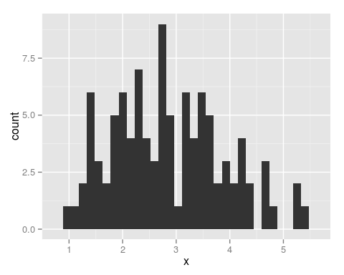
The mean of the randomly generated $x$ values is 2.8555. This makes sense, since I generated them to have a mean of 3.

Your Turn #2
data(iris)
library(knitr)
kable(head(iris))
Sepal.Length | Sepal.Width | Petal.Length | Petal.Width | Species
5.1 | 3.5 | 1.4 | 0.2 | setosa
4.9 | 3.0 | 1.4 | 0.2 | setosa
4.7 | 3.2 | 1.3 | 0.2 | setosa
4.6 | 3.1 | 1.5 | 0.2 | setosa
5.0 | 3.6 | 1.4 | 0.2 | setosa
5.4 | 3.9 | 1.7 | 0.4 | setosa

Linear Model
library(stargazer)
model <- lm(Sepal.Length ~ Petal.Length, data=iris)
stargazer(model, type="html", summary=F)
Dependent variable:
Sepal.Length
Petal.Length
0.409***
(0.019)
Constant
4.307***
(0.078)
Observations
150
R2
0.760
Adjusted R2
0.758
Residual Std. Error
0.407 (df = 148)
F Statistic
468.600*** (df = 1; 148)
Note:
p<0.1; p<0.05; p<0.01

