RT Exam
Heikki Saul
The task was to visualize a simplified model of a ethanol or methanol molecule in RViz. I chose to visualize a methanol molecule.
For visualization in RViz, I used different markers available in Rviz, namely shperical and cylindrical markers. The layout of the markers was detailed in a ROS node “alcohol” that published 10 different markers on the topic “/visualization_marker”. The markers had differing positions, orientations and colors to represent a molecule.
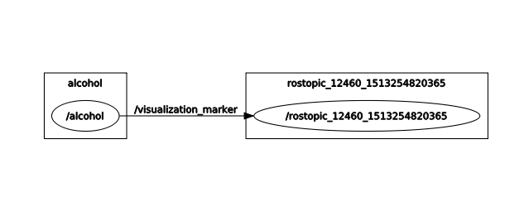Illustration 1: ROS node and topic graph
The illustration above shows the relationship between the publishing node, the topic being published and the subscriber (here being Rviz).
The ROS topic “/visualization_marker” uses “visualization_msgs/Marker” type messages, which hold information about the sequence, timing and pose of the markers being published.
I saved the fitting Rviz configuration and used a launch file (alcohol.launch) to run the entire visualization process with one command.

