Worksheet for the Cubeling app

Task 1. Build using the 3D view!

☐ a slalom

☐ a row

☐ a tower

☐ your favorite animal

Task 2. Build using the building plan!

☐ a thick tower

☐ a pyramid

☐ a fish

☐ a house

Task 3. Turn off the 3D view and the building plan! Continue building!

☐ a wall

☐ a tower

☐ the first letter of your name

☐ the largest possible „X“

Task 4. Answer the following questions about the code view! Explore the app!

☐ What buttons are there and what happens when you click on them?

☐ What is the meaning of the gray arrow at the left edge of the code view?

☐ What do the colored squares represent in the code view?

☐ For what can you use the arrows that appear when you click on one of the squares?

☐ What happens when you build a cube outside of the grid? How do you even do that?

☐ What happens when you want to remove a non-existent cube?

☐ What happens when you build a cube “wrongly”, i.e. not specifying a green or blue number?

☐ What does the symbol 􀊕 allow you to do?

Use only the code view for the next tasks! If necessary, you can use the 3D view and building plan to check your results.

Task 5.

* Create a cube structure (it doesn’t have to be connected, but it shouldn’t be too complicated)!
* Insert two blank lines!
* Now, in the code view, try to reflect this structure over the vertical center!

☐ How do the green and blue numbers of the reflected structure change in comparison to the original structure?

☐ Can you find a general rule?

☐ Would this also be the case in an 8x8 or 9x9 grid?

Task 6.

* Build cube structure 1 using the code view!
* By adding additional lines of code, construct structure 2!
* By then again adding more lines of code, transform it into structure 3!

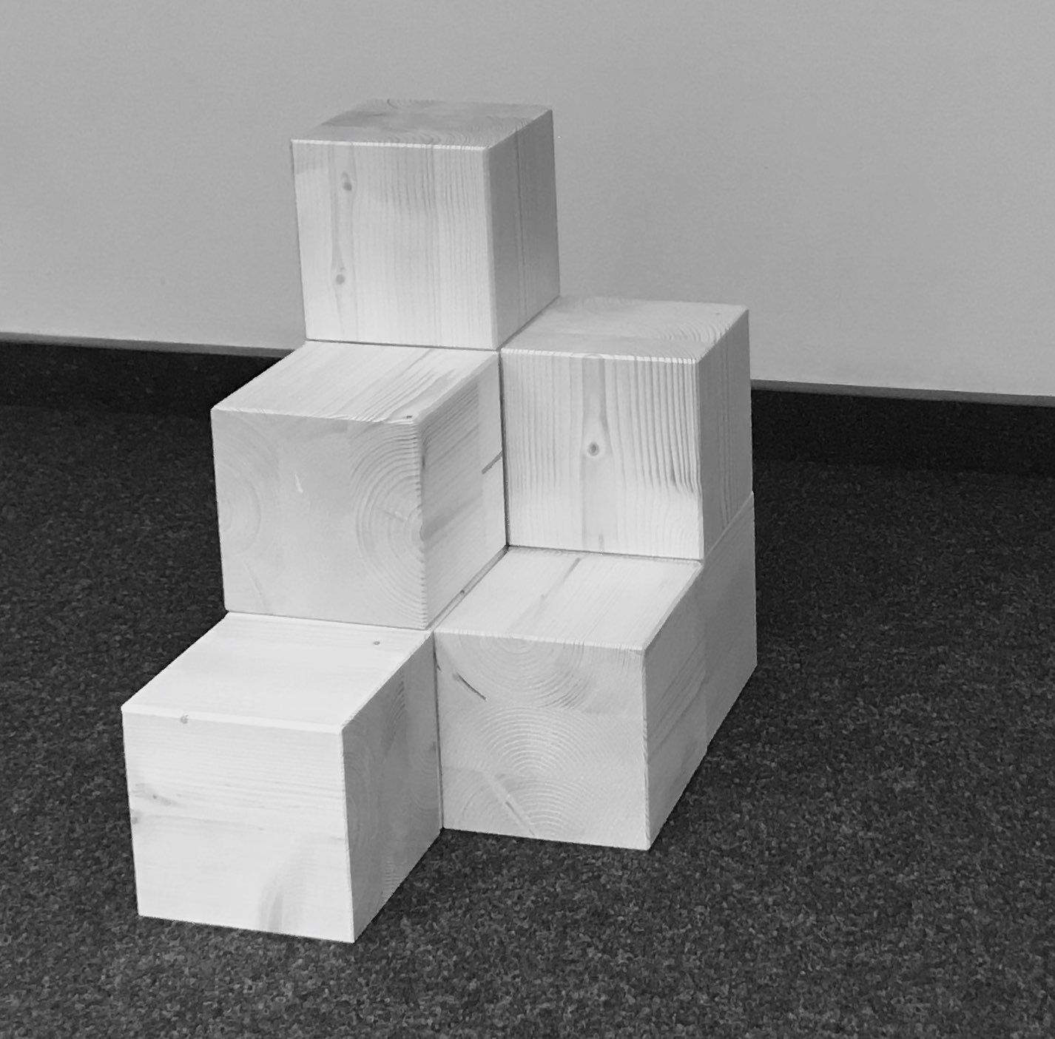 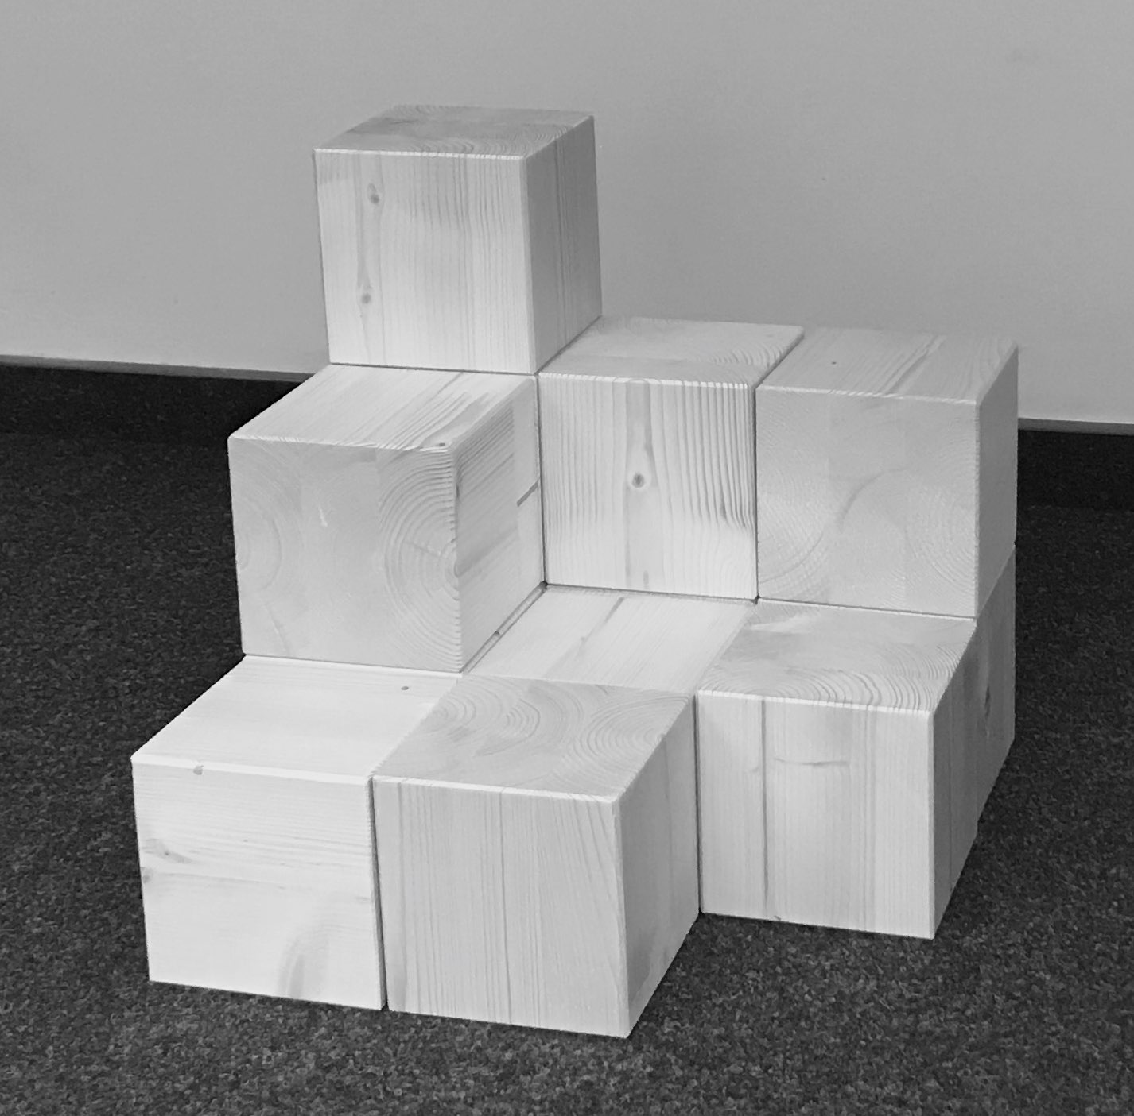 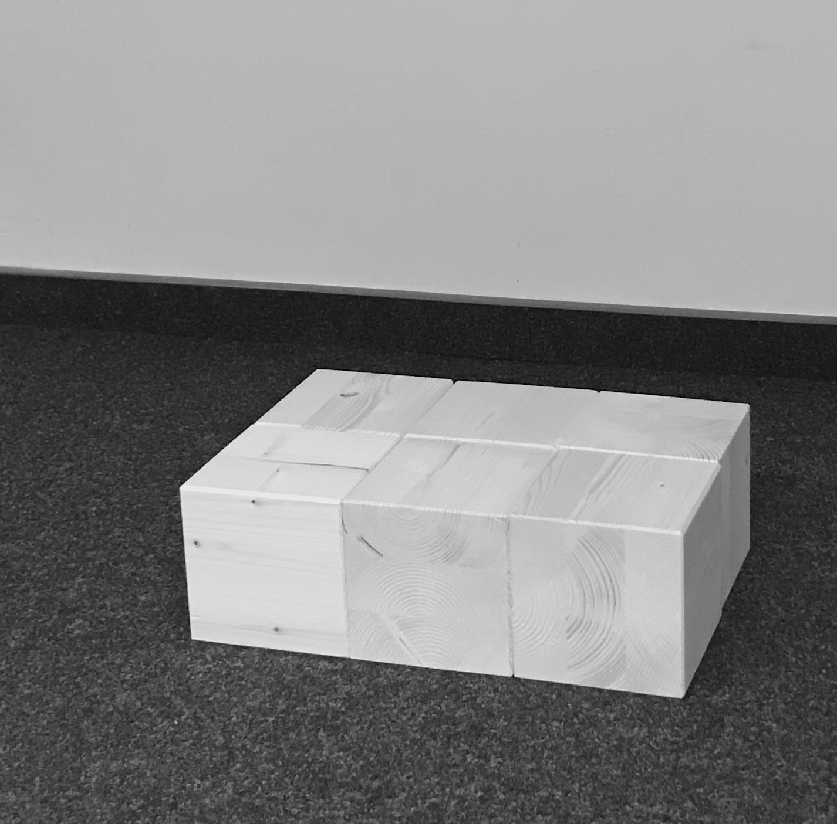  
 Structure 1 Structure 2 Structure 3

Task 7.

Play the following game:

* Think of a cube structure and show your partner this structure in only one of the views.
* Choose a view (3D, building plan, or code) for your partner to recreate the structure in!
* Compare your results. If your partner has made no mistakes, they receive a point.
* Then, switch roles. The first one to 3 points is the winner.