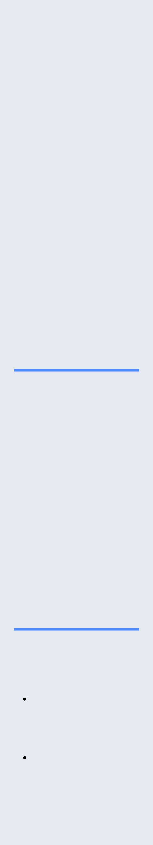BASIL HAVENS

ANDROID

DEVELOPER

[basilhavens@yahoo.com](mailto:basilhavens@yahoo.com)

206-880-1713 Bellevue, WA

[Portfolio](https://www.basilhavens.com/) | [Video](https://crash.co/basilhavens/) [LinkedIn](https://www.linkedin.com/in/basilhavens/) | [GitHub](https://www.github.com/heiligbasil/)

Experienced Android developer looking for ways to bring the world closer together with great mobile apps. On-point communication within diverse teams while also working well independently. Thrilled to continue delivering quality apps for you!

**Skills**

Android, Animations,

Coroutines,

Custom Views,

Debugging,

Design Patterns,

Espresso, Firebase,

GitHub, Gradle, Java,

JSON, JUnit, JVM,

Kotlin, Live Data,

MVVM, Picasso, Room,

SQLite, Notifications,

OAuth2, REST APIs,

Recycler Views, Retrofit,

UI, Unit Testing

**Volunteering**

Lambda School ·

Meetup Coordinator ·

04/2019 - Present Seattle, WA

Attract speakers to

monthly meetups

for students and

alumni

Coordinate activities

through polls,

feedback, and

seasonal suitability

**Apps**



[Treasure Hunt](https://www.basilhavens.com/portfolio/treasure-hunt/) 04/2020

Android app for CS concepts like blockchain, BFS, and 8-bit CPU programming

Android Studio | Kotlin | Retrofit | Fragments | Coroutines | Room | Picasso

Hidden computer science concepts like blockchain and breadth- rst search



Drew map using a custom view directly on the canvas



Listened asynchronously for the completion of work using callbacks



[Community Calendar](https://www.basilhavens.com/portfolio/community-calendar/) 12/2019 - 02/2020

App to empower local organizers to push events to their communities [[Play Store]](https://play.google.com/store/apps/details?id=com.lambda_school.community_calendar) Android Studio | Kotlin | MVVM | Room | OkHttp | Picasso | Espresso | Auth0

Executed in 2 months with a cross-functional team: 3 Android & 6 Web/UX/iOS



Planned extensively with mockups, Trello user stories, research, & UX guidance Pair-programmed, built up the UI and dialog fragment along with action intents



|  |  |
| --- | --- |
| [Health Chaser](https://www.basilhavens.com/portfolio/health-chaser/) | 05/2019 |

App for daily activity logging in 8 categories like sleep time and workout regimens Android Studio | Java | Firebase | Live Data | OpenWeatherMap API | Drawer Layout

 Contributed solely to this original idea which can also support multiple users

Refreshed weather data to log activity notes regardless of location Integrated Google login, animated GIFs, cloud persistence, and sound e ects



|  |  |
| --- | --- |
| [Simpsons Says](https://www.basilhavens.com/portfolio/simpsons-says/) | 04/2019 |

App to show a character quote from the animated TV show *The Simpsons* Android Studio | Java | JSON | OAuth2 | Fragments | RecyclerViews

Solely responsible for the frontend for the team working on the backend



Implemented login screen to the backend using OAUTH2 authentication Featuring search capability and quote generation via Machine Learning



**Employment**



Team Lead, Android - *Lambda School* Remote - 07/2019 - 11/2019

Led a team of ~5 Android students in a work setting using Agile methodology



Reviewed student code via GitHub and provided feedback and suggestions



Facilitated daily standup meetings to build camaraderie, share ideas, and progress



Mentored ~3 students on effective learning and solving programming problems



Delivered one-on-one feedback and code reviews on a daily basis



Contracting - at *NanoString, Chess4Life*... Bellevue, WA - 01/2012 - 03/2019

SDET – *Microsoft (contracts)* Redmond, WA - 11/2006 - 05/2010

Developed apps in C# to automate routine tasks and increase productivity for team

Led a team of 8 remote testers and ensured they met the quality bar

Scripted the universal onboarding install script in PowerShell



Rewrote, updated, and extended the proprietary random state language



**Education**



|  |  |
| --- | --- |
| Lambda School | 03/2019 - 04/2020 |

Android Development 2020

A 9-month computer science & software engineering academy that provided an immersive hands-on curriculum with a track focused on Android development

|  |  |
| --- | --- |
| University of Washington | 06/2012 - 06/2014 |

BA Germanics & European Studies 2014