Internship Feedback
Name: Heimang Goswami
Domain: Data Science and Machine Learning
Organization: Upskill Campus, in partnership with UniConverge Technologies Pvt. Ltd.
Internship Duration: 27 June 2026 - 4 to 6 weeks (Remote)
Project Title: Smart City Traffic Pattern Analysis and Forecasting for Junction-wise Traffic Management
Date: 22 sep, 2026
My Internship Experience
My Data Science and Machine Learning internship with Upskill Campus and UniConverge Technologies has been a genuinely valuable, hands-on learning experience. Rather than just going through theory, the internship was structured around a real, practical project, building a traffic pattern analysis and forecasting system for a smart city, which pushed me to apply data science concepts to a problem with real-world relevance.
Over the course of the project, I got to work through the complete data science lifecycle: understanding a business problem, collecting and exploring data, cleaning and engineering features, performing exploratory data analysis, and finally building, evaluating, and tuning machine learning models. Breaking the project into weekly milestones helped me stay organized and see my own progress clearly, from simply loading a dataset in Week 1 to comparing tuned models and drawing infrastructure recommendations in Week 4.
Some of the specific things I learned and valued:
- How to approach a vague, real-world problem statement and break it down into a structured, step-by-step project plan.
- Practical data cleaning and feature engineering skills, especially handling date-time data and creating meaningful flags (weekend, holiday) that genuinely improved model performance.
- The importance of using a chronological train/test split for time-series data instead of a random split, which I hadn't fully appreciated before this project.
- Hands-on experience comparing models (Linear Regression vs Random Forest) and tuning hyperparameters responsibly, without leaking test data into the tuning process.
- How to translate technical results like feature importance and error metrics into clear, actionable recommendations for a non-technical audience.
- Better documentation habits, from writing weekly progress reports to structuring a project so it's reproducible on any machine.
The project-based and practical nature of this internship, as opposed to a purely theoretical one, is what made the learning stick. I would recommend Upskill Campus and UniConverge Technologies to other students looking for an internship that genuinely builds applicable data science skills rather than just certificates.
Proof of Internship
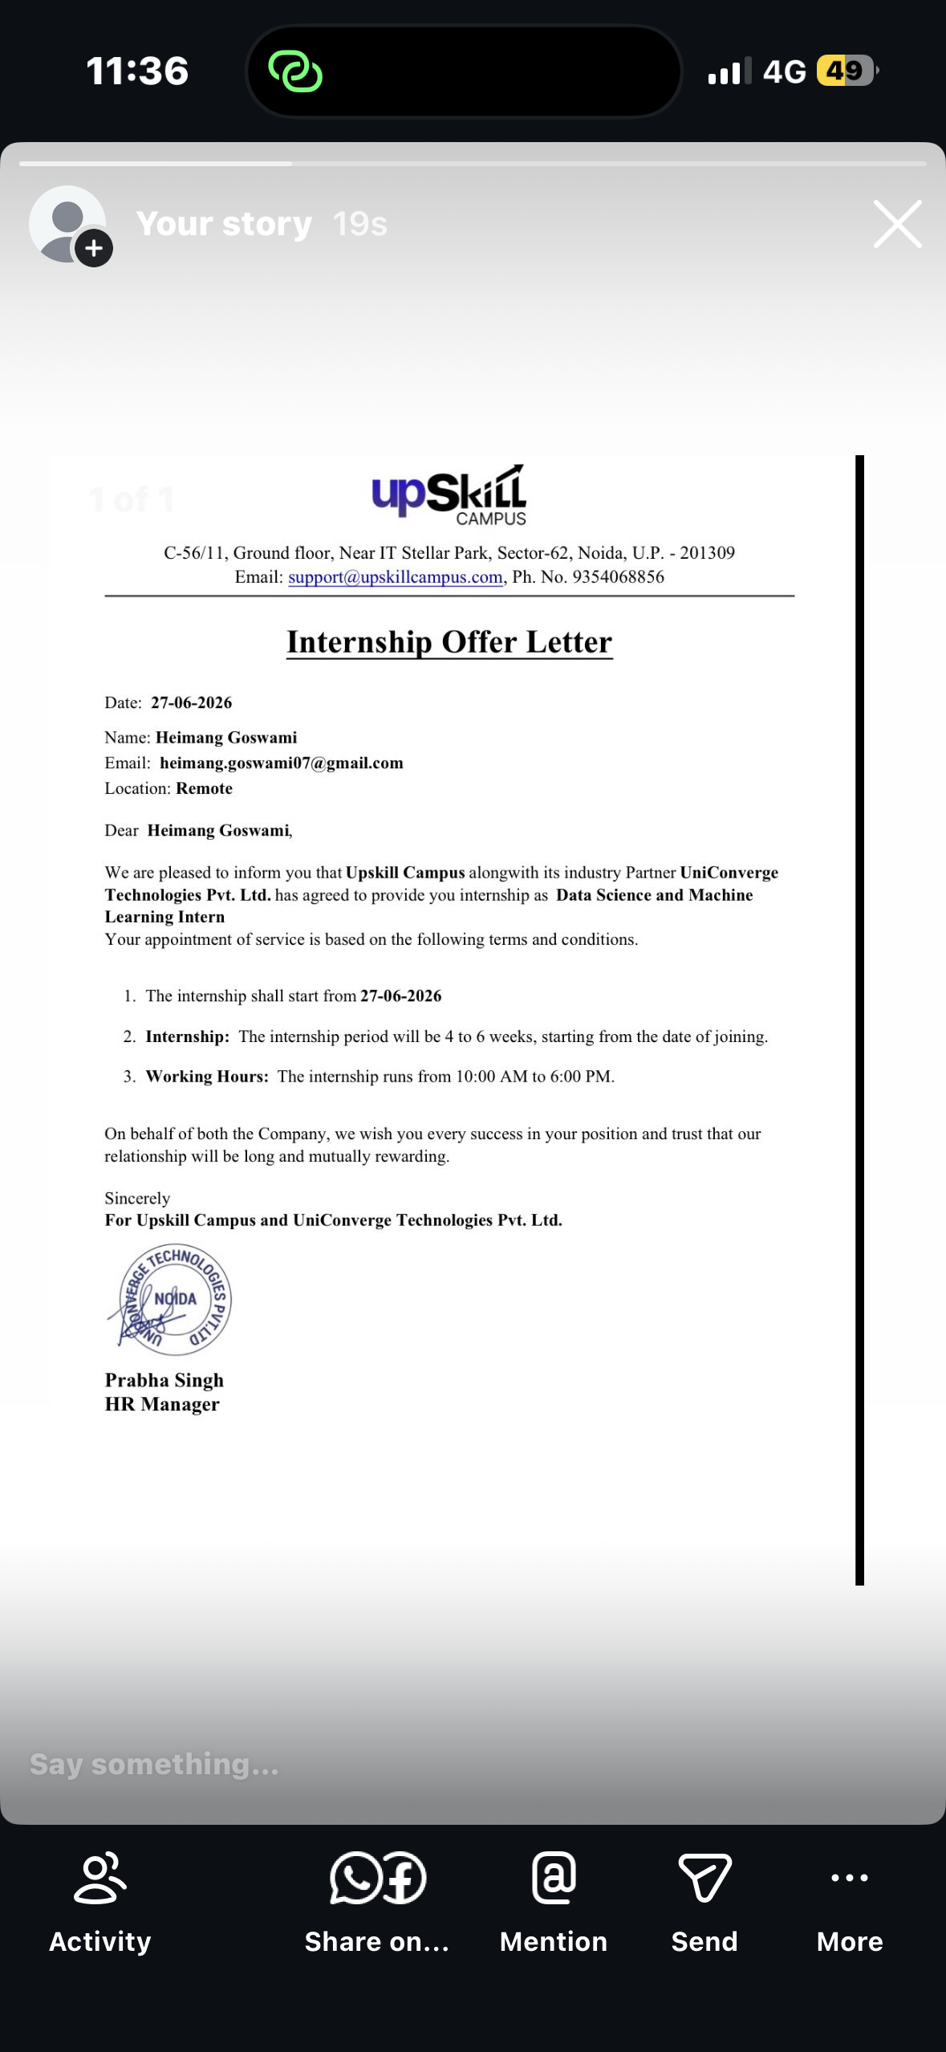
Internship Offer Letter - Upskill Campus & UniConverge Technologies Pvt. Ltd.
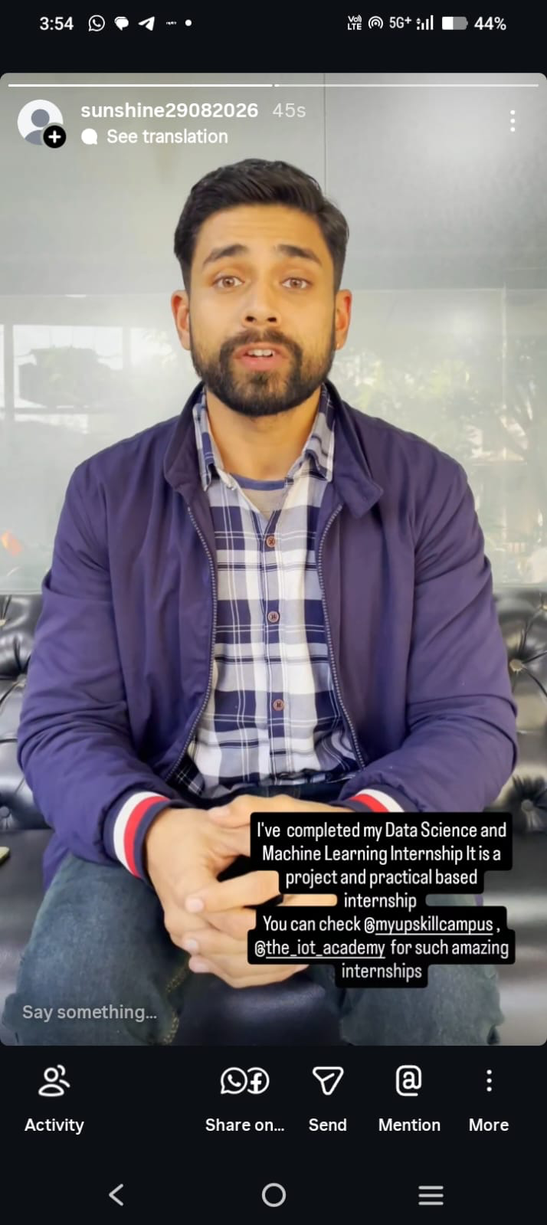
Social media post sharing completion of the Data Science and Machine Learning internship

